ALFRISTON PARISH COUNCIL
www.alfristonparishcouncil.org.uk

CLERK TO THE COUNCIL 11 Highfield Road
Victoria Rutt Horam
TN21 0ED
Tel: 01323 870212
E-mail: alfristonpc01@btconnect.com 23rd January 2018

Minutes of a meeting of Alfriston Parish Council (APC)
held in the Old Chapel Centre on Monday 15th January 2018

Present:
Cllr N. Beechey – Chair Cllr. V. Cooper
Cllr. J. Watkins – Vice Chair Cllr. D. Bell
Cllr. K. Halliday
Cllr. N. White

In attendance:
Victoria Rutt - Parish Clerk
Approximately 10 members of the public

141. Chairman’s Welcome
Cllr Beechey welcomed everyone to the meeting and wished all a Happy New Year. He wanted to express his thanks to Graham at the Gallery for the Christmas tree and to AEG for putting the tree up. Thank you to AEG for all the clearing work they have been doing around the village.
Cllr Beechey stated that all Councillors had received a letter from some parishioners about the November decision re correspondence to the Clerk. The letter and other emails received about this contain certain inaccuracies and either those present had not listened to what was said or those not present hadn’t read carefully the minutes. As per what was decided at the previous meeting, letters to the Clerk would be read at a meeting if the Clerk considers that the subject matter could form an Agenda item or if it did. The purpose was to avoid having to read letters that merely snipe. Those who write that sort of letter ought to come to the meeting and join in debate. Cllr Beechey explained that other Councils restrict public questions at their meetings to only those relating to that meetings agenda. We do not do this nor are we intending to.

- Public Questions
- Mr Geoff Ellis, Chairman of Alfriston Cricket Club was astonished at the decision in November 2017 to restrict the cricket club parking on the Recreation ground. The club have been parking there for over 50 years and no complaints have been sent to either the Club or APC. Mr Ellis explained that if parking is restricted it will cause a number of issues; extra cars around the streets, inconvenience to the Club for kit unloading and loading, number of elderly and disabled will be unable to sit in their car to watch for example. Mr Ellis went on to explain that Alfriston Cricket Club is one of the oldest organisations in the Village and has an excellent and friendly reputation. This would be a real shame if parking was restricted and is grateful that it is on the agenda for consideration.
- Mr Rod Young, representing the Historical Society who used to be a regular user of the AWMH. He explained that now that the Council has designated two spaces which are going to be funded and managed by the Hall and Church, this will go a long way to resolve the situation. However, Mr Young feels that there are still going to be times when vehicles will need to access and park on the Tye. He asked if there is going to be a consultation of the rules which APC have drafted to go alongside the new bollard. Cllr Beechey confirmed these will be circulated in due course. He explained that if people really feel they need to park on the Tye, all they need to do is contact the Clerk and the requests will be considered on a case by case basis by the Council
- Mr Adrian Butcher asked if communication can be better as it lapsed last year leading to issues. If APC would like to send anything over to the AWMH, this can then be circulated to all their users for information. Cllr Beechey thanked him and also for the generous offer to pay for the bollards and their installation. Cllr White suggested that a working party could be held to discuss the rules. Cllr Beechey explained there were already draft rules which would be circulated.
- Ms Diana Monteath-Wilson raised the widening of the path and why nothing had been done. The Clerk updated Ms Monteath-Wilson that she had been in touch with Hailsham Roadways but her contact was very busy, a site meeting is expected to take place in the next 2 weeks to go through the available options to us and then costings will be sent out, Clerk confirmed that APC and Hailsham Roadways are aware of John Nott’s proposals. Funding avenues will be considered now and if anyone from the PCC has any ideas then these would be welcomed. Clerk will keep Ms Monteath-Wilson updated.
- Mr Sillence raised the issue of the playground gate, it is still not able to close properly and the high winds has now broken the spring. The Clerk apologised that it has been on her to do list, she assured Mr Sillence it will be done by the next meeting.

- Report from Maria Caulfield MP
No attendance or report.

- Report from East Sussex County Councillor Stephen Shing
Cllr Shing sent his apologies. He did ask for it to be reported that he has received a number of complaints about the white lines in Whiteway and that he has reported it to ESCC today and it will be raised at the SLR meeting next week.

- Report from Wealden District Councillor Phillip Ede
Cllr Ede has sent his apologies, nothing to report.

- Apologies for absence
Apologies were received and accepted from Cllr Savage.

- Minutes
Clerk updated that since the draft minutes were published, Rod Young asked for wording to be added as it had been missed out of the minutes. This was done.
Cllr. White proposed and Cllr. Cooper seconded a motion that the Minutes of the meeting held on 20th November 2017 were a true and accurate record. MOTION CARRIED.
Cllr. Beechey duly signed the minutes.

- Finance
148.1 To approve the Statement of Finances
Cllr. Halliday proposed and Cllr. Watkins seconded a motion to approve the Statement of Finances [Appendix A]. MOTION CARRIED

148.2 To approve and sign Invoices for Payment
Cllr. Cooper approved and signed Invoices for Payment. MOTION CARRIED

148.3 To approve Q2 bank rec, Q2 budget and Q2 audit
Cllr. Halliday proposed and Cllr. Watkins seconded a motion to approve the Q2 finances. MOTION CARRIED

148.4 To approve the Budget and Precept
The Clerk went through the proposed 2018/19 budgets. It was highlighted that there has been a loss of income from the car park so data analysis and discussions are taking place with Wealden District Council. The allotment income has gone down due to a number of vacant plots despite advertising. Expenditure has gone up however the training will be less this for the next financial year as this year covered the new Clerk training and all the CiLCA costs. The container rent is a large amount of money despite it being reduced in price by Mr Lewis, so it was raised whether we still need this or could we purchase a shed for the allotment and house the items in there. Clerk went on to explain that expenditure has gone up and income has gone down so it was advised that the precept needs looking at. The Clerk broke down the figures if you increase by 1%, 1.5%, 2% and 3%. If APC agreed to increase by 3% this would be a £1.63 household annual increase for Band D households. Cllr. White proposed and Cllr. Bell seconded a motion to approve the 2018/19 budget and precept increase of 3%. MOTION CARRIED

- To consider and approve updated Standing Orders
Cllr Beechey read through the amendments to the Standing Orders that were previously circulated to Councillors. This covered the correspondence to the clerk and the addition of a working party. There was a debate about whether all letters should be displayed on the website. After discussion it was agreed that APC would publish with the minutes those letters read out at the meeting. The Clerk will update the Standing Orders and publish the new version next week to all via email and the website. Cllr. Bell proposed and Cllr. Cooper seconded a motion to approve and adopt the amended Standing Orders. MOTION CARRIED.

- Initial consideration of APC being involved with Alfest 2018
Clerk updated that an email had been received on behalf of the organisers of Alfest 2017 that sadly they would not be able to arrange an Alfest 2018 due to time and financial restraint. Cllr Bell asked for this to be added to the agenda as he felt it was a great shame and wanted to see if APC could look at trying to organise a similar event. Cllr’s Beechey and White said they support having the event but do not have the time to be involved in organising it. There is also the concern of the financial outlay. It was agreed that Cllr’s Bell, Cooper and Watkins would canvas volunteers, ideas and seek advice from the previous organisers to see if something could happen and will report back at the next meeting.

- To review decision to restrict parking on the Recreation Ground for Cricket Club
In accordance with the Standing Orders 3 Councillors had put in writing the request to revisit this issue within 6 months of the original decision. Cllr Beechey declared his interest as a member. The Clerk sought advice from SSALC prior to the meeting and although Cllr Beechey can vote he will not, but he will take part in the debate. Cllr White stated that he wanted to revisit this as he did not know all the information and history before the previous meeting. He stated that the Tye and Rec are very different: the Tye is beautiful and the Recreation Ground is functional. He feels that the rules should apply but permission should be given to Alfriston Cricket Club to park when they hold matches. Cllr Cooper declared her support of this decision. Cllr Bell explained that his position is clear from the November meeting, he feels that cricket is not a big part of village life and that roads are for parking so it should not matter that there would be extra cars. A lengthy debate was held about this. Cllr Watkins agreed with Cllr Bell, she stated that parking around the streets is not a problem and suggested that permission could be given to the disabled to park but feels that 20/30 cars are an excessive amount. Cllr Halliday agreed with Cllr White that the Tye and Recreation Ground are two different spaces and no complaints had been received. Cllr White proposed that Alfriston Cricket Club should be given permission to park on the Recreation Ground on match days, this was seconded by Cllr Halliday and supported by Cllr Cooper. MOTION CARRIED.

- To discuss the Village website
Cllr Beechey updated that Mark and Debbie Exley are now no longer able to run the village website. As Mr Exley needs to provide the Clerk with all the information and he would like to attend the meeting, it was agreed that this agenda item would be deferred until the next meeting [19th February].

- Report on Highways & Twittens – Cllr. Halliday
153.1 Replacement bins for Market Square
The Clerk advised Councillors on the costing of a similar bin to the one that is there now but larger capacity, it is around the £600 mark. Due to APC’s financial situation, this is a lot of money for one bin. The Clerk is going to speak to the company who empties the bin to get a costing on having an extra bin collection at the weekends.

153.2 Market Cross update
The Clerk updated that she has requested a more detail report from the Stonemason and is also going to do some research to seek a comparison quote as this will be needed with the grant application forms.

153.3 High Street traffic update
There has been no update from ESCC so Clerk will contact Mr Vaks to request one. Cllr Watkins raised the broken metal edging along the Furlongs, Clerk advised that she has seen this and it has been reported and she has the information ready to raise at the SLR meeting. The flood sign and pothole in the Square has also been reported.

- Report on Allotments – Cllr. Cooper
Cllr Cooper reported that the stakes will be done soon, Clerk to send the latest allotment plan and plot numbers to Cllr Cooper so the stakes can be numbered.

- Report on Rights of Way and Countryside – Cllr. Watkins
Cllr Watkins reported that there is nothing to update.

- Report on Car Parks and Public Transport – Cllr. Savage
156.1 Replacement bins in Willows car park
Clerk reported that still awaiting a quote from the handyman.

156.2 Bus Shelter
Clerk updated this will be raised under AEG’s update.

- Report on Strategic Planning – Cllr. Watkins
Cllr Watkins updated that she attended the Parish Conference at the beginning of December, there is nothing to update from it.

- Report on Tye and Recreation Ground – Cllr. White
158.1 Playground refurbishment – Cllr. Cooper
Cllr Cooper updated that we have received the £1000 from Tesco ‘Bags for Life’ scheme. They would like to do a cheque presentation in the Tesco Lewes store on a Monday or Tuesday, Cllr’s Cooper and Watkins will arrange and attend on behalf of APC. It was agreed that the next steps would be for two options to be put together for the playground refurb and the Clerk can send to both the Pre-School and School for their thoughts and preferred option.

158.2 Repainting and signwriting the mine
The Clerk updated that nothing has been done since the last meeting, she apologised and confirmed it is on her to do list. Both Cllr’s Bell and Halliday had ideas on how Clerk can get the money out so she will liaise with them to get this actioned.

- Report from Planning Committee - Cllr Bell
159.1 Applications to be considered by APC planning committee at this meeting

SDNP/17/06412/FUL 7A Chestnut Cottages, High Street, Alfriston, BN26 5TB
Change of use of the former hair salon to a one-bedroom holiday let
APC discussed this application and it was agreed that APC fully support this.
Clerk submitted support email to SDNPA on 16th January 2018.

159.2 Applications considered by APC Planning Committee since last meeting
159.3 Applications notified or awaiting decision from SDNPA

SDNP/17/04656/HOUS Farthings, River Lane, Alfriston, BN26 5TJ
Partial demolition and rebuilding of a boundary flint wall and raising the height of the wall along some of the length. This was approved by SDNPA.

- Reports from Outside Bodies
160.1 Lorry Watch – No report received.
160.2 Heartstart – Cllr Watkins updated that only she and her husband remain volunteers in the village and they are concerned how much longer it will continue for. They are desperate for volunteers as it would be a shame to not offer this service. Cllr Watkins to send Clerk a small catchy advert so this can be sent out to all and put on the noticeboard and in the Cuckmere News.
160.3 Alfriston Emergency Group – Vernon Reynolds updated that the pump from EA has been put in place and it has been fantastic and very grateful to EA and John Hurwood for making it happen. Mr Reynolds updated that AEG have received funding to purchase 10 more barriers so Clerk is going to send them the information of the ones they brought last year. He updated that residents have come up with some of the funds and the project is on hold until further funds become available. Thanks to Roger Cooper for a favorable timber quote. AEG are looking at Medawar Grove and making it a better tribute to Peter Medawar is it named after. He is in talks with National Trust about this. Mr Reynolds explained that he knows of the Council’s financial situation but advised it would be best to keep the container if possible due to the amount of kit that is kept in it. He explained that Deck the Halls went very well and that they are awaiting the donation from Alfriston Cuckmere Connect for their help at the event.
160.4 Flood Forum – Mr John Hurwood followed up on Mr Reynold’s comments about the pump provided from EA. This reversed a situation that could have been a real issue and we are very grateful. The Clerk has written to EA to thank them also and thanks expressed to Mr Hurwood from Cllr Beechey for all his efforts on this.
160.5 Neighbourhood Watch – no report received.
160.6 Twinning Committee – no report received.
160.7 Alfriston and Cuckmere Connect – Cllr White updated that the Deck the Halls event was a great success and thanks to AEG for help with the road closure. He will be collecting the collection tins next week and this will be split between AEG and the playground refurbishment. There are talks of holding the event again this year, on the first weekend of December so 1st and 2nd December. Cllr White also confirmed that there are going to be fundraising tins put in the businesses all year round.
160.8 Cuckmere Buses – Mr Rod Young sent in a detailed report, this is attached under Appendix B.
Cllr Beechey stated that he had heard a rumour that the Eastbourne to Lewes bus was being withdrawn. Mr Hurwood confirmed that he had received an email stating the Seaford buses were withdrawing their buses from this route except for the school service. He would forward this email to the Clerk. The Clerk will contact ESCC to urge them to look at keeping the Eastbourne to Lewes bus service.
160.9 St Andrews – Ms Diana Monteath-Wilson updated that at the end of this month there should be further information about the replacement of the Rector. There is an upcoming Restoration meeting and sadly it will be reported that their grant application has been declined by the Heritage Lottery Grant. They will be looking at other funding grants and reapplication.

- Correspondence to The Clerk
- Request from Mrs Sylvia Daw to put the A board out for one week prior to the pantomime to advertise. This was supported by Councillors.
- Request from Mrs Gulland for the Horticultural Society to have one space reserved on Thursday 1st February for a speaker to attend the AWMH at 14:30 to deliver a presentation. This was agreed by Councillors and Clerk will arrange this.

- Date of next meeting
The next meeting of the Council will be held at 19:15 on Monday 19th February 2018 in the Alfriston War Memorial Hall. The meeting will be suspended after the Chairman’s welcome to allow Public Questions and Reports from County and District Councillors.

- Public Questions

- Mr Adrian Butcher stated that he is very keen for the village website to remain as they host the AWMH site. AWMH do pay very well for this and it is hoped that with the advertisement income this could be self-financing. Mr Butcher knows of someone who may well be interested so will speak to that person again prior to it being discussed at the February meeting.

Signed Cllr Jen Watkins [Vice Chair]

APPENDIX A

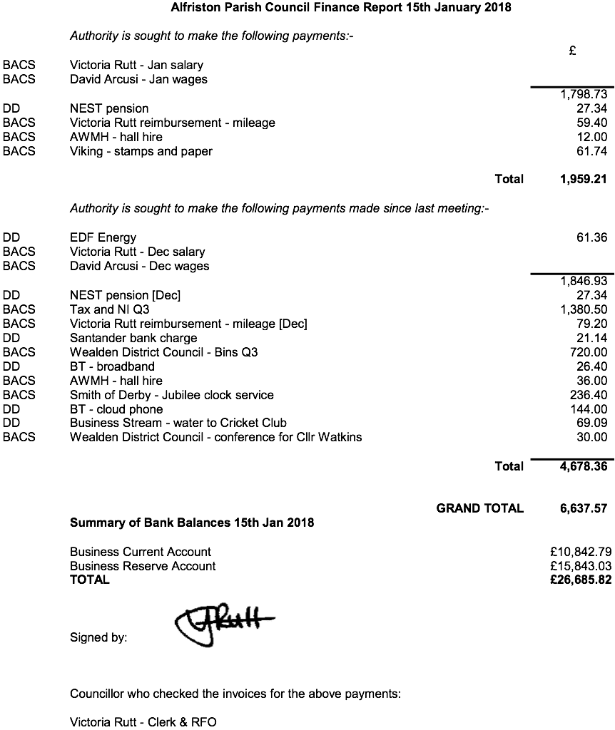

APPENDIX B

Cuckmere Buses – Stakeholders meeting held on 20 November 2017. The following is a summary of the points arising from the meeting which may be of interest to councillors.

Services
The weekend 47 ‘Rambler Bus’ Service - which travels from Berwick Station on a circular route around the Cuckmere Valley, and which brings visitors to the village - has now stopped for the winter. The service will resume in the Spring.

Finances
Income for the first three-quarters of the year was £179.2k, which represents 81.9% of the full year budget of £218.8. Corresponding expenditure was £185.1k, representing 83.4% of the full year budget of £222.0k. The deficit of £5.9k compares to a full year budgeted deficit of £3.2k, but this deficit is reducing as the year progresses, and much of Cuckmere Buses revenue comes in the final quarter. The main component of the excess expenditure continues to be maintenance costs for one of the older vehicles. Cash in hand is a comfortable £91k.
The Finance Director stressed the importance to Cuckmere Buses finances of the annual contributions from local parish and town councils.

Bus Fleet
Cuckmere Buses continues to monitor new types of bus coming on to the market. A demonstrator all-plastic bodied integral bus using Fiat running units was trialled in October, Cuckmere Buses being the first operator to try the bus in service. Reactions from drivers and users was broadly favourable. A new low floor Strata bus from builder Mellor is scheduled for trial in the coming months. The fleet has been substantially updated over the last few years, with the acquisition of new buses and the disposal of older buses. However, the new, smaller, buses, while more economical to run, have met with resistance from passengers on some routes because of the narrower seats and aisles. If a more suitable, but still economical, vehicle can be sourced, one of the more modern buses may have to be disposed of to part finance the purchase.

The Future
While the long-term downward trend in passenger numbers is a concern, Cuckmere Buses operations and finances are currently in a relatively healthy position. However, there are two worrying clouds on the horizon:

- Some years ago, a small number of commercial bus service operators in the Midlands challenged the regulations under which community transport operators work, on the basis that the community buses represented unfair competition, particularly where they tendered for local authority supported services against the commercial operators. With the threat of EU Court proceedings, the government has proposed changes to the regulations under which community bus operators work. Since Cuckmere Buses do not directly compete with local commercial bus operators, they hope that any new regulations will enable them to continue to operate under present arrangements, but there is no certainty about this.
- A more serious threat to Cuckmere Buses operations comes from a part of the proposed changes regarding community bus drivers’ licences. Drivers who gained private car licences prior to the mid-1990s (i.e. all Cuckmere Buses drivers) have a D1 licence classification included on their licence, which entitles them to drive Cuckmere Buses vehicles. The proposal is that, to retain the D1 licence, all drivers, whether paid or volunteer, would have to undergo Driver CPC training every five years at a cost of around £1,500 per person. For Cuckmere Buses, the cost involved in this would be more than their finances could sustain.

The debate still has a long way to run, and if we leave the EU as expected, the whole scenario could change in 2019. Cuckmere Buses has lobbied local MPs on the subject and Maria Caulfield has taken the matter up with Chris Grayling, the cabinet minister responsible. However, the Transport Select Committee has now become involved, which is a further complication. It seems unlikely that the government wants to see restrictions on volunteer community transport operators, but with so much government time being taken up with Brexit the possibility of new regulations which could seriously affect the viability of Cuckmere Buses remains a threat.

Rod Young - 1 December 2017

