ALFRISTON PARISH COUNCIL
www.alfristonparishcouncil.org.uk

CLERK TO THE COUNCIL
Victoria Rutt 11 Highfield Road
Horam
Tel: 01323 870212 TN21 0ED
E-mail: alfristonpc01@btconnect.com
28th July 2017

Minutes of a meeting of Alfriston Parish Council (APC)
held in Alfriston War Memorial Hall on Monday 24th July 2017
Present:
Cllr. N. Beechey – Chair
Cllr. N. White
Cllr. V. Cooper
Cllr. K. Halliday

In attendance:
Victoria Rutt - Parish Clerk
Approximately 10 members of the public

- Chairman’s Welcome
Cllr. Beechey welcomed everyone to the meeting. He expressed his thanks and congratulations to the organisers of Alfest 2017, it was a great success. We look forward to hearing from them if they are going to be running an Alfest 2018. He also thanked all involved in the French Market which was a successful event.

- Public Questions
- Katie Salmon asked whether a letter could go out to residents about keeping their hedgerows tidy as some of them have come out across the pavements and can be dangerous if have brambles. It was agreed that the Clerk would send a polite reminder via the email subscription, Neighbourhood Watch and placing something in the Cuckmere News. Action 1.
- Diana Monteath-Wilson spoke on behalf of St Andrew’s Church. She stated the tree planted on the Glebeland had no permission from the diocese. Cllr Beechey stated that no one had asked APC if it could be planted there either and no one knew who had planted it. It will be re-sited at the appropriate time of year.
- Diana Monteath-Wilson asked if St Andrew’s could be placed on the agenda under outside bodies so it can be reported on an at each meeting. APC agreed. Clerk to place it on agenda. Action 2.
- Vernon Reynolds asked if APC knew about the poles that arrived in the Village one day and were gone the next and whether there had been permission? Cllr Beechey stated that he believed it was ESCC completing a traffic survey; APC were aware they had intended to collate further data but not when or how; and ESCC do not have to seek our permission as highways are their province. Cllrs are meeting with ESCC about their traffic light proposal on the 10th August.
- Cllr Beechey brought up a recent conversation with ESH about cones being placed on the single yellow line outside the Star Inn during restricted parking hours. The Clerk has received written correspondence from Sussex Police that AEG are allowed to place cones on the single yellow lines within the restricted times [Monday to Sunday 08.00 – 19.00] as long as they are not an obstruction to traffic. Cllr Beechey stated that if AEG are willing, APC would be delighted if they would put out the cones to ensure traffic flows better thought the Village.

- Report from Maria Caulfield MP
Apologies were accepted from Maria Caulfield MP. No report.

- Report from ESCC Cllr Stephen Shing
Cllr Shing thanked everyone for making him feel welcome and he was happy to be at the meeting; he apologised for missing the previous 2 meetings due to conflicting demands on his diary. Since his election, he has met with Conserve Alfriston, with ESH and attended the SLR meeting. His next meeting is the joint one regarding the traffic light proposal on the 10th August. Stephen has also helped in sorting out the grass cutting issues. He is contactable at any time, via post, phone or email and is happy to help [01323 489265 / cllr.stephen.shing@eastsussex.gov.uk]. He said that central government had not approved funding in addition to ESCC funding to build a 2 lane bridge at Exceat. This should happen before the end of next year. Temporary traffic lights at Exceat would be in place over the course of Eastbourne Airbourne weekend.

- Report from Wealden District Councillor Phillip Ede
Apologies were accepted from Cllr Philip Ede. No report.

- Apologies for absence
Apologies were accepted from Cllr Jen Dumelow, Cllr David Bell and Cllr Ray Savage.

- Minutes
Cllr. Halliday proposed and Cllr. Cooper seconded a motion that the Minutes of the meeting held on 19th June 2017 were a true and accurate record. MOTION CARRIED.
Cllr. Beechey duly signed the minutes

- Finance
Cllr. Halliday proposed and Cllr. White seconded a motion to approve the Statement of Finances. Appendix A. MOTION CARRIED
Cllr. Cooper approved and signed Invoices for Payment.
Cllr. Halliday proposed and Cllr. White seconded a motion to approve the Q1 bank reconciliation, budget and audit.

- Report on Highways & Twittens – Cllr. Halliday
65.1 Bike Racks - Cllr Beechey confirmed that he raised the issue of bike racks at the recent SLR meeting and that ESH were not keen on having them in the Square and they could not sit in the road. A suggested place for them was the car park, however it was thought in the past cyclists would not use them. However a recent email to the Clerk from a keen cyclist and visitor to the Village asked why there were none in the car park. At present we do not have funds for a bike rack, however the Clerk is going to contact WDC to seek permission to install a bike rack if funds become available and see if WDC would be happy for us to purchase out of the car park income. It will come off the agenda for the time being but Clerk will keep this on her list. Action 3.

65.2 Bins - Clerk raised the issue of bins. A recent APC decision was to site a dog pooh bin on the Spots. This was looked into but as EA own the land they say to get the paperwork drawn up and a licence to install one would cost APC around £700 in addition to the cost of the bin. It was agreed that a new location would be decided on. A suggestion was on the Glebeland next to the bridge so Clerk to contact the church to seek their thoughts. Action 4.

The next issue was the bins on Market Square. It was agreed that the concrete one would come down to the Tye and a new double black one would be purchased once location is agreed. It was suggested that it could possibly go down Rope Walk near the noticeboards. Enquiries to be made about this. Action 5. Finally the bins on the Tye were discussed as one was removed recently due to the lid being broken. It was agreed with the concrete one and purchasing one more that should be enough for now so Clerk to purchase 1 green bin for the Tye. Action 6.

65.3 A board policy - Discussion has taken place recently about the A board policy as a request came in from Cllr White on behalf of Alfriston and Cuckmere Connect to use the board for the ACC late night shopping Friday event. It was agreed at the time but it was felt the policy needed tweaking to include events that benefit the whole village, whilst a single business could not request to use the A board. Cllr Halliday proposed that the removal of the words ‘not for profit’ to be removed from the current policy. Cllr Halliday proposed and Cllr Cooper seconded and agreed by Cllrs. The new policy can be found under Appendix B.

65.4 Traffic Light project update - At the recent SLR meeting, Ian Johnson from ESH read out a recent email from James Vaks who is leading the traffic light project for ESCC. APC confirmed that we had not had sight of this email and complained at the lack of communication from ESCC as there were still numerous questions left unanswered. Since then a meeting has been arranged for Cllrs to meet with James Vaks on the 10th August.

- Report on Allotments – Cllr. Cooper
Cllr Cooper updated that Clerk met with a resident recently to sort out the allotment plan, we are researching numbered stakes to purchase to be able to identify the plots easier. We have 7 vacant plots and the Clerk is advertising them in the Cuckmere News.

- Report on Rights of Way and Countryside – Cllr. Dumelow
No update.

- Report on Car Parks and Public Transport – Cllr. Savage
68.1 Bus shelter – this has been looked into and a few options considered, however they are expensive and APC do not have the funds at the moment. It was agreed we will make do with what we have at the moment, it will be removed from the agenda but Clerk will keep this on the list and it will be considered again if finances improve.
68.2 Bins in Willows car park – Clerk updated that a lot of carpenters do not want to quote as it is such a small job and they are too busy. It was agreed that Clerk would contact local handyman to see if he could provide a quote. Action 7.

- Report on Strategic Planning – Cllr. Dumelow
No update.

- Report on Tye and Recreation Ground – Cllr. White
70.1 Playground refurbishment - Cllr Cooper confirmed there is nothing to update, we are still waiting to hear back from Tesco regarding the grant. She wanted to express her thanks to Roger Cooper, Cllrs Halliday & Beechey and Angela Beechey who spent one day at a weekend to clear much of the overgrown hedgerow and to thank Simon Harmer and Angela Beechey for removing the debris. Cllr Halliday suggested speaking to Kelly Ellis about possible fund raising ideas for new equipment. Cllr Halliday to get Kelly and Cllr White in touch to look into this further.
70.2 Bins – Clerk covered this under 65.2.
70.3 Drop down bollard - Cllr White updated that the drop-down bollard has now been installed at the Wingrove end of the Tye, this is locked with a padlock and the combination code will be for the emergency services only. This will now come off the agenda.
Cllr Beechey also updated that the Bylaws will be displayed again soon on the Tye and once done enforcement is being looked into for cars that park on the Tye.

Cllr Halliday said that James Dopson had approached him about tidying up the area next to Deans Place near the disabled bays outside the Wingrove. Cllr Beechey believes this land was gifted to the National Trust (in memory of Peter Medawar) so need to put James in touch with them and speak to them about the possibility of a group of volunteers doing it. Clerk has contacted grass cutting contractor to remind them that the WI memorial garden and adjacent area is under their contract.

- Report from Planning Committee - Cllr Bell
  - Applications to be considered by APC planning committee at this meeting
The application published on the agenda was postponed to the 03.08.17 Planning Meeting
  - Applications considered by APC Planning Committee since last meeting
  - Applications notified or awaiting decision from SDNPA
The Carthouse has been approved, Frog Firle Barn was rejected and Burnt House Cottage is ongoing.

  - SDNPA Housing plan meeting - Cllr Beechey updated that Cllr Bell and Cllr
Dumelow met with SDNPA about their Housing Plan for Alfriston, the summary report can be found under Appendix C. The plan can be found using this link and Alfriston is on pages 21 -23. https://www.southdowns.gov.uk/wp-content/uploads/2017/03/Plan_2017March9_Agenda-Item-7.pdf
The plan will be published for its Regulation 19 pre-submission consultation in the Autumn 2017. The SDNPA will write to each Parish Council to make them aware of this consultation. They will also be asking Parish Councils to help us promote this round of consultation. At this consultation members of the public can make comments on any aspect of the Local Plan. These comments will be sent directly to an independently appointed Inspector for their consideration in assessing the South Downs Local Plan. More information on this consultation will be available on the SDNPA webpage in due course.

- Reports from Outside Bodies
72.1 Lorry Watch – Situation remains unchanged and not satisfactory. At the recent SLR the idea of a temporary weigh bridge was raised and letters have been sent to Sussex Police who have linked the Clerk with DVSA. An update will be given when more is known.
72.2 Heartstart – no report.
72.3 Alfriston Emergency Group – Vernon Reynolds wanted his thanks noted for the tea party that Alfriston School threw for them to thank them for their help with the school bug hotel. They were grateful for the school recognising their efforts and providing them with excellent cakes! Vernon stated that him and his team may be able to do something to help with the bus shelter. They will link in with the Clerk if they come up with a proposal.
72.4 Flood Forum – No update from John Hurwood, however Cllr Beechey wanted to confirm that he did ask Ian Johnson at the recent SLR if ESCC had any funds to put towards a pump to clear the road of flood water. They have said they would not contribute as they will not sanction anyone entering the road to try and unblock the road themselves.
72.5 Neighbourhood Watch – no report.
72.6 Twinning Committee – no report.
72.7 Alfriston and Cuckmere Connect – A group have taken on planting the flowers around the tree and it was requested if APC would pay for the cost of the bulbs. It was suggested that an email with the cost to be sent to the Clerk for consideration. The first Friday late night shopping had been going well.
72.8 Cuckmere Buses – It has been brought to the Clerks attention that the usual contribution to Cuckmere Buses was not paid last year. This was discussed and it was agreed that APC would make a S137 grant of £200 and send a letter of thanks them for all that they do. Action 8.

- Correspondence to The Clerk
- Clerk has received the quote about repairs to the Market Cross. There are 2 options, £9k or £6k. APC do not have the funds for this. The Clerk is looking into accessing grants and it will be placed on the agenda for the next meeting.
- Sylvia Daw has asked whether the School can run an artisan event in the Hall and a possibly a dog show on the Tye on the August Bank Holiday next year. This was agreed by APC, however if someone else wishes to run something more akin to the traditional Bank Holiday fair/weekend it was hoped they could all work together to make as one event.
- A request has come in from ‘Trek the Night’ after a successful event this year. They requested to use the venue again for their staging post on the 14th and 15th July 2018. APC approved but the Cricket Club need to be asked also. Clerk to action this. Action 9.
- June Goodfield has sent an email stating that in the last few weeks there have been a number of meetings of SAFE representatives with those from Conserve Alfriston. Amongst other matters John Hurwood, who has been a member of SAFE since its inception in 2008, has agreed to answer all pertinent questions regarding SAFE at all future Parish Council meetings

- Date of next meeting
The next meeting of the Council will be held at 7.15 pm on Monday 18th September 2017 in Alfriston War Memorial Hall. The meeting will be suspended after the Chairman’s Welcome to allow Public Questions and Reports from County and District Councillors.

- Public Questions
  - Diana Monteath-Wilson asked that if the code to the gate on the Tye gets changed due to the issue of parking, could the Church Wardens and Sherry Ward be informed please.
  - Diana also confirmed that on the subject of dog bins, if dog waste is well bagged, the bags can be placed in the general litter bins.
  - Diana also wanted her thanks noted for the change in layout of the agenda, it is informative for the public prior to the meeting.
  - Anthony Davy updated that Abbeyfield Alfriston Society have handed the running of Abbeyfield to Abbeyfield South Downs Society. The Alfriston Society is holding a meeting of members soon to see whether there is agreement to wind up the Alfriston Society.

Signed Victoria Rutt
28th July 2017

Appendix A

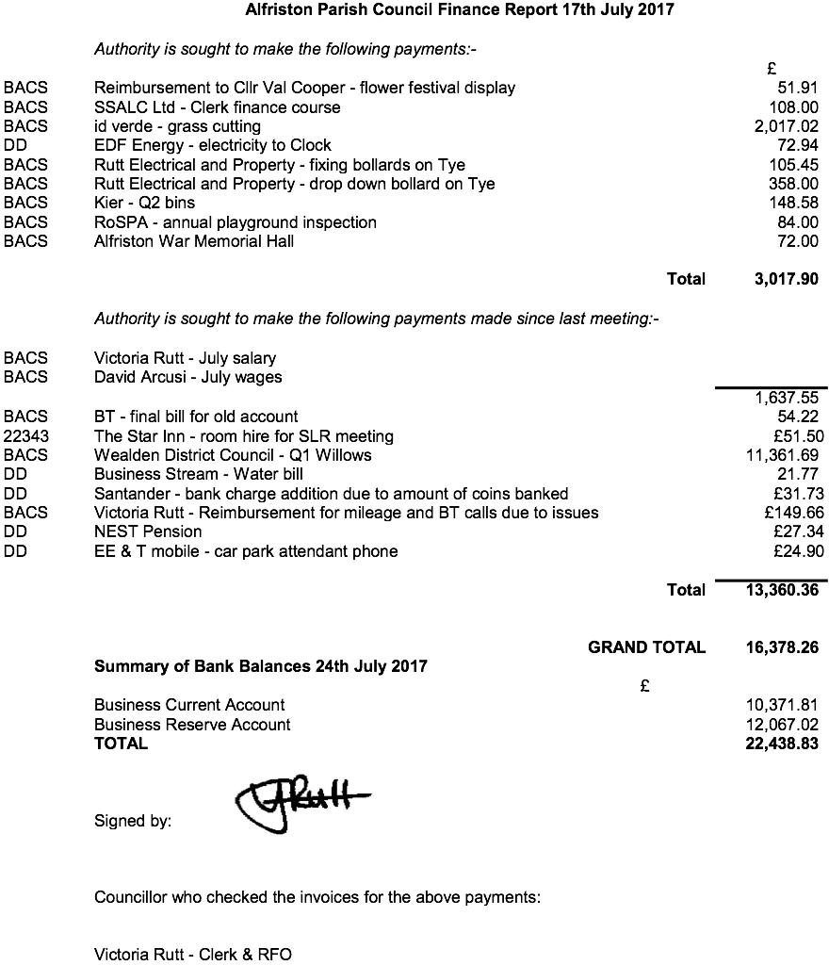

Appendix B

ALFRISTON PARISH COUNCIL

Policy on A boards placed in Market Square

The following policy was agreed at the meeting of Alfriston Parish Council on 24th July 2017.
This policy applies only to A boards placed in Market Square.

Alfriston Parish Council will only consider granting permission for an A-board in the Market Square if it is for publicising a local event held for exclusively charitable purposes or hosted by a local community group or organisation. Permission will be limited to a maximum of two events at any one time and should be requested at the PC meeting preceding the period of publicity.

Appendix C

Meeting at South Downs National Park Offices on Tuesday, 27th June 2017

Cllr Bell and I met with Robert Thain, the SDNP’s Planning Policy Lead. We had a general discussion and then talked about the two areas identified in the SDNP’s local plan. We were unfortunately unable to persuade them to rethink their plan and discussed the following:

Site at Kings Ride

There does not appear to be many problems with building on this area. The SDNP are looking to put about 8 terrace houses on this area, with at least 2 of them being affordable housing.

There does not appear to be too many problems with access issues and it does not encroach very much on the South Downs Way.

Their reasoning is that once this development is done, it will complete the development in the Kings Ride area.

Site of North Street

The SDNP have determined there could be approximately 5 terrace houses there with 2 of them being affordable houses. They are aware of flooding at the bottom of the area identified but no houses will be built there. However, as we pointed out, access is a big problem there. The SDNP have suggested that there be a one way system in place with vehicles going down River Lane and in the farm entrance at the bottom and coming out again next to Norvetts. They considered that access from the car park would not be suitable. Mr Thain acknowledged that any plan for this site would have many hurdles to overcome.

General

- All the houses in both areas would be small terraced houses and either two bed or three bed to make them more affordable.

- They are looking to progress both schemes over a 15 year period and would prefer they are not progressed immediately.

- There could be a question of who owns all the land they have identified behind North Street but that would probably be down to the developer.

- They did not feel that the extra traffic would be too much of a problem although we did point out to him that it would be an impossible situation in North Street should the traffic light system go ahead. On a positive note, unofficially, Robert Thain indicated that they were against the proposed traffic light scheme.

- The houses in Star Lane that are being built are not included in the allocation of new houses for the village as they were not in an area that was identified when they did their survey of the village.

- Re the plan for 12 houses at Pleasant Rise, Mr Thain stated that if we and/or the land owner presented him with a suitable plan, this could come under the rural exceptions rule and he would be willing to discuss this further if/when plans were available. These houses would only be considered if they were for social housing (not affordable housing).

