ALFRISTON PARISH COUNCIL
www.alfristonparishcouncil.org.uk

CLERK TO THE COUNCIL 11 Highfield Road
Victoria Rutt Horam
TN21 0ED
Tel: 01323 870212
E-mail: alfristonpc01@btconnect.com 27th March 2018

Minutes of a meeting of Alfriston Parish Council (APC)
held in the Alfriston War Memorial Hall on Monday 19th March 2018

Present:
Cllr. N. Beechey – Chair
Cllr. K. Halliday
Cllr. N. White
Cllr. V. Cooper

In attendance:
Victoria Rutt - Parish Clerk
Approximately 15 members of the public

188. Chairman’s Welcome
Cllr Beechey welcomed everyone to the meeting and thanked them for coming out in the cold weather. He especially thanked AEG for all their hard work gritting around the village, and particularly Kings Ride.

- Public Questions
- Mr Bill Rendall, representing Conserve Alfriston, asked if APC were attending the meeting on 29th March with East Sussex County Council [ESCC] re their intended traffic light trial and asked if any reports sent to APC by ESCC could be shared with them. Councillors agreed and Clerk to send report over to Mr Rendall. Action 1
Cllr Beechey explained ESCC had commissioned computer modelling of their proposed traffic light scheme and the report detailed the results. The report writers modelled as best could the current situation (for comparison purposes) and took what they said were the peak times from ESCC data: 16:00 – 18:00 on a weekday and 12:00 – 14:00 at weekend. The modelling of the traffic light scheme showed average queue lengths of 140m from the stop line for southbound traffic and 70 - 80m for northbound. Worst case scenarios are approx 200m southbound traffic and 100m northbound. The report states that the 200m queue may prove ‘undesirable’. Journey times would increase by 30 seconds for southbound traffic. The scheme modelled includes westbound traffic only from Star Lane.
- Ms Diana Monteath -Wilson asked if, when ESCC trial the traffic light scheme, there is any means by monitoring pollution? Cllr Beechey stated that he too is concerned about this and will be raising it at the meeting.
- Mrs Sylvia Daw stated that there are more blue lights coming through the village recently.
- Ms Diana Monteath -Wilson asked if ESCC had looked at when cars need to load/unload as a number of properties have no rear access. Cllr Beechey confirmed that this is a question on his list, as well as whether equestrians, horses and bin lorries had been taken into consideration. These questions have been asked of ESCC numerous times before but never properly answered; he will ask again and hopefully receive an answer.
- Mr Vernon Reynolds asked what time of day did they take the data from, Cllr Beechey confirmed the times, as above.
- Mrs Sylvia Daw stated that it was a shame they took the data from 16:00 – 18:00 as they missed the traffic at 15:00 caused by the school run.
- Mr Nathan Pope started to ask a question about the village website, however Cllr Beechey explained that as it is on the agenda and the meeting will be opened at that point for submission from interested parties and he hoped Mr Pope happy to wait. He confirmed he was.
- Mr Rod Young wanted to raised a point ahead of Tye Parking on the agenda. He felt it was a shame that Adrian Butcher was not present but he felt that his questions reflect what has been said. Mr Young feels that it is most unfortunate with the way APC have dealt with the Tye parking and that it is disappointing. One positive is the spaces that will be able to be reserved and feels that this will make a great difference. Cllr Beechey stated as APC had already determined that there was to be no parking on the Tye it was useful to have some rules in order to allow for exceptions. He said that the issue of parking on the Tye was not a new one and had been a matter of concern for APC for many years. Recourse to the minutes will show that. Cllr White reported that he has attended the AWMH committee meetings and feedback has been taken from those meeting, fed to APC and changes have been made i.e. to the rules. It is on the agenda later for discussion.
- Mrs Heather Hurst stated that Mr Adrian Butcher was unable to attend this evening, Clerk confirmed she had received apologies from Mr Butcher. Mrs Hurst went on to explain that she has lived in the Village for 30 years and feels sad that the parking situation has gone down this route. Cllr Beechey reported that 3-4 years ago it was denied by APC that once Tye road was re-marked and the new gate was installed parking on the Tye would be enforced properly. It had taken some time to put this all in place but it had now been done.
- Mrs Heather Hurst updated on the design of the new bollards, they are going to be timber gate styles ones with a long bolt to drop down with a combination padlock. A design will be circulated to Clerk and Councillors once completed.
- Mrs Sylvia Daw asked if the padlock on the gate could be raised as it is low down. Clerk apologised that she was meant to look at this but it had dropped down her ‘to do’, she will look into this and get it actioned by next meeting. Action 2.

- Report from Maria Caulfield MP
No attendance or report.

- Report from East Sussex County Councillor Stephen Shing
Cllr Shing reported that the new Council Tax bill should now have been received, it has had the largest increase ever and it is very disappointing. He also expressed his upset that the mobile library has now been withdrawn. He stated that he has received the ESCC traffic light update and feels that the proposed trial should happen he has fed this back to ESCC.

- Report from Wealden District Councillor Phillip Ede
No attendance or report.

- Apologies for absence
Apologies were received and accepted from Cllr Savage and Cllr Watkins.

- Minutes
Cllr. White proposed and Cllr. Halliday seconded a motion that the Minutes of the meeting held on 19th February 2018 were a true and accurate record. MOTION CARRIED.
Cllr. Beechey duly signed the minutes.

- Finance
195.1 To approve the Statement of Finances
Cllr. Halliday proposed and Cllr. Cooper seconded a motion to approve the Statement of Finances
[Appendix A]. MOTION CARRIED

195.2 To approve and sign Invoices for Payment
Cllr. Cooper approved and signed Invoices for Payment. MOTION CARRIED

- To discuss and approve Tye parking rules
Cllr Beechey read out the proposed Tye parking rules. The amendments requested by the AWMH committee have been included. It was agreed by all Councillors to adopt the rules. Cllr White proposed and Cllr Halliday seconded. The rules can be found in Appendix B. MOTION CARRIED

- To discuss and agree administration and ownership of the Village website
Cllr White stated that he is no longer Chair of Alfriston Cuckmere Connect [ACC] but as a member he will declare his interest as ACC are an interested party in taking on the website. If he takes parts in the conversation and votes, he will do so representing the people in the village.

Cllr Beechey opened up the meeting and explained that out of the 4 interested parties, 2 were present at the meeting. Mr Nathan Pope was invited to set out how he would manage the site. He stated that he would update the website to have mobile functionality; to adhere to new data protection rules; he would update to a different system like wordpress and would use his wife’s skills as a journalist for the social media side. He said he was focused on maintaining aside that benefited the community as well as the businesses.

Ms Jilly Byford, as new Chair of ACC, read out her previously circulated report to Councillors, on why they should be considered. ACC members have a varied group with expertise and time to put into the website and website, to ensure it is kept updated and to be a good tool for the village.

Cllr Halliday felt that the proposal sent out to those interested in running the site was not detailed enough and not enough time had been allowed for proposals. He also asked whether it should have been a formal tender process. It was confirmed that as there is no payment by APC involved there is no need to go for tender.

The future ownership of the domain name and the administration of the website was discussed. Both do not need to be held the same people/body. It is thought that the ownership of the domain should be with APC but the administration and management falls with those selected to run the website. Mark Exley (who currently owns the domain and site) has indicated that he prefers that APC own the domain and wants APC to decide on who administers the website.

Cllr Halliday asked Mr Pope what he sees as the pros/cons for APC owning the domain name. Mr Pope stated that he felt it is wise that APC own the domain name as then if anything changes you can just change the administrator. It is how he works in his personal business.

Mr Nash Robbins, as a member of ACC, stated that ACC members have concerns with APC holding the domain name: it felt muddy as who would make the decisions. Cllr Beechey stated all APC would own is the domain name, then give the administration of website to the interested party to progress and get on with.

Ms Chloe Cooper asked if Mark Exley was selling the website to APC. Councillors confirmed this is not the case, he currently owns it (having set it up) and wishes APC to own it.

Mrs Heather Hurst stated that there were previously concerns re the finances of the website and why some people pay more and less and why some have banners and some do not. The future of the website will be the perfect time to be clear and transparent.

Ms Cooper stated that if ACC took over members of ACC would be paying less for their adverts than now and then paying experts for the work on website. Cllr White and Ms Byford stated this was incorrect.

Cllr Beechey asked whether ACC have thought how much they think they might be able to give to good causes in the village each year, having included this as part of their pitch. Cllr Halliday stated he doesn’t think that matters. Cllr Beechey stated he thought it did as that was part of their proposal and it might be a point of difference to other interested parties.

ACC asked if they could have some time out to speak to Mr Pope to see if they could put something together jointly. Cllrs agreed and the meeting continued with business.

The group returned and asked if APC were happy to table the website discussion for the coming month’s meeting in order for the groups to meet and be able to present something at the next meeting. It was discussed and Councillors agreed that as the next Parish Council meeting includes the Parish Assembly, each interested party will be given 5 minutes to present their ‘pitch’ to APC and then a decision will be made. Clerk to invite interested parties to present on Monday 16th April. Action 3.

- ‘There but Not There’ WW1 commemoration
Cllr Beechey said that many people were probably already aware of ‘There but Not There’ (www.therebutnotthere.org.uk), a commemoration of the centenary of the end of WWI. It involves purchasing perspex ‘silhouettes’, one for each parishioner on the Roll of Honour. The silhouettes sit on the pews in the church; they are made by injured ex-servicemen employed by British Legion Industries and any profits go to charities that help war wounded. The silhouettes are £42 each and there are 25 people in total who lived in the village who lost their lives. For an additional £10 each, a name block for each of the fallen, to go next to each silhouette, can be purchased. Diana Monteath-Wilson and Geoff Ellis, on behalf of St Andrews supported the commemoration; Cllr Beechey had emailed Chris Goodchild to garner the British Legion’s support and awaited a reply. It was agreed that this is an excellent idea. £1300 needs to be raised and Councillors agreed to get the ball rolling by APC donating £100 to the fund. Any donations will be gratefully received and should be sent to the Clerk who will keep a record of all donations. Clerk to publish further information to promote fundraising. Action 4.

- Casual Vacancy - Election update
Cllr Beechey confirmed that Caroline Adcock was the only candidate to put herself forward for nomination so she has been appointed as the result of an uncontested election. Congratulations to Caroline from all the Councillors. It was a shame this process (as opposed to co-option) has cost the Council £400 of public money, as it will mean that something else will miss out. Cllr Adcock has been informed of the result but had to send her apologies for this meeting.

- Report on Highways & Twittens – Cllr. Halliday
200.1 Replacement bins for Market Square
The Clerk advised that this will be looked at next month when the end of year finances are known and hopefully the quote will be received from Kier for an additional collection.

200.2 Market Cross update
Cllr Beechey updated that the Clerk and he are working on a potential grant application together. Clerk to chase Stonemason report. Action 5.

200.3 High Street traffic update
Cllr Beechey reported that Cllr Halliday and he are attending a meeting with ESCC on the 29th March. All other matters were dealt with under public questions.

- Report on Allotments – Cllr. Cooper
Cllr Cooper reported that two new occupants have taken on 2 vacant plots. The fence posts were discussed and Clerk to send over the volunteer’s names to Cllr Halliday so this can be progressed. The Clerk confirmed that the allotment holder of the plot near the fence is going to cut back the brambles himself to reduce the weight on the fence. Thanks from APC to him for this gesture.

- Report on Rights of Way and Countryside – Cllr. Watkins
No report from Cllr Watkins.

- Report on Car Parks and Public Transport – Cllr. Savage
203.1 Replacement bins in Willows car park
The Clerk advised that this will be looked at next month when the end of year finances are known. The Clerk also wanted to confirm that damage to both the bus timetable and the bus stop itself has been seen, pictured and reported to ESCC and Cuckmere Buses for immediate repair.

- Report on Strategic Planning – Cllr. Watkins
No report from Cllr Watkins.

- Report on Tye and Recreation Ground – Cllr. White
  - To agree playground refurbishment options - Cllr Cooper
Cllr Cooper asked if Councilors can now agree with an option for the playground refurb so this can be progressed. There are 2 options, they have been circulated to the primary school and preschool and Option 2 is preferred. APC have £5k to spend as they previously ringfenced £4k and received £1k recently thanks to Cllr Cooper organising the application to Tesco Bags for Life grant. Councillors agreed to progress this and option 2 was proposed by Cllr White and seconded by Cllr Halliday. Clerk to progress this order. Action 6.

  - Repainting and re-signwriting the mine
The Clerk advised that this will be looked at next month when the end of year finances are known.

  - Update on Tye footpath
The Clerk advised that a quote has been received from Hailsham Roadways to widen the path using a modern type of grasscrete with a brick edging. This came to £20k. Since then a grant giving fund has been found which may fit the criteria but cost has to be over £30k so Hailsham Roadways have been asked to submit a quote to take the top layer off the whole path, widen and then cover the whole with the new material. Further funding options do need to be looked into.

- Report from Planning Committee - Cllr Beechey was agreed to chair for this meeting.
206.1 Applications to be considered by APC planning committee at this meeting

SDNP/18/00919/TPO Riverbank, River Lane, Alfriston, BN26 5SX
Removal of conifer tree as roots are destroying flint walls on property. No new tree to replace it as it will cause the same damage to flint wall.
Decision of APC: This application is supported by APC having consulted with a tree expert.

SDNP/18/01157/FUL 3 Wingrove, The Tye, Alfriston, BN26 5TL
Proposed change of use from C3 to C1 in order to create 4 no. additional hotel suites at Wingrove House Hotel, Alfriston.
Decision of APC: The planning committee object to this application as they do not wish to see the loss of a further smallish residence, give the shortage of these in the village and feel there is no proven need for additional hotel rooms.

206.2 Applications considered by APC Planning Committee since last meeting
206.3 Applications notified or awaiting decision from SDNPA

SDNP/18/00377/FUL Timbers, Sloe Lane, Alfriston, BN26 5UU
Demolition of existing dwelling and construction of new replacement dwelling. Awaiting update.

SDNP/18/00197/HOUS Frog Firle Barn, Whiteway, Alfriston, BN26 5T
Porch extension. Awaiting update.

- Reports from Outside Bodies
207.1 Lorry Watch – Still the same as last month, no improvement.
207.2 Heartstart – no report.
207.3 Alfriston Emergency Group – Mr Vernon Reynolds expressed his thanks to APC for paying the container rent [for the year gone], also thanks to Alfriston Cuckmere Connect for the cheque for £91. Mr Reynolds confirmed that they have purchased the medium petrol pump and in due course it will be housed at Deans Place.
207.4 Flood Forum – no report.
207.5 Neighbourhood Watch – no report.
207.6 Twinning Committee – We continue to have a very active programme. Towards the end of February, sixteen members and others met in the home of Angela and Robert Morrison to enjoy a getting-to-know-you 'Tea with a French Flavour'. All enjoyed a superb wide range of beautifully prepared homemade pastries and scones. Close contacts continue to develop between students in our school and others in Veules thanks to active work of their teachers.
On Saturday 7th April- between 4pm & 7pm- we are holding our first International Games Tourney in the War Memorial Hall! This is a trial event for members, their families and friends. Please come: enjoy the games, the company and the refreshments.
We will be sharing these with our Twinning friends over the weekend of12/13 May. Other activities such as walks introducing our guest to the South Downs National Park, will also take place. We anticipate rescheduling many of these events for all in Alfriston at a later date.
207.7 Alfriston and Cuckmere Connect – no report.
207.8 Cuckmere Buses – Mr Rod Young confirmed there is nothing new to report.
207.9 St Andrews – Ms Diana Monteath-Wilson reported on behalf of St Andrews that thanks would like to be passed onto all of AEG for all the gritting works around the village but in particular around the church, it was very helpful. Cuckmere News will update on most things; however a Rector interview is being held on the 12th April. She confirmed that the Restoration Committee has not disappeared, the core group has met and priority is to get spire restored to ensure church is waterproof. Other events coming up will be published in the Cuckmere News.

- Correspondence to The Clerk
- The Art Club wrote to APC asking if they could have a parking space reserved for visiting artists on the 24th March, 21st April, 6th October and 10th November from 09:00 – 16:30. Councillors approved this.
- Mr Adrian Butcher emailed Clerk about putting enrolment forms for the 300 club in the rack in Willows car park. This was agreed. He also reported a cherry tree on the Glebeland, Clerk has asked Dan Larkin to quote for this.
- Email request from Extreme Energy Events seeking permission to have a small check point in River Lane again for an event on the 7th May 2018. They held it there last year and were respectful and tidied up. Councillors agreed.
- Permission to park on the Tye has been given to a disabled lady who wishes to attend the Art Club weekly she is not able to walk up the path. Councillors were informed of her request via email and agreed to make an exception and grant her access to park outside the hall for the Art Club. Clerk will send her a permit to use.

- Date of next meeting
The next meeting of the Council will be held at 19:15 on Monday 16th April 2018 in the Alfriston War Memorial Hall. The meeting will be suspended after the Chairman’s welcome to allow Public Questions and Reports from County and District Councillors.

- Public Questions
- Mrs Sylvia Daw asked on behalf of Holly Jones from the Clergy House if the Clergy House can be included as an outside body. Cllr White felt they should not be added as they are a commercial business. Councillors discussed and as National Trust is a charity felt that it is different so a vote took place and it was approved to add them as an outside body. The Clergy House report is they are now open but struggled recently due to the bad weather. They wanted to express their thanks for residents’ patience with the fibre cable work on the Tye Road, it was out of their control. Due to ill health they have been struggling to open at the weekend. If anyone interested, they need volunteers between 10.30 – 13.30 or 13.30 – 16.30. Cllr Beechey reported that the trench for the cable work was poorly executed and so they have agreed to resurface the whole section of road. Clerk is liaising with them to arrange the works.
- Mr Bill Rendall asked with the Tye parking rules, is there still emergency access to the Tye. Cllr Beechey confirmed that yes, that is a given.
- Mr Rod Young asked whether it was possible to sponsor a There but Not There silhouette. It was agreed that it would be best to fundraise for the total as then anyone can donate as much or as little as they can manage, with each and every donation equally important.

Signed Victoria Rutt – Clerk and RFO

APPENDIX A – FINANCE REPORT

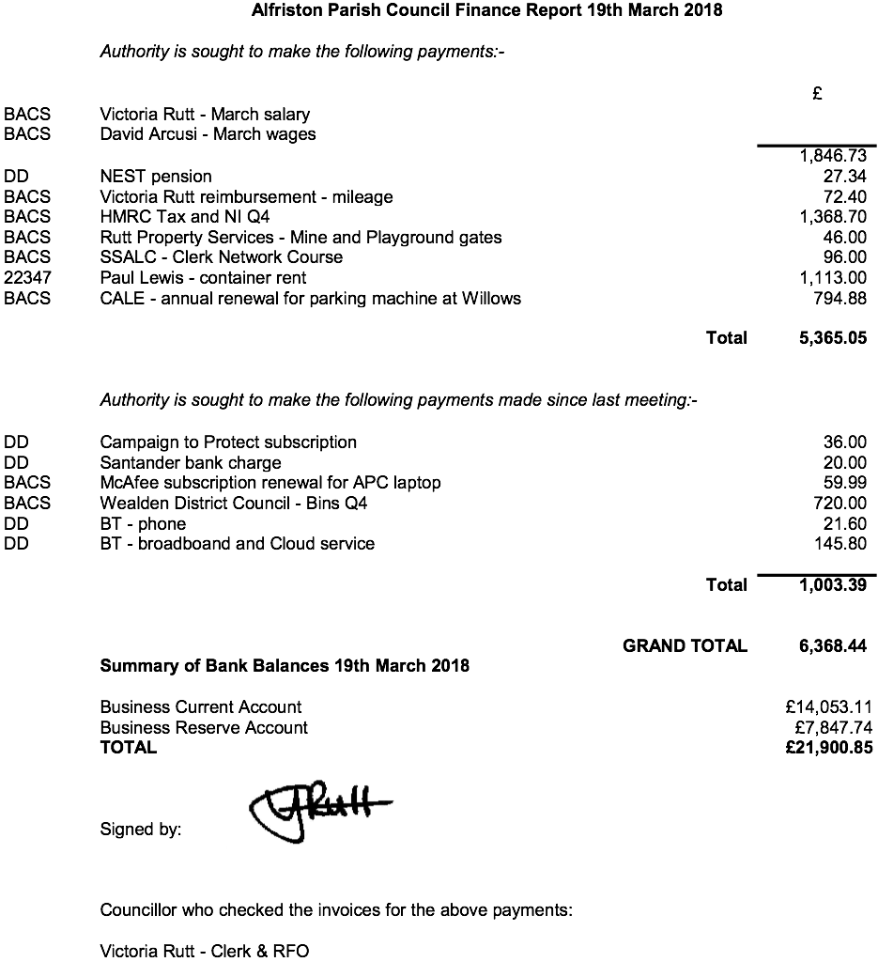

APPENDIX B – TYE PARKING RULES

Tye Vehicular access rules

- Two reservable parking spaces have been provided on Tye road for use by church and AWMH users only. Reservations to be managed by PCC and AWMH Committee.

- There shall be no vehicular access and no parking on the Tye (excepting Tye road) save for the following:

- Access and parking for a hearse

- Access and parking for one wedding car

- Access only (no parking) for loading and unloading

- ‘Special circumstances’ applications to be determined by APC on a case by case basis (please give as much advance notice as possible).

