ALFRISTON PARISH COUNCIL
www.alfristonparishcouncil.org.uk

CLERK TO THE COUNCIL 11 Highfield Road
Victoria Rutt Horam
East Sussex
TN21 0ED
Tel: 01323 870212
E-mail: alfristonpc01@btconnect.com 23rd June 2018

Minutes of a meeting of Alfriston Parish Council (APC)
held in the Alfriston War Memorial Hall on Monday 18th June 2018

Present:
Cllr. J. Watkins – Chair Cllr. R. Savage
Cllr. N. White – Vice Chair Cllr. C. Adcock
Cllr. K. Halliday Cllr. V. Cooper
Cllr. N. Beechey

In attendance:
Victoria Rutt - Parish Clerk
Approximately 10 members of the public

34 Chairman’s Welcome
Cllr Watkins welcomed everyone to the meeting.

- Public Questions
- Mrs Sylvia Daw expressed her sadness that Steamer Trader are leaving the village.
- Mr Graham Skelcey stated that, on behalf of Conserve Alfriston, he is proposing to ask East Sussex County Council [ESCC] some questions relating to their decision to proceed with a trial of traffic signals in the village. Members of Conserve Alfriston’s steering group have drafted an email which Councillors have had sight of. Mr Skelcey is mindful that APC has stated clearly its “implacable opposition” to traffic signals and a trial, however would like to know if they wish to join forces with this email. It was confirmed that APC want to keep an open dialogue with ESCC, as the APC require more information on how ESCC are going to collect data and what criteria they will use to measure success or failure of the trial. Councillors supported APC sending a letter, and Conserve Alfriston doing one also. Cllr Beechey stated that as in the Conserve Alfriston letter, APC must ask how the trial is going to be monitored, whether there will be monitoring of rat running round the back of village, how ESCC will assess queue lengths and that ESCC should publish in advance the criteria against which they will measure success or failure. Nothing in APC’s letter should give the impression APC supports either the trial or a traffic light scheme. It was agreed that Cllr Halliday would draft a letter. Action
- Mr John Hurwood asked about the plaque for the Phillips by the tree at the bottom of Kings Ride. Mrs Daw confirmed that this has been made but putting it in has been delayed due to the work taking place on the old garage. Now that this has been completed the plaque will be installed.

- Report from Maria Caulfield MP
No attendance or report.

- Report from East Sussex County Councillor Stephen Shing
Cllr Shing reported that it is good to hear that APC and Conserve Alfriston are going to write to ESCC about the trial scheme. He confirmed that he is happy to get involved in anything as there needs to be an improvement to the traffic but traffic lights are not the answer. Cllr Beechey expressed his congratulations to Cllr Shing on his appointment as Conservator of Ashdown Forest.

- Report from Wealden District Councillor Phillip Ede
No attendance or report. Clerk confirmed that she has made numerous failed attempts at contacting Cllr Ede. She will now contact the PA of Wealden’s Chairman to seek advice.

- Apologies for absence
No apologies.

- Minutes
Cllr Adcock stated that she wanted the minutes amended because she had not stated that she was a co-founder of SAFE. The Clerk was unable to check the recording as it had stopped working. Cllr Beechey and the Clerk agreed that she had stated this, and Cllr Beechey stated that she had said the same at the previous ESCC meeting also. The Clerk reminded all Councillors that they have the draft minutes for a week to check the minutes and inform Clerk of any changes. Cllr Halliday said as Cllr Adcock had said it was a fairly insignificant amendment then it should remain.

Cllr Adcock also stated that in the minutes it was recorded that she would not answer the question whether SAFE still existed. She has prepared a very lengthy response and provided a copy to Cllr Beechey, the Clerk and will give one to Ms Diana Monteath-Wilson when she sees her. This is available from the Clerk on request.

Cllr. Beechey proposed and Cllr. Halliday seconded a motion that the unamended unadopted Minutes of the meeting held on 21st May 2018 were a true and accurate record. MOTION CARRIED.
Cllr. Watkins duly signed the minutes.

- Finance
  - To approve the Statement of Finances
Cllr. Beechey proposed and Cllr. Savage seconded a motion to approve the Statement of Finances
[Appendix A]. MOTION CARRIED

  - To approve and sign Invoices for Payment
Cllr. Cooper approved and signed Invoices for Payment. MOTION CARRIED

Cllr Beechey wanted to take the time to thank those residents, surprisingly few in number, who donated generously to the There But Not There fund; APC were now able to purchase the silhouettes and name blocks. If anyone wishes to make further donations for this, then we are sure other churches in the benefice might wish to benefit.

- Presentation from SCATE on the A27 proposals – Mr David Johnson
Mr David Johnson attended to give a short presentation on SCATE [South Coast Alliance for Transport and the Environment]. There are a number of stakeholders involved in the A27 discussions and some meetings have taken place previously. It was agreed at a meeting that they need to see the outcomes of the £75 million that is going to be put into the A27 before looking at other issues. There are a group of people pushing a business case forward and some MPs are involved. He said that the evidence for the business case appeared lacking. A new route is being considered between Beddingham and Polegate roundabouts and the options include three new routes for a dual carriageway further north than the existing A27. Information can be found at http://scate.org.uk/ and https://transportforthesoutheast.org.uk/
Mrs Sylvia Daw attended a previous meeting and stated it was very one sided and there was an explanation on what was not wanted but not what might be advantageous. It was agreed that a letter should be sent to Maria Caulfield MP. Action.

- To approve the privacy notice on the website
Cllr Watkins asked Councillors if all had seen the previously circulated privacy notice. All confirmed they had seen and are happy with the content. Cllr Beechey stated this should be a temporary measure and in due course all relevant documents should be merged into one. Cllr Cooper proposed and Cllr Beechey seconded a motion to approve the privacy notice. MOTION CARRIED.

- Report on Highways & Twittens
  - Market Cross update

Clerk reported that with Councillors permission she will go out to other stonemasons to request further estimates. All Councillors agreed. Action.

  - High Street traffic update
Cllr Halliday stated that there is nothing new to report other than the discussion earlier in public questions. He will draft a letter to ESCC in regards to the trial lights.

  - Seaford pinch point meeting update
Cllr Halliday reported that Cross Seaford Transport Working Group had invited him to their meeting to share with them the information APC has following the Lead Member meeting as they see Alfriston as a pinch point for Seaford residents. They made a few observations i.e. that the worst area for traffic in Alfriston is not that part known as the narrows, but the junction of North St and the Square and North St. Cllr Halliday will attend their next meeting in 6 months.

Cllr Adcock raised the question of restoring the lamp in the Square. She asked about the mantle as the Clerk has tried to look into it with British Gas. Cllrs Beechey and Savage reported that the previous Clerk, Martha, had undertaken a lot of research on this. The mantle is impossible to find and to install a new type of mantle is very expensive. Cllr Adcock raised the possibility of changing this into an electric light. There was general disagreement with the idea of introducing any street lighting (the gas lamp was just a flicker) and Cllr Savage indicated that the cost would be prohibitive. It was agreed that the Clerk would speak to Martha and see where she got to and progress from there. Cllr White asked if the lamp could be repainted together with the railings around the square. Action.

- Report on Allotments
Cllr Cooper reported that one plot holder has asked if a skip could be provided on the allotments. This was discussed but at £181 for each skip this is not something APC though cost effective or they could afford. There was a concern that people would dump rubbish in a tip. A communal compost facility was spoken about but again this is not ideal due to attracting rodents and needs to be carefully managed. The previous communal compost had to be cleared at cost to APC. It was mentioned that most residents manage to take their garden rubbish to the tip if needs be. It was agreed that things would continue unchanged with the existing green waste bins and some plots having their own composting facility. Cllr Cooper also reported that 2 more plots have been leased so we are now down to just 5 vacant which is a real improvement. The numbered stakes are now up at the allotments for the plot holder to collect and place on their plot.

- Report on Rights of Way and Countryside
Cllr White had nothing to report.

- Report on Car Parks and Public Transport
  - Bus shelter in Willows car park
Cllr Savage reported that he met with Wealden District Council on Friday with the Clerk to speak about the bus shelter. Cllr Adcock attended as the local fundraiser for the project. The bus shelter was agreed. They did share the same concerns as APC with regard to vandalism. Alfriston Emergency Group [AEG] will start the build in November and it will be installed early next year. The bins that are nearby will be removed and a bin will be installed on the side of the bus shelter.

The tap in the gents toilets in the Willows has finally been fixed.

Whilst WDC were there a discussion took place about utilising the space in the coach park. It was agreed that one side, the centre white line and the ‘Coaches Only’ wording, will be blacked out and some white T lines placed to create 10 further bays. APC will undertake this work themselves with Cllr Savage leading.

The Clerk raised concerns about the area going out of the Willows car park towards the village. This area is not in the grass cutter’s contract and it is has got out of control and looks very messy. Clerk suggested that it could be presented as one of the volunteer projects. This was agreed and Cllr Adcock is going to lead on getting volunteers and clearing it up. Action.

The Clerk informed Councillors that she is having an informal meeting with WDC in two weeks to go through all the costings for the two car parks and once that is done she will submit a report to the Council explaining the changes that WDC would like to make to the way we currently process the income. They would like this change for 2019/20 financial year so need to get on with it.

  - Replacement bins in Willows car park
Clerk is working on this; the quote will be circulated to Councillors shortly.

- Report on Strategic Planning
  - Update from Cllr Adcock on GTR/Berwick PC meeting re train timetable changes
Cllr Adcock updated that she attended the meeting but was given the incorrect start time so missed most of the discussion. The contact details for the lady leading the complaints is Jane Cobb [jane.cobb@gtrrailway.com]. Cllr Beechey wished it minuted that he had asked a number of times if APC was going to have a stance re the timetable changes but got no response. It was felt that this is a good opportunity to send a letter to GTR outlining the issues and Cllr Beechey agreed to draft a letter for circulation. Action.

  - Consider response to Heritage Coast survey
Cllr Adcock had circulated a draft response on behalf of Alfriston Parish Council. All Councillor agreed and the Clerk will submit the response. Appendix B.

- Report on Tye and Recreation Ground
  - Update on Tye footpath
Cllr Beechey reported that he and the Clerk will be meeting with a contractor at the end of this week to discuss the Tye path options. Mr Adrian Butcher has reported to the Clerk that the bollards will be installed shortly on the first two disabled bays at the top of Tye Road and all disabled markings will be removed.
Cllr Beechey reported that BT are paying for a local contractor to resurface the bottom of Tye Road after they put in a trench in the wrong place. This is due to take place on the 16th July for 2 days but when the Clerk receives official confirmation she will inform residents.
Sadly the grass cutting has gone downhill again, the Recreation Ground has been cut well this week but the Tye has not. Clerk will speak to grass cutters tomorrow. Action.
The mine has been repainted and sign writing completed. This looks excellent but it is a shame it has been scratched already. The gatepost at the playground will be repaired shortly. The water fountain was discussed and the stop cock location is yet to be found but a metal detector will now be used so this can be progressed.
Finally, the potholes will soon be filled on the Tye which APC are doing themselves which will save a lot of money.

- Report from Planning Committee
  - Applications to be considered by APC planning committee at this meeting

SDNP/18/02568/HOUS - Glenard, North Road, Alfriston, BN26 5XB
Retrospective Renewal of Lapsed Approved Application SDNP/14/04110/HOUS - Approved 07/10/14 Proposed side porch and demolish existing detached garage & replace with attached garage with room over.
APC discussed and it was agreed that they support this application.

SDNP/18/02765/NMA - Ropewalk Cottage, Rope Walk, Alfriston
Non-Material Amendment to planning consent SDNP/17/05500/LIS - installation of new beam to support roof and installation of timmers/beams to support stairs
APC discussed and it was agreed that they support this application.

SDNP/18/02947/HOUS - 1 The Broadway, Alfriston
Erection of single storey rear extension (off of existing foundations)
APC discussed and it was agreed that they support this application, however they would like to see a provision for a blackout blind on the glass roof light in accordance with the Dark Skies policy.

SDNP/18/00324/TPO – Smugglers Close, Alfriston
TPO placed on 10 sycamore trees
This was discussed, all Councillors have no issue with this so no objection submitted.

  - Applications considered by APC Planning Committee since last meeting
  - Applications notified or awaiting decision from SDNPA

SDNP/18/00245/HOUS - Little Paddock, Sloe Lane, Alfriston, BN26 5UR – SDNPA approved

SDNP/18/01888/FUL Highdown, The Broadway, Alfriston, BN26 5XH – SDNPA approved

Cllr Adcock raised two enforcement issues that have arisen recently: Complaints have been received about Pleasant Rise Campsite’s encroachment of the site beyond its boundary and the issue of waste; and removal of flint wall and erection of a wooden structure at Riverbank, River Lane. Both are being looked at by the Enforcement Officer for the SDNPA.

- Reports from Outside Bodies
51.1 Cuckmere Buses – Mr Rod Young stated that there is nothing to report at this time. The stakeholders
meet quarterly so a report will be provided after those meetings.
  - Lorry Watch – nothing new to report.
  - Heartstart – Cllr Watkins reported that they will soon be providing a defibrillator to the school
and running a familiarisation course.
  - Alfriston Emergency Group – Mr Vernon Reynolds asked APC for permission to clear the pathway up to
the community shed on the allotments. All Councillors agreed. AEG also requested permission to take a vehicle and a trailer on the Tye once a day during the festival [24th – 27th August]. This was agreed. He also reported that AEG are looking at seeking public liability insurance. His final question was whether anyone knew where the festival banners were? This was discussed and the one place that came up was the AEG container which Cllr Savage will go and check.
  - Flood Forum – nothing new to report.
  - Neighbourhood Watch – no report.
  - Twinning Committee – nothing new to report.
51.8 Alfriston and Cuckmere Connect – Ms Jilly Byford provided the following report. ACC meet at least once a month, and are currently busy creating the new ACC website, and getting an updated and newly designed map finalised which they hope to distribute this summer. It is hoped that this will be a really useful resource for visitors to the village and Cuckmere Valley, and the local community. ACC have just created a working committee to organise the festivities for the Christmas weekend - to be held on the 1st and 2nd December this year. This is something that they anticipate being great fun for villagers and visitors alike. More details to follow as and when. They are fully supportive of the Cuckmere Pilgrim Path project at St Andrews, and hope that they will get their funding, and that they can coordinate events with them should they be successful.
51.9 St Andrews Church – no report.
51.10 Clergy House – Mrs Sylvia Daw reported on behalf of Holly Jones. The Clergy House will be opening on Fridays in July and August in addition to their normal openings hours. They were hoping to replace the currently leaking dam at the bottom of the orchard with a new one and have been working on it since last year. Unfortunately the quotes received are very expensive so this is on hold. After the success of the parlour re-interpretation, they are now looking to update the Timeline. They are very grateful for receiving a donation from Mid Sussex National Trust Association which will pay for the work. As always they are looking for weekend volunteers – please apply at the Clergy House.

- Correspondence to The Clerk
- Clerk reported that a complaint has come in from a resident about the hedge from Winton Street coming towards the village and the Lullington Road crossing. The Clerk reported this immediately to East Sussex Highways [ESH] as it is very dangerous. ESH acknowledged the work on the 11th June and have put it on a 28 day call out.
- A resident has reported to the Clerk that the roundabout is broken in the playground. It can still be used but very hard to push. The Clerk confirmed that the playground inspection is happening this month so any repairs will be made following that report.
- Holly Jones has made a request for an A board on Fridays in July and August to advertise that the Clergy House is open. All Councillors agreed as NT is a charitable trust.
- British Heart Foundation are seeking permission to use the Dene car park for a few hours on the 29th July 2018 to provide a rest stop for riders taking part in a bike ride. They will have a first aid vehicle, mechanic and water bottles. They did ask for a portable toilet but Clerk will let them know no need for one as toilets in the car park. All Councillors agreed.
- Clerk reported that a resident copied her into an email to numerous authorities complaining about Pleasant Rise Campsite. The email stated that APC have taken no action. Clerk contacted the resident to inform him this is incorrect. He later forwarded her an email from SDNPA confirming they are looking in to regularising planning consent for the campsite and associated buildings.
- June Goodfield contacted the Clerk to say that she had been informed by a few people that at the previous meeting the status of SAFE was raised. She requested the following to be read out: SAFE has NOT been disbanded; JG is still Chairman; when she is away for any length of time another person takes over. Who this is varies, depending on everyone’s many commitments, whether personal or professional. Several members have contributed to the comments that follow.
From the moment that the problem of resolving Alfriston’s traffic problem was formally taken over by East Sussex County Council, the need for regular meetings of SAFE was reduced. The reason is very simple: all present and future actions are now in the hands of ESCC, as, guided by the response to their recent public presentations, they work towards a conclusion that satisfies the majority of residents.
If SAFE ever was disbanded this would entail a formal meeting, a closure of the bank account, and a decision to donate any balance to the charity initially specified, etc. This is not expected even to be considered until the current traffic problem is resolved.
A draft of JG’s presentation to ESCC meeting in September 2016 – largely a statement of historical facts – was sent to SAFE’s working group – including Caroline Adcock – asking for comments and suggestions. All responded; minor alterations to the draft were suggested; all agreed that the presentation should be made.
- Ms Jilly Byford has informed Clerk that some flint walls have been repaired poorly and it is not known if they have gone through the proper channels with SDNPA before the work was undertaken. It was agreed that an email along with pictures would be sent by the Clerk to SDNPA.
- Ms Jilly Byford has reported the bench in the Market Square to the Clerk, it is close to breaking. Clerk will look to see if possible for repair or replacement. It was raised whether a bench could be taken from the Tye. The Clerk will look into this as she explained most are benches in memory of someone and they have been specifically requested to be placed on the Tye.

- Date of next meeting
The next meeting of the Council will be held at 7.15 pm on Monday 16th July 2018 in Alfriston War Memorial Hall. The meeting will be suspended after the Chairman’s Welcome to allow Public Questions and Reports from County and District Councillors.

- Public Questions
- Mrs Heather Hurst asked about the purpose of a TPO. Cllr Beechey explained that a TPO means that anyone wanting to do work on a protected tree has to submit an application and there are significant penalties if work is done without permission.
- Mrs Heather Hurst reported that someone has been strimming the vegetation in the twittens including Rope Walk and it is damaging the flint wall. Clerk will speak to grass cutters.
- Mrs Salmon raised the issue of an overgrown hedge at Glebe Eedge, Clerk is going to find the property and post a letter to the resident asking for it to be cut back.
- Mrs Jo Young asked the name of the person to contact regarding the trains. Cllr Adcock will provide her with this information.

Signed: Victoria Rutt
Clerk and RFO

APPENDIX A

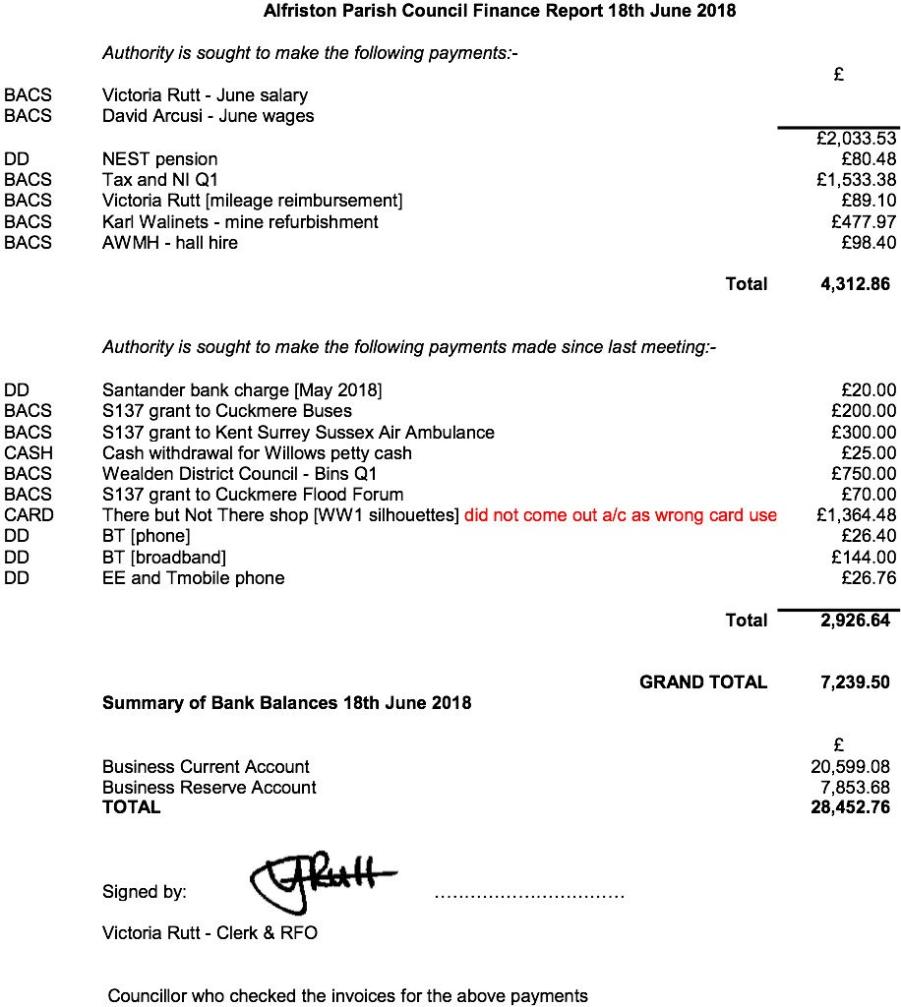

APPENDIX B

This part of our coastline offers a unique opportunity to enjoy a natural landscape which has largely been untouched by human influence over thousands of years. Despite the constant wearing away of the cliffs to reveal fresh chalk it appears much as it did in the Bronze Age and yet it is easily accessible to many towns, cities and large conurbations. It is also close to every amenity including public transport, overnight accommodation, refreshments and other services.
A gentle stroll or a more rigorous hike is equally possible and every visit offers the chance to enjoy fresh sea air and the ever changing conditions of sea and sky. The light reflected from the white chalk cliffs is unforgettable when contrasted with a darker sea and sky. On a fine day the hypnotic waves, occasional seabirds and distant sheep are the only sounds to disturb the peace.
It's an experience which we locals never tire of and we remain eternally grateful for the stunning views which are so evocative of the South Downs. An area which has a place in the heart of so many people to all around the world.
Many people enjoy discovering the flora and fauna of the locality and would appreciate a well presented visitor centre at one of the main gateways such as Exceat. Although there is already a visitor centre here it has considerable scope for improving its role in educating and entertaining visitors to the area.

