ALFRISTON PARISH COUNCIL
www.alfristonparishcouncil.org.uk

CLERK TO THE COUNCIL 11 Highfield Road
Victoria Rutt Horam
East Sussex
TN21 0ED
Tel: 01323 870212
E-mail: alfristonpc01@btconnect.com 27th September 2018

Minutes of a meeting of Alfriston Parish Council (APC)
held in the Alfriston War Memorial Hall on Monday 17th September 2018

Present:
Cllr. J. Watkins – Chair Cllr. R. Savage
Cllr. N. White – Vice Chair Cllr. C. Adcock
Cllr. V. Cooper
Cllr. N. Beechey

In attendance:
Victoria Rutt - Parish Clerk
Approximately 15 members of the public

53 Chairman’s Welcome
Cllr Watkins welcomed everyone to the meeting.

- Public Questions
- Mr Dan Raisbeck asked if the Council would consider undertaking a housing needs survey? Cllr Adcock stated that we should be commenting on the Wealden Local Plan and asked the Clerk why this had not happened yet. The Clerk stated that Wealden had not approached for comment. Cllr Ede from Wealden District Council [WDC] confirmed that Alfriston do not come under the plan hence why APC had not been consulted. Cllr Beechey stated that Mr Raisbeck question was about a housing needs survey which it was agreed would be a good idea. Clerk will link in with Cllr Ede to find out the process and report back to Council. Action 1.
- Mrs Nicky Vassell stated that a lot of houses in the village are being developed as Air BnB’s and/or are available for holiday lets. It could change the feel of the village.
- Mrs Sylvia Daw informed the meeting that the trial traffic lights commenced today! Mrs Daw reported that Conserve Alfriston is monitoring the traffic as they need the data. They do require helpers to help collate the data, it does not matter which way you vote for the lights. If anyone has the time please contact Mrs Daw on 01323 871188. Mrs Daw reported that they are monitoring speed, congestion, queues and pollution.
Cllr Beechey reported that listening to the radio that morning, Rupert Clubb said that what they are most interested in are what the businesses and residents, like and want. They also listed incorrect data figures on the radio. The questionnaire asks a question whether pedestrians feel safe walking from Star Lane to Weavers Lane, it does not mention the rest of the High Street. It was agreed that a letter should be sent to East Sussex County Council [ESCC] stating that APC are disappointed that they had no input into the questionnaire, secondly yet again it is a directive questionnaire. It was also agreed it is APC’s moral duty to point out to ESCC and ESH that they have created a serious hazard at the junction of Star Lane and High St. A number of near misses had been witnessed where drivers pulling out of Star Lane were narrowly missed by those travelling North on a green light. It is feared an accident is very likely to happen. Councillors agreed that Cllr Beechey would draft a letter to go out to ESCC the following morning.
Action 2.
Cllr Adcock disagreed with sending a letter pointing out other issues as the trial is only for the Narrows area. The Council disagreed and feels that the debate should be taken wider.
- Mrs Daw reported that the Headmistress at the Primary school had commented about how much traffic had been going past the school that day, the first day of lights installation.
- Mr John Nott asked why the views of the hall and church had not been considered when it came to the quote for the widening of the path. Cllr Beechey confirmed that this was on the agenda in November 2017 and the minutes state that it was agreed that the path would be widened by 1m. Cllr Beechey is meeting with Mr Adrian Butcher from the hall in due course and will update after this meeting.
- Ms Liz O’Neill asked could the vandalism be looked at in the Dene car park and if the Council can’t go down the route of CCTV, that other options are looked into. Cllr Savage stated that it is on the agenda for discussion later in the meeting.
- Mr Bill Rendall reported that he has seen that the campsite at Pleasant Rise has expanded and there are no toilets in the field. It was confirmed that two enforcement notices have been served on the campsite, they commence on the 1st October 2018 and have six months to be compliant.

- Report from Maria Caulfield MP
No attendance or report.

- Report from East Sussex County Councillor Stephen Shing
Cllr Shing reported that the County Council are continuing to cut funding and many services are being reduced. As of the 1st October 2018 there will be a charge for taking soil and building material to the local tips. Cllr Bennett has recently made a comment that there is no evidence that charging for waste disposal leads to increased fly-tipping. Cllr Shing stated that having seen the trial traffic lights in place, he believes there will be an accident. Cllr White asked whether a safety audit said there will be accidents, it was not known if ESCC had actually undertaken a safety audit for this scheme.

- Report from Wealden District Councillor Phillip Ede
Cllr Ede reported that any events of fly tipping, report direct to Wealden District Council [WDC] and they will deal with promptly. As stated earlier in meeting, Alfriston do not come under the Wealden Local Plan but to keep everyone informed, the consultation period is open until Monday 8th October, anyone can view it online and submit their views. Cllr Ede reported that there have been bin collection problems, the Kier contract is expiring next year in April 2019. The current situation is being looked into. It is very important when reporting a missed bin collection to Wealden, that all residents in the street report as this will incur a larger penalty to Kier which may improve their service. Cllr Ede confirmed that he will link the Clerk in with someone to help make a start on a housing needs survey.
Cllr Savage asked whether Cllr Ede knew anything about protection environment pollution which is the rollout of 5G. Cllr Ede did not but he will try to find out more. Cllr Ede stated that any vandalism in the village should be reported to Sussex Police and the Police Crime and Commissioner. Cllr Ede ended his update by stating he had witnessed a near miss at the Star Lane junction with High St and feels that SDNPA should be invited to attend to see the lights and give their feedback. He suggested writing direct to Margaret Paren.

- Apologies for absence
Apologies were received and accepted from Cllr Halliday.

- Declaration of interests
Clerk reported that this is a new agenda item which will now be a standardised item which will covered any declaration of interests that Councillors wish to make in regards to the agenda.
Cllr Savage declared an interest under planning as Pleasant Rise Campsite will be raised and he is a part owner. He also declared that he is a member of Conserve Alfriston.
Cllr White declared an interest under 65.5 due to his car being one that was vandalised.
A discussion was held whether Cllr Adcock should declare she is a member of Conserve but no declaration was received.

- Minutes
Cllr. White proposed and Cllr. Savage seconded a motion that the unadopted minutes of the meeting held on 18th June 2018 were a true and accurate record. MOTION CARRIED.
Cllr. Watkins duly signed the minutes.

- Finance
61.1 To approve the Statement of Finances
Cllr. Beechey proposed and Cllr. Cooper seconded a motion to approve the Statement of Finances for July and August – September.
[Appendix A]. MOTION CARRIED

61.2 To approve and sign Invoices for Payment
Cllr. Cooper approved and signed Invoices for Payment. MOTION CARRIED

61.3 To approve Q1 bank rec, VAT return and audit report
Cllr. Savage proposed and Cllr. White seconded a motion to approve the Q1 bank rec, VAT return and audit report. MOTION CARRIED

- Report on Highways & Twittens

62.1 Market Cross update

Clerk reported that at the beginning of August, she met with SDNPA along with Cllr Watkins at the Market Cross to discuss the options open to them. SDNPA looked at the quote received by a Stonemasons and confirmed they would not approve as it would change the cross itself and it would no longer be historical. SDNPA asked the question ‘why do you want to change the cross’? Clerk raised this question at the meeting to seek clarification. It was agreed at the meeting that it was looked at originally due to large pieces of brick coming away from the base, but as the SDNPA observed, the cross is the shaft and the cross itself. The base is not the historical section. It was agreed that the Market Cross would be removed from the agenda but the Clerk will keep the information obtained from SDNPA on file in case we need in future.

62.2 High Street traffic update
Cllr Watkins reported that most of the update was given earlier in the meeting; the only outstanding update is an additional 24 signs will be going up with the 20mph rule. Cllr Beechey asked if anyone knew of the location of the pollution monitors, it was reported that there is one in North Street but the other locations are not known. It was agreed to ask of their locations in the letter to ESCC. Action 3.

62.3 Water leaks in High Street and North Street
Cllr Adcock reported that she has heard a rumor that the water pipes are being replaced next year, WDC have said the following year. The Clerk has reported numerous leaks to them recently particularly down North Street and Market Square. It was agreed that APC would write to the water board and enquire to see what their plan is. Action 4.

Cllr Adcock raised under Highways the issues in Sloe Lane. Large vehicles are going through and causing damage to walls and occasionally getting stuck. Cllr Watkins confirmed to Cllr Adcock that this was raised at the recent Strengthening Local Relationship [SLR] meeting and ESCC are not able to add any additional signage or stop traffic from going through. The minutes from the SLR meeting are available on the APC website and had been circulated to Cllrs.

- Report on Allotments
Cllr Cooper reported that a meeting was held at the allotments prior to this meeting with allotment plot holders as some issues needed to be sorted out. It is work in progress but Cllr Cooper will work with the Clerk to get them resolved.

- Report on Rights of Way and Countryside
Cllr White had nothing to report.

- Report on Car Parks and Public Transport
65.1 Bus shelter in Willows car park
Cllr Savage reported that SDNPA do not require planning permission for the bus shelter and AEG are going to start build in November 2018. Cllr Adcock reported that she has heard different from Mr Reynolds that the build is not happening. Cllr Savage will find out and report back.

65.2 Replacement bins in Willows car park
Cllr Savage reported that the main bin at the Willows entrance has been fixed by the volunteer working group, so thank you to them. It was hoped that the bin in the picnic area can now be looked at for repair. Action 5.

65.3 Update on Willows and Dene car park lease proposals
Clerk reported that at present, she collects the coins from the Willows, banks the money and pays for any outgoing costs of the car park such as ticket machine admin and staff costs with the car park attendant. Every quarter, the Clerk submits a return to Wealden District Council [WDC] which covers that quarters income and expenditure, an amount is then invoiced, minus 25% which APC keep, to return to Wealden.
As of April 2019, WDC are proposing to change the lease so that all money will be banked to them, all outgoings will continue to be paid by them i.e. the insurance, toilets etc. APC will continue to pay their costs and invoice quarterly WDC for these costs. At the end of the year whatever is left in the pot after all outgoings will be split 50/50. Clerk reported that this will significantly affect the APC’s income and ability to serve the community.
The Council had a lot of questions as to why this change now and whether anything can be done to prevent it. The Clerk confirmed that WDC only have 2 car parks that they charge for, Willows and Pevensey, they want to standardise the leases and update them as they were last updated in 1987. WDC have stated that the running costs of the toilets, recent vandalism and insurance is costing them a lot and they are not receiving an income. Cllr Savage stated that we are being ripped off by a Local Authority and could the village not take over the car park and manage it.
Cllr Beechey stated that WDC own the land and only have to give 1 months’ notice to amend or cancel the lease, we have to tread very carefully. He spoke about when the car park was a garage and the land was sold to Wealden, that may be where the original 25% split came from. Clerk advised that WDC have said they are going to be sending over the proposed lease in the next 2/4 weeks. It was agreed that a working group needed to be formed to discuss this and it was agreed that Cllr’s Savage and Beechey would meet to move this forward.

65.4 To consider charging for Dene car park parking permits
Clerk reported that as part of her discussion with WDC about the lease, WDC were surprised to hear that APC did not charge for permits in the Dene car park. The Clerk undertook a consultation and sent letters/emails to all 97 permits holders. The Clerk received 15 responses, 5 positive and 8 negatives. Councillors discussed and as the money would not go in the APC’s income and improve the community, it would go into WDC pot, the permits will go ahead and be renewed by the Clerk with no charge attached, but to be reviewed once we know more about the future agreement with WDC.

65.5 To discuss car park security
The recent vandalism within Dene car park was discussed and whether CCTV could be installed. The Clerk reported that she has spoken with WDC and the installation of CCTV would not be supported for a number of reasons; the cost, who would monitor, the regulations around installing, the signage required, the regulations around it and the requirement to change the car park order. It was noted that unless the person is known to Police, a picture does not solve the crime. A discussion took place between Cllr’s Beechey and White about CCTV which at times turned heated. Cllr Watkins stepped in and asked whether Cllr White had any other suggestions instead of CCTV as something needs to be done but CCTV may not be the answer. Cllr White confirmed he had not thought properly but one idea could be a barrier system however it was pointed out that this would not work as the car park is free and again it would be cost implications to APC which Council can’t afford. It was discussed whether volunteers doing patrols in the evening could be a consideration. It was agreed that other options would be looked into.
Action 6.
- Report on Strategic Planning
66.1 Update on A27 meeting
Cllr’s White and Adcock recently attended two separate meeting about the A27 works. It is still not known what is happening, a reference group has been set up to obtain funding for the A27 but a decision has not yet been made on how to spend it. The group reassured stakeholders that there would be an extensive public consultation and a public enquiry if any funding bid was successful. They hope to find out late 2018 / early 2019. They have already obtained £72 million which they will be using the improve the current A27.
MP’s Maria Caulfield and Stephen Lloyd were surprised that minutes were not published by the A27 meeting and will ensure this happens. The business case is being prepared by Highways England.
A new group has been set up with powers called ‘Transport for the South East’, led by Rupert Clubb. They meet on Friday afternoons and the next one is in December. The business case for this project is confidential so has not been seen, or the reasons as to why they need a new road.

66.2 Update on Govia Thameslink meeting
Cllr White reported that the meeting had allocated 60 minutes on this subject with 104 delegates. The bulk of the time was spoken about the Thameslink line. Cllr White asked why trains are not stopping at Berwick? The response was due to people not buying tickets from Berwick. It was agreed that APC should write formally to Govia with feedback, Cllr White agreed to draft the letter. Action 7.

- Report on Tye and Recreation Ground
67.1 Update on Tye footpath
Cllr Beechey reported that a quote has been received and he will be meeting with Mr Butcher shortly on this subject due to some concerns raised and an update will follow once the meeting has taken place. He asked for ideas for possible funding avenues if anyone has any. He mentioned AWMH have discussed some ideas.

67.2 Playground inspection report
Cllr Beechey reported that the annual playground report has been received and it did highlight some issues, a walk-around with the Clerk will be arranged so the issues can be discussed and resolved. Further funding is required to continue to maintain and improve the playground so if anyone has any fundraising ideas please contact the Clerk.

- Report from Planning Committee
68.1 Applications to be considered by APC planning committee at this meeting

SDNP/18/04248/HOUS
Frog Firle Barn, Whiteway, Alfriston, BN26 5TT
Porch Extension to Dwelling
APC comments submitted to SDNPA on the 21st September 2018:
Alfriston Parish Council met on Monday 17th September to discuss this application. The Committee considered the application and agreed that it is not in keeping with the traditional design of a Sussex flint barn. The Committee raised concerns about light spillage and the effect on the dark skies in this prominent location, especially as the large expanse of glass is in the centre of the house near to the main living areas. Unless the applicant can work with SDNP to satisfy an acceptable level of mitigation can be achieved in order to reduce the impact which artificial light could have, we recommend refusal.
  - Applications considered by APC Planning Committee since last meeting

SDNP/18/02527/LIS – SDNPA have approved this.

Ye Olde Smugglers Inn, Waterloo Square, Alfriston, BN26 5UE

Internal alterations to form en-suite bathrooms

SDNP/18/02950/HOUS - SDNPA have approved this.
The Carthouse, Whiteway, Alfriston, BN26 5TS

Addition of 1 window at west elevation and 1 roof light at south elevation. Addition of glass canopy on Glazed Link on east elevation. Internal alteration as shown clouded on the floor plan.

  - Applications notified or awaiting decision from SDNPA

Cllr Beechey raised two planning issues that came up recently and was enquiring if there was an update. They are the structure down Riverbank and the flint wall down River Lane. Cllr Adcock confirmed that both have been reported by her and the Clerk, that enforcement officers have been out to investigate but no further update received. Cllr Adcock will chase this. Action 8.

Cllr Adcock wanted to raise the recent walking event that was held on private land over the bank holiday weekend that had a considerable effect on the village. It was agreed that the Clerk would contact organisers to find out the date for next year and ask them to communicate with APC about the event. Action 9.

- Reports from Outside Bodies
  - Cuckmere Buses – Mr Rod Young submitted a report in July. Appendix B.
  - Lorry Watch – nothing new to report.
  - Heartstart – Cllr Watkins reported that they had held a fundraising event at Follers Manor recently which was a great success.
  - Alfriston Emergency Group – no update.
  - Flood Forum – no update.
  - Neighbourhood Watch – no report.
  - Twinning Committee – nothing new to report.
  - Alfriston and Cuckmere Connect – Ms Jilly Byford sent in the following report: ACC will be releasing their new website within the fortnight, with information on local businesses and upcoming events and other insights to our village and its surroundings. They are building a page with contact information for societies and organisations and would be very happy to include the parish council and links to their site. Any groups or societies wishing to add their details to the website, please contact Jilly via the Clerk please. The brochure is currently going through final proof reading, and will be going to print very soon and distribution to follow. Plans for the weekend of 1st and 2nd December to host a Christmas celebration across the local businesses to be updated next month.
  - St Andrews Church –
Ms Diana Monteath-Wilson confirmed that a new Rector has been appointed, Rector Stephen Stukes. Personal thanks to everyone who donated money towards the shingles. Next month there will hopefully be some positive news on grants.
69.10 Clergy House – Mrs Sylvia Daw reported Clergy House’s thanks to the Parish Council for letting them put an A board in the village square over the summer. July and August were particularly busy and the publicity really helped with visitor targets. Currently the house has welcomed just over 20,000 visitors to the clergy house and village this year. In December they will have some Christmas events and will be seeking permission again to use an A board in the village square on weekends in December to help advertise them. These events are the Clergy House being festively decorated celebrating Christmas through the ages and also a Christmas decorating workshop.
The property is currently working on a Conservation Management Plan with the goal of really investigating their story from the time the NT purchased the property in 1896 to opening to the public in 1977. If anyone remembers any stories of what the house was like many years ago, as a child or old family stories about maybe going in the house or stories about the people who lived here, they would love to hear from you and even better if you have any photographs. Lastly thank you to all those in the village who supported their attempt to purchase the Gun Room, your time and efforts were most appreciated.

- Correspondence to The Clerk
- Clerk reported that since the last meeting in June a request was denied for a 6ft sail to be purchased by the Art Club to be used in the Square. APC sent a letter of support regarding National Trust purchasing the Gun Room which has since been sold, it is not yet known officially who too. The idea of someone in the village taking on the Post Office was raised, APC wanted it noted that they would endorse and support, in some way, if anyone would be interested.
- A board request from the Historical Society for the 20th September, 18th October and 15th November was agreed.
- The Beachy Head Marathon have requested some space in the car park for the event which is being held on Saturday 27th October 2018. It was agreed that like previous years, they can reserve one half of the Willows coach park. Clerk will inform car park attendant.
- Cllr Beechey reminded Clerk that an email had come in from Mrs Frankie Reynolds asking the Council to consider writing to ESCC again about the lack of criteria for trial evaluation. It was agreed by Councillors that Mrs Reynolds comments will be included in the letter sent to ESCC.
- Clerk informed Councillors and residents that she is pleased to announce that she has submitted all her CiLCA coursework and is awaiting final confirmation that she has passed.

- Date of next meeting
The next meeting of the Council will be held at 7.15 pm on Monday 15th October 2018 in Alfriston War Memorial Hall. The meeting will be suspended after the Chairman’s Welcome to allow Public Questions and Reports from County and District Councillors.

72. Public Questions
- Mrs Sylvia Daw asked if anyone knew who the ‘Alfriston Traffic Communication Group’ was as an email was received recently and it was signed off by Ms June Goodfield. Cllrs, save for Cllr Adcock, were not aware of this new group.
- Mrs Nicky Vassell wanted it recorded that the village needs toilets due to tourists and the number of events held in the village, if one was to be closed she would not support this. Mrs Vassell also asked if anyone knows who the culprits are for the vandalism. It is not known.
- Mrs Janet Banham commented on the number of motorbikes that have started coming through the village on a Sunday morning. Cllr Beechey thinks they are 4 off road bikes that come through about 09:00. It was confirmed that there is nothing we can do about this unless someone can get their registration numbers so the Clerk can report them via Operation Crackdown.

Signed: Victoria Rutt
Clerk and RFO

APPENDIX A

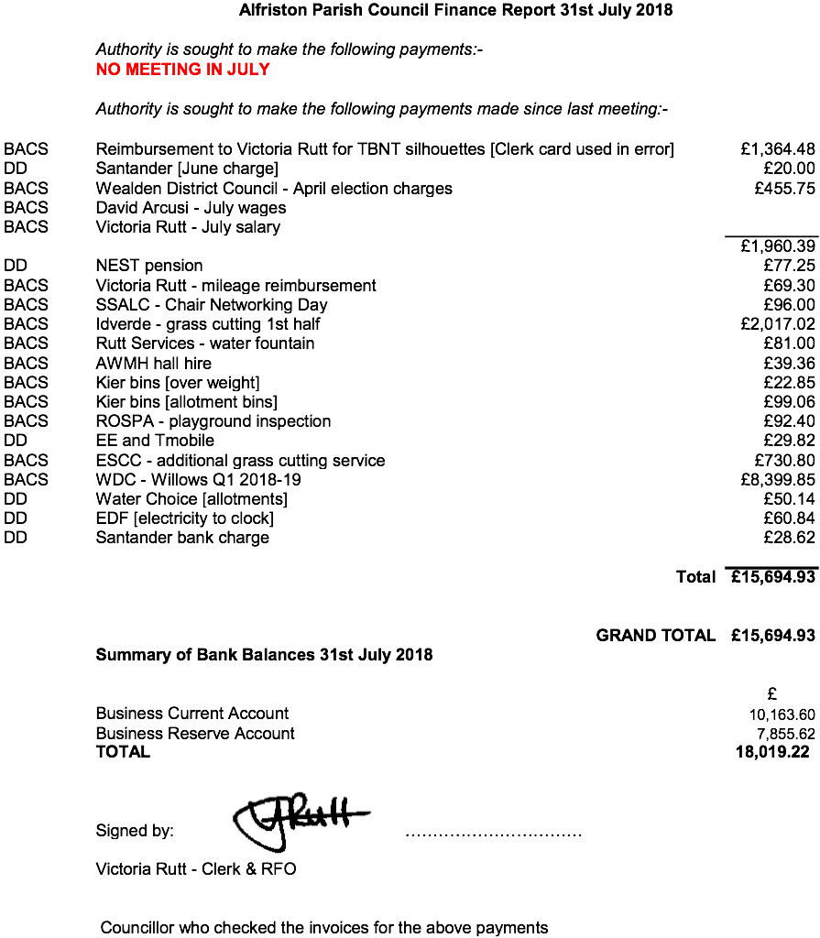

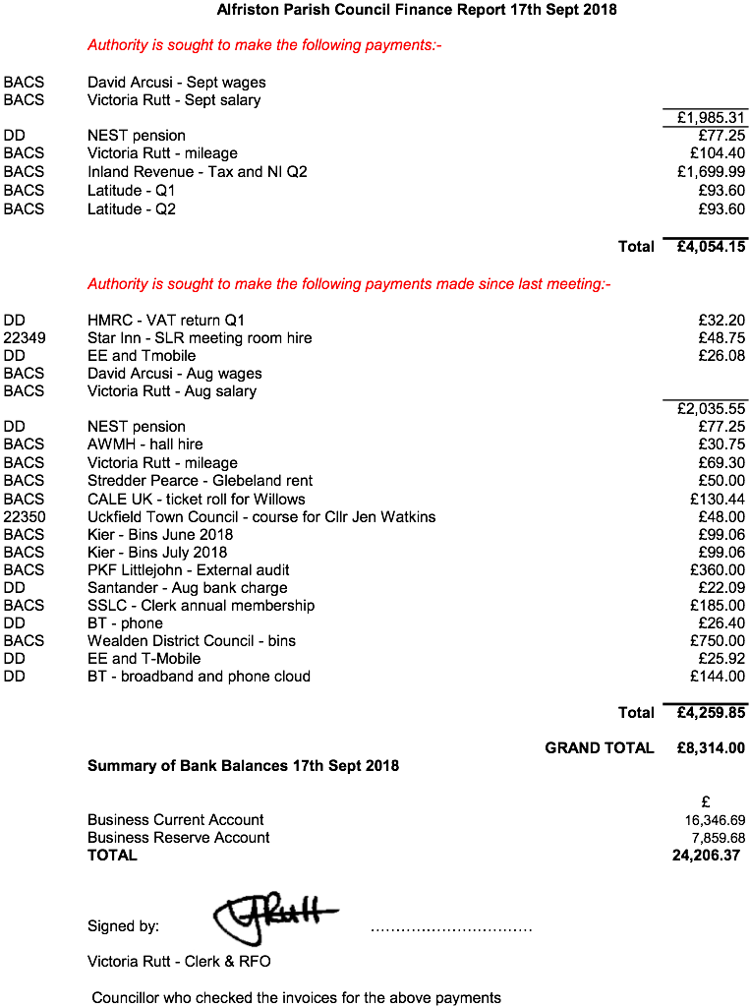

APPENDIX B

CUCKMERE BUSES - Report of Stakeholders’ meeting held on Monday 30 July 2018

The following is a summary of those points discussed at the meeting which may be of interest to Alfriston Parish Councillors

- Seasonal services will be withdrawn or reduced from the end of October, when the clocks change. Of the services calling at Alfriston, No 47 – the Cuckmere Rambler - will be withdrawn for the winter. No 126 – Seaford to Eastbourne – will finish at 1644 during the winter, instead of 1817.

- These two services, and particularly the 47, are scheduled to call at Berwick Station at a time which fits with the arrival of the trains to and from Eastbourne. Recent train timetable changes have meant that this is not currently happening. However, we are told that permanent Southern Rail timetable changes will not now be in place until March 2019 and the appropriate changes to the Cuckmere Buses timetables will have to wait until then.

- Services are kept under regular review, to ensure that we are best meeting changing passenger demand. A review of the entire Hailsham Town services has been undertaken, and new timetables will be introduced from 17 September. Little used parts of the current service will be withdrawn, and a more frequent service provided in busier parts of the town.

- The programme of updating the bus fleet to reduce maintenance costs continues. A new Mercedes Sprinter, part of the mid-sized range, was ordered in April for delivery in September. One of the smaller buses will be sold to part fund the purchase. Grant applications are being made to various funds with the aim of replacing one of our older, larger Sprinters, now fourteen years old.

- The future of the current permit system, under which Cuckmere Buses and other volunteer community bus services operate, as well as the future of the D1 licence, remains uncertain. The D1 licence, which allows the holder to drive a bus with up to 16 seats on a voluntary basis, was automatically given to anyone passing the private car driving test up to 1997. Drivers passing their test after this date do not receive a D1 licence. Withdrawal of the permit system, or of the D1 licence for those who currently hold it, could result in a situation where the cost of training and test for anyone wishing to drive our buses could amount to £1500 - £2000 a head, which is clearly more than any volunteer service could bear. Moreover, the pool of D1 licence holders will gradually dry up. The government’s intentions are currently unclear, and the situation could be affected by the UK leaving the EU. Cuckmere Buses finds it hard to believe that the government will allow changes which could destroy community bus services.

- Meanwhile, Cuckmere Buses need for more volunteer drivers is becoming urgent. Passenger demand for its services remains, and its finances are sound, but it is becoming increasingly difficult to find drivers to cover all the services we run. All local parish magazines are being asked to carry an advert to appeal for new volunteers, and anything APC can do to help this drive would be very much appreciated.

Rod Young
Aug 2018

