ALFRISTON PARISH COUNCIL
www.alfristonparishcouncil.org.uk

CLERK TO THE COUNCIL 11 Highfield Road
Victoria Rutt Horam
East Sussex
TN21 0ED
Tel: 01323 870212
E-mail: clerk@alfristonparishcouncil.org.uk Friday 22nd February 2019

Minutes of a meeting of Alfriston Parish Council (APC)
held in the Alfriston War Memorial Hall on Monday 18th February 2019

Present:
Cllr. N. White [Vice Chair] Cllr. V. Cooper
Cllr. C. Adcock Cllr. N. Beechey
Cllr. K. Halliday

In attendance:
Victoria Rutt - Parish Clerk
Approximately 10 members of the public

140. Chairman’s Welcome
Cllr White welcomed everyone to the meeting.

- Public Questions
No public questions.

- Report from Maria Caulfield MP
No report and no attendance

- Report from East Sussex County Councillor Stephen Shing
Cllr Stephen Shing reported on the budget for ESCC, the Exceat Bridge, the traffic trial and the white lines at Whiteway. His full report can be found at Appendix B.
There was a brief discussion about the white lines at Whiteway and Cllr Beechey explained that Ian Johnson (ESSC Highways) informed that they were removed about three years ago subsequent to a sustainable transport & tourism report. Clerk reported that an official request was sent to East Sussex County Council [ESCC] after the January 2019 meeting to ask them to review the decision. It will be raised on Friday at the Strengthening Local Relationship [SLR] Meeting. Action.

- Report from Wealden District Councillor Phillip Ede
No report or attendance.

- Apologies for absence
Apologies were received and accepted from Cllr Watkins.
No apologies have been received by Cllr Savage.

- Declaration of interests
Cllr White declared an interest in the Cross House planning application. Cllr Halliday and Cllr Beechey declared they are a customer of the Barbers but that will not affect their decision making.

- Minutes
Cllr. Halliday proposed and Cllr. Adcock seconded a motion that the unadopted minutes of the meeting held on 21st January 2019 were a true and accurate record. MOTION CARRIED.
Cllr. White duly signed the minutes.

- Finance
148.1 To approve the Statement of Finances
Cllr. White proposed and Cllr. Cooper seconded a motion to approve the Statement of Finances.
[Appendix A]. MOTION CARRIED

148.2 To approve and sign Invoices for Payment
Cllr. Cooper approved and signed Invoices for Payment. MOTION CARRIED

- Report on Highways & Twittens

149.1 High Street traffic update
Cllr Halliday reported that there is nothing to update and he will chase the traffic team at ESCC to seek one. Cllr Beechey reported the had been approached by someone saying the cones outside the Star Inn are ugly. Although these are effective could a better long-term solution be considered. Double yellow lines were raised although Cllr Cooper did ask would they be taken notice of and could they be enforced. Cllr Halliday confirmed that he would raise the double yellow lines at the SLR meeting on Friday. Action.
Cllr Adcock suggested putting metal bollards on the pavement but Councillors did not feel that this would prevent parking. Cllr White suggested that we could paint the cones a less garish colour.
APC will await the SLR minutes to see what ESCC suggest.

- Report on Allotments
Cllr Cooper reported that the allotment renewals have gone out, there has been a good return and will be able to report at the next meeting how many plots are vacant. Cllr Cooper confirmed that the Clerk has reported the allotment bin as stolen and it is hoped this will be replaced in due course by Biffa.

151. Report on Rights of Way and Countryside
Cllr White reported that he has noticed that the White Bridge is starting to peel and fade away. Cllr Beechey confirmed that ESCC are responsible for this. Clerk to raise this with the Rights of Way team. Action. Cllr Adcock raised a government proposal to declare any unidentified Rights of Way in the Parish. Councillors did not believe there were any unidentified but will be corrected if anyone knows of any.
The deadline for declaring any is the 1st January 2026.

- Report on Car Parks and Public Transport
152.1 Bus shelter in Willows car park
There is nothing new to report at this time.

- Report on Strategic Planning
Cllr White had nothing to report.

- Report on Tye and Recreation Ground
154.1 Update on Tye footpath
Cllr Beechey confirmed that South Downs National Park Authority [SDNPA] and the Charity Commission [CC] have responded about permission for widening Tye Path. The CC do not need to be informed and therefore will not need to give permission. However, SDNPA have stated that they do require planning permission. It was raised whether there would be a cost, the Clerk has asked the question but no response as yet. Cllr Beechey thinks the Parish Council may be exempt. It was discussed who would pay for the application if there was a cost, it was agreed that it should be a three way split between APC, St Andrews and Alfriston War Memorial Hall [AWMH]. Clerk will look into this with SDNPA and then speak to both AWMH and St Andrews about the application. Action.
Cllr Adcock spoke about the sides of the path, whether they should be metal or brick edge. Cllr Beechey confirmed that the existing quote was for metal edge as will be less visible. This was agreed again as the preferable option.

Tye Road – Cllr Beechey reported that the pothole outside the Wingrove Courtyard has got worse over time and could now be considered a trip hazard. Two quotes have come in, one for £1090 which would be to cut the road out and fill it, or a quote from APC’s handyman for £633.10 to use tarmac bags with a compactor to fill the holes and any left-over can be used for other holes appearing on Tye Road.
Councillors discussed and agreed to go with the handyman as it needs to be done ASAP and could get the cost of two lots of repairs for the price of one. Clerk to arrange this ASAP. Action.
Cllr Adcock raised the edge of Tye Road seems to be crumbling. Cllr Beechey explained that this has been looked at some years ago and it was many thousands to repair this then. It was agreed that we need at least 5/6 years’ worth of savings which will be ring fenced to enable APC to resurface the whole road when that is needed.
Cllr Beechey also confirmed that the Wingrove have kindly given a donation of £200 towards the repair of the large pothole outside their courtyard.

Grass Cutting - Cllr Beechey asked if the grass contractors could be contacted sooner rather than later to ensure a better season this year as last year was poor at times. A rotary mower to be used on the cricket field and a list of the fixtures to be sent over to them. Action.

Playground – Cllr Beechey asked if anything has happened with the playground. Following the January 2019 meeting when a budget was agreed to replace the slide, the Clerk has contacted Playdale who is attending the playground on Thursday to measure up for the slide and provide a quote. Once the Clerk has received this, it will be brought to Councillors for approval. Action.

- Report from Planning Committee
155.1 Applications to be considered by APC planning committee at this meeting

SDNP/18/05981/LIS
Cross House, High Street, Alfriston, BN26 5UF
To attach a traditional barber pole to the shop front
The applicant explained that this is a retrospective application as the pole has been up for a while as she did not know it required planning permission. She explained the Barbers pole is crucial for her business and it helps people to know she is there. APC Planning Committee agreed that there are no objections to this application.

SDNP/19/00289/LIS and SDNP/19/00288/FUL
Burnt House, Whiteway, Alfriston, BN26 5TS
Demolition of existing garage structure with new build construction of brick and flint garage.
APC have no objection to this renewal (now lapsed) but would like to see measures taken to address light spillage in view of the six velux windows. The council also suggest that a condition is added to ensure the proposed development will be ancillary to the main dwelling and only used as a garage for the residents.

155.2 Applications considered by APC Planning Committee since last meeting
155.3 Applications notified or awaiting decision from SDNPA

SDNP/18/06260/FUL Winton Grange, Winton Street, Alfriston, BN26 5UH
SDNP/18/06517/LIS Burnt House, Whiteway, Alfriston, BN26 5TS
The two above are still awaiting decision from SDNPA.
SDNP/18/05322/FUL 2 Steamer Cottages, High Street, Alfriston
SDNPA approved this retrospect application with a few conditions.

Enforcement issue – Cllr Adcock confirmed that SDNP consider that the unauthorised development at a Riverbank, River Lane is unacceptable and an enforcement notice is imminent.

Community Infrastructure Levy [CIL] - Cllr Adcock asked the question should we be receiving CIL? The Clerk confirmed that she had received an email saying we are not entitled this year and both the Clerk and Cllr Beechey believe this is only received on new developments. Cllr Adcock thinks that the recent Air BnB at Steamer Cottages is classed as a new development. Clerk to find out. Action.

156. Reports from Outside Bodies
156.1 Cuckmere Buses: no report.
156.2 Lorrywatch: no report.
156.3 Heartstart: At present there is only one responder in Alfriston. They desperately need new volunteers so if anyone feels able to help or needs further information please contact Jen on 07932 600143 or alfristonheartstart@gmail.com.
156.4 Alfriston Emergency Group: Mr Vernon Reynolds explained the work that Alfriston Emergency Group [AEG] do around the village when it comes to salting and gritting. They are happy and willing to do it and believe they do a good job. A recent email received from APC made them doubt this which was incorrect, APC were asking how much salt had been used and if APC were required to purchase more in the future permission will be required first as with the Council’s finance processes. Mr Reynolds stated that a request has gone to the Council to budget for two pallets of salt per annum if required. Clerk stated this is being raised under Clerks Correspondence. Cllr White expressed on behalf of all the Councillors that they are very grateful for all that AEG do for the village.
156.5 Flood Forum – Mr John Hurwood sent in a report. The report states that last weekend the heavy rain flooded the field and the coach park. Concerns were raised by the emergency group on Sunday evening, about why the pump had not auto-started to prevent this. The Environment Agency [EA] came out and it appears that the floats have been interfered with, and tied up high above the water. The EA is not very happy about this as it has happened a few times and point out that as well as being anti-social, whoever did this is breaking the law. APC would like to ask whoever is doing this to please stop as it is not very community minded and we may lose the essential pump due to this disruptive behaviour.
Mr Hurwood also reported that the river has been flowing downstream surprisingly well during and after the recent heavy rain, this despite the strong SW gales which have moved the shingle at the river mouth, the river is now flowing to the sea to the east of its designated channel, but flowing well and not causing flooding in our vicinity. The emergency flood number will be added to the APC’s website under emergency contacts. Action.
156.6 Neighbourhood Watch – no report
156.7 Twinning Committee – no report.
156.8 Alfriston and Cuckmere Connect – no report.
156.9 St Andrews Church – Ms Monteath-Wilson reported that the Church have agreed to match fund the £500 for the Tye Path, however they would like to see the plan and costings prior. Clerk will send this over to them. Action.
  - Clergy House – no report.

157. Correspondence to The Clerk
- Clerk reported that a request has come in from Extreme Events to hold a checkpoint on the 6th May 2019 for a running event. It will be from 10:00 – 14:00 near the White Bridge and they will tidy up and cause no obstruction. Clerk stated they have done this previously in 2017 and 2018 with no issues. Councillors granted permission.
- Clerk asked Councillors to consider Mr Reynolds earlier request to allocate £260 in the budget per annum for two pallets of salt. Councillors agreed that this could be incorporated into the village maintenance budget so that the salt can be purchased if required.
- Clerk reported that an email has been received informing the Council that a running event will come through the village on the 16th March using some of the public rights of way. The event is being run by Endurance Life.
- Clerk raised the ‘Great British Spring Clean’ which is running from the 22nd March to 23rd April. Cllr White opened the meeting so Mr Michael Anderson could speak. Mr Anderson confirmed that he has spoken with Wealden to get the equipment and as he arranges three litter picks a year, he will be arranging this one also. It was raised that recently the volunteers have been asked to sort the litter out that they have collected. Clerk will speak to Wealden about this. Action.
- Clerk raised that SDNPA have come back saying the proposed Sculpture on the Tye will require planning permission. It was discussed and there are still a lot of questions outstanding i.e. who will be responsible for the sculpture, who will maintain it, whose insurance will it come under for example. Clerk to speak to the Sculpture Group about these questions and it will be a formal agenda item for the March meeting to consider whether APC support before any application is submitted. Action.
- Clerk reported that following a public question raised by Mr Dan Raisbeck a few months previously some work has been undertaken at looking at doing a Housing Survey. The Clerk has finally been pointed in the direction of ‘Action in Rural Sussex’ [AiRS]. The Clerk spoke with Mr Warder from AiRS who explained that the Parish Council would commission them to do the survey. They would then send out a six-sided questionnaire to all properties in the Parish, they would then analyse the responses and provide a short report. The cost of this is £2,700. It was not known there would be a cost and one so high, however this needs to be done as there is a serious need for affordable housing in the village. Cllr Adcock stated she understood the need for one but did not know how it would be taken forward. Cllr Beechey and Mr Raisbeck explained that you can’t do anything about the problem without first having a report showing there is a need.
It was agreed that the Clerk would speak to AiRS again about whether they could consult with the questions and the Council do the survey themselves. Clerk is going to report back to Councillors via email so there is no delay. Action.

158. Date of next meeting
The next meeting of the Council will be held at 7.15 pm on Monday 25th March 2019 in Alfriston War Memorial Hall. The meeting will be suspended after the Chairman’s Welcome to allow Public Questions and Reports from County and District Councillors.

The next meeting date will also be the date of the Annual Assembly, the Clerk will send out further information about this in due course.

159 Public Questions
- Ms Diana Monteath-Wilson asked will there be a consultation with the village about the proposed Sculpture as it is not known if residents actually want it. APC confirm that this will take place, they are still in discussions with the Sculpture Group.
- Mr Vernon Reynolds stated that the housing survey is a really good idea and that Action in Rural Sussex have plenty of money so they should help us.

Signed: Victoria Rutt – Clerk and RFO

APPENDIX A

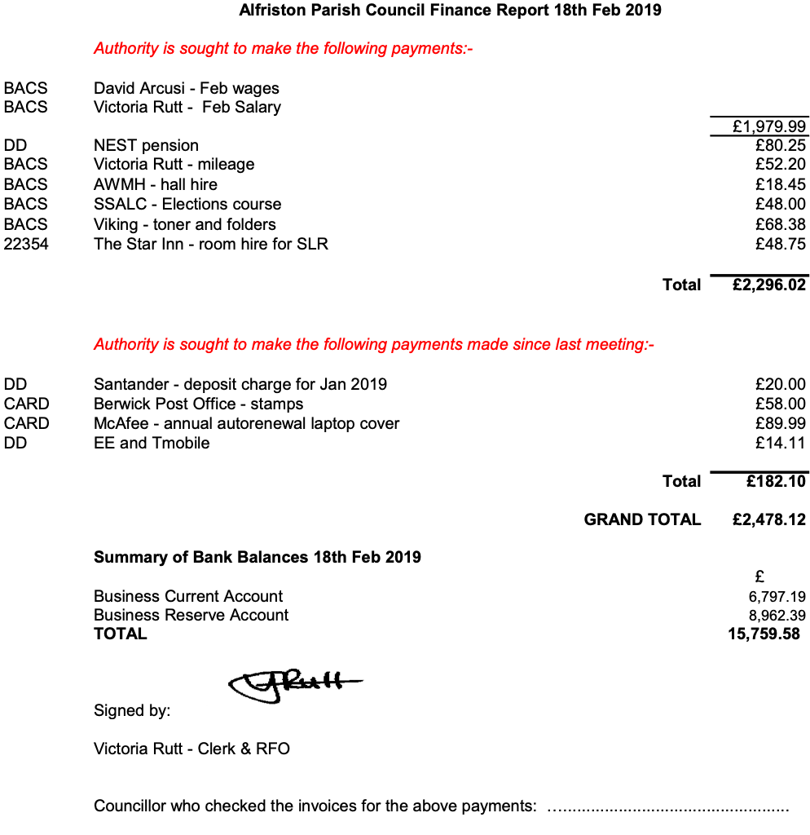

APPENDIX B

County Councillor Report to Parish Council Meeting February 2019

EAST SUSSEX COUNTY COUNCIL - COUNCIL TAX

East Sussex County Council full council meeting held on 5th February agreed the proposals for service changes and funding across East Sussex next year. This decisions about spending £ 375 million on vital services and proposals to make savings of £ 5.13 million to deliver a balanced budget in 2019/20, and also look ahead to 2020/21 and 2021/22. The latest estimates for the next two years to 2021/22 continue to show a deficit of £ 21.2 million.

To save £ 5.1 million, ESCC proposes to reduce its spending on school improvements, removing the subsidy for meals on wheels and increasing parking charges.

County Councillors agreed an increase in council tax for next year of 2.99 per cent, the equivalent of 80p extra per week for the average household in East Sussex.

With good financial management and successful lobbying of central Government, which has resulted in some additional one-off funding, means the savings requirement for the next financial year, from service changes, is lower than first estimated.

Among the New One off Funding to have an effect on plans for 2019/20, is money from the 75 per cent business rates retention pilot, and an additional £ 4.4 million for social care Support Grant 19/20

EXCEAT BRIDGE UPDATE

The project is progressing as expected and ESCC are still aiming to submit the planning application in September as previously indicated. Further site investigation works are planned for February. ESCC are expecting formal responses from the consultees such as Natural England later this month which will help progress the project, so far the responses are positive.

TRAFFIC LIGHTS TRIAL - ALFRISTON

East Sussex County Council is continuing to analyse the data from the trial and the feedback received during and after the trial. The data being analysed includes information on the roads in and around Alfriston, and all the submissions from the public and Conserve Alfriston Group comprising of written, photographic and video material. ESCC plans to report the outcome of the trial and any recommendations in late spring to the Lead Member for Transport. With our request, ESCC agreed that some road joining works outside 80 Coppice Avenue is needed and are seeking to complete this during the Easter school holidays. They have also agreed to investigate surface water on the road and slabs.

We would like to take this opportunity to thank the residents for bringing this matter to our attention and supporting the petition. We are always interested to hear of ongoing issues so please don’t hesitate to contact us.

WHITEWAY

I received a few more residents express concerns about the central line of Whiteway. The responsible officer was on sick leave and just return to work today (18th February), I spoken to him briefly about residents concerns. As we are due to Strengthening Local Relationships SLR meeting this Friday (22nd February) with the parish, therefore we will have it on the agenda for a discussion. The re-paint the central line was discussed last year at SLR meeting, agreed that remain as it is and monitor the situation. If any changes if require should request from the parish council. It is important to note that if any changes have been made, as result increase traffic speed. East Sussex County Council will not have the resources to make further improvement as we want.

East Sussex County Councillor Stephen Shing

