29/1/2020
Work in Waterloo Square and High Street – Phase 2 of the water mains renewal project
Dear Customer

New water main installation in Alfriston – Access during Phase 2 Waterloo Square and High Street, as far as Star Lane

The works along North Street are progressing well and phase 2 - from the top of North Street to the junction with Star Lane - is now underway. The map overleaf shows the route.

How will this section of work affect me?

During the next phase we will be excavating around Waterloo Square, a few metres into West Street and along High Street as far as the junction with Star Lane.
As previously, access to businesses for deliveries and for residents in this area, including River Lane, will be maintained. However, there may be some inconvenience. There will be no vehicle access through Waterloo Square during Phase 2. Buses will use Weavers Lane and Broadlands and passengers will be able to “Wave and Stop” along this part of the Village to avoid the need to walk into Waterloo Square.

Will I still be able to access my property or accept deliveries?

Yes, homes and businesses will always be accessible, but at times, you may need to bear with us. There may be a short delay in providing direct access to properties and deliveries. The site team will work with you to ensure access and we would ask you assess which route to your property would be most suitable each day.
Businesses should advise suppliers the most suitable route to reach you and at times, when access to directly in front of businesses will not be possible, supplies will have to be manhandled to the premises.
To ensure the safety of the residents, pedestrians and workforce, access for all vehicles will not be possible from Weavers Lane, through Waterloo Square and into West Street/North Street.

We are committed to maintaining access to businesses, as close as is possible, at all times, and we ask for your continued support when delivery vehicles cannot reach outside your property. This distance will be minimal at all times.

Map showing extent of phase 2 (shown in green)

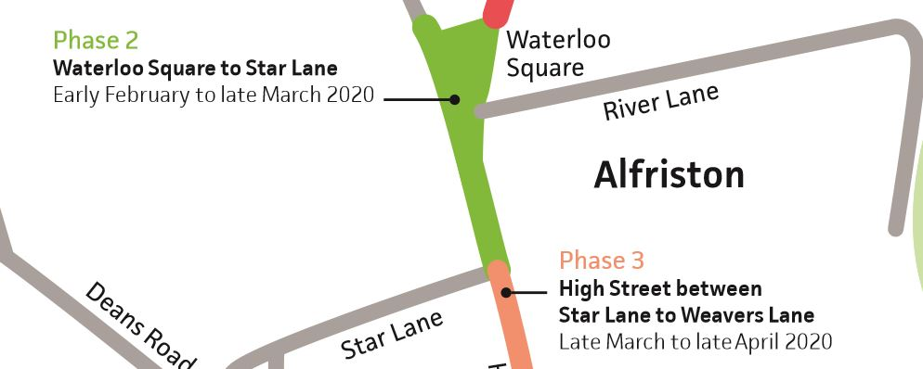

Who can I contact if I have any queries about these works or my bin collection?

All waste collection services have been informed about the progress.

There will be some specific access needs and requirements and Steve Anthony, our dedicated Customer Service Manager, is contactable on 07926 535414 to discuss your individual needs in relation to access and deliveries.

On behalf of South East Water, I thank you in advance for your continued patience and co-operation during these improvement works.

Yours sincerely
Jeremy Dufour
Project Manager

