ALFRISTON PARISH COUNCIL
www.alfristonparishcouncil.org.uk

CLERK TO THE COUNCIL 33 Swaines Way
Victoria Rutt Heathfield
East Sussex
TN21 0AN
Tel: 07936 904743
E-mail: clerk@alfristonparishcouncil.org.uk Wednesday 27th May 2020

Minutes of a meeting of Alfriston Parish Council (APC)
held remotely via Zoom on Monday 18th May 2020 at 19:15

Present:
Cllr Watkins [Chair] Cllr Daw
Cllr Beechey [Vice Chair] Cllr Savage
Cllr Rabagliati Cllr Adcock

In attendance:
Victoria Rutt - Parish Clerk
Approximately 5 members of the public

1. Chairman’s Welcome
Cllr Watkins welcomed everyone to the meeting and wanted to express her thanks on behalf of APC to all the volunteers in the Village who have assisted in deliveries of groceries and prescriptions, it has worked incredibly well. Cllr Watkins went through the housekeeping rules of the meeting, all attendees to remain on mute unless asked to update to avoid background noise. Councillors would be asked for a show of hands when voting and/or agreeing to items. The Clerk will review the process with the Chair after the meeting to see if any changes need to take place for the next meeting.

2. Public Questions
There were no public questions.

3. Apologies for absence
Apologies received and accepted from Cllr Cooper.

- Report from Maria Caulfield MP
No report or attendance.

- Report from Cllr Stephen Shing [ESCC]
Cllr Shing reported that he had not been to the Village since lockdown but had heard that the water works project finalised a month earlier than planned which was excellent news. He stated that ESCC services are returning back to normal slowly. Any issues with road or hedges can now be reported as Highways are undertaking repairs.

- Report from Cllr Michael Lunn [WDC]
No report or attendance.

- Declaration of interests
Cllr Daw and Cllr Watkins declared an interest as they are part of Alfriston Emergency Group [AEG].

- Minutes
Cllr. Beechey proposed and Cllr. Daw seconded a motion that the unadopted minutes of the meeting
held on 16th March were a true and accurate record. MOTION CARRIED.
The minutes could not be signed as it was a remote meeting but they will be signed next week
by Cllr Watkins.

- Finance
  - To approve the Statement of Finances: EOY March 2020 and May 2020
Cllr. Daw proposed and Cllr. Beechey seconded a motion to approve the Statement of Finances for March 2020 and May 2020. [Appendix A]. MOTION CARRIED
The finance report and invoices could not be signed as it was a remote meeting but they will all be signed next week by Cllr Watkins.

  - To approve and ratify the NEST pension contributions
Clerk reported that Councillors had received an email about the need for an increase in pension contributions, this has happened slowly over the past 3 years taking it to the maximum level. This year incurred a 2% increase for the Clerk and 1% increase for APC. This was agreed prior to the meeting via email due to the pension deadline. Cllr Beechey proposed and Cllr Daw seconded a motion to approve the pension increase. MOTION CARRIED

  - To approve and ratify Clerks performance pay increment 2020/21
Clerk reported that following a confidential personnel committee meeting held in March 2020, all Councillors agreed to award the Clerk one increment pay rise linked to her performance. Cllr Rabagliati proposed and Cllr Daw seconded this pay increment rise. MOTION CARRIED.

  - To confirm that Councillors have had sight of the Internal Audit report
Clerk reported that she had circulated the recent internal audit report to all Councillors for their information. Cllr Rabagliati proposed and Cllr Savage seconded that they had received the report. MOTION CARRIED

  - To ratify and approve annual return 2020/21
Clerk reported that the annual return for 2020/21 had been completed and circulated to all Councillors for approval. Cllr Beechey proposed and Cllr Daw seconded to approve the annual return. MOTION CARRIED. The process requires a wet signature on the form before Clerk can submit to the external auditor so Cllr Watkins will be doing this next week.

  - To approve and adopt Finance Regulations and Standing Orders 2020
Clerk reported that the following two agenda items are required to be reviewed and approved annually in May. Cllr Beechey proposed and Cllr Adcock seconded to approve the Finance Regulations and Standing Orders 2020. MOTION CARRIED.

  - To approve and adopt Risk Register and Asset Register 2020
Cllr Beechey proposed and Cllr Daw seconded to approve the Risk Register and Asset Register 2020. MOTION CARRIED.

  - To approve insurance renewal with BHIB Insurance Brokers for 2020/21
Clerk reported that the annual insurance renewal has been received, Parish Councils have limited access to insurance companies and Clerk reports it is a good price for the cover required. Cllr Beechey proposed and Cllr Savage seconded to renew with BHIB. MOTION CARRIED.

- To agree the Councillors portfolios
Clerk reported that all Councillors wish to keep their current portfolios. It was agreed that as Cllr Savage no longer has the car parks portfolio, he would take on Rights of Way and Countryside alongside Public Transport so Cllr Daw can focus on Strategic Planning.

- Report on Highways & Twittens – Cllr Rabagliati
Cllr Rabagliatii reported that the most notable event since the last meeting has been the completion of the water main replacement project, a month ahead of schedule. There has been universal praise for the efficiency, professionalism and friendliness of the teams involved, and APC has written a letter of thanks to SE Water/Clancy Docwra. Some questions remain about the repainting of road markings over sections that have been resurfaced. Contractors are required to repaint areas that they have disturbed, but they are not required to repaint the entirety of the marking hence, where the painting was previously faded, the end result appears quite patchy. A snagging list has been sent to Clancy Docwra and this included the painting and verge by the Dene car park exit. Cllr Rabagliati felt that we all benefitted from the road closure during the lockdown period!

Following on from the road works, the Dene car park exit to North Street is to remain 2 way, as the 2 way entrance was very successful during the works. APC have contacted WDC to establish the position regarding the West Street entrance but have not had a response. The road signs are still in place, so we presume that this exit remains 2 way as it was during the road works period.

We are still awaiting a date for the next stakeholder meeting to discuss the High Street traffic plan. At the meeting last year where APC presented its plan, ESCC promised a date in April for a presentation of the evolved plan. Naturally, this has been delayed, however, we will press them for a date in the near future.

Last week, Cllr Rabagliati walked around the village to check the roads and twyttens, noting locations of potholes. In some places these are quite deep. We are seeking to establish what depth potholes have to be before ESCC will come to fill them in.

Just before lockdown, the Task Force undertook some clearing of the Twytten by the village store, road sign washing, and clearing the high path leading North out of the village. Thanks to those who came out in good numbers. During the lockdown period, ESCC Highways undertook a complete clearing of this path all the way to the roundabout, and thanks are due to them for this. The A27 road widening scheme from Beddingham roundabout to Polegate has commenced. This will last for an extended period, and closures and delays for drivers are to be expected

Cllr Beechey suggested that APC write to ESCC asking for their written proposals along with costings whilst we are awaiting a meeting date. All Councillors agreed and Cllr Rabagliati will draft a letter. Action 1.

- Report on Allotments – Cllr Cooper
Clerk reported that the allotments are now full after a lot of interest during lockdown has meant all the overgrown plots are now being used. There is now a waiting list with two names on. There have been some issues with the allotment bins but after some fantastic volunteer work this seems to have been sorted and Clerk is arranging for signs to be placed onto the bins to prevent any future issues.

- Report on Car Parks and Public Transport – Cllr Savage
Clerk reported that the car parks reverted back to the ownership of WDC from the 6th April. Emails have gone back and forth about the loss of income in the last quarter due to the ticket machine breaking in the December flooding. WDC agreed and APC received just under £6000 to cover the expenditure spent in that time and the loss of income.
Cllr Beechey explained that members of the public are unaware what APC have discussed as the meetings had to be confidential at the time, however it was agreed these can now be published. Clerk will publish them on the on website and circulate via email. Action 2
Cllr Beechey went on to explain that APC looked into legal advice regarding the car park matter and agreed to send a judicial review pre-action protocol [PAP] letter. This was sent to WDC and a response was received from them on the 17th March. Clerk circulated this response to all Councillors and Cllr Beechey responded with a number of options for Councillors to consider but none responded. Clerk chased at a further date and no responses received again so no further action has been taken. The time limit for judicial review has now passed so APC missed the chance to develop that route. Cllr Beechey asked Councillors whether they wished simply to leave the matter or pursue it further to see if the Willows could be made a free at point of use car park. Both Cllr Adcock and Cllr Daw apologised for missing the email and agreed that we should pursue. It was agreed that a letter would be sent to WDC about this. Action 3.

- Report on Rights of Way and Countryside – Cllr Daw
Cllr Daw reported that the streets have been swept recently and residents have been cleaning outside their properties. Clerk reported that a resident had reported a low dangerous branch to her on a footpath, exact location not known. Later in the meeting the resident explained it was behind the Church on Church land so Clerk will contact the PCC. Action 4.

- Report on Strategic Planning – Cllr Daw
Cllr Daw reported that the Village wide efforts putting together volunteer groups during COVID-19 have been overwhelming and fantastic that no one in the Village has felt isolated during this difficult time.

- Report on Tye and Recreation Ground – Cllr Beechey
Cllr Beechey reported that the new grass contractors are doing a great job on the Tye and Recreation Ground. A recent quote from a contractor in the Village has come in about the water fountain. The pressure is high in the Village which has resulted in the tap breaking a few times. Discussions were held about the two possible options and it was agreed to hold fire at the moment as unsure what future guidelines will be for supplying water. It will be placed on the agenda for the next meeting. Action 5.

- Report from Planning Committee – Cllr Adcock

SDNP/20/01514/HOUS
Pailin House, 6 Kings Ride, Alfriston, BN26 5XP
First floor extension over garage
The Planning Committee discussed this application and agreed the following words to be submitted
to SDNPA. APC still maintain that the proposed extension creates a large house which is out of proportion with the size and scale of the relatively narrow site. The gradient of the site means that a higher and bulkier structure will result in overpowering the immediate neighbours who are in close proximity at a lower level. The finished dwelling appears unsightly and over-dominant in the street scene. APC therefore recommend refusal. OBJECT.
SDNP/20/01531/HOUS and SDNP/20/01532/LIS
Clifton House, High Street, Alfriston, BN26 5SY
Replacement extension and internal/external alterations
The Planning Committee discussed this application and agreed the following words to be submitted
to SDNPA. No objection subject to the satisfaction of the Conservation Officer. The dark skies policy should be given due consideration due to the presence of a roof lantern. APPROVE.
Enforcement update
Cllr Adcock reported that a new advert in a field advertising the Smugglers Inn has been reported to SDNPA enforcement officers who are looking into this due to the location and size. It was suggested that if this sign is reported, so should the two large signs for the Nursing Home as you come in to the Village. Cllr Adcock will action this. Action 6.

18. Reports from Outside Bodies
18.1 Volunteer Task Force: Cllr Adcock reported that the path had been cleared as Cllr Rabagliati had mentioned earlier. The Taskforce have contacted WDC about placing a bus stop in the Willows car park, they are awaiting a response about this. When the road was closed, litter picking was completed from Frog Firle to High and Over but sadly there is litter there again already.
18.2 Heartstart: Cllr Watkins reported that Mr John Harmer has agreed that a defibrillator can be placed on the Pavilion so this will be installed when it is safe to do so.
18.3 Alfriston Emergency Group: Mr Steve Woodgate reported that when the Covid pandemic began to unfold, AEG had only just finished dealing with the second phase of the Cuckmere flooding, so they dried themselves off and began to plan. It was obvious that there was a need for food and medication deliveries, and they setup a system with Bev in the village shop for food supplies to be ordered and delivered. Working in conjunction with APC and the Church, AEG setup a second helpline for prescription deliveries, and a rota was established for AEG, APC and the Church volunteers to carry these out. Since the second helpline was established, there have been 155 calls taken, with a total time of 311 minutes. The AEG helpline has taken 43 calls, a total of 98 minutes. They carried out the shopping deliveries as AEG until the 13th of May, when it was felt that some of the village volunteers could assist, so a rota was put in place to deploy this valuable resource. Since the 31st of March, AEG have carried out 156 shopping deliveries; the actual figure will be higher but they have no details from the volunteers who cover other days.
During the last phase of the water main renewal, the village was completely cut in two, so AEG relocated their quad bike to the south of the village, and thanks to the kind permission from PC to cross the Tye, they were able to maintain deliveries to the south.
18.4 Flood Forum – Mr John Hurwood reported that there was a scheduled meeting for 23 March 2020 in the AWMH, which had to be cancelled at short notice due to the lockdown. The meeting would have included a review of the flooding events over the winter, and an update from the EA on their role since the government has apparently further reduced their funding (or are they being pressed to only spend where there is large scale flooding ???) – no written report from them has appeared yet. As you all know Alfriston suffered twice during the winter, immediately before Christmas and again early in March, with roads, car park and houses by the river flooded. The shingle was all cleared in December, leading to a speedy reduction in the flooding. Although it has been very dry since March you will have noticed that the river has not gone down to its normal summer dribble, the reason being that there is some shingle partially blocking the river mouth, which is holding the river level up at low tide. This shingle was deposited in the river mouth during the spring gales; which is why we still see the river here with water in it, and why a number of fields have still not drained. Because we have not met I have no report on what (if anything) is planned to improve the drainage situation for the partially flooded fields. When I hear something, I shall let you know at a future meeting.
18.5 Neighbourhood Watch – no report.
18.6 Twinning Committee – Mr Michael Anderson sent in the following report: “Sadly, as for all other groups, all activities have been cancelled and future plans suspended following the government’s guidelines on Covid-19. The visit by the Veulais, originally end May, has already been cancelled and the return visit by us in September is in serious doubt. We can but hope that 2021 will return to “business as usual” but we shall, of course, have to reassess constantly according to both guidelines and people’s concerns.”
18.7 Alfriston and Cuckmere Connect – Ms Jilly Byford sent in the following report: "Well I won't dwell on the many adjectives that abound at the moment, I think we all know that this last 6 months have been brutal to traders here in the Village and the wider valley. From floods to the roadworks and the current unmentionable, but the roadworks are finished (a month early - thanks to the friendly workmen from Clancy Docwra), which is to be welcomed. I wanted to canvass businesses within ACC to see who is doing what, and when we might expect some life to return to the retail and hospitality side of the Village. We all really appreciate that Bev and her team at the Village Store, along with Jim and Clive at Hicks the Newsagents have kept open throughout offering vital services to the village. Many of the retail businesses have been creative and innovative with commerce both online and social media, in an effort to keep things afloat. In the next few weeks, the retail side of things will be emerging, optimistically we can look forward to some traders opening their doors by June and more in July. Some of the tea rooms and pubs are working out how to ensure staff and customers safety to see if and when they will be able to open. Along with the hope of businesses opening their doors, we are exploring the possibilities of events and attractions to help inspire visitors to come back as well as entertain our own loyal community.” Details of proposed shop openings can be found in Appendix B.
18.8 St Andrew’s Church – Ms Diana Monteath-Wilson sent in the following report: “As you are aware, St. Andrews has been shut since the beginning of Lockdown. The Rector and his pastoral team have been been providing virtual services each Sunday and have been continuing their pastoral work including collecting shopping and prescriptions for villagers. We are hoping that any time within the next 6 weeks we will be able to open the church, if not for services, for prayer with the appropriate self-distancing measured. This month’s Cuckmere News is available on line, Cuckmere churches website. The Rector and pastoral team can still be contacted as before.”
18.9 Clergy House – Cllr Daw reported that no date yet for the Clergy House to reopen.
18.10 Cuckmere Buses – Clerk reported that Mr Rod Young has requested to stand down as the representative for Cuckmere Buses. Clerk suggested that Cllr Ray Savage could take it on under the Public Transport portfolio, all Councillors agreed. Thanks to Mr Young for all his work as the representative.

- Correspondence to The Clerk
- Discussion was held around the recent delivery of 20mph stickers sent to Cllr Watkins from Sussex Police. It was agreed not to put them on wheelie bins as firstly it would encourage bins to be kept out and they should only be placed out on day of collection, secondly the village does not yet have a 20mph zone. Clerk reported that PCSO Marcos had contacted her this week as had received reports of speeding through the village since the road has reopened. He suggested looking again at the idea of setting up a speedwatch group, this could be run with 4 volunteers. Clerk will send an email out again seeking volunteers. Action 7.
- Clerk reported that a trustee from Alfriston Pre School has been in touch to see if APC has or knows of anyone who may have land they can use to restart the forest school for the children. Cllr Savage confirmed that someone has contacted him and they are trying to arrange access for them.
- Clerk reported that she had circulated an email that morning to Councillors from a resident requesting that APC look into changing one of the disabled bays along Tye Road into a ‘commercial vehicles only’ bay. This will be placed on the agenda for the next meeting for a decision. Action 8.
- It was noted that an accumulation of rubbish is gathering outside a garage that backs onto Tye Road, Clerk will contact the owner to ask for it to be removed or report it as fly tipping. Action 9.
- Clerk reported that Cross House has changed ownership. The new owner has been sent details of the past financial year for the Jubilee Clock to see where savings can be made.

20. Date of next meeting
The next meeting of the Council will be held at 7.15 pm on Monday 20th July 2020 remotely via Zoom. Please note there will be no meeting in June 2020.

- Public Questions
No public questions

Signed: Victoria Rutt - Clerk and RFO

APPENDIX A

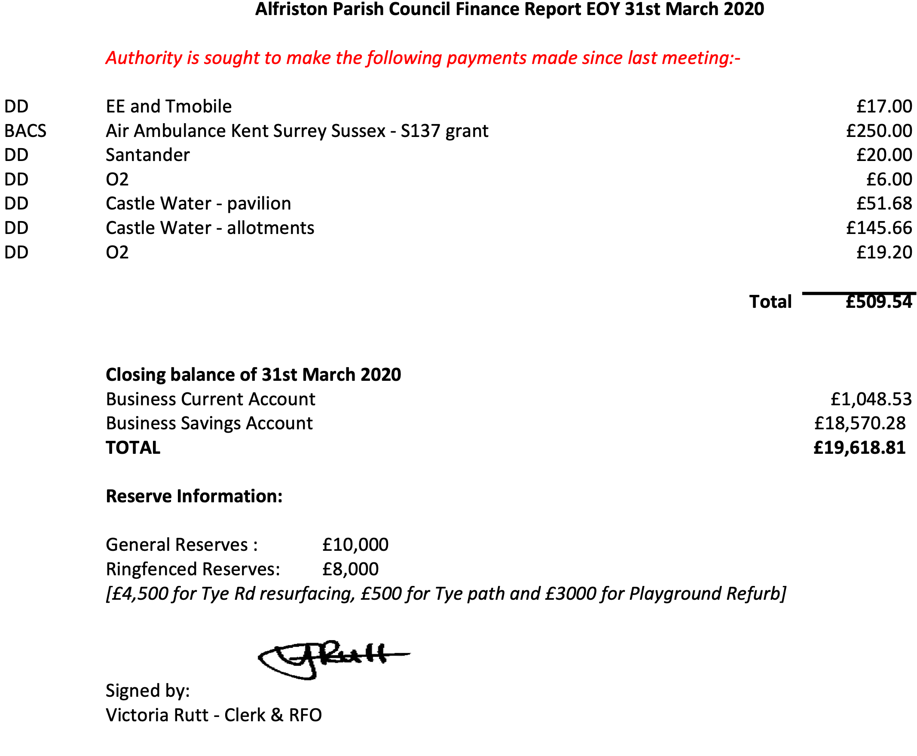

APPENDIX A -CONTINUED

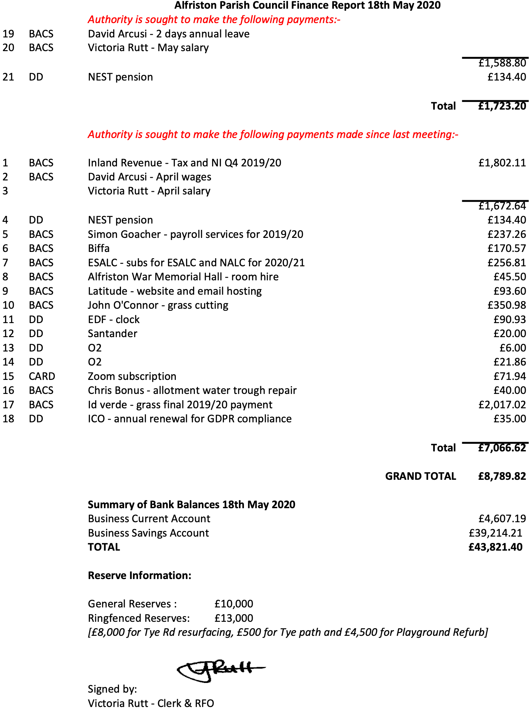

APPENDIX B

In no particular order - these are the responses from those traders who have replied so far.

Of course, everything is dependent upon Government restrictions and any future advice.

Styled to Pawfection - open for appointments only from Monday 18th May

Liquid Spirit Coffee Roasters on-line and available in the Village Store

Reformery Barbers - online shop opened this past weekend and are taking appointments from 4th July

Hand Spun Botanics - planning on opening at the beginning of June. Possibly limited to Thursday to Sunday. Continuing to operate online throughout.

Village Store - will continue to stay open with the current opening hours of 10am to 5pm for the foreseeable future, but hoping to go back to the normal summer opening hours some time in July.

Chestnuts Tea Rooms - hope to open 1st July, but continue meantime to offer take away services

Much Ado Books - are hoping to open in June but continue to offer a full service online and via social media.

Emmett and White - hoping to open in June

The Dressing Room - hoping to open in June

Diana Kelly Interiors - opening soon via appointment only.

The Apiary - plant shop opening this week in the garden – by appointment only, Gift and Clothes shop in June. The coffee room and tea garden won't be opening this season.

Badgers Tea House - awaiting further Government announcements and perhaps opening in July.

Shot Coffee House - continuing deliveries to the village and other areas, awaiting further details of when they can open again.

Cuckmere Busses are been busy getting appropriate measures in place – screens to protect drivers, sanitizer on buses, masks and gloves for drivers, wipes to clean surfaces, but have not yet found a way to help passengers with any shopping trolleys and expect to ask passengers to wear face coverings and to use contactless payment rather than cash when able to restart. "If we can do so soon, we will all be very pleased, but must respect the current restrictions to protect drivers and passengers alike.

