 | OUR REF:  DATE:  YOUR REF: | JS/TS05062020  5th June 2020
 | Ms Victoria Rutt  Clerk & RFO  Alfriston Parish Council  Sent via email to: clerk@alfristonparishcouncil.org.uk |  |  | Trevor Scott  Chief Executive

Dear Victoria

Thank you for your letter of 27th May and we are appreciative of your comments regarding the layout in the Dene car park.

We are aware of your disappointment over or decision to take over control of the Willows car park but are pleased that you are no longer pursuing any legal challenge to that decision. In our opinion, that would have been a significant waste of public funds.

Regarding the issue of charging in the Willows car park, as previously advised to you, we are planning on continuing the arrangements that were in place when your Parish Council operated the car park. Whilst noting the points you raise about the current Covid-19 situation, we did take a decision to temporarily suspend enforcement of any parking regulations in car parks whilst the lockdown was in place. As the country comes out of lockdown, we will gradually be reintroducing our car parking enforcement operations. Longer term, we can see no justification for the changes you are now proposing. In short, if charges were ok when the Parish Council ran the car park, we don’t think that should change simply by fact of Wealden running the car park.

In any event, as you will be aware, we have to pay not only for the maintenance and upkeep of the car park, but also the toilet facilities that are available within Alfriston Parish. Those present a financial burden on us, and any car parking income will help off-set those costs. As we are sure you will agree, those toilet facilities are of benefit to the village centre and support the visitor economy that is so important to the traders in the town.

In terms of help and support for businesses during the Covid-19 crisis, you may be aware that we have administered payments of over £36m to businesses in Wealden to support them during the current crisis and that this is in addition to the one year suspension of business rates payments that we organised for over 2200 businesses in the District. I’m sure you will agree that that this has been a vital package of support to help businesses in addition to any furlough support employers and employees may have received.

Yours sincerely

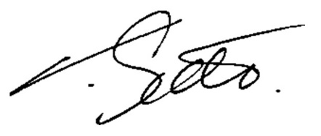

Trevor Scott
Chief Executive

c.c. Cllr Bob Standley
Cllr Michael Lunn
Tina Ford

