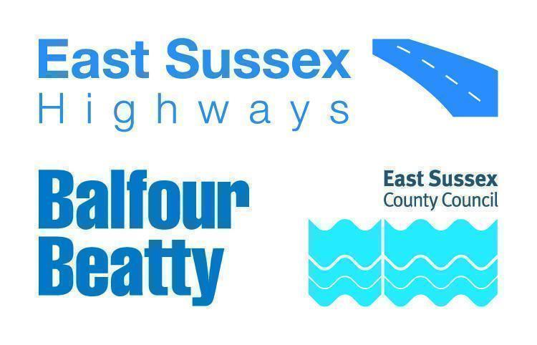

**IMPORTANT ROADWORKS INFORMATION 14 February 2023**

**High Street, Alfriston**

Dear Resident,

Balfour Beatty is working in partnership with East Sussex County Council to manage the highways service across East Sussex. As part of this, we will be carrying out targeted patch repairs in High Street, Alfriston.

Once completed, these works will help improve the condition of the road surface.

**When do they start?**

Work will be carried out between **Tuesday 5 March** and **Wednesday 6 March**. We will inform you of any changes to the dates or times via advanced warning signs on site.

**How will this impact highway users?**

The team will be working from Wingrove House to Shop No 27. The road will be closed to through traffic between 7pm and 7am.

The diversion route will be placed via Alfriston Rd, A27, A26, A259, Alfriston Rd, White Way, High Street and Vice Versa.

If you need vehicle access, please discuss this with the team on site to see if this is possible. Please bear in mind there will be delays whilst the area is made safe and your vehicle is escorted by site marshalls.

**Information for residents and businesses**

**Parking:** If required, we will put out ‘no parking’ signs and cones on the site to advise where parking is restricted. Please avoid parking in these locations as it will delay our works.

**Weather:** All of these works are subject to favourable weather conditions, for example heavy rain may affect the progress of the works.

Properties close to the carriageway may experience a temporary disturbance as this can be a noisy process and those properties may experience flashing lights and reversing sirens.

We would like to take this opportunity to apologise in advance for any inconvenience or disruption this work may cause, however this forms part of our continuing improvement for the East Sussex highway network.

For information on roadworks and journey planning, visit www.One.Network.com. Please follow us on X (formerly Twitter) @esccroads or Facebook @EastSussexHighways for updates. If you would like to know more about East Sussex Highways and what we do, please visit our website www.eastsussexhighways.com.

Thank you,

**East Sussex Highways**

**Report a problem here: Leave feedback on these works here:**

**

**Map of works area**

