ALFRISTON PARISH COUNCIL

AGENDA

CLERK TO THE COUNCIL Alfriston War Memorial Hall
Mrs Suzanna Dry - Clerk and RFO Old School House
Phone – 07936 904743 The Tye, Alfriston BN265TL

Email – clerk@alfristonparishcouncil.org.uk
Monday 11th March 2024

All members of the Parish Council are summoned to a meeting of Alfriston Parish Council to be held in the Alfriston War Memorial Hall on Monday 18th March 2024 at 19:15.

Please note that a digital sound recording is made of all meetings of Alfriston Parish Council including Public Questions sessions. The recording is not for publication and is only used to aid accurate minute taking.

S.C. Dry Mrs Suzanna Dry –Clerk and RFO to the Council

______________________________________________________________________________

176. Chairman’s Welcome
177. Public Questions

178. Apologies for absence

179. Update from Maria Caulfield MP (Appendix A)

180. Update from Cllr Stephen Shing – East Sussex County Council

181. Update from Cllr David Greaves - Wealden District Council

182. Declaration of interest

183. Minutes
To agree as a true record the minutes of the APC meeting held on 19th February 2024.

184. Finance
To approve the Statement of Finances: March 2024. (Appendix B).

185. Civility & Respect Pledge
Clerk’s report for Cllrs to discuss the dignity at work policy template and training required, as previously circulated. (Appendix C)

186. Annual Assembly - Monday 22nd April 2024
To decide on a speaker to be invited to the Annual Assembly on 22nd April 2024.

187. Wealden Draft Local Plan
To discuss and decide if Cllrs wish to attend one of the face to face consultation days. (Appendix D)

188. External Events on APC Land
To discuss and clarify APC’s legal and insurance obligations. Clerks report attached . (Appendix E).

189. APC Mobile Phone
To discuss & agree on Clerk’s report for upgrading APC mobile phone contract (Appendix F).

190. Update on Coffeehouse Conversations

191. To set a date for a Confidential Personnel Meeting
For Cllrs to discuss completion of the Clerk’s probationary period and review
hours.

192. Report on Highways & Twittens – Cllr Rabagliati
- Flooding

193 . Report on Allotments and Recreation ground – Cllr Daw
- D Day Celebrations – to discuss purchase of D Day Flag. (Appendix G)

194. Report on Public Transport – Cllr Harris (Appendix H)

195. Report on Rights of Way and Countryside – Cllr Harris (Appendix I)
- Update on Postponed Work by Water Management Alliance

196. Report on Strategic Planning – Cllr Spring (Appendix J)

197. Report on Tye– Cllr Parkinson (Appendix K)
- To discuss quotes received for the Tye Road Specification.

198. Report from Planning Committee – Cllr Watkins

198.1 Applications considered by APC Planning Committee since last meeting:

SDNP/23/05422/LIS Saddlers House, High St, Alfriston, BN26 5SZ. Internal alterations to
create staff accommodation, minor modifications to the previously approved rear terrace – creation of a new opening in the flint wall to the southern side of the terrace. (Revised proposal).
SNDP/23/05421/FUL As above.

198.2 Applications notified or awaiting decision on from SDNPA
APPROVED: None received.

IN PROGRESS:

SDNP/23/03986/FUL Kings Ride Farm, Kings Ride, Alfriston, BN26 5US. Awaiting decision of SDNPA committee meeting on 15th February.

SDNP/24/00084/TPO Trees west of Smugglers Close, Alfriston. To reduce back to 20/30% for good tree management. Pending Decision by SDNPA.

198.3 Enforcement updates

None received

199. Reports from Outside Bodies
199.1 Heartstart
199.2 Alfriston Emergency Group
199.3 Flood Forum
199.4 Neighbourhood Watch
199.5 Twinning Committee (Appendix L)
199.6 St Andrew’s Church
199.7 Clergy House
199.8 Cuckmere Buses
199.9 Alfriston War Memorial Hall
199.10 Speedwatch
199.11 Events

200. Correspondence – Asking for permission from the Council

CVHS Annual Flower & Produce Show 27/28th July – request for an A board at Market Cross
on 26th – 28th July.

201. Public Questions

202. Date of next meeting

The next meeting will be the Annual Assembly, followed by the Council Meeting on Monday 22nd April 2024 in the AWMH at 19:15.

APPENDICES ATTACHED BELOW

Appendix A – Update from Maria Caulfield MP

Update for Alfriston Parish Council

March 2024
Please accept my apologies that I am unable to join you at your upcoming meeting. I do however have the following updates for the parish.
Drop in Energy Price Cap
I am delighted to welcome Ofgem's announcement regarding a significant reduction in the energy price cap for the second quarter of 2024. This decision will bring about a 12.3% decrease compared to the previous quarter, effective from April 1 to June 30, 2024. For the average household using dual fuel and paying by direct debit, this means an annual savings of £238, equating to around £20 per month. This reduction signifies the lowest energy prices we've seen since the escalation of tensions due to Russia's invasion of Ukraine in February 2022, which significantly inflated wholesale energy costs. I attribute this positive development to the government's Energy Price Guarantee, which helped mitigate bill increases during that turbulent period. I am hopeful that this trend of declining energy prices will continue, aiming to return to historical averages.
Government Crackdown on Bonuses for Water Company Bosses
I am pleased to support the announcement that water bosses will be prohibited from receiving bonuses if their company has committed serious criminal breaches. This initiative, led by Ofwat, the water regulator, will undergo a consultation to determine the specific criteria for implementing such a ban, which may include instances like Category 1 or 2 pollution incidents or serious management failings. The ban, applicable to executive board members and Chief Executives, is expected to be enforced later this year pending consultation outcomes. If enacted, Ofwat will implement these measures by modifying the conditions of water company licenses, leveraging powers granted through the Environment Act 2021. Notably, last year, 10 water bosses received bonuses amounting to £2.5 million, highlighting the necessity of such regulatory measures. These actions align with the government's broader strategy to combat pollution, enhance water quality, and secure a sustainable water supply for the future. It is imperative that we hold water companies accountable for illegal behaviour, and I encourage everyone to participate in the consultation process when it commences.
NHS Dental Recovery Plan
I am thrilled to endorse the Government's NHS Dental Recovery Plan, a crucial component of its long-term strategy to enhance access to NHS dentistry and fulfill the Prime Minister's commitment to reducing waiting lists. With £200 million in new Government funding, this plan outlines a comprehensive set of initiatives aimed at providing an additional 2.5 million NHS dental appointments over the next year, strategically allocating them where they are most needed and expanding preventative care for younger children to combat tooth decay.
You can search for local dentists using the NHS Find a Dentist Website (Find a dentist - NHS (www.nhs.uk) or you can call 0300 123 1663 for more information. Dentists are required to update the NHS Website to say whether they are accepting NHS patients. All NHS Dental Services are open to anyone from any area and you can receive care in any practice able to offer you an appointment
Launch of Pharmacy First
I am thrilled to welcome the launch of the Pharmacy First service, which commenced today, January 31st. This innovative service empowers community pharmacists to provide comprehensive care for patients without necessitating a visit to their GP. Alongside expansions to pharmacy blood pressure checking and contraception services, this initiative is projected to save up to 10 million general practice team appointments annually, facilitating quicker and more convenient access to care, including the provision of appropriate medicines for minor illnesses. Joined by the Prime Minister at a pharmacy for the launch, I have been a longstanding advocate for the Pharmacy First model, championing it even during my tenure as Minister for Primary Care.

Highly trained pharmacists will now have the capacity to assess and treat patients for various conditions without the need for a GP appointment or prescription, including sinusitis, sore throat, earache, infected insect bite, impetigo, shingles, and uncomplicated
urinary tract infections in women under 65.

This launch signifies a significant step forward in enhancing access to healthcare, and I extend my gratitude to pharmacists nationwide for their invaluable contributions to our communities, providing essential advice and care.

Homes and Beds to help Hundreds of Rough Sleepers off the Streets
I welcome the news that a share of £220 million of government funding is being allocated to our local council today, aimed at preventing hundreds of families from facing homelessness and providing essential support to help rough sleepers transition off the streets. Minister for Housing and Homelessness, Felicity Buchan, unveiled this funding boost, targeting areas most in need and emphasising specialist support for the most vulnerable individuals requiring mental health or substance misuse assistance.
Lewes District Council is set to receive £232,214 in additional funding for 2024/25 with Wealden District Council receiving £403,670. Combined with the existing funding announced for the year it brings the total funding for homeless prevention in the districts to £774,194 and £969,890 respectively.
Update on Water Outage
I'm pleased to share that dredging operations for the Cuckmere are set to begin, aimed at reducing future flooding risks and preventing a recurrence of the water plant flooding incident.
Securing permits from the EA has been a lengthy four-year process, but I'm pleased to confirm that they are now in place, marking a significant milestone towards commencing the much-needed work.
I'd like to extend a special thank you to the Alfriston Emergency Group for their outstanding efforts in ensuring the distribution of bottled water to various villages, including Berwick and Selmeston. Their dedication and swift action have been invaluable in supporting our communities during this challenging time .

ENDS

Appendix B

Appendix C

ALFRISTON PARISH COUNCIL

Date: 5th March 2024
Title: Report on Civility & Respect Pledge
By: Suzanna Dry (Clerk & RFO)
Purpose: To discuss and agree on action required

The following matter is for discussion at the March Council Meeting, Agenda Item No: 185.
As per the council’s resolution at the February meeting, the Clerk has now signed up APC to the Civility & Respect Pledge. A copy of the certificate is shown below.

As part of the Pledge, APC need to have a Dignity at Work Policy. Please see below a template policy provided by NALC & SLCC for this purpose.

Putting in place a training programme is also part of the pledge. The initial training recommended and offered to Cllrs and Clerks through NALC, is an on line ‘Standards in Public Life’ course, costing £16.00 per person.

Recommendations:
APC agree to adopt the Dignity at Work Policy, as per the NALC & SLCC template.
APC agree to offer all Cllrs and the Clerk a place on the Standards in Public Life training course.

Dignity at Work Policy Template shown on next page.
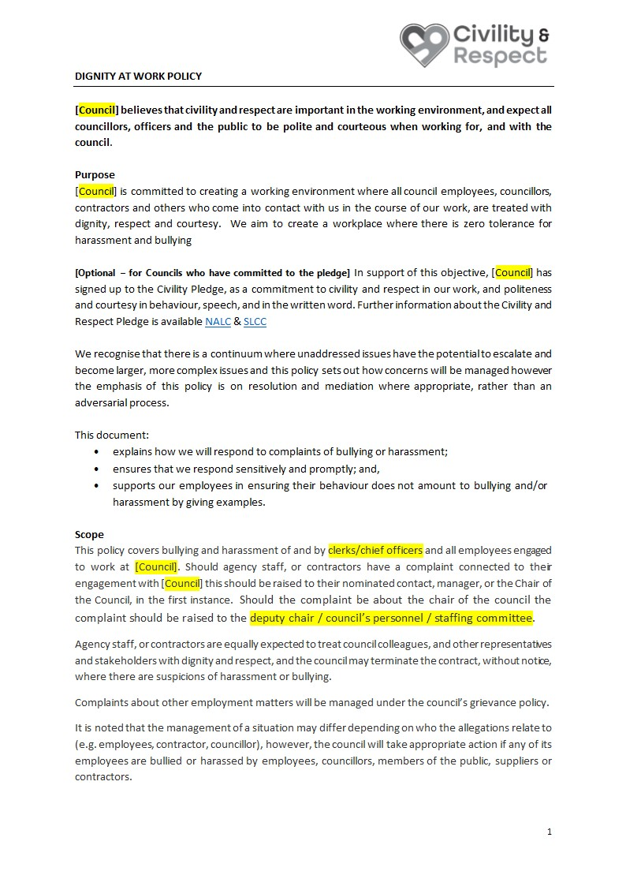

Appendix D

021/24 26 February 2024
Wealden Draft Local Plan consultation dates released

An eight-week public consultation will start in March 2024 regarding the recently agreed Wealden Draft Local Plan.
The Draft Local Plan Regulation 18 document was agreed at a Full Council meeting and will be consulted on alongside its supporting Sustainability Appraisal.
The consultation dates are now confirmed, meaning the consultation period will run from 5pm, Friday 15 March to 5pm, Friday 10 May 2024.
Alongside the face-to-face exhibitions, Wealden District Council will launch a virtual exhibition accessed via the council’s website so that residents who cannot or do not want to visit the face-to-face exhibitions can still partake in the consultation. Interested parties wishing to be notified when the consultation commences can register using the consultation portal at https://consult.wealden.gov.uk/kse

Councillor Ian Tysh, Alliance for Wealden (Green Party), and lead councillor for Planning and Environment, said, “It is important that everyone has their say on the Local Plan as it affects everyone living in Wealden. There is an online consultation which can be accessed by residents at the comfort of their own home, as well as face-to-face consultations which are spread across various venues in the district.
“I would like to encourage residents, businesses, and communities to give their views as this will help shape the final version of the Local Plan.”
The locations of the face-to-face consultations are confirmed below.
Venue | Address | Date | Time
Hailsham Civic Centre | Vicarage Lane, Hailsham, East Sussex BN27 2AX | Saturday 23rd March 2024 | 10.00AM - 16.00PM
Maresfield Village Hall | Bridge Road, Maresfield, East Sussex TN22 2HJ | Monday 25th March 2024 | 14.00PM - 20.00PM
Polegate Community Centre | 43 Windsor Way, Polegate, East Sussex BN26 6QF | Tuesday 26th March 2024 | 14.00PM - 20.00PM
Uckfield Civic Centre | Council Offices, Uckfield, East Sussex TN22 1AE | Saturday 13th April 2024 | 10.00AM - 16.00PM
Heathfield Community Centre | Sheepsetting Lane, Heathfield, East Sussex TN21 0XG | Wednesday 17th April 2024 | 14.00PM - 20.00PM
Crowborough Community Centre | Pine Grove, Crowborough, East Sussex TN6 1FE | Saturday 20th April 2024 | 10.00AM - 16.00PM
East Hoathly Village Hall | Church Marks Lane, East Hoathly, East Sussex BN8 6EQ | Monday 22nd April 2024 | 14.00PM - 20.00PM
Frant Memorial Hall | The Green, Frant, East Sussex TN3 9ED | Tuesday 23rd April 2024 | 14.00PM - 20.00PM
Horam Village Hall | Horam, East Sussex TN21 0JE | Saturday 4th May 2024 | 10.00AM - 16.00PM

For further information please contact: Nichola Watters, Head of Planning, Economy & Climate Change, Wealden District Council, Email Nichola.watters@wealden.gov.uk

Appendix E

ALFRISTON PARISH COUNCIL
Date: 11th March 2024
Report Subject: External Events – Insurance & Risk Assessments
By: Suzanna Dry, Clerk & RFO
The purpose of this report is to appraise councillors of the need for external event organisers to have public liability insurance and risk assessments in place, when using APC land for events. Also to look at ways of making these requirements easier for event organisers to comply with.

Background
APC regularly give permission for external events to be held on council land i.e on The Tye and Recreation Ground. It is a requirement of the Health & Safety Act 1974 and a mandatory requirement by our own insurers, that event organisers have suitable public liability insurance and carry out a risk assessment for all activities taking place.
APC have public liability insurance, which covers the council for any public event it arranges and carries out. When APC give permission for an external organisation to hold a public event on APC land, our insurance requires the external organisation to have their own public liability insurance. If this is not the case, then our own cover is invalidated.
Therefore when giving permission for external events, APC need to show due diligence in requesting copies of public liability insurance and risk assessments.
A Boards - The above also applies to erecting A boards on Market Cross. The event organiser needs to have public liability insurance to cover their A board and carry out a suitable risk assessment.

Making it as easy as possible for event organisers to comply with these requirements
APC have no choice but to ensure the above requirements are in place, at the same time we do not wish to deter organisers from putting on events.
To this end, the Clerk will provide organisers with a link to the HSE (Health & Safety Executive) website, where templates can be found for risk assessments. Also recommend that organisers look on the internet for examples of risk assessments for similar activities, to help pull together their own risk assessment.
All public events must have public liability insurance, Clerk to recommend that organisers contact their insurers to gain a copy of the policy. This should already be in place.
For any events where APC is the organiser, APC will carry out all risk assessments and be covered by our own public liability insurance.
A Boards - Cllr Parkinson has suggested APC consider purchasing their own A board and allow external organisers to use this A board. As this would be the council’s own A board on its own land, public liability insurance would be provided by APC as well as the risk assessment. It would require the organisers to collect and return the board and to carry out daily checks on the board, to ensure it has not fallen over or causing an obstruction (as per the risk assessment).

Recommendation
Council consider purchasing an A board and allow external organisers to use it, instead of their own A board. This would take away the need for external organisers to provide public liability insurance or carry out a risk assessment.

Appendix F

ALFRISTON PARISH COUNCIL
Date: 5th March 2024
Report Subject: Review of APC Mobile Telephone Contract
By: Suzanna Dry, Clerk & RFO

The purpose of this report is to appraise councillors of the changes required to the current APC mobile phone contract, the cost element, provide options and give the Clerks recommendation.

Background
The current APC mobile phone contract is on a ‘small business tariff’ with O2. The contract is for a two year period and is due for renewal in September 2024. With this contract there are unlimited calls and texts, and 1gb of data. The handset is owned by APC and the cost per month, if staying within the 1gb of data, is £11.73 (+vat) per month.

Analysis
The inclusive data is proving to be insufficient to use outlook on the mobile phone. Therefore the Clerk is unable to access or send e-mails when working away from the home office, without incurring extra charges. Looking back on O2 bills for the last 12 months these vary between £11.73 - £25.40 depending on the amount of data used in excess of the 1gb.

Options
Increase the data available on the current contract or terminate the contract and look at other providers. To this end, I have researched the costs for upgrading our current contract against the costs other providers can offer. Details for these options are shown in the table below.
Amount of Data | Current Provider O2 | EE | Sky
1gb | £11.73 + vat | £12.25 + vat | £12.50 + vat
6gb | £12.90 + vat | £13.75 + vat | £14.25+ vat
20gb | £18.76 + vat | £19.25 + vat | £21.25 + vat

Conclusion
Having looked at different levels of data i.e. 1gb, 6 gb and 20 gb, our current provider gives the cheapest offer for data within our existing contract.
Looking back over the last 12 months of phone bills, we have often used more than our allowed data of 1gb which has meant we have incurred extra charges, in some cases costing up to £25.00 per month. The most data we have used is 4gb.

Recommendation
That the council authorise the Clerk to upgrade the current contract to include 6gb of data at a cost of £12.90 + vat per month. This represents an increase of £1.17 per month. Amount of data required to be reviewed at the renewal of the contract in September 2024.

Appendix G

Report on Allotments and Recreation Ground – Cllr Daw

Playground

On Saturday 24th February at 7am, Chris I cut back the brambles, ivy and all overgrown vegetation. This has been put the other side of the play area until October when we will dispose of it, thank you David Lewis who with his chainsaw helped clear the saplings ready for the new fence to be erected between the Allotments and the playground. We were done by 10am when Anna Franklin (Friends of Alfriston Playground) and other families came to celebrate the 1st birthday of the playground with cakes and juice well done, also people came to help trim the bushes so thank you. Chris put the new no dogs allowed signs on both gates, I apologise to plot 4 on the allotments as we left cut branches and more, thank you for your help in clearing the mess.

On Monday I met with the man from Wickstead who was fixing the stepping logs I showed him several things which Anna and I had found, which have been fixed apart from a very large Beechnut tree which overhangs the castle. The nuts are falling on the matting and remain hard and sharp for quite some time, I will talk to Dan Larkin and seek his advice. My proposal going forward is:-
The first Saturday in March should be put in the diary for maintenance on the playground such as cutting back and maintenance of the hedges and fences, so as to avoid such hard work and hopefully more helpers.
The first Saturday in October to clear all debris from March’s work.
I will talk to Dan regarding the Beechnut Tree.

Allotments

Water has been turned on and regular readings of the water meter have shown no leak, I will continue to take readings. The renewal notices have gone out and possible new allotment holders have been notified, thank you Suzanna.

Recreation ground

Not a lot to report but the high winds bought down some Fir tree branches which have been reported.

Sylvia Daw

Appendix H

Public Transport

Little to report this month, though the flooding of course has obviously caused disruption to services.

I still have not received confirmation from ‘Connected Kerb’ that their EV charging points in Willows Car Park are safe in flood conditions – or indeed when they will be connected. I will continue to chase them.

Cuckmere Buses are still/always looking for volunteer drivers. I have mentioned this before in connection with the ‘Arts Bus’ service which is run by them. They will provide driver training, and the only requirement is to hold category D1 on your driving licence – most people do.

Appendix I

Rights of Way and Countryside.

I have not received any reports of problems with Rights of Way, and have only noticed once minor blockage myself – a fallen tree. This was reported on the East Sussex ‘Rights of Way’ website, and has been cleared.

Flooding is clearly still a major issue, and the dredging/desilting works which were due to be carried out in February by the Water Levels Management Alliance obviously could not be carried out. Unfortunately this means that the WLMA have had to apply to the Environment Agency for an extension to the dates during which the work can be carried out. Copy of e-mail below:

From: Revai Kinsella <Revai.Kinsella@wlma.org.uk>
Sent: Friday, February 23, 2024 4:49 PM
To: clerk@alfristonparishcouncil.org.uk; and various others
Subject: RE: Works on the Cuckmere River and Alfriston - Silt removal
Good afternoon all,
Unfortunately, due to the persistent wet weather, we have taken the decision to cancel the planned works for now.
We have started discussions with the Marine Management Organisation regarding the extension of our licence, which is expiring in September, and the potential change of the working window stipulated in our licence of between 1st February and 15th March.
We plan to start similar discussions with the Environment Agency in the coming weeks.
I will email you with an update once we have reached agreements with the two organisations and have a new date for the works on the river and embankments.
Kind regards
Revai Kinsella CEng MICE
Water Management Alliance

Replies were sent to this email from the Parish Councils affected by these works and the situation, including the following from your Chairman
Dear Revai,
Thank you for your e-mail dated 23rd February, advising that the Phase 2 works on the Cuckmere have had to be cancelled due to the current flooding.
As I am sure you will be aware this comes as a major disappointment to the community, particularly as there is no revised date scheduled for these works. It is imperative that Phase 2 is conducted before April, so that Phase 3 work can still go ahead this summer as planned. If this doesn't happen we will be in exactly the same position next winter with numerous floods cutting off the village.
Can you please convey our concern to the Environment Agency and Marine Management Organisation. We hope that letters of support from both ourselves and Cuckmere Valley Parish Council will help in getting the current licences extended, so that this vital work can be carried out.
Please let us know if there is any other way we can support the Water Management Alliance to this end, we look forward to hearing from you.
Kind regards
Diana Monteath-Wilson
Chair Alfriston Parish Council
No information has yet been received about a revised timetable for the works

Cllr Adrian Harris.
10/3/24

Appendix J

ALFRISTON PARISH COUNCIL JONATHAN SPRING
ORDINARY PARISH COUNCIL MEETING STRATEGIC PLANNING PORTFOLIO
18 MARCH 2024 REPORT APC/STRAT/2024/001

STRATEGIC PLANNING – COUNCIL PRIORITIES AND OBJECTIVES

- INTRODUCTION
1.1 This report sets out the current position on the Council’s Parish Plan and its priorities and objectives. The report is split into the following sections:
- Council Priorities.
- Portfolio Objectives.
- Recommendations.
- Suggested steps to the take initiative forward.

- COUNCIL PRIORITIES
2.1 The Council currently does not have a Parish Plan but would benefit from having one.
2.2 A Parish Plan is the document that sets out the Council’s priorities and objectives which is used to inform decision making and spending.

2.3 A plan can be either a detailed document, or a simple list of priorities and objectives.

2.4 My suggestion is:
- Due to time and resource constraints, we initially only produce a list of priorities and objectives.
- For practicality Council priorities should be limited to a maximum of five.
- Council Priorities should not be portfolio specific. Instead, they should be broader issues that affect our village as a whole, for example the impact of flooding.

3 PORTFOLIO PRIORITIES
3.1 Currently there are six portfolios plus the Chair with one Councillor assigned to each. At the monthly Council meetings each portfolio holder has the opportunity to provide a verbal or written update.
3.2 This approach does not allow for a clear oversight of what the Council is trying to achieve, and what it is working on.
3.3 My suggestion to address this is:
- Each portfolio should have up to five objectives that are being worked towards.
- The objectives should be specific to the portfolio description including business as usual.
- These should be written down and an update provided on each objective at Council meetings. This could be as simple as ‘no change’.

4 NEXT STEPS
4.1 The steps I would suggest to progress this are:

- Engage with residents and businesses (to include a coffee house session) to identify the top Council priorities.
- Councillors to draft key objectives for their own portfolios.
- Bring the priorities and objectives identified into one document (family tree style see appendix A).
- Share the priorities at the soonest Council Meeting for discussion.
- Ratify the priorities at the following Council Meeting.
- Publish the document on the website.
- Review and re-publish the document annually.

Jonathan Spring
Strategic Planning Portfolio
stragegicplanning@alfriston-parishcouncil.org.uk

APPENDIX A
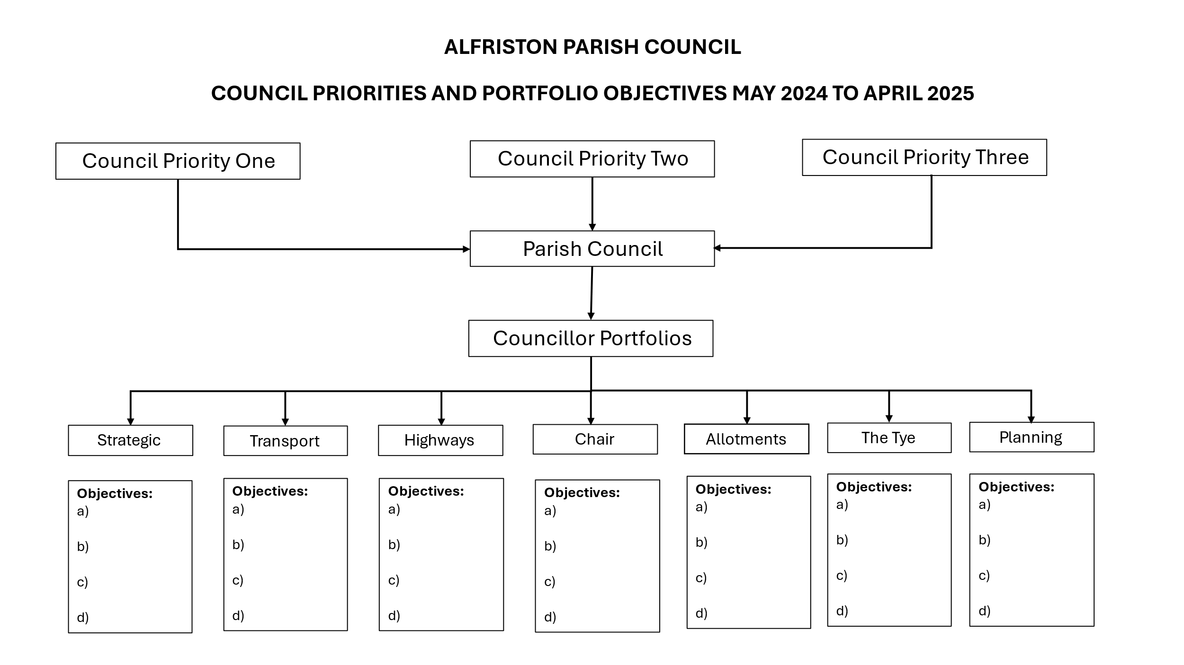

Appendix K - Report on The Tye : Gardening Update & Proposal – Cllr Parkinson

Introduction
- The Tye Team have met on several Saturdays, improving the look of our Tye in advance of the spring influx of visitors. We are grateful for everyone’s hard work.
- Several people in the team and at the Coffeehouse have suggested ideas for the Tye and this report summarises initial proposals for the coming weeks.
  - Wider developmental proposals will be considered by a volunteer group later, as discussed at the February APC meeting.
- Our overall approach to enhancing the Tye is to maintain it as a rural village green, rather than creating a more formal garden.

Orientation Map

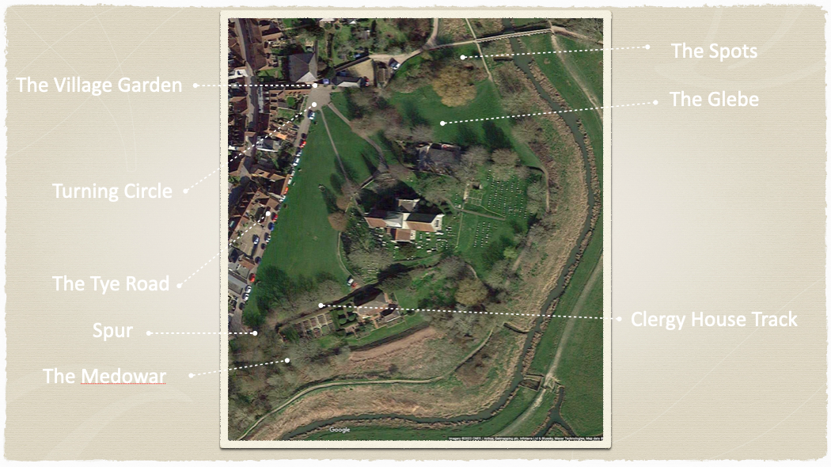

The Turning Circle Garden
- This could be renamed The Village Garden.
- It consists of three beds, which have been cleared. All now need preparing and populating with donated plants.
- We would be grateful for donations of hardy, low maintenance, bee and butterfly friendly plants. The following have been suggested:-
  - Grasses
    - Pennisetum alopecuroides “Purple Fountain”
    - Miscanthus Grosse Fountaine
  - Shrubs
    - Hypericum white berry
    - Euonymus Emerald n Gold
    - Brachyglottis - also known as Senecio
    - Pittosporum
    - Salvia Microphylla “Hot Lips”
    - Cistus Obtusifolius Thrive
    - Ceratostigma Plumbaginoides. “Hardy Plumbago”
    - Lavandula
    - Allium
    - Other
    - Lavender
    - Salvia
    - Echinops
    - Verbana

The Clergy House Track & Wall
- The road and wall have been cleared of dead leaves, and snowdrops will be transplanted “in the green” as previously agreed.
- Along the wall, we also hope to plant crocuses, and small colonising daffodils in the autumn.

The Grassland border with the Clergy House Track
- This area has been cleared of leaves and the brambles removed from around the hawthorn bush by the gate.
- We intend to retain the hawthorn for this year and see how it looks. The tree branch dangling into it needs to be removed (as part of an annual tree review with Dan Larkin).
- We propose to remove the stinking iris from under the tree near the churchyard.
- We propose to plant British bluebells under the trees and allow them to naturalise.
- A substantive and attractive bee & butterfly friendly border area could be formed by stopping grass cutting all the way to the road edge, instead asking the contractor to stop short of the trees.
  - This would allow grass to grow under the tree canopy, which could be supplemented in future by wildflowers.
  - The benches would be moved forward to the perimeter of the cut grass.
  - We would also need to maintain the border adjacent to the track.
  - As the grass grows, we should consider removing the concrete bollards along this perimeter. It is imperative that cars do not drive on the Tye, but there is an incline here, plus the gate at the end of the track. With the assistance of the Church and the NT, this could perhaps be locked using the same code as the chain across the corner of the Tye by the Wingrove.
  - These measures could be trialled over this season and reviewed.

The Medowar
- Initially we intend to maintain this as a wilderness. Nevertheless it requires some management if it is to thrive.
- We intend to remove brambles and dead material as previously agreed.
- We propose to ask the contractor to keep a strip strimmed between the Spur Road and the first tree line.
- We may then plant additional shrubs along this line to create a more defined boundary.
- We need to reseat the perimeter wooden posts which are all leaning.

The Tye Road
- We can discuss cutting the hedge/shrub along the Tye Road closer to the wall in the annual review with Dan Larkin. This would ease access along the road.

The Spots & The Glebe
- Retained as is, but with brambles and dead material removed as at the Medowar, if resources are available.

Recommendation:
- Councillors are asked to consider these proposals for approval at the March APC Meeting.
- And to approve the email circulation of the plants request list to villagers seeking donations for the Village Garden.

Appendix L
Reports from Outside Bodies:
  ALFRISTON NEIGHBOURHOOD WATCH
  View this email in your browser

The March 2024 edition of OUR NEWS is here

We are pleased to bring you the latest edition of our newsletter for Neighbourhood Watch supporters across England and Wales.
Here are some highlights in March's edition:
- ERA offers expert tips on home security when renovating - don't miss out on their Easter competition!
- You could be eligible to join the SP Energy Network's Priority Services register
- The Rt Hon Chris Philp MP reflects on the Government's recent ASB Action Plan
READ THE MARCH NEWSLETTER HERE.
Don't forget...
You can now register for our March series of crime prevention webinars - click HERE.
- NEW Crime prevention booklets are available to buy in the Neighbourhood Watch shop - click HERE.
We hope you enjoy this edition - please share it far and wide with your comunities

Nick Cattell - Coordinator

Appendix M

Alfriston and Cuckmere Valley Twinning Association

We have been delighted to welcome several new members to recent events, and they are looking forward to meeting our French friends in June. New members are always welcome, and there is no need to speak French, or to have a huge house- just come along and say hello! We have members in a wide area of the Cuckmere Valley, Alfriston and Seaford, so do get in touch if you would like to join us.

Our next events are:

AGM on Sunday 24th March, in the Old Chapel Centre between 4:30 and 6:00 pm

And the popular:
Big Fat Quiz
Friday 26th April 2024
6:30 pm onwards
The Old Chapel Centre, Alfriston.
£1 per person entry, and Non-members welcome.
RAFFLE
Bring your own snacks and soft drinks
Beer & wine available

We are also very pleased so many of our Veules-les-Roses friends are visiting this June. There's no requirement to be a host, but it is fun and rewarding for those of our members who are able to look after one or two French visitors for a weekend, and helps us return the amazing hospitality they give us. Do get in touch if you are interested!

Wendy Little e-mail: frogfirle@outlook.com



Appendix N
News from the Clergy House

The flooding, as for everyone, has been relentless and taken its toll on the garden, garden sheds and garden equipment here these last few months. At times the height of the water in the gardens was very worrying to say the least but spring has definitely sprung with lots of beautiful bulbs now in full flower and the garden team have worked so hard the gardens really are looking rather lovely.
Lots of work taking place in the house over the last few weeks getting it ready for the start of our season. We open on 29th March again like last year our open days are Fridays and Saturdays (10.30 to 4.30 last admission 4pm) up until the end of October. We haven't the staff resources to open more than that at the moment however we are going to be holding many special events on Thursdays throughout the year.
Some events in April include:
From Small Acorns….. To start our schedule of small exhibitions this year we look at the events running up to the purchase of the property and the challenges faced immediately afterwards. Copies of handwritten letters and other documents showing that it was not always plain sailing!
Harriets Chicken Trail and life in the 1800s – a fun family trail helping to find Harriets Chickens and learning some interesting facts about what life was like in the 1800s when Harriet Coates lived at the Clergy House.
Garden Tours – focussing on celebrating all things blossom.
Many thanks, Holly Jones, Site Manager
National Trust nationaltrust.org.uk
Alfriston Clergy House
01323 871961

