ALFRISTON PARISH COUNCIL

AGENDA

**CLERK TO THE COUNCIL** Alfriston War Memorial Hall

Mrs Suzanna Dry - Clerk and RFO Old School House

Phone – 07936 904743 The Tye, Alfriston BN265TL

Email – clerk@alfristonparishcouncil.org.uk

Wednesday 3rd April 2024

All members of the Parish Council are summoned to a meeting of Alfriston Parish Council to be held in the Alfriston War Memorial Hall on **Monday 22nd April 2024. This meeting will follow the Annual Parish Assembly which commences at 19.15hrs.**

*Please note that a digital sound recording is made of all meetings of Alfriston Parish Council including Public Questions sessions. The recording is not for publication and is only used to aid accurate minute taking.*

S.C. Dry Mrs Suzanna Dry –Clerk and RFO to the Council

______________________________________________________________________________

**203. Chairman’s Welcome**

**204. Public Questions**

**205. Apologies for absence**

**206. Update from Maria Caulfield MP** (Appendix A)

**207. Update from Cllr Stephen Shing – East Sussex County Council**

**208. Update from Cllr David Greaves - Wealden District Council**

**209. Declaration of interest**

**210. Minutes**

To agree as a true record the minutes of the APC meetings held on Monday 18th March 2024 and Monday 25th March 2024.

**211. Finance**

211.1 To approve the Statement of Finances for the End of Year 2024 (Appendix B)

211.2 To confirm sight and approval of Q4 2023/24 audit paperwork (Appendix C)

211.3 To approve the Statement of Finances for April 2024 (Appendix D)

**212. Update on Coffeehouse Conversations**

**213. South Downs National Park Authority Nominations**

To discuss and agree APC’s nomination for SDNPA Board member. (Appendix E )

**214. Report by Cllr Parkinson on APC Structure for 2024/25**

To review and discuss Cllr Parkinson’s report (Appendix F)

**215. Update on APC A board**

**216. Report on Highways & Twittens – Cllr Rabagliati**

**217. Report on Allotments and Recreation ground – Cllr Daw**

* Update on D Day Celebrations

**218. Report on Public Transport – Cllr Harris**

**219. Report on Rights of Way and Countryside – Cllr Harris**

**220. Report on Strategic Planning – Cllr Spring**

**221. Report on Tye– Cllr Parkinson**

**222. Report from Planning Committee – Cllr Watkins**

222.1 Applications considered by APC Planning Committee since last meeting:

**APPROVED**:

**SDNP/23/05421/FUL** – Saddlers House, High St, Alfriston, BN26 5SZ.

Internal alterations to create staff accommodation, new opening in flint wall.

**SDNP/23/03581/FUL** – Rathfinny Farm, The Flint Barns, Whiteway, Alfriston, BN26 5TU

Retrospective application for area of hardstanding, erection of a marquee on an annual basis between

Apr & Nov. until 2025.

**IN PROGRESS**:

222.2 Enforcement updates

**223. Reports from Outside Bodies**

223.1 Heartstart

223.2 Alfriston Emergency Group

223.3 Flood Forum

223.4 Neighbourhood Watch

223.5 Twinning Committee

223.6 St Andrew’s Church

223.7 Clergy House

223.8 Cuckmere Buses

223.9 Alfriston War Memorial Hall

223.10 Speedwatch

223.11 Events

**224. Correspondence – Asking for permission from the Council**

**225. Public Questions**

**226. Date of next meeting**

The next meeting will be the Annual Meeting held on Monday 20th May 2024 in the AWMH at 19:15.

**APPENDICES ATTACHED BELOW**

**Appendix A**

Update for Alfriston Parish Council

April 2024

Please accept my apologies that I am unable to join you at your upcoming meeting. I do however have the following updates for the parish.

Chancellor’s Spring Budget Update

I am delighted to commend the Chancellor's spring budget, which brings about significant tax cuts benefiting working families across our constituency. With the main rate of employee National Insurance Contributions (NICs) reduced from ten percent to eight percent, over 27 million working individuals will experience a boost in their pay packets, amounting to an average tax cut exceeding £900 for those earning £35,400 annually. This reduction marks the lowest effective personal tax rate since 1975, underscoring the government's commitment to supporting hardworking people.

Additionally, changes to the high-income Child Benefit Charge, including raising the threshold and halving the rate of Child Benefit withdrawal, will provide significant relief for families, with some parents set to benefit by an average of £1,260. These measures, coupled with the extension of fuel and alcohol duty freezes, demonstrate the government's dedication to easing financial burdens on families and fostering economic growth.

£6.9m for SEND Funding in East Sussex

I am pleased to announce that East Sussex County Council will benefit from a substantial funding injection of £6,696,429 aimed at supporting children with special educational needs and disabilities (SEND) as well as those in alternative provision (AP). This funding, part of the Government's broader commitment to invest a record annual sum of £850 million in councils, underscores the Government’s dedication to providing high-quality education tailored to the needs of every child. With the aim of creating new places for young people with SEND and AP in mainstream and special schools, this initiative seeks to offer specialised support for children facing various challenges such as autism, learning difficulties, and mobility issues.

Supporting the Ban on the Import of Hunting Trophies

I have stood in support of a crucial bill in Parliament aimed at banning the import of hunting trophies from approximately 6,000 species, including majestic creatures like lions, elephants, rhinos, and polar bears. This legislative effort builds upon the groundbreaking Ivory Act, which has been in effect since 2022, significantly limiting the trade and import of elephant ivory in the UK. The devastating impact of trophy hunting on endangered species, as highlighted by research from Oxford University, underscores the urgency of this measure, particularly evidenced by the alarming decline in African lion populations. I am proud to have contributed to this effort.

Halting HMRC Plans to Close the Phone Lines over Summer

I would like to express my appreciation for Chancellor Jeremy Hunt's decision to intervene and suspend HMRC's plans to close their phone lines over the summer. HMRC's initial proposal to suspend phone services for six months, from April to September, raised concerns among taxpayers who rely on telephone assistance for their tax-related queries. I have been contacted by many concerned residents about issues they are having getting through to HMRC on the phone. We must see an improvement in the service so that residents can quickly and easily resolve any issues.

Expansion of the Boiler Upgrade Scheme

I would like to take the opportunity to praise the government's decision to modify the Boiler Upgrade Scheme, facilitating support for properties off the gas grid. The scheme now offers grants of up to £7,500 for households seeking to transition to air source or ground source heat pumps. Notably, the government has eased the requirement for properties to have no outstanding Energy Performance Certificate recommendations for loft and cavity wall insulation, potentially saving households £2,500 in costs. Recognising the suitability of ground source heat pumps for rural properties, the government plans to increase the capacity limit for shared ground loops from 45kW to 300kW, aiming to distribute the infrastructure costs more evenly. Moreover, the government will introduce flexibility into regulations to potentially adjust grant levels for off-grid properties in the future, while maintaining simplicity.

Funding Boost for Schools across the Constituency

I welcome the announcement of a £2.2 million increase in funding for schools within the Lewes Constituency for the 2024-25 academic year compared to the previous year. This increase is part of the total school revenue funding in England, which amounts to £59.6 billion for the same period, resulting in the highest ever real-terms per pupil funding. The boost translates to approximately £35,000 extra for a typical primary school with 200 pupils and around £200,000 additional funding for a typical secondary school with 900 pupils. Notably, schools have the autonomy to allocate the additional funding as they see fit, whether on staffing, classroom materials, or other operational expenses.

ENDS

Appendix B





Appendix C

|  |  |  |  |  |  |  |  |
| --- | --- | --- | --- | --- | --- | --- | --- |
| Alfriston Parish Council Quarterly Bank Reconciliation **QTR 4** | | | | | |  |  |
|  |  |  |  |  |  |  |  |
| Financial year ending 31st March 2024 | | | |  |  |  |  |
|  |  |  |  |  |  |  |  |
| Prepared by Suzanna Dry, Clerk and R.F.O | | | | |  |  |  |
|  |  |  |  |  |  |  |  |
|  |  |  |  |  |  |  |  |
| Balance per bank statements as at 31st March 2024 | | | | |  | £ |  |
| Santander Savings Account number 53120866 | | | | |  | 39,693.37 |  |
| Santander Current account number 53120183 | | | | |  | 3,472.88 |  |
| Net balances as at 31st March 2024 | | | |  |  | **43,166.25** |  |
|  |  |  |  |  |  |  |  |
| The net balances reconcile to the Cash Book for the the year : | | | | | |  |  |
|  |  |  |  |  |  |  |  |
| Cash Book (Ledger) | |  |  |  |  |  |  |
|  |  |  |  |  |  |  |  |
| Opening Balance 31st December 2023 Savings | | | | |  | 54,199.59 |  |
| Opening Balance 31st December 2023 Current | | | | |  | 2,241.94 |  |
| Add: Receipts in the quarter + VAT | | | |  |  | 1,254.78 |  |
| Less: Payments in the quarter + VAT | | | |  |  | 14,530.06 |  |
|  |  |  |  |  |  |  |  |
| Closing balance per cash book as at 31st March 2024 | | | | | | **43,166.25** |  |
|  |  |  |  |  |  |  |  |
|  |  |  |  |  |  |  |  |
| Checked and signed by Cllr ……………………………………………………………………………… | | | | | | | |
|  |  |  |  |  |  |  |  |
| On date |  | ………………………………… | | |  |  |  |
|  |  |  |  |  |  |  |  |

APPENDIX D



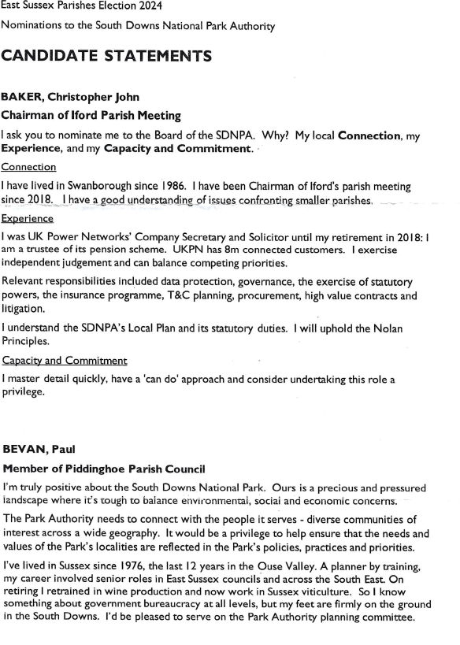

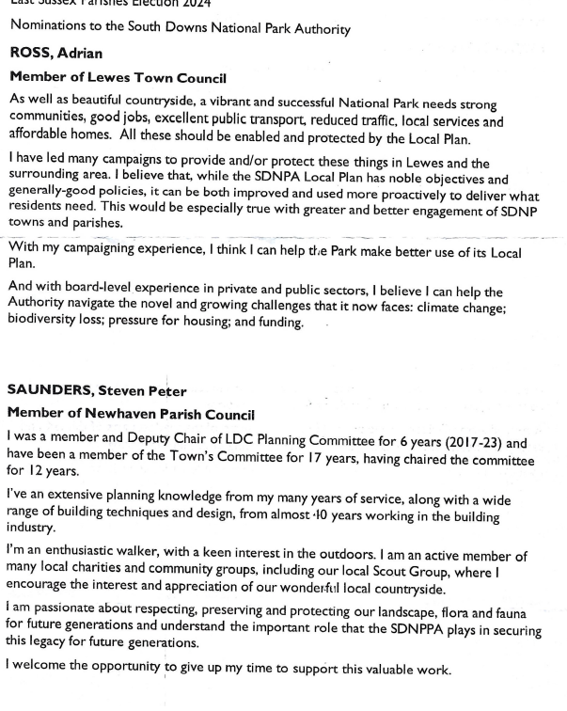

**APPENDIX F – CLLR PARKINSONS REPORT ON APC STRUCTURES**

# Alfriston Parish Council

## APC Structures 2024/25 – Ideas for Discussion

## March/April 2024.

## Neil Parkinson

Introduction

* This is a list of ideas *for discussion*.
* I didn’t want us to get to April’s annual meeting and hurriedly repeat current structures. Circulating these ideas in March gives time for reflection.
* I realise and apologise that I’m commenting on others’ portfolios and committees. To be clear, these suggestions are “In My Humble Opinion”, based on best practice gleaned from the NALC/eSALC training courses, and my views on Council/village priorities and workloads - not on any current postholders or committee members.
* Others will have their own suggestions.
* So…

Create a Personnel Subcommittee

* (I can’t see any reference to an existing Personnel group on the APC website.)
* A group of, say 3, councillors to:-
  + Manage the employment of the Clerk
    - This would benefit both the Clerk and the Chair by making this one to one relationship less central if issues arise
  + Ensure that APC is fulfilling the formal requirements of the Civility and Respect undertaking
* The group wouldn’t need to meet unless there is an issue and could essentially just be a formalisation of the team that carried out the recent clerk recruitment.

Enhance the Finance Subcommittee

* It seems odd that this currently only meets (basically) annually to “enquire why any changes… to the budget have been made” by the Clerk and RFO once they have done the legwork(!).
* The Subcommittee should be more proactive in drafting the budget, especially now that the Clerk/RFO has fewer hours, whilst still utilising their expertise
* A rolling 3 year business plan should be created based on APC developmental priorities and portfolio holder’s aspirations for each area, using the process outlined by NALC (see the Strategy comments below).
* The subcommittee should also
  + Maintain a Contracts List of values, terms and expiry dates, alongside the Clerk/RFO, so that reviews can be diarised.
  + Review quarterly YTD spend v budget reports from the Clerk/RFO and discuss any issues, to catch overspends quickly.

Rename Transport and Rights of Way / Countryside to Transport and Environment

* to more overtly incorporate Flooding & Climate Change, both important issues for villagers.

Strategic Planning Prioritisation

* Pragmatically, I feel that creating a 3 year plan (using the process outlined by NALC, to be costed alongside the finance group) is more important than a longer term Parish Plan. It would:
  + Have more immediate utility (including justifying any funding applications) and
  + Take less resource to produce.
* So, initially focus on creating this 3 year plan
* Since the plan would include desired capital projects, it would inform what level of resource (if any) is subsequently needed for grant funding applications and reporting on any approved projects
  + The SP portfolio might be able to provide this core resource, but even so individual portfolio holders would need to provide supporting justifications and costings
* The prioritisation of any grant funding activity would need to be reviewed against the resourcing of a longer term Parish Plan.

Agenda Wording Changes

* Chairman’s Welcome becomes Chair’s Welcome
* Public Questions becomes Public Participation
  + Many people want to comment on an issue or make a point, not ask a question
  + “Participation” sounds more inclusive.