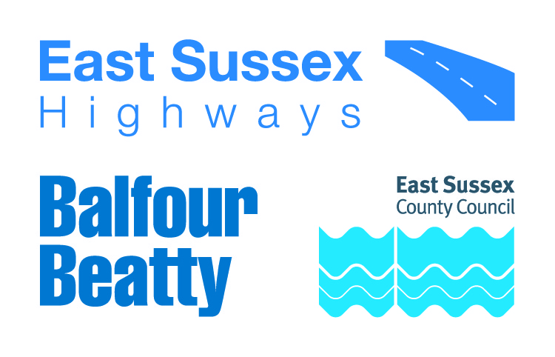

**IMPORTANT ROADWORKS INFORMATION** 25 October 2024

**Alfriston Road, Alfriston**

Dear Resident / Business owner,

Balfour Beatty is working in partnership with East Sussex County Council to manage the highways service across East Sussex. As part of this, we will be carrying out vegetation works on Alfriston Road, Alfriston.

**When do they start?**

These works will be carried out from **Friday 15 November 2024** to **Friday 22 November 2024** between9:30am and 3:30pm.

We will inform you of any changes to the dates or times via advanced warning signs on site.

**What does the work involve?**

This works involve clearing overgrown vegetation to return the footway to its original width.

**How will this impact highway users?**

The team will be working in phases between Drusillas Park and Winton Street.

The road will remain open with temporary traffic lights in place for the duration of the works.

**Information for residents and businesses**

**Parking:** We will put out ‘no parking’ signs and cones on the site to advise where parking is restricted. Please avoid parking in these locations as it will delay our works.

**Weather:** All of these works are subject to favourable weather conditions, for example heavy rain may affect the progress of the works.

Properties close to the carriageway may experience a temporary disturbance as this can be a noisy process and those properties may experience flashing lights and reversing sirens.

We would like to take this opportunity to apologise in advance for any inconvenience or disruption this work may cause, however this forms part of our continuing improvement for the East Sussex highway network. Should you have any queries regarding these works, please contact us on eshcomms@balfourbeatty.com.

For information on roadworks and journey planning, visit www.[One.Network](https://one.network/).com. Please follow us on X (formerly Twitter) [@esccroads](https://twitter.com/esccroads) or Facebook [@EastSussexHighways](https://www.facebook.com/EastSussexHighways/) for updates. If you would like to know more about East Sussex Highways and what we do, please visit our website www.eastsussexhighways.com.

Thank you,

**East Sussex Highways**

**Report a problem here: Leave feedback on these works here:**

**Map of works area**

CC