CityFibre Rollout in Alfriston
Description: ‘Excavation & installation of new fibre optic cable & duct with any required road crossings for Fibre To The Home project. This includes any required laterals, boxes, chambers and cabinets.’
The table below maps the upcoming road closures and diversions for the works being carried out:
Road / Location | Date | Closure in force' | Type
The Tye | 15th Oct - 18th Oct | All the time | Road Closure
Lullington Road | 17th Oct - 24th Oct | All the time | Road Closure / Diversion
Whiteway | 27th Oct - 2nd Nov | All the time | Road Closure / Diversion
River Lane | 29th Oct - 1st Nov | All the time | Road Closure
The Street | 3rd Nov - 10th Nov | All the time | Diversion
Chapel Hill | 3rd Nov - 10th Nov | All the time | Road Closure
Milton Street | 11th Nov - 19th Nov | All the time | Diversion
Lullington Road | 11th Nov - 19th Nov | All the time | Road Closure
North Street | 1sst Dec – 9th Dec | All the time | Diversion
Waterloo Square | 23rd Nov - 26th Nov | All the time | Road Closure
High Street | 26th Nov - 1st Dec | All the time | Road Closure
River Lane | 29th Oct - 1st Nov | All the time | Diversion
Lullington Road | 2nd Dec - 9th Dec | All the time | Diversion
Waterloo Square | 2nd Dec - 9th Dec | All the time | Road Closure

NB: Emergency access will be maintained at all times.
Please note that there is one additional closure / diversion on the Lullington Road this month on 25th October for the Beachy Head Marathon (therefore unrelated to CityFibre). This will be in place from 7am until 3pm.

Map of works
The map below is taken from the OneCauseway platform, where all upcoming roadworks are listed by ESCC Highways once permits have been granted by the Network Management Department. Members of the public can sign up to the platform free of charge using the following link:
https://one.network/public
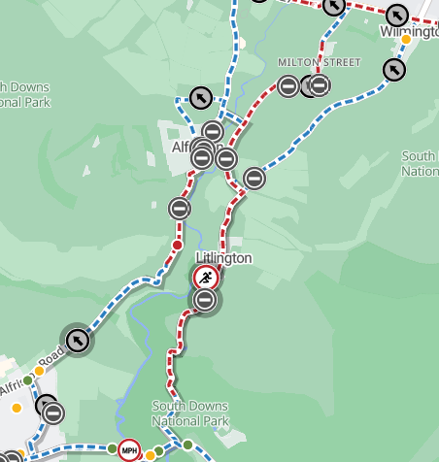
Blue lines and Circled Arrows = Diversions
Red lines and ‘Stop’ signs = Road closure / Roadworks
Running man = Beachy Head Marathon

