ALFRISTON PARISH COUNCIL

CLERK TO THE COUNCIL Alfriston War Memorial Hall,

Mrs Suzanna Dry Old School House, The Tye,

Alfriston,East Sussex, BN26 5TL

Telephone – 07936 904 743

Email – clerk@alfristonparishcouncil.org.uk Tuesday 11th November 2025

All members of the Parish Council are summoned to a meeting of Alfriston Parish Council to be held in the Alfriston War Memorial Hall on Monday 20th October 2025 at 7.15pm.

Please note that a digital sound recording is made of all meetings of Alfriston Parish Council including Public Questions sessions. The recording is not for publication and used only to aid accurate minute taking.

S.C. Dry

Mrs Suzanna Dry CiLCA – Clerk & RFO_______________________________________________

AGENDA

183. Chair’s Welcome
184. Public Questions

185. Apologies for absence

186. Update from MP.

187. Update from Cllr Stephen Shing – East Sussex County Council

188. Update from Cllr David Greaves - Wealden District Council

189. Declaration of interest

190. Minutes
To agree as a true record the minutes of the APC October meeting held on 20th October 2025.

191. Finance
To approve the Statement of Finances for November 2025. (Appendix A)

192. Coffeehouse Conversation - Sat 22nd November 2025.
Update on arrangements – Cllrs Parkinson & Harris

193. Monthly Report from PCSO

194. Internal Interim Audit
To review and approve the Internal Interim Audit Report 2025/26. (Appendix B).

195. Urban Grass Cutting Service 2026/27
To decide on the level of urban grass cutting carried out by ESCC in 2026/27. (Appendix C).

196. New Lease Agreement for Allotments
To review and agree amended lease agreement for Allotment holders to include deposit, effective
January 2026.

197. To Ratify decision on APC Christmas Tree
To ratify decision made by APC to agree to Alfriston Businesses sponsoring the Christmas Tree this year.
And for APC to apply for and pay for the temporary licence required from ESCC Highways.

198. Report on Highways & Twittens – Cllr Embry
Update on Cityfibre works.

199. Report on Allotments & Recreation Ground – Cllr Rabagliati

200. Report on Public Transport & Environment – Cllr Harris

201. Report on Strategic Planning – Cllr Parkinson .
Feedback received from ESCC on Emergency Plan.

202. Report on Tye – Cllr Spring.

203. Reports from Outside Bodies
203.1 Heartstart
203.2 Alfriston Emergency Group
203.3 Flood Forum
203.4 Neighbourhood Watch
203.5 Twinning Committee
203.6 St Andrew’s Church
203.7 Clergy House
203.8 Alfriston War Memorial Hall
203.9 Speedwatch
203.10 Events

204. Correspondence to The Clerk – Asking for permission from the Council.
Christmas Crafts & Fayre on Saturday 13th December in the OCC. Request for A Board Poster to be up for
Two weeks, from 29th Nov to -13th Dec. (Appendix D ).
Rude Mechanical Theatre – request for permission to perform on The Tye on Sunday 26th July 2026.
(Appendix D ).
UK Ultra South Downs Run - Saturday 6th December - advising that the run will go through Alfriston.
Organisers have confirmed noise will be kept to a minimum and Marshall’s will be made aware that
runners do not have priority over pedestrians.

205. Public Questions

206. Date of next meeting – to be held on Monday 19th January 2026 in AWMH 7.15pm.

Please see Appendices attached below and\or on the website.

APPENDIX A - November Finance Report

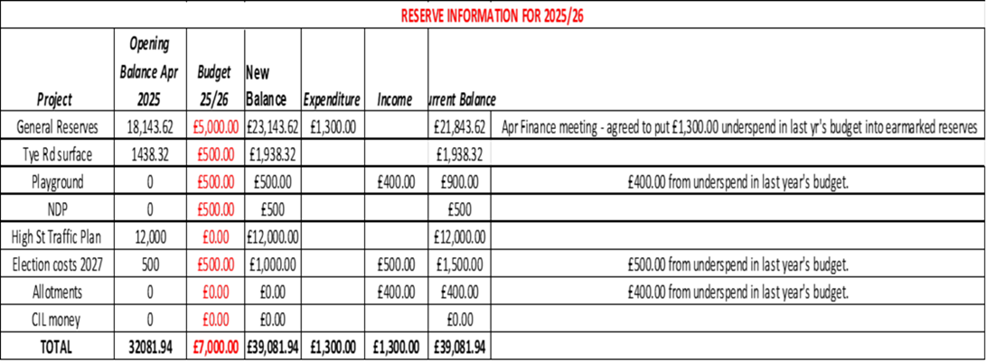

APPENDIX B - Internal Interim Audit Oct 2025

This document was too large to download and can therefore be found as a separate document - Appendix B on the APC Website.

APPENDIX C - Urban Grass Cutting Service for 2026/27

APPENDIX D - Requests for Permission from APC

From: Gayle Hudsohn Sent: 28 October 2025 12:38
To: Alfriston Parish Council <clerk@alfristonparishcouncil.org.uk> Subject: Notice board in square
Hi Suzanna
Could we have permission to display this 2 weeks in advance in Market Square? So 29th November?
Thanks, Gayle


From: Rowan Talbot Sent: 20 October 2025 09:37
To: clerk@alfristonparishcouncil.org.uk
Subject: The Rude Mechanical Theatre Company - Summer 2026

Dear Suzanna

I hope you are very well.

As always we loved performing in Alfriston last summer and we hope to be able to do so again next summer. Would it be possible to request permission from the Parish Council to perform on The Tye again on Sunday 26th July? We have provisionally booked the village hall and the date has been pencilled in with them.

I have attached a copy of our risk assessment and will be able to provide a copy of our PLI when it renews in February.

Thanks for your help and very best wishes
Rowan Talbot
Morning Suzanna.

Hope all is well.

I just wanted to get in touch to make you aware of my annual running event that takes place on the South downs. The date this year is December 6th and runners will briefly pass through Alfriston along the South Downs Way on their way towards Eastbourne.

I will again make sure that noise is kept right down at all times and that Marshalls are made aware that runners do not have priority of pedestrians in regards to the points you made for this event last year.

Its a fairly small event of 250 runners who will all be extremely spread out by th etime they reach Alfriston.

I have again booked in at the Chapel for use as an Aid Station.

Best Wishes
Neil



Neil Kirby
Managing Director, UK Ultra Ltd.

