APC FINANCE MINUTES JAN 2026 – APPENDICES (part 3)
Savings Account

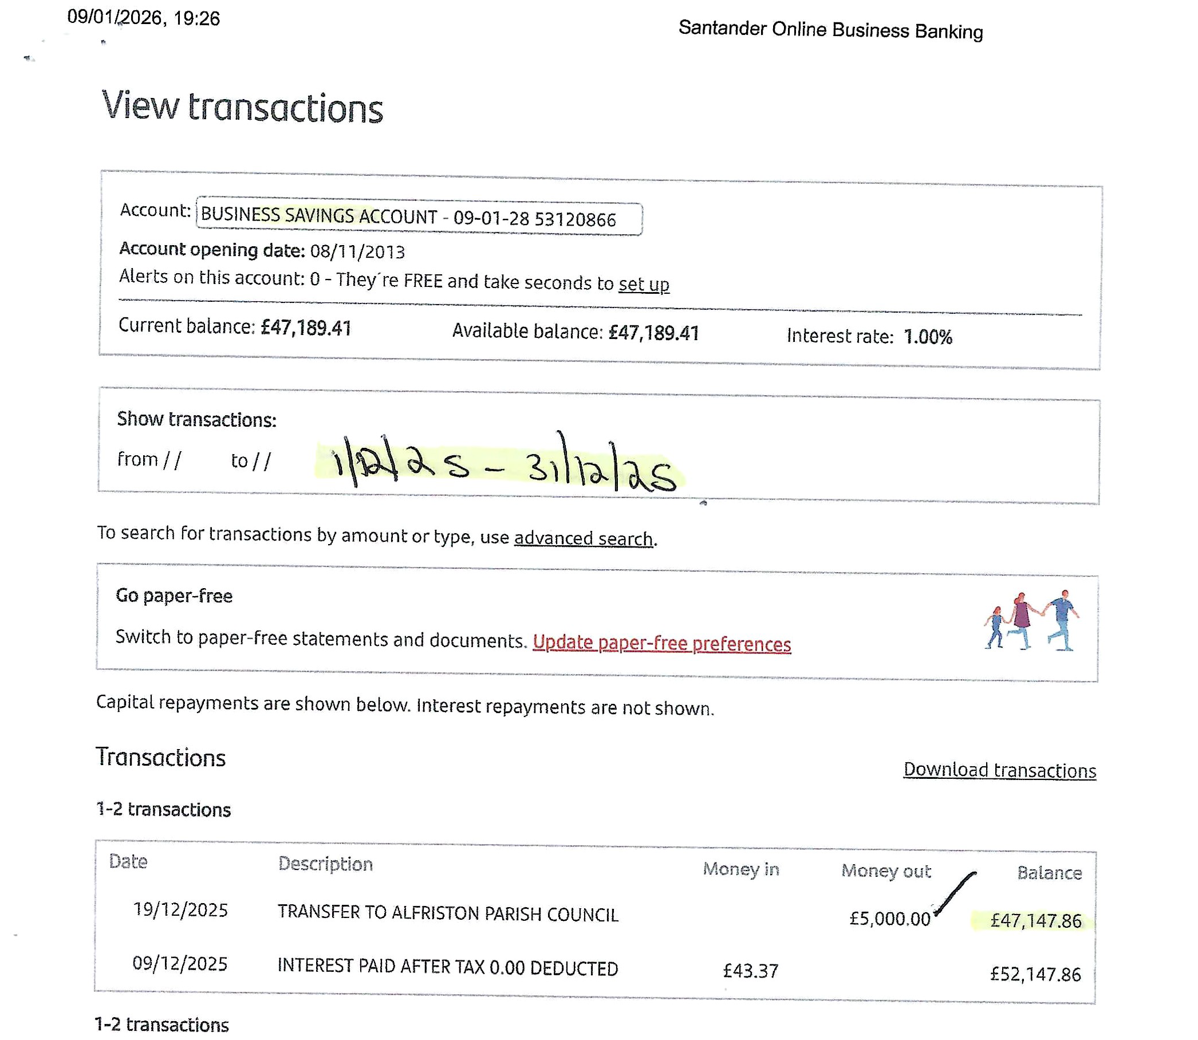

Appendix B – Qtr 3 VAT Return

