ALFRISTON PARISH COUNCIL

CLERK TO THE COUNCIL Alfriston War Memorial Hall,

Mrs Suzanna Dry Old School House, The Tye,

Alfriston,East Sussex, BN26 5TL

Telephone – 07936 904 743

Email – clerk@alfristonparishcouncil.org.uk Tuesday 13th January 2026

All members of the Parish Council are summoned to a meeting of Alfriston Parish Council to be held in the Alfriston War Memorial Hall on Monday 19th January 2026 at 7.15pm.

Please note that a digital sound recording is made of all meetings of Alfriston Parish Council including Public Questions sessions. The recording is not for publication and used only to aid accurate minute taking.

S.C. Dry

Mrs Suzanna Dry CiLCA – Clerk & RFO_______________________________________________

AGENDA

233. Chair’s Welcome
234. Public Questions

235. Apologies for absence

236. Update from MP. (Appendix A)

237. Update from Cllr Stephen Shing – East Sussex County Council

238. Update from Cllr David Greaves - Wealden District Council

239. Declaration of interest

240. Minutes
To agree as a true record the minutes of the APC November meeting held on 17th November 2025.

241. Finance
To approve the Statement of Finances for January 2026. (Appendix B)
Update on Recommendations from Internal Auditors Report – Clerk’s report attached. (Appendix C)

242. Monthly Report from PCSO

243. Coffeehouse Conversation -
Update from November’s Coffeehouse.
To decide on date and topic for next Coffeehouse.

244. Grass Cutting 2026-28
To review and agree new grass cutting quotes for 2026-28. Quotes and Clerks report attached.
(Appendix D).

245. AWMH Committee
To discuss and agree APC Cllr to sit on AWMH Committee. (Appendix E).

246. Local Government Reorganisation Consultation.
To confirm sight of and APC’s response to the consultation. (Appendix F).

247. To discuss access to Communications when Clerk is on leave.

248. Report on Highways & Twittens – Cllr Embry
Update on CityFibre road closures and diversion routes.
Behaviour towards AEG & APC volunteers
Update from SLR meeting with ESCC Highways in January.

249. Report on Allotments & Recreation Ground – Cllr Rabagliati
Allotment Deposits - to discuss the new requirement for deposits as of January 2026.
Renewal of Allotment Gate Permission – to review and agree renewal of gate permission for a further
12 months to Mr Bickers. (Appendix G)
Vacant Plots – making good for re-letting.

250. Report on Public Transport & Environment – Cllr Harris

251. Report on Strategic Planning – Cllr Parkinson .

252. Report on Tye – Cllr Spring.

The recent chill has meant that we have had to grit the paths a few times recently. So far a little salt is
going a long way and keeping the paths safer.

2. Sunken Road Repair
I am very hopeful that City Fibre are going to do this repair for us free of charge as a good will gesture to
the village in part for the disruption they have brought with them.
I have had an email saying that they plan to do this works in January which if so is good news.

If they do the repair for us I am asking that the money allocated for the repair go to installing/ replacing
the bollards.

3. City Fibre on the Tye.
City Fibre want to get infrastructure across the Tye to both the Church and Village Hall.

The council will need to give permission for this which involves works of approximately one day to dig
across the grass.

Tom from City Fibre will give more details to us nearer the time. However it should not be too disruptive
or damaging. January is also the time to do it as the grass is not growing.

4. Yellow Lines
I have taken delivery of some more paint.
As soon as the weather is right I will get the remaining lines painted on the turning circle.

Update on Bins, following meeting with WDC Waste Management Dept. – Clerk.

253. Reports from Outside Bodies
253.1 Heartstart
253.2 Alfriston Emergency Group
253.3 Flood Forum
253.4 Neighbourhood Watch
253.5 Twinning Committee (Appendix H)
253.6 St Andrew’s Church
253.7 Clergy House
253.8 Alfriston War Memorial Hall
253.9 Speedwatch
253.10 Events

254. Correspondence to The Clerk – Asking for permission from the Council.
AWMH Disabled Parking – request to consider disabled parking outside hall. (Appendix I)

A Board Poster - Eras & Heroes Poster for Alfriston & Cuckmere Valley Twinning Association, 1-14th
February. (Appendix J).

255. Public Questions

256. Date of next meeting – to be held on Monday 16th February 2026 in AWMH 7.15pm.

257. Password Procedure on APC e-mails accounts.
257.1 To resolve that Agenda Item No. 257 is to be discussed in confidence, and the press and public be
excluded in accordance with the provisions of Section 1(2) of the Public Bodies (Admission to Meetings)
Act 1960, in view of the confidential nature of the business to be discussed.

257.2 To discuss and review password procedure on APC e-mail accounts as requested by Cllr Spring.
Nathan Pope of Latitude, who are APC’s website and E-mail provider, will be in attendance to answer
technical questions.

Please see Appendices attached below and\or on the website.

APPENDIX A - MP’S Report

APPENDIX B - January Finance Report

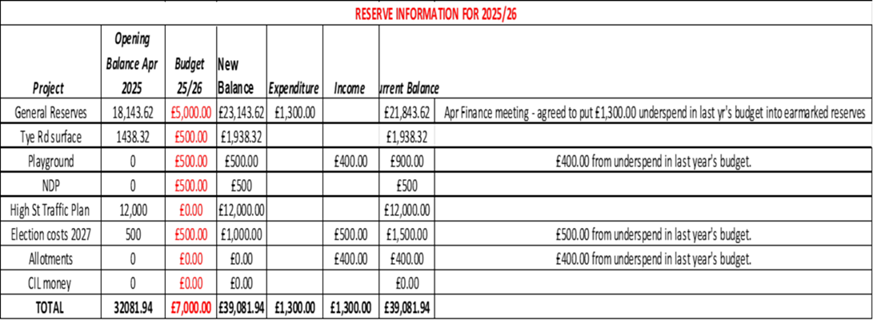

APPENDIX C - Update on Recommendations from Internal Auditor’s Report

APPENDIX D - Grass Cutting 2026-28

APPENDIX E - AWMH Committee

From: Adrian Butcher
Sent: 26 November 2025 12:10
To: clerk@alfristonparishcouncil.org.uk
Subject: AWMH Committee Member

Dear Suzanna

After Sylvia's departure I was wondering whether any councillor had shown willing to sit on our general committee to represent the APC? We meet just 4 times a year, and it's just a way of improving communication between the various user groups of the War Memorial Hall.

Best wishes,

Adrian

Adrian Butcher
Chair AWMH Management Committee

APPENDIX F - Local Government Reorganisation Consultation
From: Clerk Dated: 25.11.25 12.54pm
Dear Subscriber,
The government have issued a public consultation on the options for Local Government Reorganisation in Sussex. Please ensure you have your say using the following link. Deadline for comments is 11th January 2026.
https://mcusercontent.com/e3f52207777897b3397e690b8/files/93bc4c05-2546-5d56-5ffb-3662f888c0a7/NEW_PUBLIC_CONSULTATION_ON_LOCAL_GOVERNMENT_REORGANISATION_IN_SUSSEX.01.pdf
Kind Regards
Suzanna
Mrs Suzanna Dry CiLCA Clerk and RFO

APPENDIX G - Renewal Allotment Gate Permission for Bickers.

APPENDIX H - Twinning Committee

APPENDIX I - Request for Disable Parking at AWMH

Dear Chair & Cllrs,

Please see below correspondence and my reply, regarding disabled parking and the AWMH.
I will bring this up at the Jan meeting, for Cllrs to discuss.

All the best and speak soon.

Suzanna

Mrs Suzanna Dry CiLCA
Clerk and RFO
Please note that I work flexible part time hours.

-----Original Message-----
From: clerk@alfristonparishcouncil.org.uk
<clerk@alfristonparishcouncil.org.uk>
Sent: 04 December 2025 13:55 To: 'Lisa Kearney Subject: Parking outside AWMH

Dear Lisa,

Thank you for your below e-mail.

I can confirm that the parking space outside the AWMH is to be used for loading\unloading or drop off only by prior arrangement with the hall, and cannot be used for disabled parking. I will however forward your e-mail to all Cllrs for their consideration.

With kind regards

Suzanna
Mrs Suzanna Dry CiLCA
Clerk and RFO
Please note that I work flexible part time hours.

-----Original Message-----
From: Lisa Kearney Sent: 27 November 2025 18:31
To: clerk@alfristonparishcouncil.org.uk Subject: Parking

Dear Mrs Dry

I write regarding the disabled parking bays located near the “mine” not far from St Andrew’s Church and The Village Hall.

My father has attended exercise classes at The Village Hall run by Stephanie Wadlow on Wednesday mornings making use of a disabled bay and has managed to walk to The Hall to participate in these classes.

Unfortunately, due to his ailing health and later years he is now not able to walk from the disabled bay without the support of his crutches and has not been able to participate in these classes.
My reason for writing to you is that it would be extremely helpful, not just for my father but for other disabled people and those who find it difficult to walk to The Village Hall and, indeed, St Andrew’s Church, to create disabled parking spaces actually outside The Village Hall which is currently grassed over.

My father lives on his own since my mother passed away some two years ago and this class was a way for him to connect with the community.

Others also cannot easily use the hall or the Church facilities due to the current location of the disabled parking bays.

Yours sincerely
Lisa Kearney

APPENDIX J - Request for A Board Poster

Dear Mrs Day

May I ask on behalf of The Alfriston and Cuckmere Valley Twinning Association (ACVTA) if it would be possible to put the attached poster on display in the noticeboard in the village square and, indeed, in any other locations? (See Appendix H – Eras & Heroes Poster).

We have been very grateful for being allowed to advertise past events as we don’t rely on advertising only on social media. Cllr Stephen Rabagliati was very helpful when I supplied him with a poster for a previous event which he kindly put on the noticeboard in the village square.

I understand that there is a Parish Council meeting in the near future and hope that our request will be met positively. If there is agreement, I would appreciate knowing when I can deliver a poster or posters to the appropriate person to display it/them.

Thank you in advance.

Kind regards

Angela Morrison
Secretary
ACVTA

