CityFibre Rollout in Alfriston: January 2026
Description: ‘Excavation & installation of new fibre optic cable & duct with any required road crossings for Fibre To The Home project. This includes any required laterals, boxes, chambers and cabinets.’
Map of works & Traffic Management Plans (TMPs)
The map below is taken from the OneCauseway platform, where all upcoming roadworks are listed by ESCC Highways once permits have been granted by the Network Management Department. Members of the public can sign up to the platform free of charge using the following link:
https://one.network/public
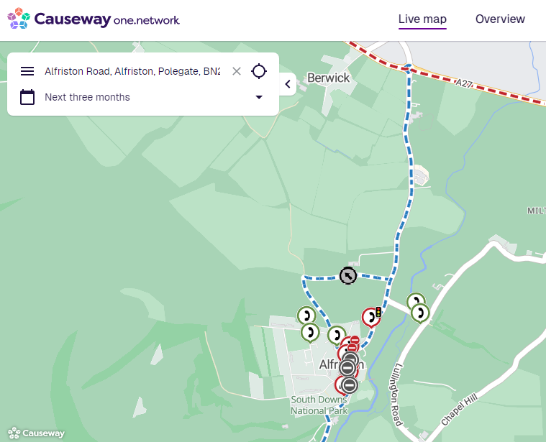

Please find additional detail below provided by CityFibre:
(Note the references to 3 PDF files highlighted in RED, that have been attached along with this communication, and contain more detailed Traffic Management Plans of the works that require road closures).
Dates | Road | Type of works | Permit Ref
5th to 7th Jan | North Road | Excavate and clear blockages on Openreach Network. | KG088-PN803-NR-01
5th to 9th Jan | North Street | Road Closure.  PDF ‘TMCD12016, RC, North Street, Alfriston, Polegate, BN26 5UG’ | KG088PN803-FMJ-NS-06
6th to 8th Jan | The Furlongs | Excavate and clear blockages on Openreach Network. | KG088-PN803-TF-02
12th to 16th Jan | Lullington Road | Excavate and clear blockages on Openreach Network. | KG088-PN801-LR1-01, 14/01 to 16/01  KG088-PN801-LR-01, 12/01 to 13/01
12th to 16th Jan | Waterloo Square | Road Closure.  PDF ‘TMCD12015, RC, Waterloo Square, Alfriston, Polegate, BN26 5UE’ | KG088PN803-FMJ-WSQ-03
19th to 26th Jan | High Street | Road Closure.  PDF ‘TMCD12014, RC, High Street, Alfriston, Polegate, BN26 5TD’ | KG088PN803-FMJ-HS-03
27th to 29th Jan | West Street | Excavate and clear blockages on Openreach Network. | KG088-PN803-WS-02
27th to 30th Jan | North Street | Test, Rod & Rope Openreach Network & Clear any blockages identified. | KG088-PN804-NS-02

CityFibre have further advised that it has now been agreed with ESCC that the works through Waterloo Sq will be carried out in 2 phases, instead of both sides being worked on simultaneously. Please note that this will not be reflected on OneNetwork platform, or the PDF file they have provided.
APC has flagged that the ‘Businesses Open as Usual’ signs were not deployed as part of the advanced warning signs, and CityFibre are working to get these up asap. As an interim solution AEG has deployed the APC BOAU signs.

