ALFRISTON PARISH COUNCIL
www.alfristonparishcouncil.org.uk
CLERK TO THE COUNCIL Alfriston War Memorial Hall
Mrs Suzanna Dry Old School House
Tel: 07936 904743 The Tye, Alfriston, BN26 5TL

E-mail: clerk@alfristonparishcouncil.org.uk 31st July 2025
Minutes of the Finance meeting of Alfriston Parish Council (APC), held in the Alfriston War Memorial Hall on Monday 21st July 2025 at 8.45pm
___________________________________________________________________________________
Present:
Cllr J Watkins Cllr N Parkinson
Cllr R Embry Cllr J Spring
Cllr A Harris

In attendance:
Mrs Suzanna Dry – Parish Clerk & RFO
2 members of the public present.

94. Chair’s Welcome
In Cllr Monteath-Wilson’s absence, Cllr Watkins chaired the meeting.

95. Public Questions

There were no public questions.

96. Apologies for absence
Apologies were received from Cllr Monteath-Wilson

97. Declaration of interest
There were no declarations of interest in relation to this meeting.

98. Finance
98.1 Cllr Parkinson proposed and Cllr Harris seconded a motion that the Quarter 1 Audit Paperwork be approved . (Appendix A). This was unanimously RESOLVED.
98.2 Cllr Spring proposed and Cllr Harris seconded a motion that the Quarter 1 VAT Return be approved. (Appendix B). This was unanimously RESOLVED.
98.3 All Cllrs confirmed sight of the Expenditure against Budget Figures for Quarter 1 (Appendix C).
98.4 All Cllrs confirmed sight of the Forecast Figures for Quarter 2 (Appendix C).

98.5 General Reserves - Cllrs reviewed and were happy with the level of General Reserves (Appendix C). As agreed in the June APC meeting, £4,500.00 will be moved from the High Street Traffic Plan into the Tye Road Surface,
once repair of the sunken area of The Tye Rd is agreed.

99. Date of next APC meeting - Monday 15th September 2025 in the AWMH at 7.15pm.

The meeting closed at 9.00pm.

Appendices, as referred to in the minutes, attached below or are available on the website.

Appendix A
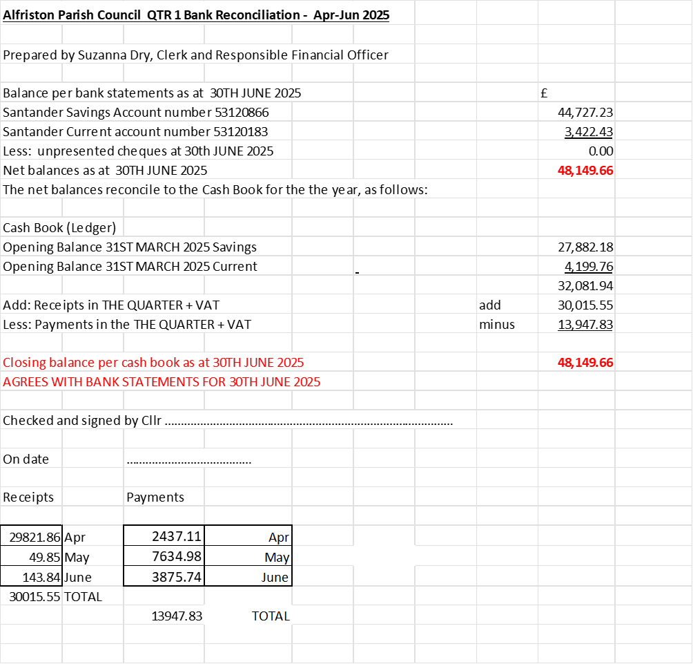
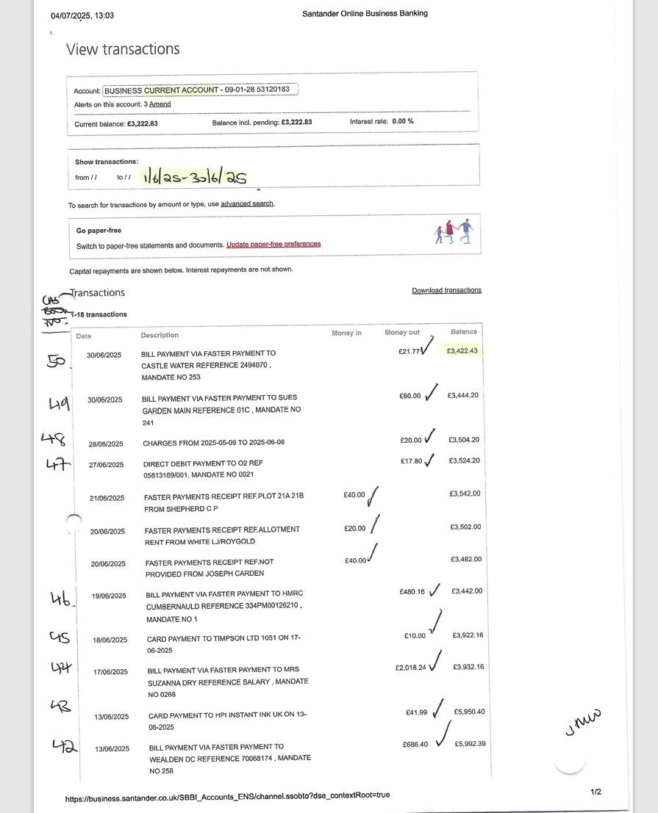
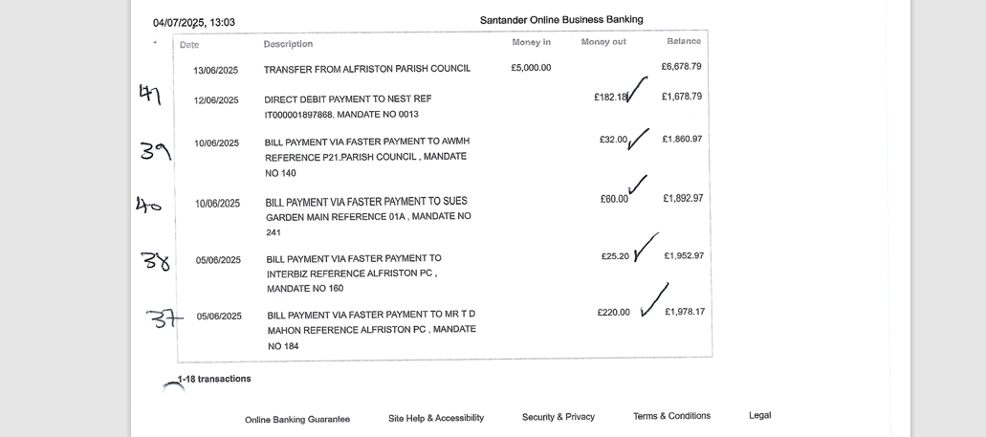

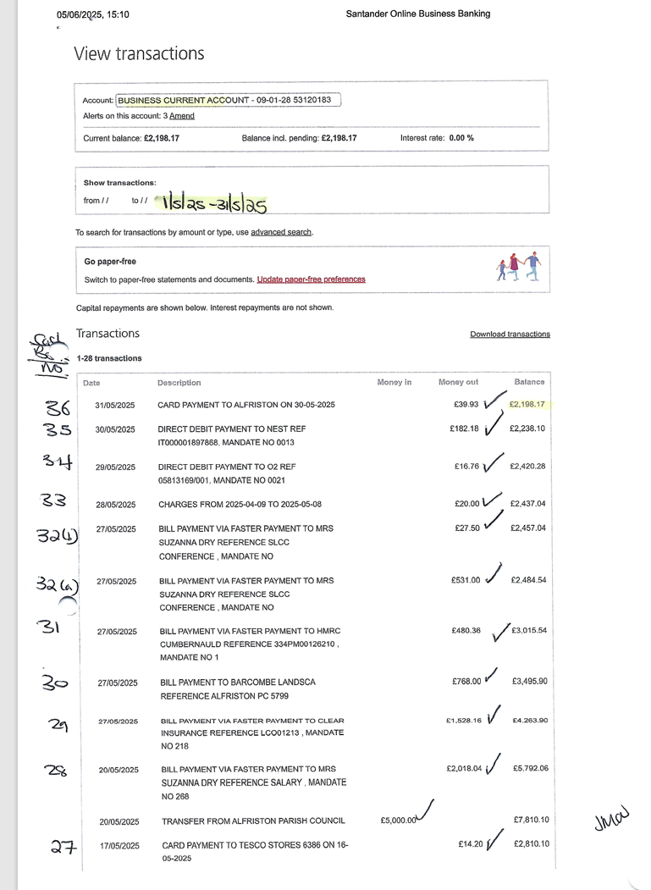
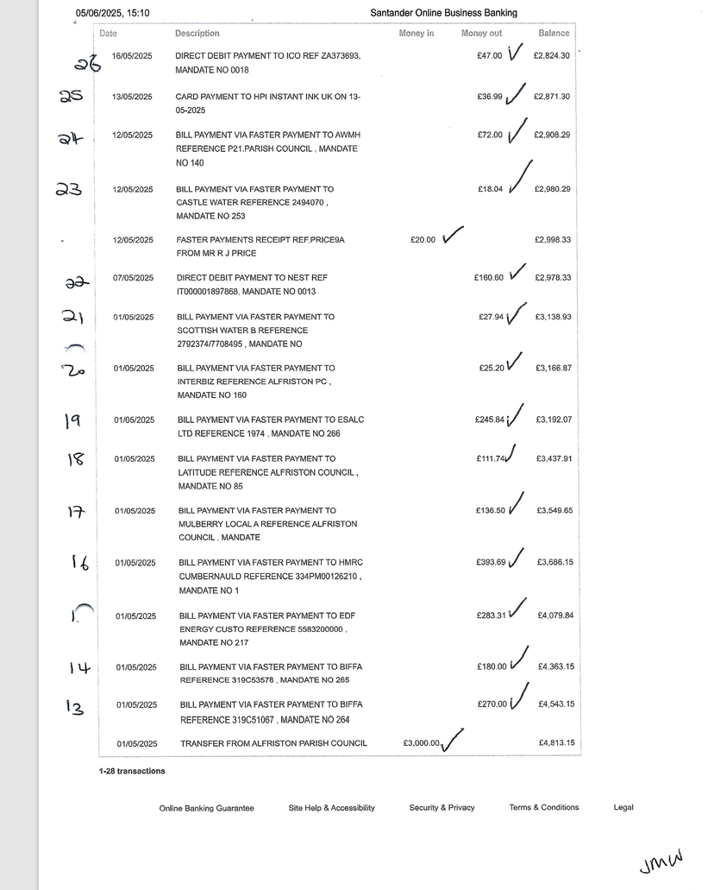
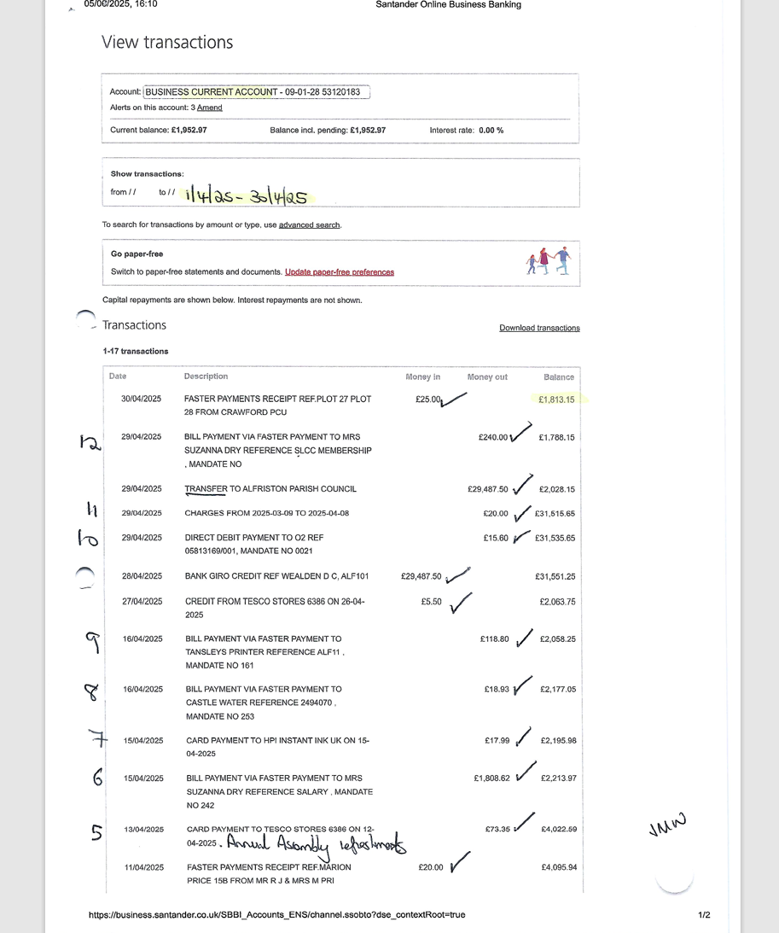
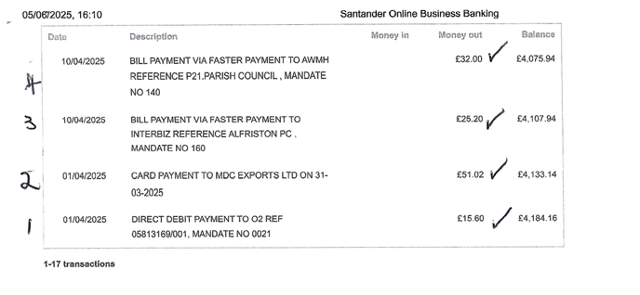
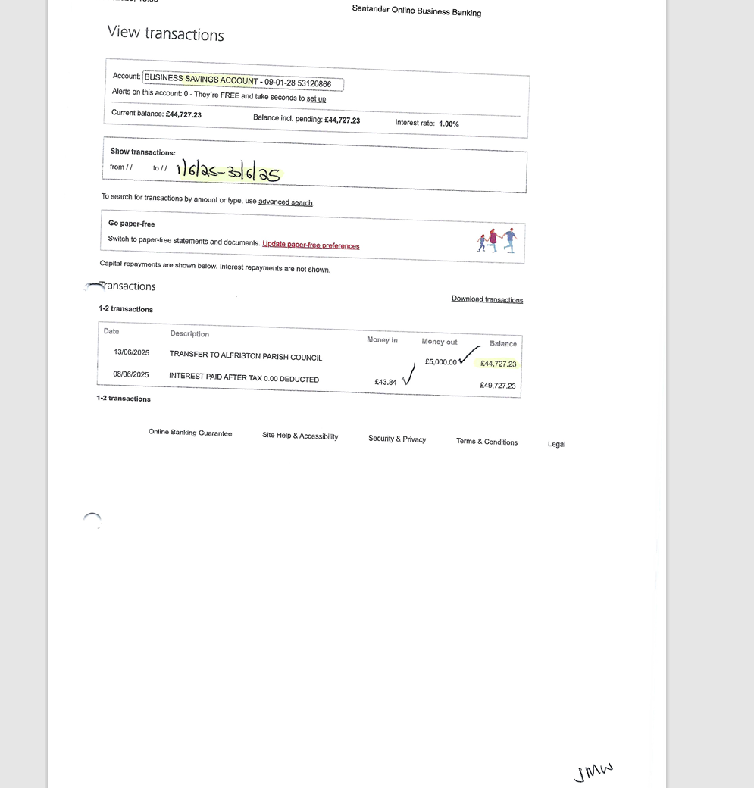
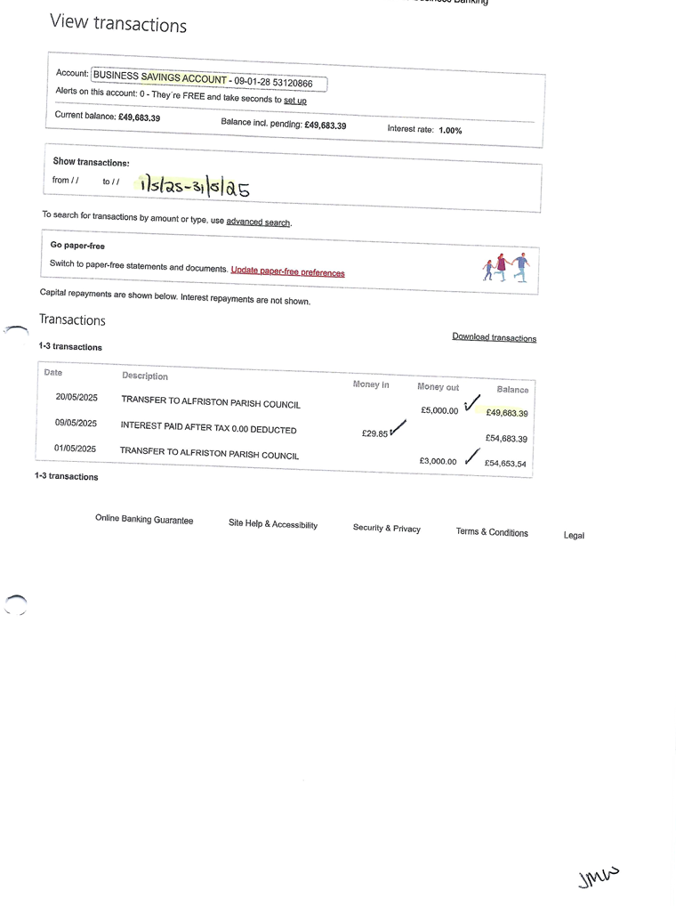

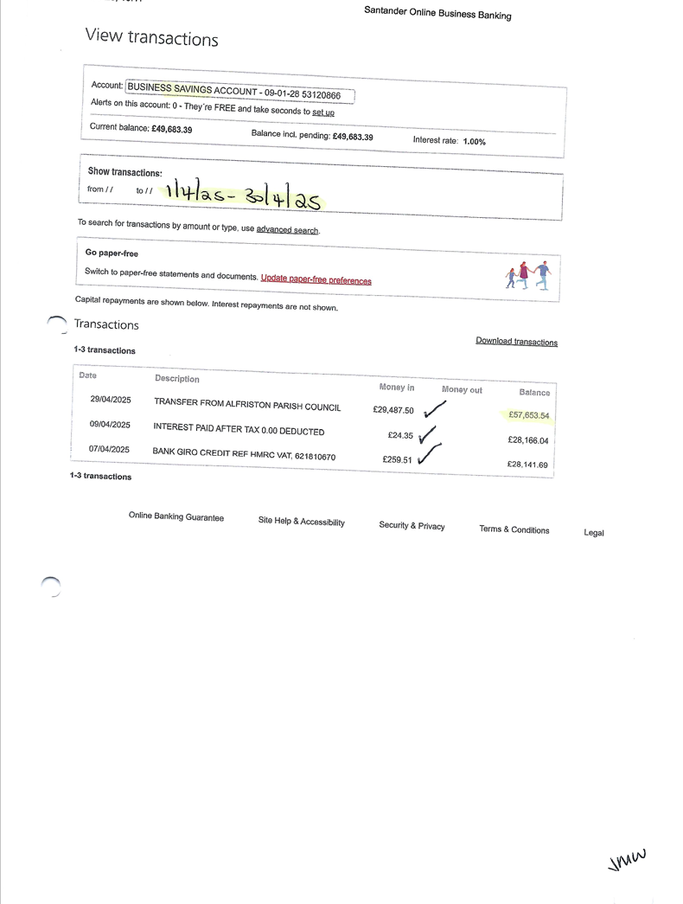

Appendix B
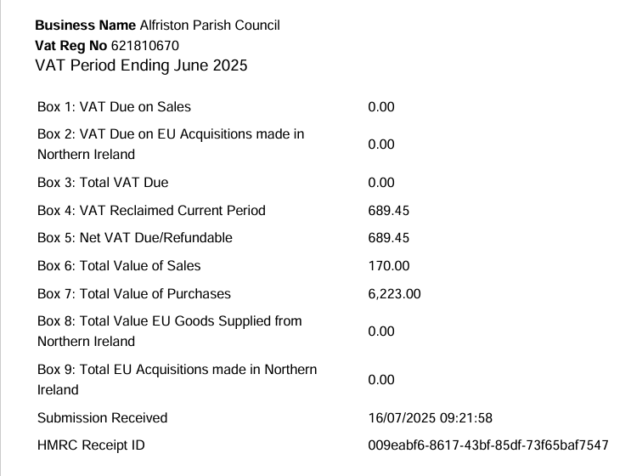

Appendix C
