ALFRISTON PARISH COUNCIL
www.alfristonparishcouncil.org.uk
CLERK TO THE COUNCIL Alfriston War Memorial Hall
Mrs Suzanna Dry Old School House
Tel: 07936 904743 The Tye, Alfriston, BN26 5TL

E-mail: clerk@alfristonparishcouncil.org.uk 23rd October 2025
Minutes of the Finance meeting of Alfriston Parish Council (APC), held in the Alfriston War Memorial Hall on Monday 20th October 2025 at 9.00pm
___________________________________________________________________________________

Present:
Cllr D Monteath-Wilson (Chair)
Cllr J Watkins Cllr N Parkinson
Cllr R Embry Cllr J Spring
Cllr A Harris Cllr Rabagliati

In attendance:
Mrs Suzanna Dry – Parish Clerk & RFO
No members of the public present.

168. Chair’s Welcome
The Chair welcomed everyone to the meeting.
169. Public Questions
There were no public questions.
170. Apologies for absence
There were no apologies for absence.
171. Declaration of interest
There were no declarations of interest in relation to this meeting.
172. Finance
172.1 To confirm sight and approval of Quarter 2 Audit (Jul-Sep 2025) (Appendix A).
Cllrs unanimously APPROVED the Quarter 2 Audit.

172.2 To confirm sight and approval of Quarter 2 VAT Return (Jul-Sep 2025) (Appendix B).
Cllrs unanimously APPROVED the Quarter 2 VAT Return.

172.3 To discuss Expenditure against Budget for Qtr 2 (Jul-Sep 2025)
Cllrs discussed expenditure against Budget for Qtr 2. No concerns were raised. As per Appendix A on the Agenda.

172.4 To review the Forecasts for Qtr 3 & Qtr 4
Cllrs reviewed the Forecasts for Qtr 3 and Qtr 4. No concerns were raised. As per Appendix A on the agenda.

172.5 To discuss the Draft Budget for 2026/27 (Appendix C).
Cllrs considered the Draft Budget prepared by the Clerk and RFO. As per the Clerks Report (Appendix C), the Clerk made clear to Cllrs that the Draft Budget was the absolute minimum required for APC to function. The Clerk asked Cllrs to consider any projects that they may wish to carry out in 2026/27 so that funding for these can be added to the budget. It was unanimously AGREED to hold another Finance Meeting in November, when Cllrs had had a chance to consider any additional funding required.

173. Date of next Finance meeting - Monday 17th November 2025 in the AWMH, following the Monthly meeting.

The meeting closed at 9.20pm.

Appendices, as referred to in the minutes, attached below or are available on the website.

Appendix A
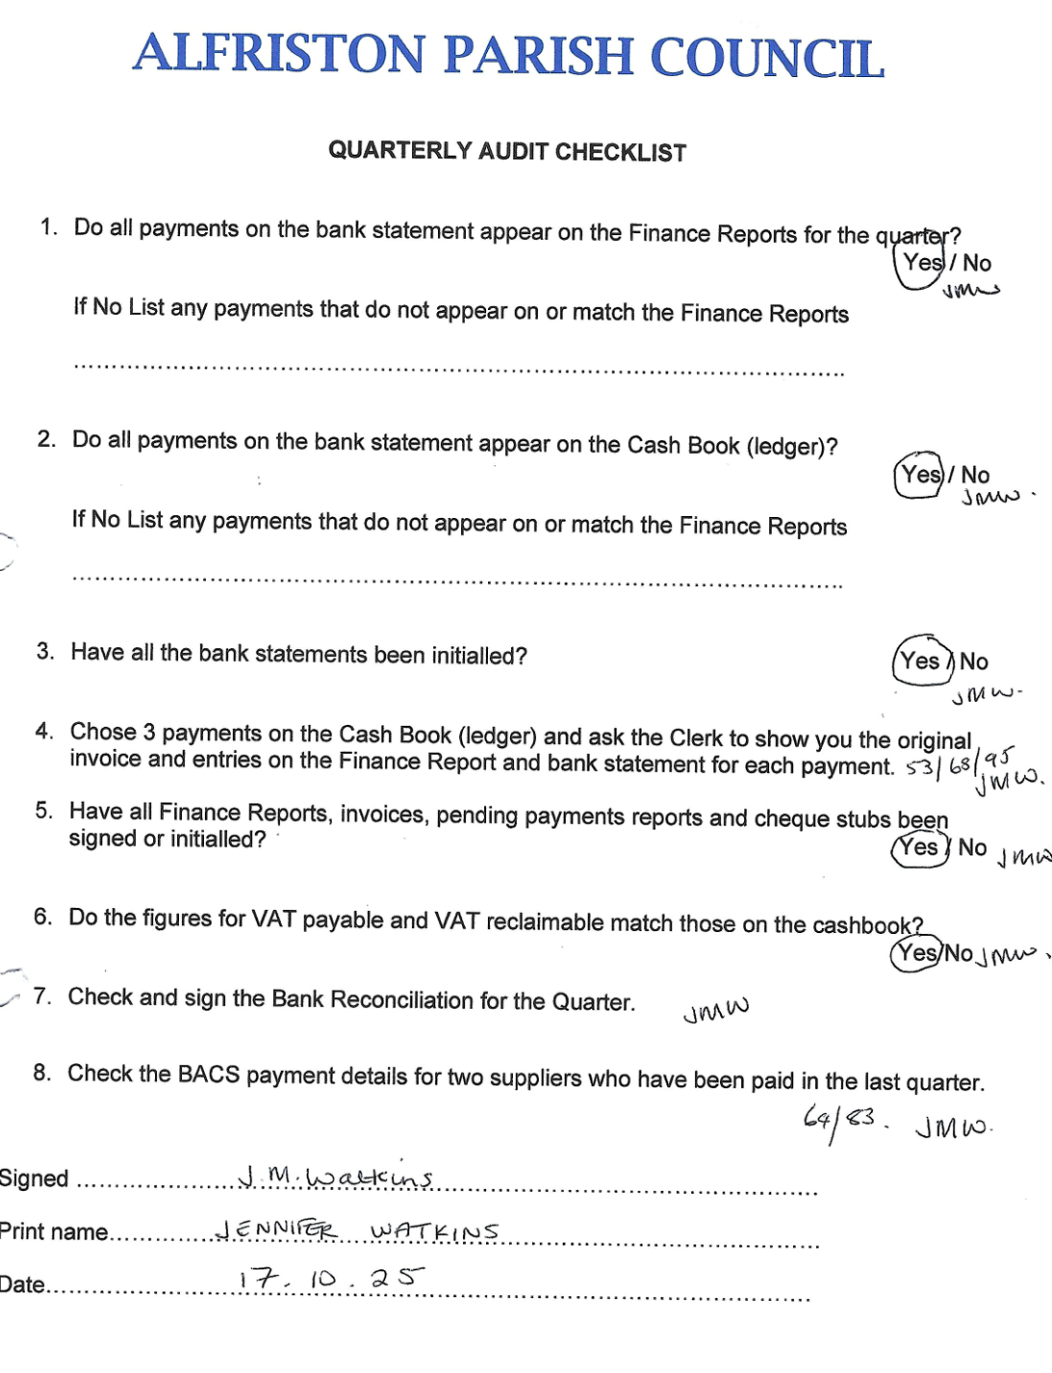

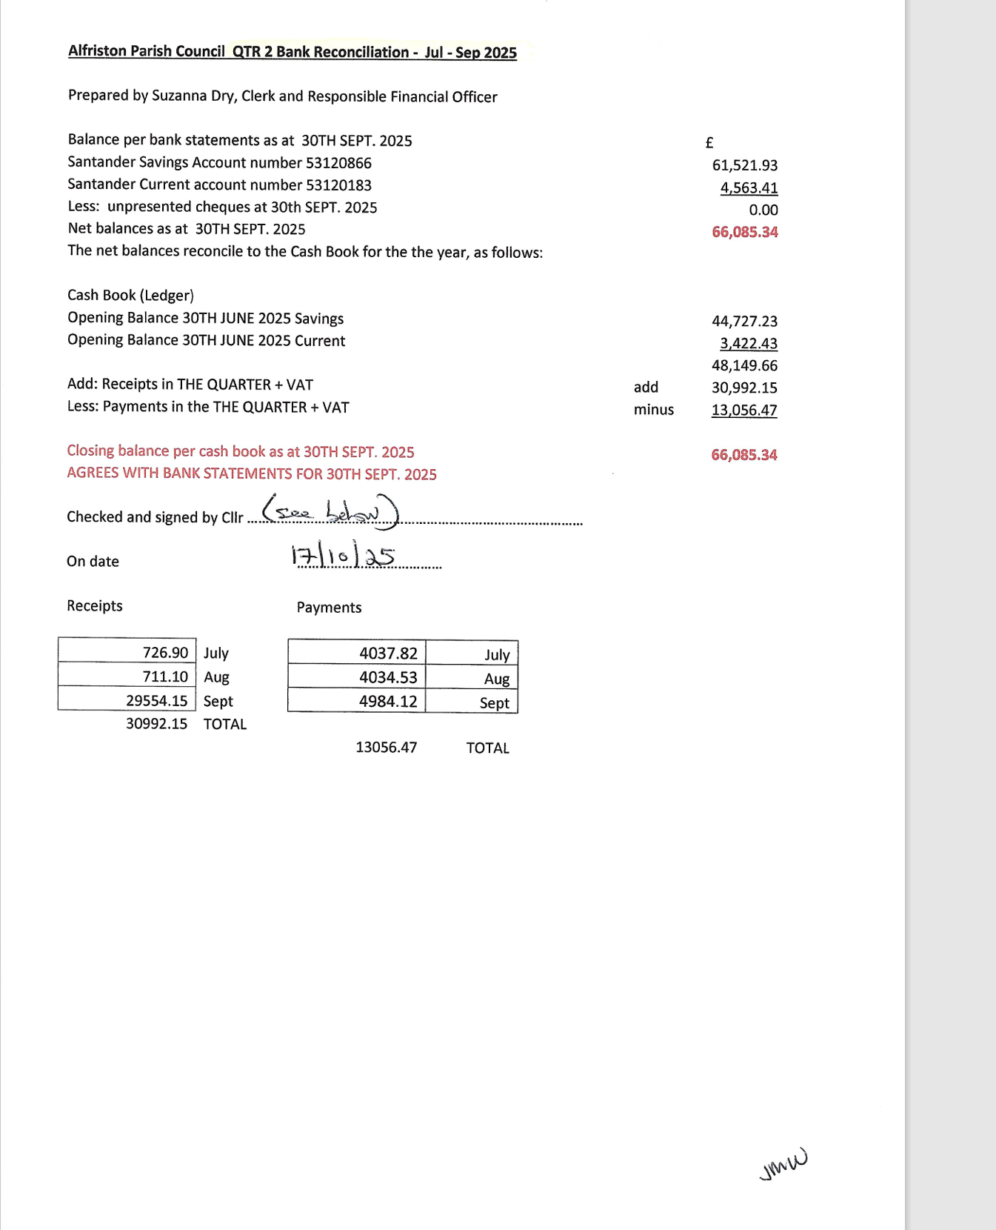
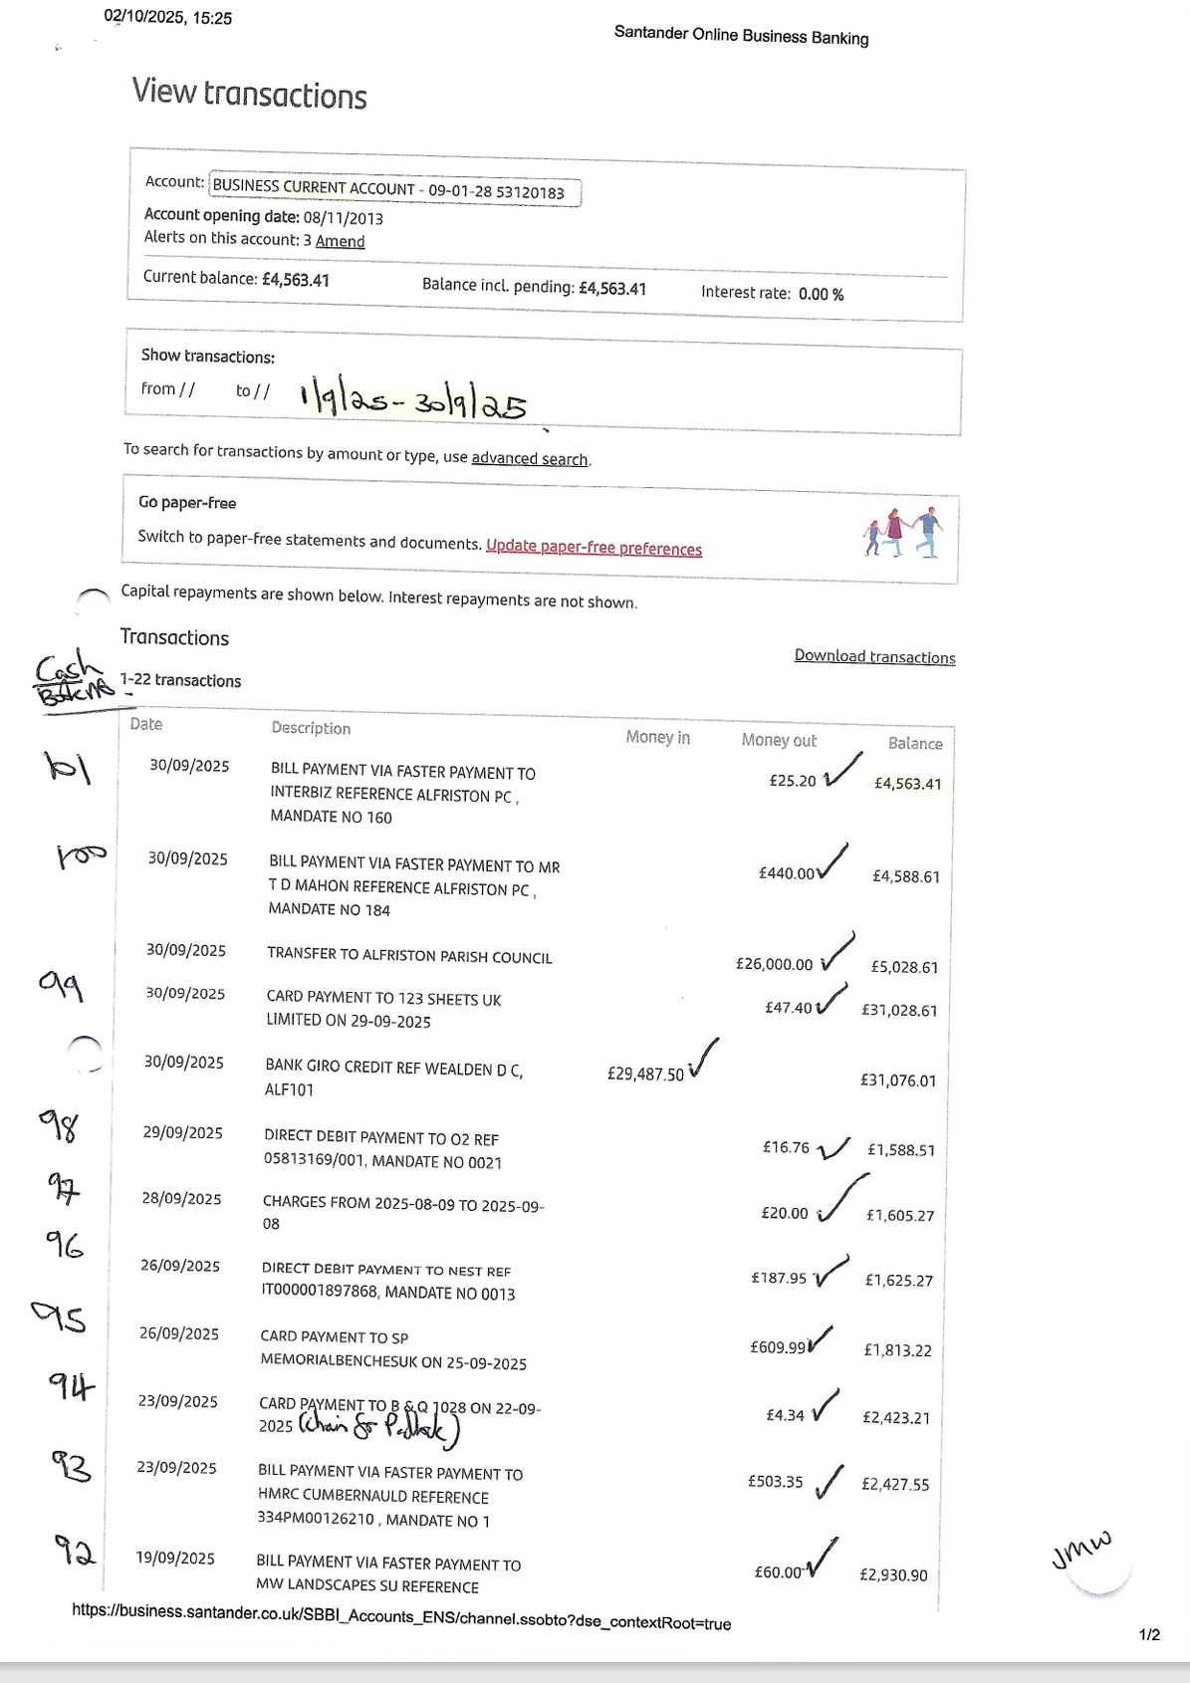
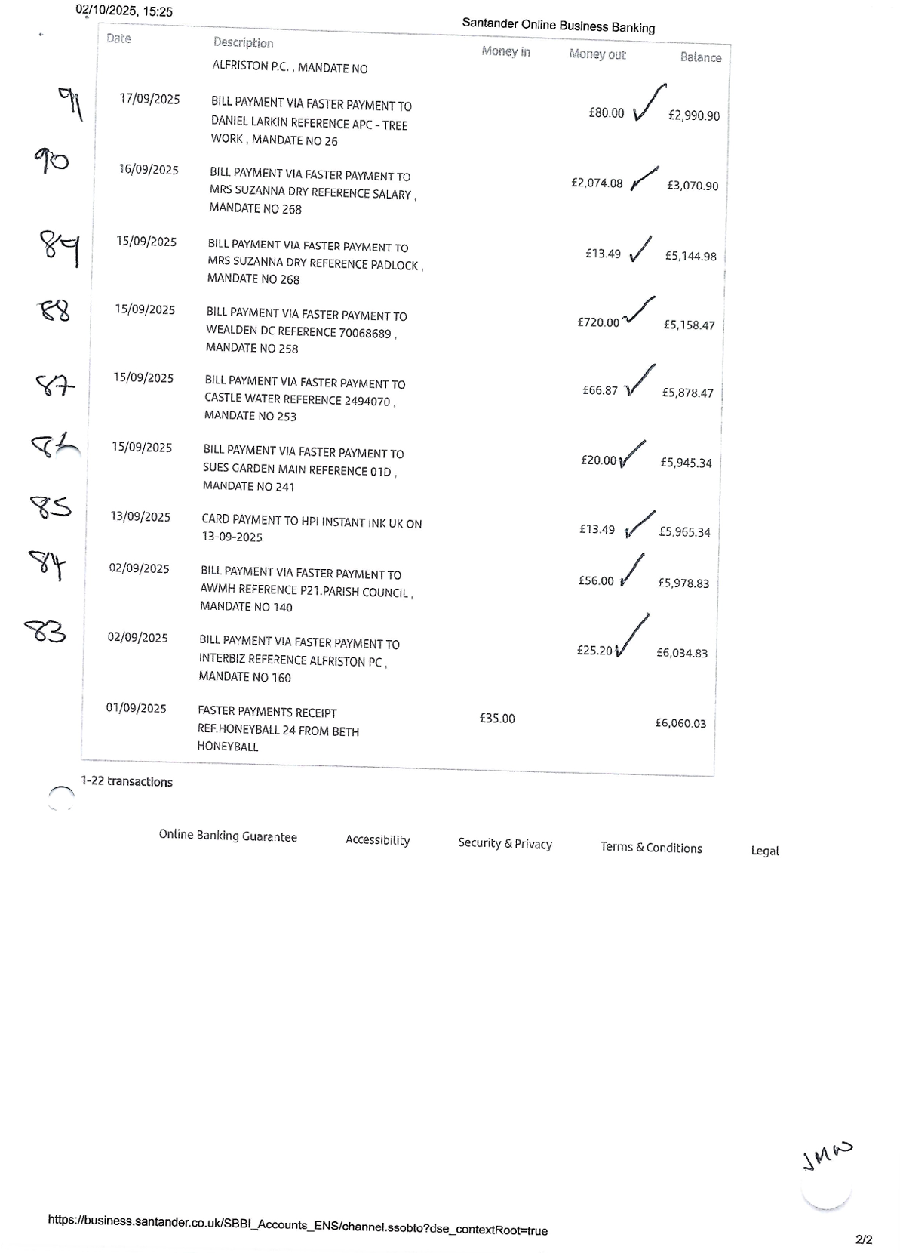
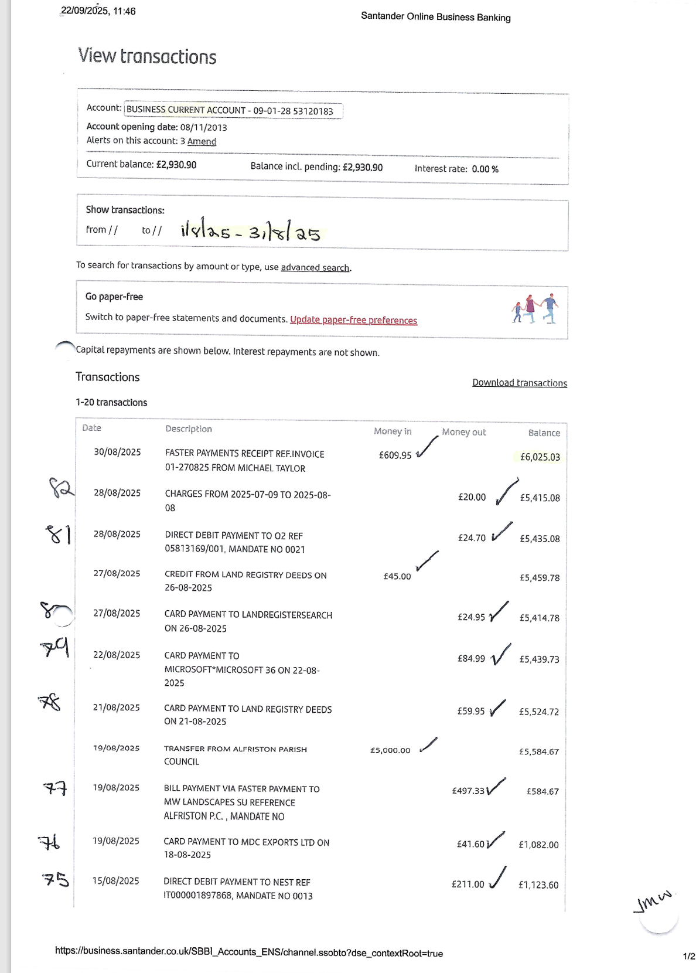

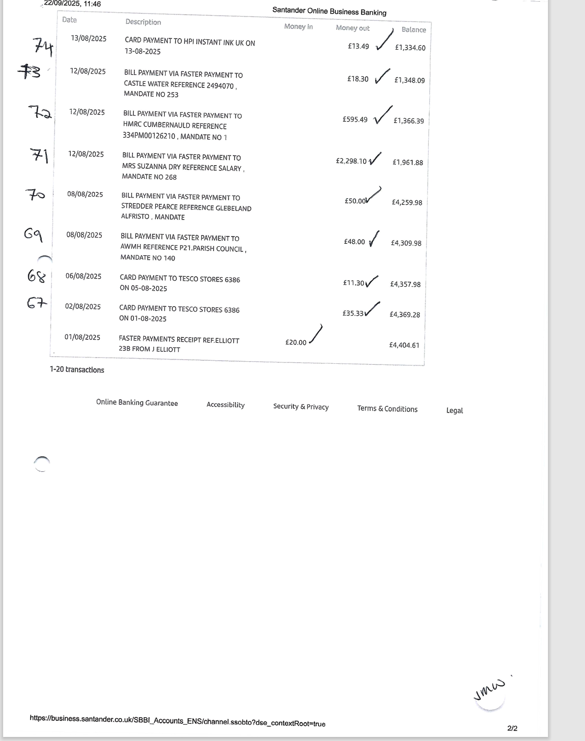
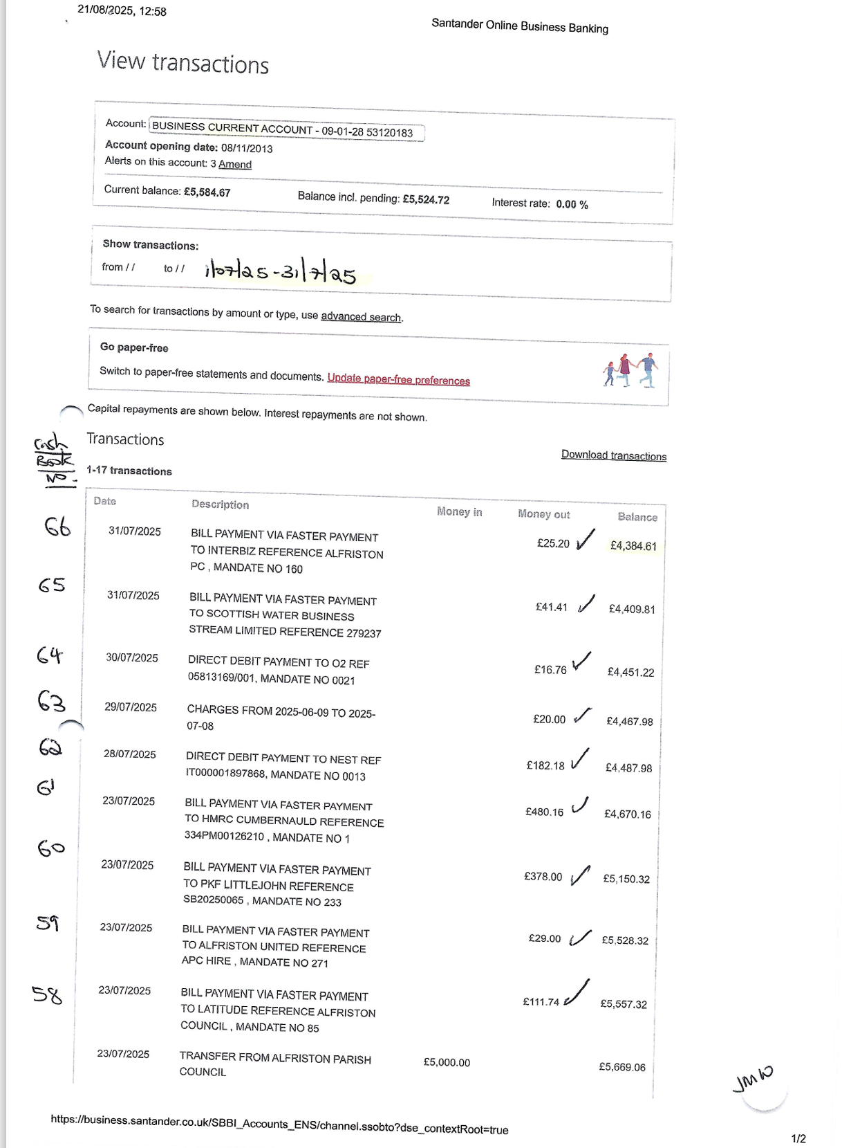
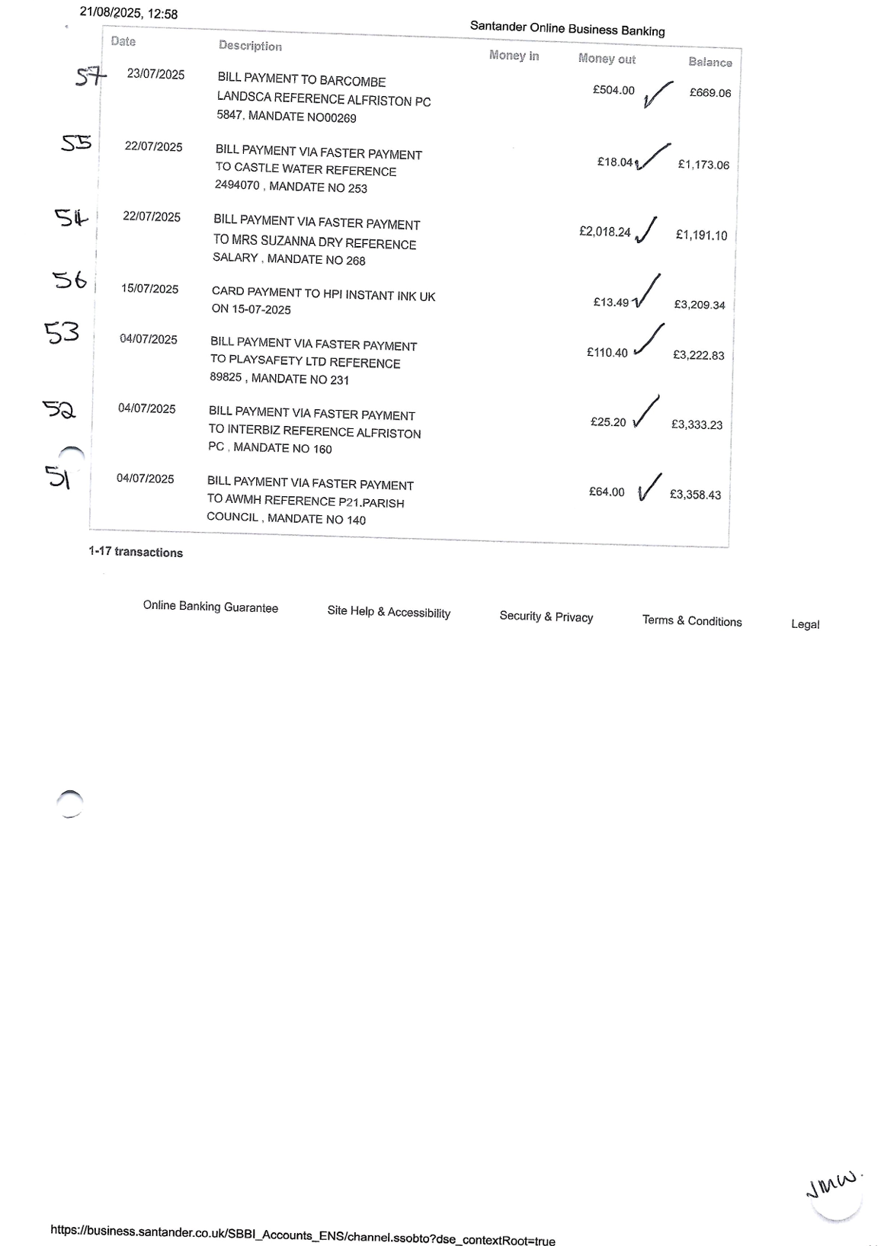
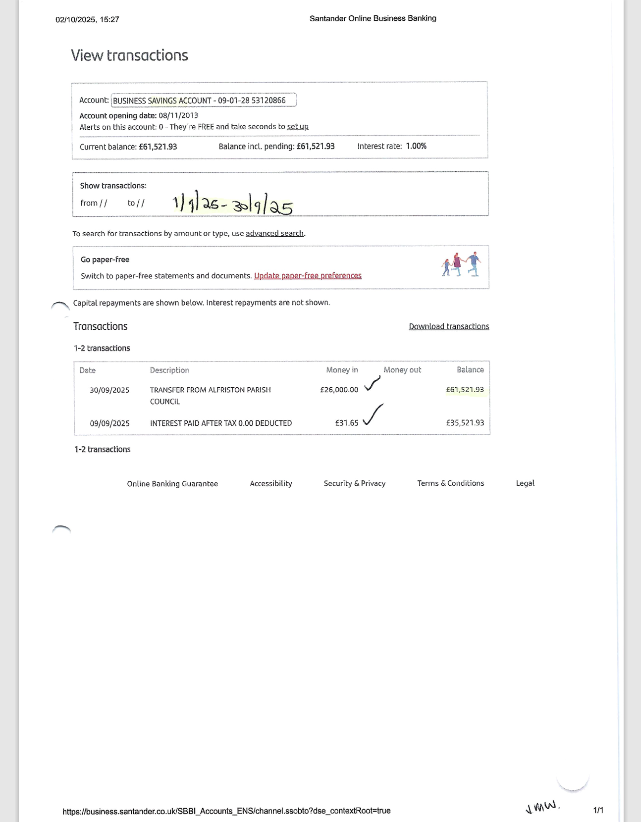
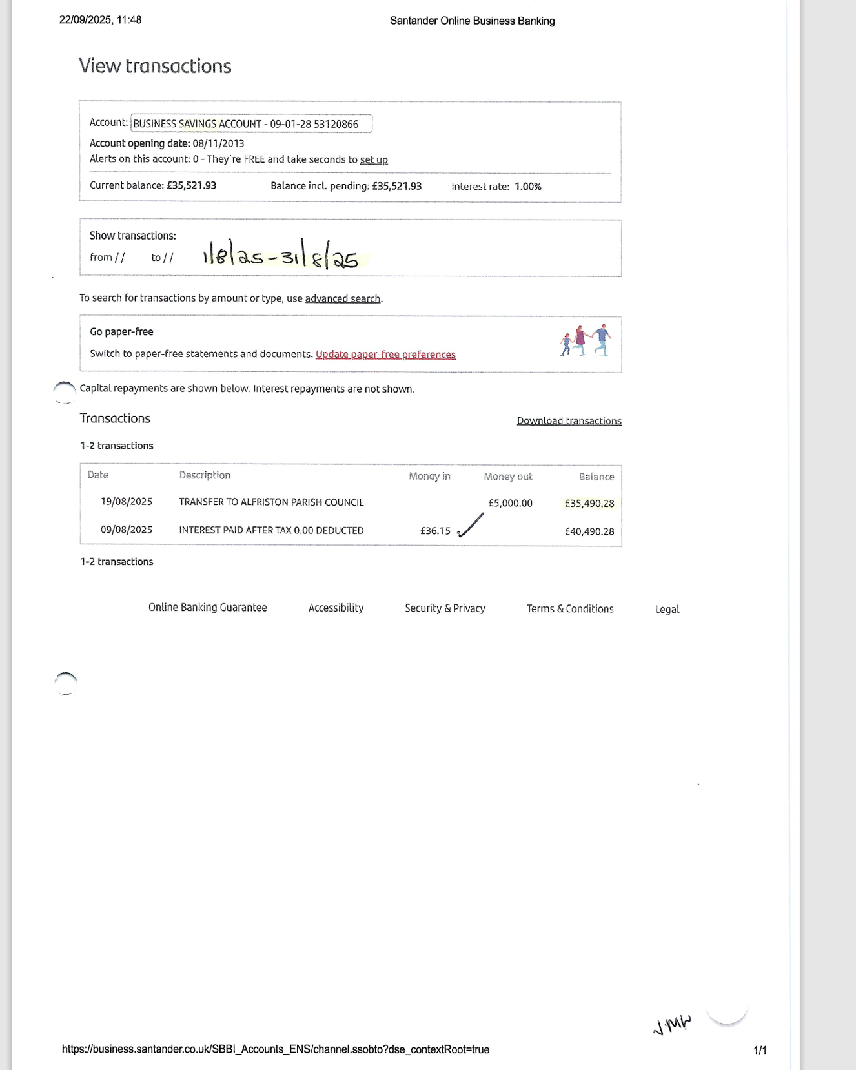
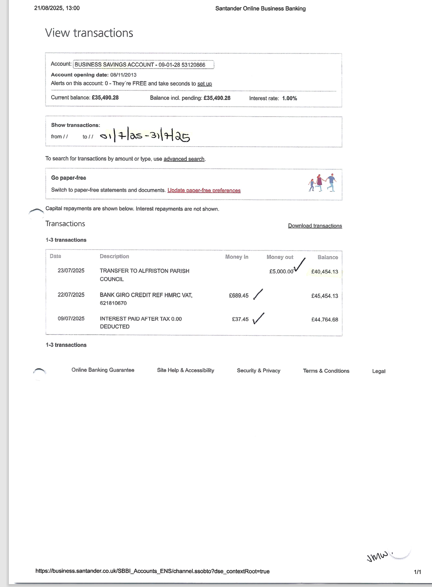
Appendix B
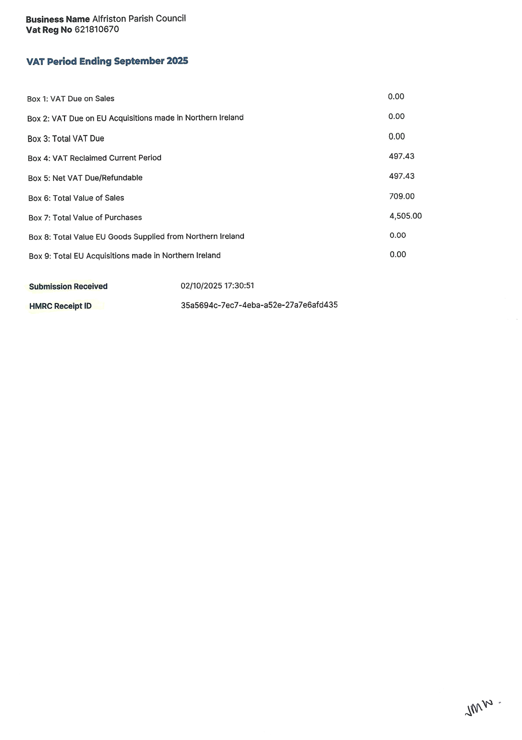
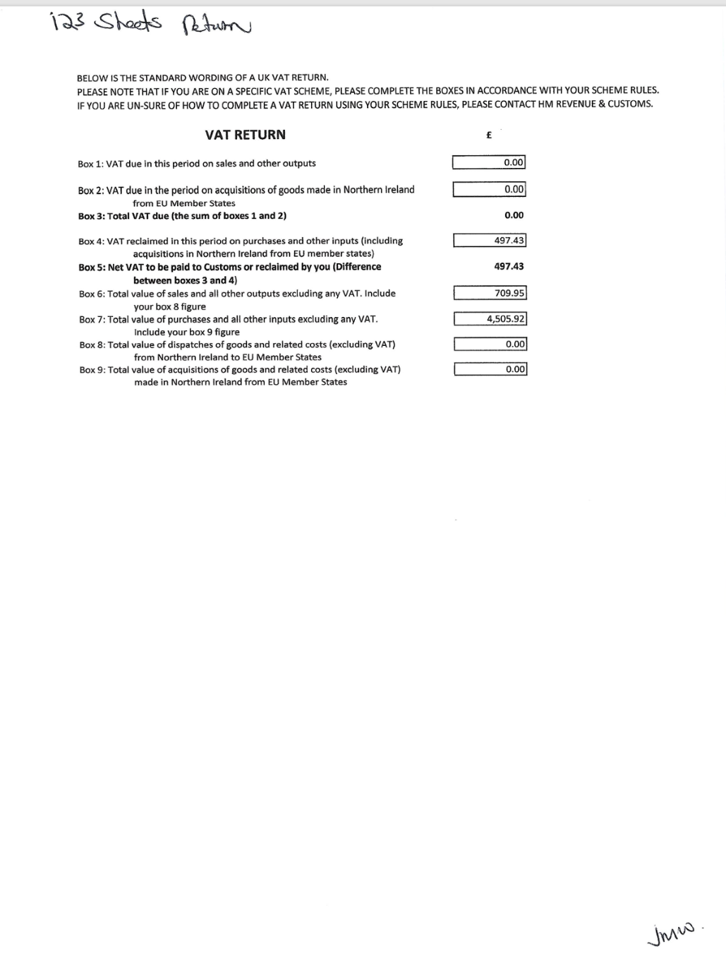

Appendix C

