ALFRISTON PARISH COUNCIL
www.alfristonparishcouncil.org.uk
CLERK TO THE COUNCIL Alfriston War Memorial Hall
Mrs Suzanna Dry CiLCA Old School House
Tel: 07936 904743 The Tye, Alfriston, BN26 5TL
E-mail: clerk@alfristonparishcouncil.org.uk 6th June 2025
Minutes of a meeting of Alfriston Parish Council (APC), held in the Alfriston War Memorial Hall on Monday 19th May 2025 at 8.00pm
__________________________________________________________________________________
Present:
Cllr D Monteath-Wilson (Chair) Cllr A Harris
Cllr J Watkins (Vice Chair) Cllr N Parkinson
Cllr R Embry Cllr J Spring
Cllr S Daw

In attendance:
Mrs Suzanna Dry – Parish Clerk & RFO
There were approximately 5 members of the public present.

16. Chair’s Welcome

The Chair welcomed everyone to the monthly meeting and advised that we now have a dedicated PCSO, Issac Wood. The Clerk and Chair will be meeting him on The Tye tomorrow morning, any Cllrs that are free are welcome to come along. We will ask if he can arrange a ‘meet and greet’ in the village, as well as inviting him to attend future Parish Council meetings. With regard to APC’s mailbox in the hall, the Chair will ask the AWMH Committee to re-consider APC’s request for an external mailbox.

17. Public Questions
A question was asked as to where we are with re-instating the village post box. The Clerk replied that a date had not yet been confirmed for the work to start from the project managers. The last update received was a month ago and the Clerk will contact the project managers for an update. Action Point 1.

18. Apologies for absence
Apologies were received from Cllr Stephen Shing, ESCC.

19. Update from MP
There was no report for the meeting. This has since been received and is attached to the minutes. Appendix A.

20. Update from Cllr Stephen Shing – East Sussex Council
Cllr Shing had sent through his report and the Clerk read this out. A copy is attached, Appendix B.

21. Update from Cllr David Greaves - Wealden District Council
Cllr Greaves presented his report to the meeting. A copy is attached to the minutes. Appendix C.

22 . Declaration of interest
Cllr Daw declared an interest as she is a Church Warden, trustee of Children with Cancer and the Women’s Institute. Cllr Watkins declared an interest as she is a member of AEG & Heartstart. Cllr Parkinson declared an interest in allotments.
23. Minutes
Cllr Harris proposed and Cllr Daw seconded a motion that the unadopted minutes of the Annual Parish meeting held on 14th April 2025, were a true and accurate record. It was unanimously RESOLVED that the Chair duly sign the minutes as an accurate record.

Cllr Embry proposed and Cllr Watkins seconded a motion that the unadopted minutes of the Finance meeting held on 22nd April 2025, were a true and accurate record. It was unanimously RESOLVED that the Chair duly sign the minutes as an accurate record.

Cllr Embry proposed and Cllr Watkins seconded a motion that the unadopted minutes of the Personnel meeting held on 22nd April 2025, were a true and accurate record. It was unanimously RESOLVED that the Chair duly sign the minutes as an accurate record.

Cllr Harris proposed and Cllr Spring seconded a motion that the unadopted minutes of the APC monthly meeting held on 28th April 2025, were a true and accurate record. It was unanimously RESOLVED that the Chair duly sign the minutes as an accurate record.

24. Finance
To approve the Statement of Finances for May 2025 as attached to the Agenda. Cllr Harris proposed & Cllr Parkinson seconded a motion these be approved. This was unanimously RESOLVED.

25. Report on VE Day Celebrations – Monday 5th May 2025
Cllr Daw reported that due to the cold weather the event was held inside the War Memorial Hall. It was very successful with a lot of people attending. Approximately £200 was made from the cake sale held by Alfriston Women’s Group. Cllr Daw confirmed the village bunting and poppies are now kindly being stored by Emmett & White. The Chair and Cllrs thanked Cllr Daw for organising the event. The Alfriston Women’s Group have since confirmed that the final figure made from the cake sale was £286.90, which will be used to help fund their programme of meetings and activities.

26. Consultation on East Sussex Freight & Rail Strategies
Cllr Parkinson commented that he would like rail freight to be prioritised over road freight. Cllr Spring also agreed with this in order to get freight off the B roads. Cllrs all AGREED with this. The Clerk was asked to log these comments with the consultation. Action Point 2. The Clerk confirmed that the consultations have been put on the website and sent out via Mailchimp for residents to comment on.

27. SLCC National Conference – October 14th & 15th
Cllrs AGREED unanimously for the Clerk to attend the Society for Local Council Clerk’s National Conference on 14th & 15th October. With the cost of £450.00 being funded from the training\courses budget.

28. Report on Highways & Twittens – Cllr Embry
Cllr Embry reported that the re-scheduled road works will commence on Monday 2nd June and run until 14th June. APC’s Customer Services Manager for ESCC Highways will be leaving at the end of May. It is hoped a replacement will be in post by June. The Clerk confirmed that the e-mail is a generic one and any queries in the meantime will be picked up by the department. It does however mean that the next SLR (Strengthening Local Relationships) meeting with Highways scheduled for June has now been cancelled. Once a new Customer Services Manager is in place we will look to reinstate this.

29. Report on Allotments & Recreation Ground – Cllr Daw.
Allotments - I’m happy to say the rubble is well on it’s way to being removed from the allotments thank you Councillor Spring for your offer of help with this. The Clerk and I realised the new allotment signs saying Allotments holders only have still not arrived so the Clerk will be looking into this. Action Point 3. I am concerned that weeds which caused so much damage to the old fence which has now been replaced (at no cost to PC) are now growing back and because all the bins and other obstacles blocking the pathway it is very difficult for the owners of the fence to keep it clear. Especially as this part of the allotment is covered in stinging nettles and is in a very sad state, this should be accessible and not allowed to regrow and cause damage to the fence.
There are now only 3 allotments up for rent and our new allotment holders are working very hard and there is a massive improvement, thank you.
Playground - thank you to Anna Franklin for your e mail regarding the twisted wood that runs across the top of the Fort, the Clerk has reported this to Wickstead but we have our inspection In June, we never know the date just some time in June. It has been suggested a monthly call goes out on the Friends of Alfriston Playground face book page asking if anyone has any issues to raise re the playground this would get the message out to the community.
Recreation Ground - the cricket season has begun and they are always looking for new players. Thank you to the cricket team for painting the outside of the Pavillon and I think the inside has had a clean as well. I’m suggesting that when the season is finished then the Pavilion should be inspected by the portfolio holder.
30. Report on Public Transport – Cllr Harris
We have recently received notice from East Sussex County Council of the changes in bus services following a grant received by them of £41.4 million. I have read through the proposals, and as far as I can tell there is not change to any of the bus services servicing Alfriston – either improvements or cuts. Full details of the proposals affecting other parts of Wealden District can be found on the East Sussex C.C. website at https://www.eastsussex.gov.uk/roads-transport/public/bus-service-improvement-plan/bus-service-changes. Cuckmere Buses have published the new Summer timetable on their website which is easily accessible and distributed leaflets locally.
31. Report on Environment & Countryside
I have been notified by Southern Water of two incidents since our last meeting on 17th March, both relating to what they define as “genuine storm overflow releases that are likely to have impacted water quality at Seaford”. These took place on 15th and 23rd April after rainfall of just over ½” and approximately ¾” respectively. I find it somewhat alarming that in this fairly dry period, the drainage system cannot cope with a fairly small amount of rain.
On weather statistics,, we have had 1 ½ inches of rain this month, compared with 2 ½ last year, and in the six weeks since the last APC meeting, 2 ½ inches have fallen, compared with 4 inches for the same period last year. Rain has fallen on 8 days, compared with 25 last year.
River Bank downstream from the White Bridge. We received late notice on 15th April from the Water Management Alliance of the closure of the footpath from 16th April for up to 21days to allow for spreading more topsoil and re-seeding. In fact the footpath reopened after only a few days after the work had been completed. There are however notices asking the public to keep off the top of the bank and walk along the bottom to allow the seed to germinate and take. The lower ground currently is quite firm. In spite of the late notification, I would to record that Revai Kinsella of the Water Management Alliance does an excellent job in keeping information flowing and in responding rapidly to enquiries. Cllr Parkinson mentioned there are two big piles of spoil on the footpath near White Bridge, Cllr Harris will look into this.
Nothing to report on Public Rights of Way – I did come across a small tree blocking the path near the campsite – but was able to pull it to one side!
32. Report on Strategic Planning – Cllr Parkinson
Update on Emergency Plan - Cllr Parkinson reported that feedback received had been very positive. We need to get the emergency telephone number set up, which alerts all Cllrs and AEG. Cllr Spring offered to provide a dedicated emergency number at no cost. This would remain cost free whilst Cllr Spring continues to run his company, if and when he leaves the cost would then be around £10.00 per month. The Chair and Cllr Parkinson will liaise with AEG. All agreed that APC need to have control of the telephone line as it is part of the Emergency Plan. Cllr Parkinson reported that Tansleys had quoted approximately £70.00 to print 500 leaflets of the Emergency Plan. Cllrs AGREED to this cost. Action Point 4. Points to consider going forwards are purchasing yellow APC tabards and whether we should look at investing in a generator.

33. Report on Tye – Cllr Spring
Update on repair to Tye Rd - Hailsham Roadways have been asked to quote to repair the sunken area and last pothole on The Tye. Yellow Lines - currently waiting for a replacement sachet to mix with the paint before work can commence. Water Fountain - approximate costs to set this up are in the region of £733.00 per qtr due to legionella testing, making it not viable to pursue. All AGREED.

Sustainability Event on The Tye - Looking possibly at holding this on 9th or 10th May 2026. Don’t need a decision from APC yet, just for information at this stage.

34. Report from Planning Committee – Cllr Watkins.
34.1 Applications considered by APC Planning Committee since the last meeting.

Ref. No: SDNP/24/02440/FUL - Appeal re: Former Allotment Site, North St.

APC logged a new comment on the Appeal, endorsing the Historic Buildings Officer’s report.

Ref. No: SDNP/25/00989/FUL - The Tudor House, High St., BN26 5SY. No objection

Internal & external alterations. APC logged their concern at a loss of retail space.

Ref. No: SDNP/25/01585/FUL & 01586/LIS - Ye Olde Smuggler’s Inne. No objection

Upper floor guest room & access from courtyard.

Ref. No: SDNP/25/01512/HUS - Danny Cottage, Winton St. BN26 5UJ. No objection

Erection of single storey garden room.

Ref. No: SDNP/25/01501/CND - Pyewacket, 19 Deans Rd, BN26 5XJ No objection

Change of condition 3 (materials).

34.2. Applications notified or awaiting decision from SDNPA

Ref. No: SDNP/25/01006/LIS - Winton Barn, Winton St, BN26 5UJ. Approved

Internal alterations.

34.3 Enforcement updates from SDNPA - Sunnyvale, France Hill.

SDNPA advised an unauthorised sand school had been constructed, SDNPA report this has now

been removed and will be returned to grassland.

35. Reports from Outside Bodies
35.1 Heartstart - Nothing to report.

35.2 Alfriston Emergency Group - No report.

35.3 Flood Forum - Nothing to report.

35.4 Neighbourhood Watch - No report.

35.5 Twinning Committee - Report read out at the meeting (as attached to the Agenda).

35.6 St Andrew’s Church - Cllr Daw advised it was Christian’s last day on Sunday, there was a lovely send off for him that took place in the church . He will be missed greatly.

35.7 Clergy House - No report.

35.8 Alfriston War Memorial Hall - No report.

35.9 Speedwatch - No report, currently on hold.

35.10 Events - No report.

36. Correspondence to The Clerk – Asking for permission from the council.
Wedding Catering Van – 19th July (details attached to the Agenda). APC AGREED to the catering van but not the request for a gazebo on The Glebe. The Clerk was asked to reply accordingly. Action Point 5.
Southdowns Music Festival - 15-20th July (details attached to the Agenda). APC AGREED to the mobile bar being parked on The Tye from 15-21st July. The Clerk was asked to reply accordingly and ensure a copy of the Public Liability Insurance and Risk Assessment is received for the event. Action Point 6.

Councillor Resignation - Cllr Daw announced to the meeting that she is resigning as a Councillor, as she is leaving the village. The Chair thanked Cllr Daw for all her work over the years both to APC and the village. The Chair went on to say Cllr Daw had been one of the most hard working councillors she has known, has a great practical and rational response to issues, consideration of others and sense of humour, which will be greatly missed. Cllr Daw thanked her fellow councillors, it has been an interesting and wonderful time. The Chair confirmed there will now be a vacancy on the Parish Council, hopefully we can go to co-option if there is no request for an election, as elections cost a great deal of money. The Clerk asked Cllr Daw to put her resignation in writing to the Chair with the Clerk copied in, and then Wealden District Council will be informed. Action Point 7.

37. Public Questions
The Chair closed the meeting at 9.23pm and opened the floor to public questions. The meeting was then re-opened at 9.33pm.

38. Date of next meeting – The next meeting will be held on Monday 16th June 2025 in the AWMH at 7:15pm
The Chair closed the meeting at 9.36pm
Please see Appendices attached below and\or on the website

Appendix A - MP’s Update
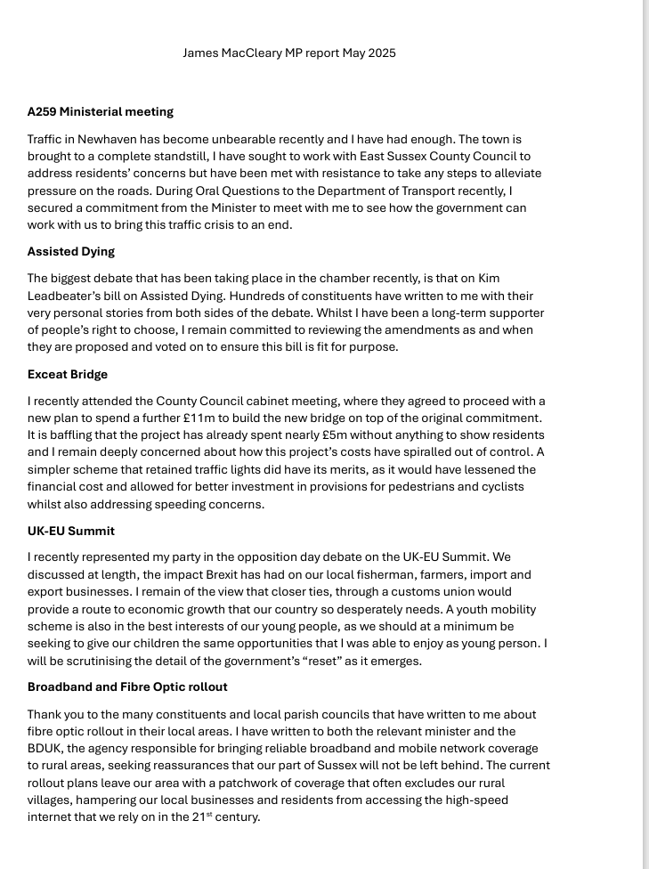
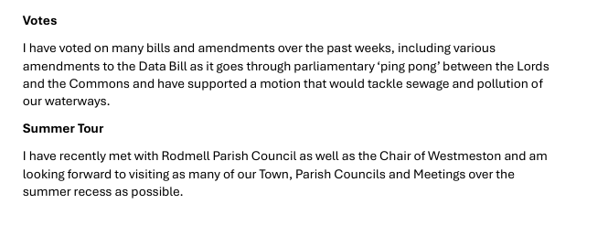

Appendix B - Update from Cllr Stephen Shing ESC

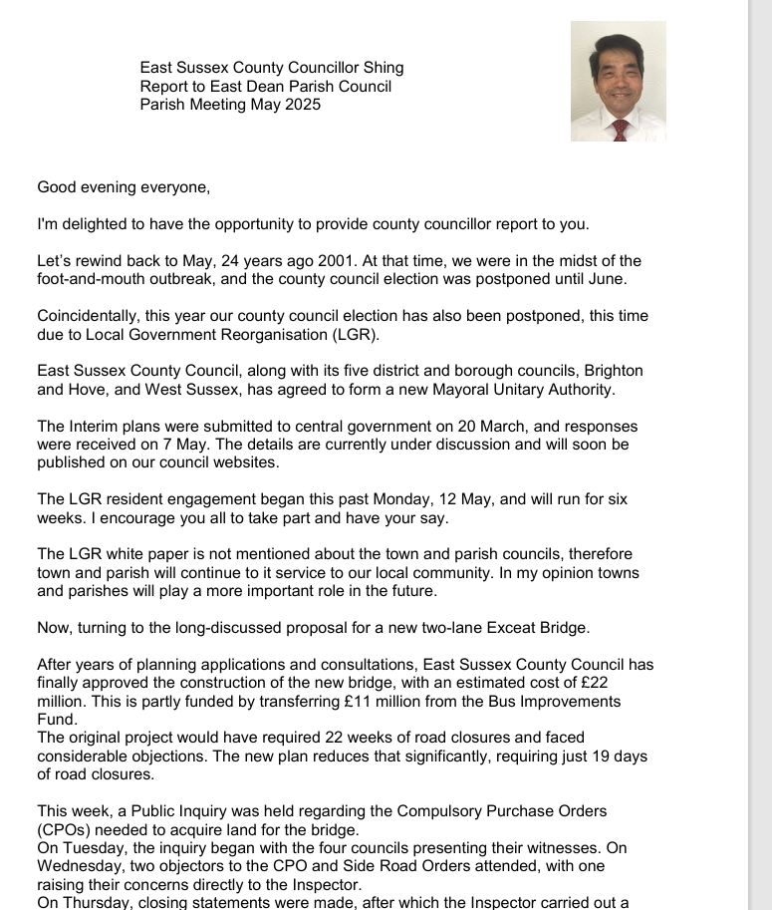
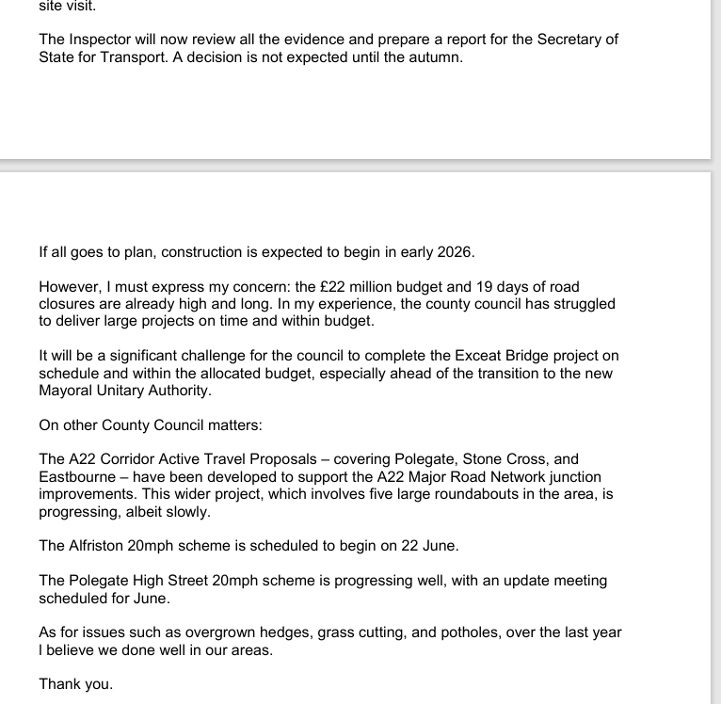
Appendix C - Update from Cllr David Greaves WDC
Report –Alfriston PC - Monday 19th May 2025

- Local Government Reorganisation
The government wants to reorganise local government so that everyone in East Sussex gets their services from just one council. This could mean East Sussex County Council, Eastbourne Borough Council, Hastings Borough Council, Lewes District Council, Rother District Council and Wealden District Council, would be replaced by a single authority.
Other options could also be considered if they attract wide public support and government backing.
Local Government Reorganisation is set to be the most radical shake-up of local government in decades and people are being encouraged to have their say.
With a new council expected to be elected in 2027 and start work in 2028, the county council and district and borough councils are working on plans and asking residents for their views.
Wealden council leader Councillor James Partridge said, “Acting on the government’s request, we have worked with our colleagues in councils in East Sussex to draw up an initial plan for a single local authority for East Sussex that could provide best quality and value for all its 550,000 residents.
“We now need to know what local residents, businesses and the voluntary sector think about this so that we can make a plan which will deliver the greatest benefits to our communities. Final, detailed proposals have to be submitted to the government in September.”
The consultation is now available to complete online at www.smartsurvey.co.uk/s/EastSussexLGR/ until Monday 23 June.
In the interim plan, East Sussex County Council and the five district and borough councils have set out what they believe any new local authority would have to achieve including:
- Improving outcomes for residents and communities
- Making best use of resources now and for the future
- Enhance local democracy, local identity, transparency, accessibility, local decision making and accountability
- Support and drive decision making and public service reform at both Sussex and local level
- Provide a stronger and unified voice to help attract investment and tackle priorities
More information about Local Government Reorganisation in East Sussex can be found at www.eastsussexcouncils.org

- The creation of dedicated ward budgets for councillors to spend on supporting improvements within their communities has been approved by Wealden District Council.
Each of the 45 councillors will be allocated £10,000 to fund projects and initiatives that directly benefit their wards. The funding, totalling £450,000, will come from General Fund reserves and represents a cost-effective mechanism for addressing local priorities identified by residents and councillors alike.
Councillor ward budgets have been successfully used by councils across the country to support grassroots initiatives that may otherwise lack financial backing. This approach strengthens community engagement and empowers local representatives to drive meaningful change.
Councillors will be able to collaborate within their wards, combining their allocations where appropriate, and will assist community groups in submitting funding applications. They will also be responsible for ensuring that funds are used in accordance with approved projects.
Within Wealden, this scheme will enable members to seek out opportunities quickly and easily to direct funds where they are most needed in their individual wards, places and communities they know best.
Over the next two months, a scheme will be designed to distribute the funding, including agreeing criteria for awarding funds, with the anticipated start date during July 2025.

For further information please contact:
Laurence Woolven  Chief Financial officer  Wealden District Council  Email: Laurence.woolven@wealden.gov.uk | Or | Annemarie Field  Senior Media and Communications officer  Wealden District Council  Tel: 07985 812076  Email: Annemarie.field@wealden.gov.uk

- Wealden District Council’s Infrastructure and Community Spaces Grants programme has allocated funding to support 12 impactful projects across the district.
The funding programme was made available through the Government’s Rural England Prosperity Fund.
This initiative aims to enhance local infrastructure, improve community spaces, and create more accessible, sustainable environments for residents and visitors alike.
A total of £42,878.86 has been allocated in the second round of the programme to support various projects. These include East Dean and Friston Cricket Club’s addition of picnic benches and parasols to a value of £1,254.
The funding programme was made available through the Government’s Rural England Prosperity Fund. The England-wide initiative is a new £110million, two-year capital fund from the Department for Environmental, Food and Rural Affairs, complementary to the UK Shared Prosperity Fund – run by the Ministry of Housing, Communities and Local Government. It has enabled councils to support projects in rural areas of the district.

- A survey undertaken by Wealden District Council’s waste contractor, Biffa, has revealed that 91% of all residents surveyed are satisfied with their waste and recycling collections.
- The aim of the survey was to help Biffa, the council’s joint waste partner and Wealden District Council understand the levels of satisfaction with the service and to gain a better picture of how residents dispose of their waste.
- When shown a list of household waste items 94% of respondents are correctly choosing to recycle paper, aluminium cans, cardboard and glass bottles/jars in the recycling bin.
- However, the survey also highlighted some areas for improvement. Most residents are getting it right; however, some are still putting plastic items such as plastic pots, tubs and trays in the rubbish bin instead of recycling them. The survey also showed that items such a textiles and black plastic bags are incorrectly being placed in the recycling bin.
- Whilst textiles can be recycled at some recycling points and at the Household Waste and Recycling Sites in the district, black bags cannot be recycled and must be put
- Statistically Wealden recycles more of its waste than any other authority in East Sussex.
- New Simpler Recycling rules for households are being introduced next April.

For further information please contact:
Chris Bone  Head of Waste and Customer Services  Wealden District Council Email:Chris.bone@wealden.gov.uk | Or | Sian Killean  Media and Communications officer  Wealden District Council  Tel: 07970233321 Email: Sian.killean@wealden.gov.uk
- BT Launches National Campaign for Digital Landline Switch
BT has launched a new campaign to raise awareness of the UK’s move from analogue to digital landlines – and to spotlight the help available for customers who may need extra support.
With the full switch to digital landlines due by January 2027, BT is ramping up the rollout of Digital Voice – its new home phone service delivered over broadband, offering crystal-clear calls and built-in protection against scam and nuisance calls. Almost three million customers across the UK have already made the switch to Digital Voice, helping to future-proof their communications and ensure they’re ready for a more connected, digital future.
The new campaign is designed to reassure customers that, for most, switching to a digital landline is simple – whilst also helping those with additional needs, or their loved ones, to understand what support is available to them and how they can make the move with confidence.
Publicity is highlighting how Digital Voice features like Enhanced Call Protect – which blocks over 17,000 scam calls every day – can offer extra peace of mind, particularly for older or more vulnerable people.
For most people, it’s as easy as plugging your phone into your broadband router, and you’re good to go. BT is supporting its customers through the change.
Recognising that some customers may require additional support, BT's latest regional rollout is focused on ensuring help is available for those who need it most. From late-spring, vulnerable customers will begin making the switch to Digital Voice, supported by free in-home visits from engineers and battery backup units to keep them connected during power cuts.
Rollout is schedule for vulnerable customers during Autumn 2025 for South East England.
BT is working closely with local authorities, telecare providers and community organisations to deliver the right support, in the right places, at the right time.
For those without broadband, BT will provide a dedicated landline service, requiring no new equipment or engineer visit. This will ensure these customers can continue using their landline in the same way they do today until 2030.
For most households, the switch to Digital Voice is as easy as plugging a phone into the broadband router instead of the wall socket. Over 99% of handsets already work with Digital Voice.
All customers will receive at least four weeks’ notice before any change. Those who feel they need extra support are encouraged to register via BT’s Additional Needs webform.To learn more or request support for yourself or a loved one, visit bt.com/connected-together or call BT’s customer care team.

Healthy Heart Grants – Heart Research UK
Healthy Heart Grants of up to £15,000 are available for community projects aimed at supporting adults to reduce their risk of coronary heart disease, helping them to live healthier, happier and longer lives. The grants are available to charities and community interest companies across the UK.
The application windows for 2025 in England are:
- England North: 7 May to 4 June
- England South: 16 July to 13 August
Link: Healthy Heart Grants - Heart Research UK
- Postal Votes (information from WDC)
This is just to give you advance notice that the Electoral Services Team will be sending emails to 15,300 postal voters over the next few months. The email will be sent via the Gov.UK Notify account. If any constituents contact you about this and are worried, please reassure them that the email is genuine or encourage them to contact the Electoral Services Team (01892 602407 or elections@wealden.gov.uk )

The implementation of the Elections Act 2022 means that a postal vote arrangement cannot last longer than three years. 2025 is a transitional year for the Postal Vote Renewal Process and the majority of our postal voters will fall into the Renewal Process this year. Overall, we have 22,700 postal voters (we have email addresses for approx. 15,000) to contact before the end of January 2026. If these electors want to continue to vote by post, they will need to reapply by 31 January 2026.

To try and ‘flatten the peaks’ and reduce the number of letters and forms that will need to be sent, returned and manually processed, the Team are hoping that the email will encourage voters to reapply early and online.

The emails will be sent in batches by Ward – the first batch (Arlington Ward) will be sent over the weekend of 10/11 May 2025.

Heather Blanshard | Electoral Services Manager
Electoral Services for Wealden District Council
Phone: 01892 602416 Mob: 07985 811907
Email: heather.blanshard@wealden.gov.uk
Council Offices | Vicarage Lane | Hailsham | East Sussex | BN27 2AX
- Councils Given New Powers to Tackle Fly-Tipping Vehicles
The Government has announced new powers for councils aimed at tackling the persistent problem of fly-tipping across England’s streets, lanes and rural areas. Under the latest measures, local authorities will be able to seize and destroy vehicles involved in waste crime without requiring a conviction, helping to deter illegal dumping and keep communities cleaner.
This change is part of a broader crackdown on environmental crime and follows calls from councils and campaigners for stronger enforcement tools. The Department for Environment, Food and Rural Affairs (Defra) highlighted that waste crime costs the economy an estimated £1 billion per year, placing a significant burden on taxpayers and local services.
Under the new rules, councils can immediately crush or permanently remove vehicles suspected of involvement in fly-tipping, streamlining the process and reducing the resources previously needed to take enforcement action.
Environment Minister Robbie Moore stated that the measures would empower councils to take decisive action against repeat offenders and organised criminal activity linked to illegal waste disposal.
The Government has also committed to supporting councils with guidance on using these new powers effectively. These changes build on other initiatives to tackle waste crime, including increased fines for fly-tipping and further investment in enforcement resources.
For further information please contact:
Laurence Woolven  Chief Financial officer  Wealden District Council  Email: Laurence.woolven@wealden.gov.uk | Or | Annemarie Field  Senior Media and Communications officer  Wealden District Council  Tel: 07985 812076  Email: Annemarie.field@wealden.gov.uk
Appendix D - Twinning Report

