ALFRISTON PARISH COUNCIL
www.alfristonparishcouncil.org.uk
CLERK TO THE COUNCIL Alfriston War Memorial Hall
Mrs Suzanna Dry CiLCA Old School House
Tel: 07936 904743 The Tye, Alfriston, BN26 5TL
E-mail: clerk@alfristonparishcouncil.org.uk 31st July 2025
Minutes of a meeting of Alfriston Parish Council (APC), held in the Alfriston War Memorial Hall on Monday 21st July 2025 at 7.15pm
__________________________________________________________________________________
Present:

Cllr J Watkins (Vice Chair) Cllr N Parkinson
Cllr R Embry Cllr J Spring
Cllr A Harris

In attendance:
Mrs Suzanna Dry – Parish Clerk & RFO
There were approximately 11 members of the public present.

72. Chair’s Welcome

In Cllr Monteath-Wilson’s absence, Cllr Watkins chaired the meeting.

73. Public Questions
Jamie Mansfield introduced himself as a representative for the Alfriston Welfare Lobby Group and spoke of their concerns on traffic offences occurring in the village and the lack of enforcement of these offences. AWLG have a database of traffic offences carried out. The group are also concerned over the diversion route for traffic when Exceat Bridge is closed for works. Cllrs listened to and responded to the groups concerns, and are happy to receive details of their proposals. Mr Mansfield gave Cllrs a letter for APC to respond to. A copy of the letter and APC’s response is attached. Appendix A. ESCC Cllr Shing responded saying that the Alfriston Traffic Calming Scheme recently installed, took the longest to agree in his 25 years as a Cllr. ESCC can’t solve all the problems and the current scheme is the best solution they can find.
Exceat Bridge works, Cllr Shing advised that work is due to start in Spring 2026 and the bridge will only be closed for a period of 19 days which is when the diversion route will be in place.

The Clerk asked AWLG to send details of their database of traffic offences to Sussex Police, who are responsible for enforcing traffic offences, to Operation Crackdown; www.operationcrackdown.org. or ring 101. APC invited Sussex Police Neighbourhood Policing Team to the Parish Assembly back in April, and they stressed the importance of members of the public that witness offences report these onto Operation Crackdown as this is how they log, deal with and retain data on traffic issues. And will form the basis for any Police response.

74. Apologies for absence
Apologies were received from Cllr Monteath-Wilson.

75. Update from MP
James MacCleary’s report was read out at the meeting and a copy is attached to the minutes. Appendix B.

76. Update from Cllr Stephen Shing – East Sussex Council
Cllr Shing presented his report to the meeting. A copy is attached, Appendix C.

77. Update from Cllr David Greaves - Wealden District Council
Cllr Greaves presented his report to the meeting. A copy is attached to the minutes. Appendix D.

78 . Declaration of interest
Cllr Watkins declared an interest as she is a member of AEG & Heartstart. Cllr Parkinson declared he is the owner of Grenville House and an interest in allotments.
79. Minutes
Cllr Spring proposed and Cllr Embry seconded a motion that the unadopted minutes of the APC monthly meeting held on 16th June 2025, were a true and accurate record. It was unanimously RESOLVED that the Chair duly sign the minutes as an accurate record.

80. Finance
To approve the Statement of Finances for July 2025 as attached to the Agenda. Cllr Harris proposed & Cllr Parkinson seconded a motion these be approved. This was unanimously RESOLVED.

81. Alfriston PCSO Issac Wood – Meet & Greet to be arranged.
The Clerk reported that our dedicated PCSO Issac Wood, will be having a ‘meet & greet’ session for Alfriston residents. This will be held on Sunday 10th August from 1.00-2.00pm on The Tye and will be a chance for residents to discuss local issues. As soon as Sussex Police release a poster for this the Clerk will distribute it. Action Point 1.

82. SDNPA Management Plan Survey
APC to agree response to the survey - Cllrs AGREED for the Clerk to complete the survey on behalf of APC using comments put forward by Cllr Parkinson and Cllr Embry. Action Point 2. APC’s response can be viewed on the SDNPA website. The Clerk confirmed that details of the survey for members of the public to respond directly, had been sent out by Mailchimp and on the APC website. The link is: https://www.southdowns.gov.uk/partnership-management-plan/.
83. Replacement Laptop for APC
Clerk to provide quotes and get APC’s agreement for new Laptop (following last year’s assessment) - The Clerk reported that quotes had not yet been received and will therefore bring this back to the next APC meeting. Action Point 3.
84. Report on Highways & Twittens – Cllr Embry
Update on Roadworks - Cllr Embry reported that the obsolete sign for single yellow lines outside The Star has now been removed. Additional road markings outside The Alfriston are scheduled to be completed by ESCC Highways this summer. It was brought to Cllr Embry’s attention that the footway from the Willows car park to Winton Street is severely overgrown, this has now been reported to ESCC Highways. We urge residents to self-report these issues, as the more reports received by Highways the quicker action will be taken. The website address is: https://live.eastsussexhighways.com/report-problem/report-problem-condition-footway.

85. Report on Allotments & Recreation Ground – Cllr Vacancy
ROSPA Inspection of Playground – The Clerk reported APC have now received the report, a copy of the full report can be found on the APC website. In summary there were no high risks, four medium risks being:- the damaged gate, vehicle gate post wobbly- both of these are being repaired in August. New post on the fort needs rounding off and gaping on the fireman’s pole – these have been reported to Wickstead to be actioned.

Update on removal of rubble from allotment plot - Cllr Spring reported he has started to remove the rubble and will continue to get this done. The Chair thanked Cllr Spring for his help in getting this sorted. Action Point 4.

86. Report on Public Transport & Environment – Cllr Harris
Approximately 26mm of rain have fallen over the last 3 days, and rain has fallen on four other occasions since the last meeting of the Parish Council on 16th June. However, Southern Water have reported ‘Genuine Discharges’ into the sea at Seaford on 3 occasions, potentially affecting water quality – ie sewage. This is not strictly a Parish Council matter, but I do continue to snap at the heels of Southern Water. I receive the standard response of ‘All the spills met the pass forward rate and were consented storm discharges’. I have yet to discover what that actually means!
Not surprisingly, there have been no flooding issues in Alfriston Parish.
The highest temperature recorded in Alfriston since the 16th June was 29.1c on both the 22nd June and 1st July.
I have received no reports of issues relating to footpaths, but have reported – again – the state of the stiles on the footpath on the west bank of the Cuckmere between the White Bridge and the Stone Bridge. As ever, I invite others to report these on the East Sussex County Council website – to keep pressure on the authority. The footpaths at this time of year are of course a bit overgrown, but I have not come across any that I would classify as impassable – a few stings excepted!
As I reported at the last meeting, the two piles of spoil on the east bank of the river, just downstream from the White Bridge are scheduled to be removed in August/September
I have nothing to report in respect of Public Transport.
87. Report on Strategic Planning – Cllr Parkinson
Emergency Plan Update - Cllr Parkinson confirmed the main document and circular have now been finalised. Once Cllr Spring provides details on the administration for the emergency number, Cllr Parkinson will get the documents published. Action Point 5.

88. Report on Tye – Cllr Spring
To discuss and decide on repair to Tye Rd - Cllr Spring reported that the two other quotes requested had not come back yet. Cllr Spring will chase these up and report back at the September meeting. It is preferable that work does not commence until after September when tourist numbers reduce.

89. Report from Planning Meeting – Cllr Watkins.
89.1 Applications considered by APC since the last Planning Meeting:

Ref. No: SDNP/25/02047/LIS Grenville House, High St, Alfriston, BN26 5SY.

Replacement windows and double doors and various window repairs. No Objection.

Ref. No: SDNP/25/02046/HOUS Grenville House, High St, Alfriston, BN26 5SY.

Replacement windows and double doors and various window repairs. No Objection.

Ref. No: SDNP/25/01994/LIS The Bakehouse, Whiteway, Alfriston, BN26 5TS.

Extension of existing cottage incl. demolition of extension & enhanced landscaping. Object.

On grounds of visual aspect from public footpath. ensure the Dark Sky’s policy.

Ref. No: SDNP/25/01853/DCOND The Sanctuary, Winton St, Alfriston, BN26 5UL.

Discharge of Condition 4 & 5 of Planning approval SDNP/14/02288/HOUS. No objection.

Ref. No: SDNP/25/01501/CND Pyewacket, 19 Deans Rd, Alfriston, BN26 5XJ.

Change of Condition 2 (Approved Plans) for SDNP/20/03656/HOUS. No objection.

89.2 Applications notified or awaiting decision from SDNPA - None

89.3 Enforcement updates from SDNPA - None

90. Reports from Outside Bodies
90.1 Heartstart - The leaders at Eastbourne have been contacted regarding three new volunteers. We may soon have a responder in the village. Another defibrillator familiarisation course is being arranged for September.

90.2 Alfriston Emergency Group - No report.

90.3 Flood Forum - No report.

90.4 Neighbourhood Watch - No report. Although weekly reports continue to go out through the Neighbourhood Watch e-mail listing.

90.5 Twinning Committee - No report.

90.6 St Andrew’s Church - Cllr Harris mentioned the South Downs Summer Music Festival has just finished and they had record audiences.

90.7 Clergy House - No report.

90.8 Alfriston War Memorial Hall - The hall continues to enjoy a busy schedule of use by local clubs & societies and a full calendar of wedding bookings. The hall is available to be used as part of the August bank holiday Sunday events on The Tye. If anyone wishes to be signed up to the Alfriston Hub, please e-mail alfristonhub@gmail.com.

90.9 Speedwatch - On hold.

90.10 Events -
Sunday 24th August - Gayle Hudson reported the Church will be doing the usual blessing of the animals, which will be followed by a dog show and fete. This is a community event for villagers so advertising is being kept local. Stall holders will be supported with parking. A risk assessment has been given to the Clerk and public liability insurance is being taken out very shortly and a copy will be forwarded to the Clerk.

91. Correspondence to The Clerk – Asking for permission from the council.
Alfriston Dog Show – Sunday 24th August – Request for permission for AEG’s fire engine to come on to the track beside The Tye and Clergy House (appendix B on the Agenda). Cllrs AGREED, as long as the vehicle is insured. Request for A board poster in Market Square from 3-24th August. Cllrs AGREED.
Exhibition of Sculpture’s in St Andrew’s Church - Request for A board poster in Market Square from 7-21st September. (appendix C on the Agenda). Cllrs AGREED to display the poster for two weeks only and on the proviso this is a non-paying event. The Clerk was asked to confirm this. Action Point 6.
Letter of thanks to Alfriston Village & Community - (appendix D on the agenda). – Andrew Geoghegan’s e-mail thanking Alfriston village and community for supporting wounded veterans, through Kevin’s Open Garden, was attached to the agenda. Over £3,000.00 was raised.

92. Public Questions
The Chair closed the meeting at 8.33pm and opened the floor to public questions. The meeting was then re-opened at 8.35pm.

93. Date of next meeting – The next monthly meeting will be held on Monday 15th September 2025 in the AWMH at 7:15pm

The Chair closed the meeting at 8.40pm

Please see Appendices attached below and\or on the website

Appendix A - AWLG Letter & APC’’s Response
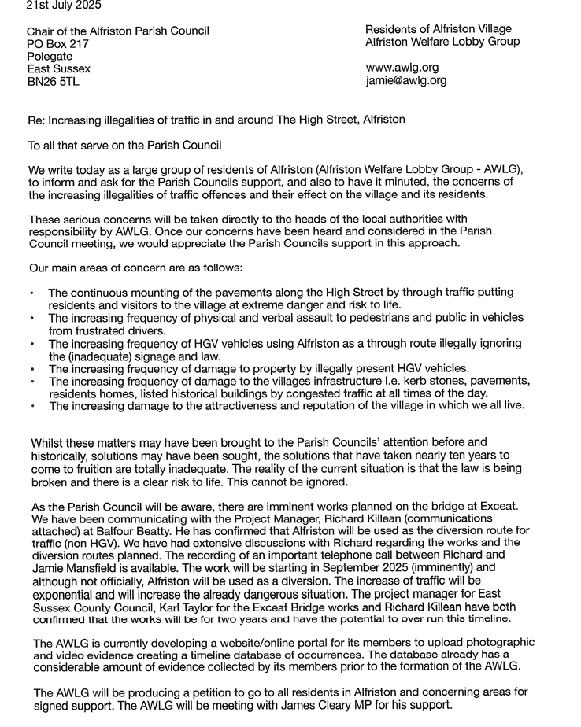
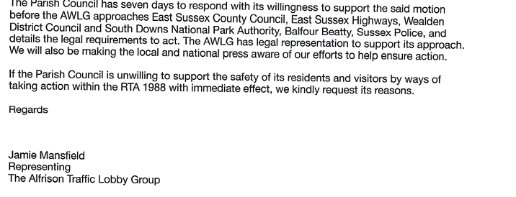
From: clerk@alfristonparishcouncil.org.uk <clerk@alfristonparishcouncil.org.uk>
Sent: 28 July 2025 11:44 cc: APC Cllrs
To: jamie@awlg.org.
Subject: APC REPLY TO ALFRISTON WELFARE LOBBY GROUP
Dear Alfriston Welfare Lobby Group,
Increasing Traffic Offences in and around The High Street, Alfriston.
Thank you for your letter (copy attached) which was presented to the Parish Council at the July meeting.
Alfriston Parish Council can certainly appreciate your frustrations as APC have spent over a decade campaigning on this issue. This has included collection of evidence, public meetings, petitions, community surveys and calls for ideas to improve the situation. These ideas were collated and presented to ESCC Highways who have trialled some solutions and carried out safety audits of proposals. The traffic calming measures that have recently been installed were agreed by ESCC Highways having met their statutory obligations, guidelines and safety criteria.
With regard to the lack of enforcement we agree this is a major concern and have raised this with Sussex Police. APC invited the Sussex Police Neighbourhood Policing Team to attend the Annual Parish Assembly in April to discuss this, they stated how important it is that any traffic offences are reported by the public to Operation Crackdown on www.operationcrackdown.org or call 101. This is to ensure that Sussex Police have a record of all offences taking place. At the April meeting Sussex Police advised that there had been no incidents reported, therefore they were unaware of any issues. We urge you to pass your database of incidents to Operation Crackdown, so that these can logged with the Police and to advise your members of the importance of reporting incidents directly to Operation Crackdown, or to call 101. Our local PCSO Issac Wood is holding a ‘Meet & Greet’ session for residents on Sunday 10th August between 1-2pm on The Tye, where residents can discuss their concerns. The Parish Council will be advertising this throughout the village. PCSO Issac Wood can also be contacted via the Wealden Neighbourhood Policing Team at Hailsham on https://www.sussex.police.uk/area/your-area/sussex/wealden/alfriston-alciston-berwick-ripe-and-chalvington/about-us or tel. 101.
County Councillor Stephen Shing did advise at the Parish Council meeting that the Exceat Bridge will only be closed for 19 days during the whole of the works and at all other times traffic will be able to pass through. This will limit the amount of traffic being diverted through Alfriston to a very short window.
We hope you find the above information useful and wish the Alfriston Welfare Lobby Group every success in your endeavours.
With kind regards
Suzanna
For and on behalf of Alfriston Parish Council
Mrs Suzanna Dry CiLCA Clerk and RFO
Appendix B - MP’s Update
Local Roads - A259 Follow up from my question to the Prime Minister and safety improvements on Avis Road.
I was glad to present the petition calling on East Sussex Council alongside Vera Zakharov to immediately implement a safe crossing point on Lewes Road in Newhaven between Lawes Avenue and Robinson Road. This is following a girl being injured here. I raised this with the Prime Minister, who agreed to look into this personally, and I look forward to working with him on this. Until the work is done this will continue to be an ever-present risk.
After months of pushing, I’m really pleased to share that East Sussex County Council has agreed to reduce the speed limit on Avis Road to 30mph – and deliver new safety measures for pedestrians. This is a big win for our campaign and for local people who’ve been calling for action. The new plans include:
- A new pedestrian island to make crossing the road safer
- A new stretch of pavement linking to the southbound bus stop
- Better access for people walking to Drove Ponds and Drove Park
These improvements really matter – as they make it safer for families, older residents and everyone trying to get around on foot or by bus. Huge thanks to local Lib Dem councillor Corina Watts, who’s been brilliant throughout – and to all the residents who raised this with us. Your voices made the difference. We’ll keep a close eye to make sure the plans are delivered properly – and we’ll keep pushing for road safety improvements wherever they’re needed.
School Visits
Recently I have visited several schools across the constituency and saw all the amazing different things they are doing. I was honoured to be invited to Chyngton Primary School to celebrate their Parent Teacher Friends Association's (PTFA) success in securing a donation of £10,000 from the Morrisons Foundation. The grant funded a new Trim Trail which will be used for outdoor play activities at the school. This will be a fantastic resource for promoting active play and a healthy lifestyle among the children. Thank you to Sophie Carpenter the Community Champion at the Morrisons in Seaford, and the school for inviting me; it was a privilege! It was lovely to be invited to the opening of the Grow Community Garden at Willingdon Primary School. It was fascinating meeting all the children and learning about plants and their new garden, which will be enjoyed by pupils for years to come. I was also able to talk to them and teach them a little bit about being a politician.
It was great to visit Seaford Head School and talk to the students there. I had the privilege of meeting some of the very switched-on history and politics students. We discussed (among other things): Changing the voting system, Lowering the voting age to 16, The sewage crisis in our local waterways. Finally, it was fun to visit Seaford Primary and play football with some of the year 5s. I was really impressed by the children’s skill and their ability to work as a team! Best of all, I even scored a goal! Unfortunately, this sporting prowess came at a cost the next day.
WASPI
I spoke in a debate about the Women Against State Pension Inequality campaign (WASPI). This government, like the previous one, is treating WASPI Women atrociously. These women were completely blindsided by the government increasing the state pension age, despite having paid into the system their entire working lives. They deserve better than this, which is why I am campaigning for them to receive compensation for their lost years of retirement. Having campaigned for them for years, it is disgraceful that now the Labour party has the power to right this wrong, they are now doing the exact opposite and taking these women to court.

Personal Independence Payments Cuts
I have spoken in parliament against the governments proposed changes to welfare, in particular their cuts to Personal Independence Payments (PIP) This is something I strongly oppose. The government's 'tough choices' seem to only target those of us in society who are having the toughest time. This has been something I have been persistently raising in parliament by questioning the relevant ministers to try and get them to show some humanity. The government should be helping the most vulnerable in society, not picking on them. I am glad their backbenchers were able to make the government reconsider.

Local Government Reorganisation
There have recently been rumours about the redrawing of Brighton & Hove’s boundaries. The government's plan for local government is centralisation by stealth. They are giving themselves more power at the top whilst taking powers away from local people here in Sussex. This is a dangerous step, which is bad for our democracy, local services, and residents. Our communities must not lose their voice. We’ve seen Brighton try to shift its problems onto us before — we can’t let that happen again. I understand the need for Brighton to grow but going west makes more sense than going east.

Royal Mail Fail
I’ve criticised Ofcom for letting Royal Mail off the hook after they announced they’ll allow second-class deliveries to be scrapped on Saturdays and cut back during the week. This will leave so many people across Seaford, Lewes, Newhaven, Polegate and our villages in the lurch. I have heard a lot from residents fed up with delays to their post. Local posties do a brilliant job despite leadership that keeps failing them. Instead of giving those at the top a free pass, Ofcom should be holding Royal Mail properly to account. People shouldn’t have to just grin and bear it – Our communities deserve a reliable postal service.

Hyperemesis gravidarum
I asked the Prime Minister about Hyperemesis Gravidarum (HG). A pregnancy condition that can mean vomiting more than 20 times a day. It causes extreme physical discomfort, acute malnutrition, and severe dehydration, with profound and long-lasting mental health consequences. Fortunately, there is a treatment, Xonvea. An anti-nausea drug that is available through the NHS. Unfortunately, its availability is not universal, and women face a postcode lottery when it comes to access. I am glad the Prime Minister has agreed to arrange a meeting between me, campaigners, and the relevant minister so we can hopefully improve access to this life saving drug.

Media interviews
My question on Hyperemesis Gravidarum was reported on by Sky News. I was also on BBC South East talking about Special Educational Needs & Disability provision in Sussex and the South East. BBC Radio Sussex interviewed me about the proposals for local government boundaries where I set out my view opposing Brighton’s eastward expansion.

Summer Tour
I look forward to visiting Alfriston on the 5th August and discussing any issues the parish may be facing.

Appendix C - Update from Cllr Stephen Shing ESC
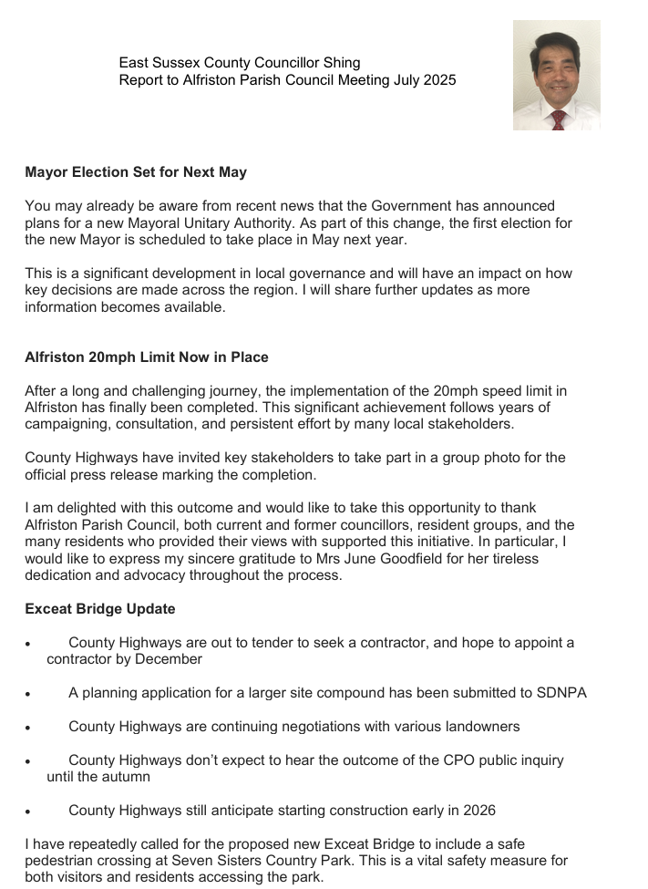
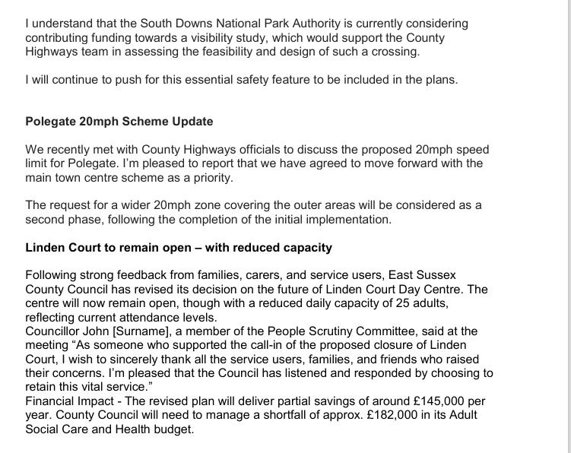
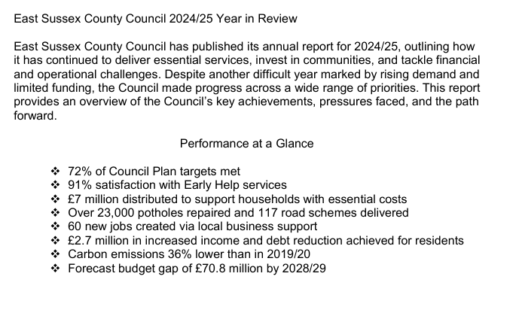
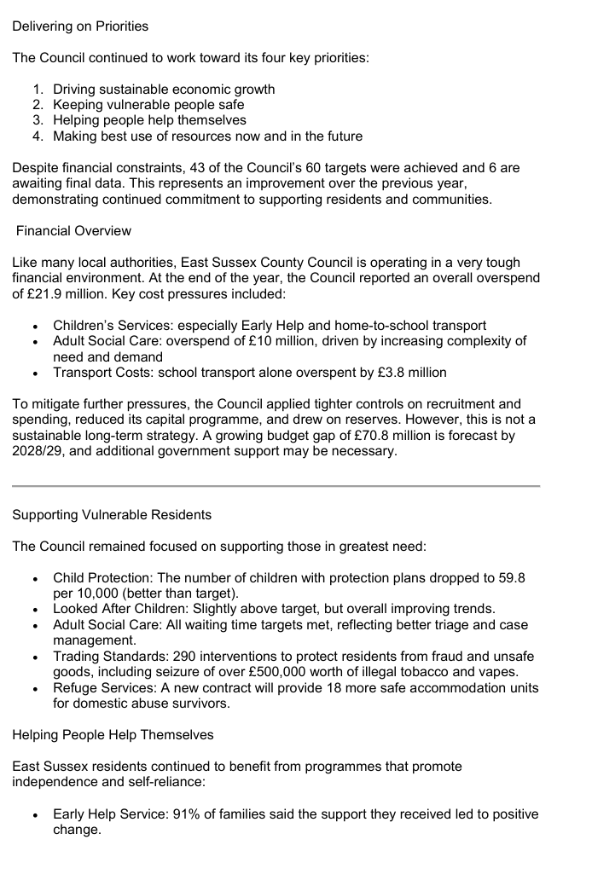
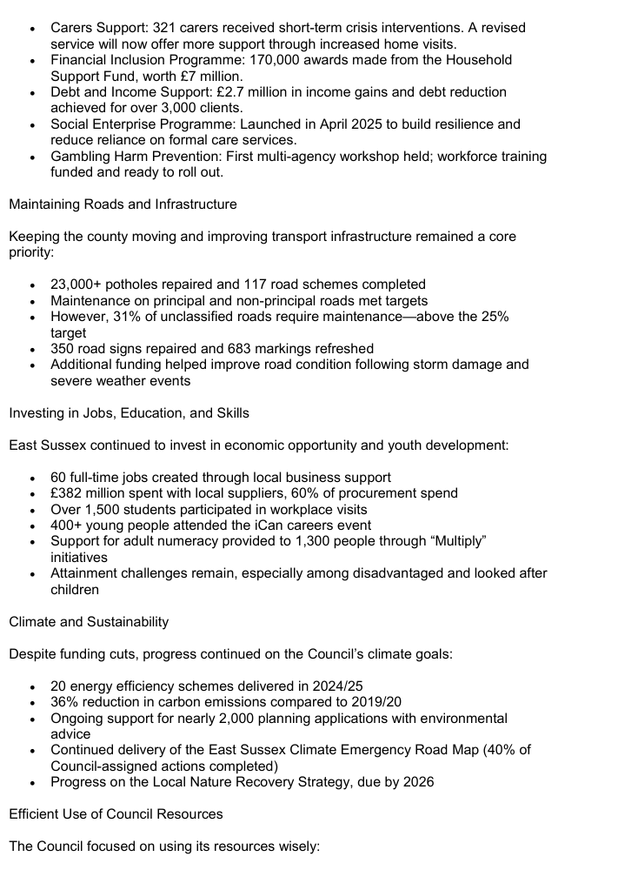
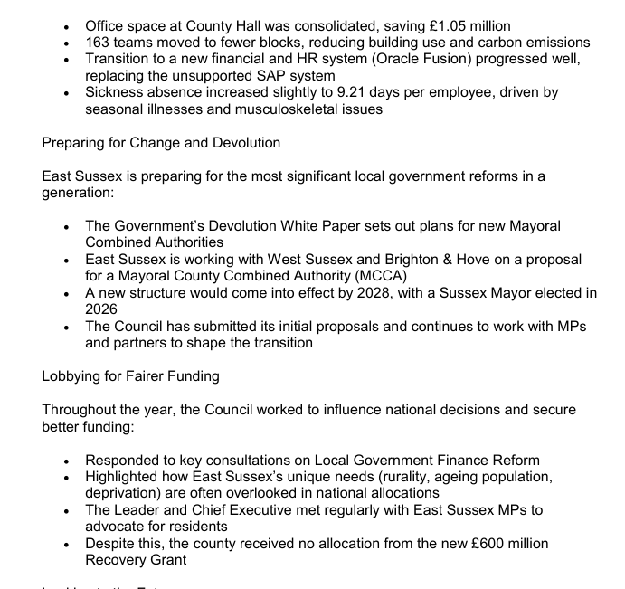
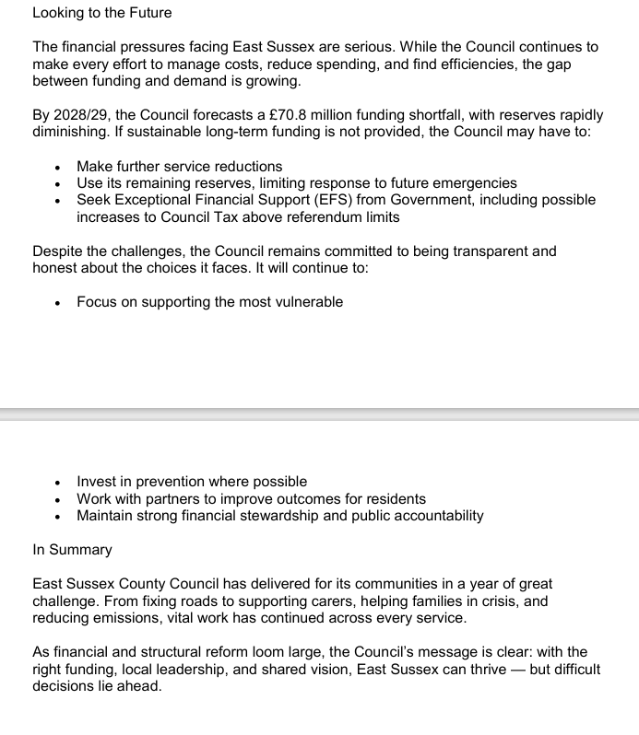
Appendix D - Update from Cllr David Greaves, WDC

Report – Alfriston PC - Monday 21st July 2025

- Rural Services Network and BT Digital Switchover
The RSN hosted a BT Digital Switchover Event in June.
This was an extremely informative session and BT’s presentation by Chris Hockley might be of interest to anyone in the Ward who relies on a care alarm and the current analogue telephone line connection. Things are changing (going digital) and there is an explanation of the safeguards that are being put in place for residents. To access the video recordings, presentations and useful links from the event, please click on the following link: https://rsnonline.org.uk/16-06-25-member-induction-and-bt-switchover-event Chris Hockley’s presentation is the 3rd item down accessible through the above link:
To request a BT Digital switch over, online event in your area, contact: East England, London & South East – Chris Hockley - Christopher.hockley@ee.co.uk
- Council climbs to fourth place in climate rankings
Remarkable improvements have been nationally recognised for Wealden District Council as a climate action leader according to an assessment that took place between July 2024 and March 2025.
Climate Emergency UK is an independent organisation that supports and empowers both councils and communities to drive local climate change action. The organisation assessed councils across the UK on the steps they are taking to reach net zero.
The independent assessment evaluated councils on the steps they are taking to deliver climate action and consisted of up to 91 questions, across seven different key areas including planning and land use, buildings and energy, and community engagement - each council was marked against the criteria.
Wealden District Council has made a 20% improvement since 2023, ranking fourth among district and borough councils in the climate change scorecards. This achievement reflects the council’s growing commitment to addressing the climate crisis through clear policy, strong leadership, and meaningful local action.
The council also outperformed the national average in five out of seven categories, including standout results in planning and land use and buildings and heating, critical to long-term emissions reduction and climate resilience.
A Wealden council spokesperson said, “We’re proud to see our continued efforts on climate action recognised at a national level. These results reflect the hard work happening across the council and the district to make sustainability part of everything we do — from planning and biodiversity to how we engage with our communities. It’s encouraging to see real progress that benefits both the environment and the people who live and work in Wealden.”
This recognition highlights Wealden’s growing commitment to climate leadership, embedding sustainability into local policy and working collaboratively with residents, businesses, and partners to build a greener future.
For further information please contact:
Nichola Watters, Head of Planning, Policy, Climate Change & Economy, WDC
Email:
Sian Killean, Media & Communications Officer, WDC, T: 07970233321 sian.killean@wealden.gov.uk
- Emergency Planning
A cyber security exercise was held this week to test all of the council’s service areas’ Business Continuity Plans. The event was well attended with staff engaged in the exercise and it was a good opportunity to test resilience and those BCPs in the event of a cyber-attack.
- SE Water – Newsletter – 4th July 2025
See link: https://mailchi.mp/southeastwater/your-latest-news-from-south-east-water-13938659?e=6ceda631e9
- National Park’s Local Plan Review takes another step forward
The process of reviewing the South Downs National Park’s Local Plan continues at pace after more than 3,700 comments were received to a consultation.
The National Park Authority has been analysing all the feedback to the consultation that was held between January and March as it prepares for the next stage of the Local Plan Review. The award-winning South Downs Local Plan is being updated to ensure it addresses important issues such as nature recovery, climate change, affordable housing and helping local communities thrive.
Earlier this year more than 1,000 people visited 20 consultation events across the National Park and over 10,400 people viewed the online consultation. More than 1,900 individuals responded to the consultation, making 3,714 separate comments.
Following a meeting of the National Park’s Planning Committee last week, the next stages have been agreed:
- In response to the first consultation, 28 new sites were put forward to the Authority to consider for development. In addition to this, further feedback was submitted regarding 38 existing sites that the Authority had previously excluded or rejected in the Land Availability Assessment (LAA). An updated LAA, outlining the Authority’s assessment of potential sites for development, will be published this autumn and inform the next consultation in 2026.
- Further engagement with National Park Parishes will take place during the autumn about any proposed changes to potential site allocations.
- All the feedback so far will be considered as the Authority prepares the next stage of the Local Plan Review, with the second public consultation taking place between May and July 2026.
- Submission of the revised Local Plan to the Government’s Planning Inspectorate is expected in the autumn of 2026 and full adoption as planning policy by the National Park Authority in 2027.
Tim Slaney, Director of Planning at the National Park Authority, said: “I’d like to thank every person and organisation who took the time to respond to the first consultation as we carefully shape this updated Local Plan.
“This Local Plan Review is the framework for the future of this incredible National Park. It shapes where and how development takes place, ensuring we conserve and enhance its wonderful landscape, wildlife and heritage, whilst enabling villages and towns to flourish. We’ve had a real variety of responses, with broad support for policies around nature, climate and community facilities, for example, while housing and viticulture attracted mixed views.
“We’re working diligently and methodically through the various formal stages of the process and look forward to engaging further with the public, parishes, landowners and partner organisations.”
The Authority will be preparing several studies and evidence documents over the summer to support the next version of the Local Plan going out to consultation.
All comments so far have been registered and any personal information redacted, and published to view on the consultation platform at https://sdnpalocalplanreview.commonplace.is/
Summaries of the feedback by policy and site allocation are also available to read at www.southdowns.gov.uk/local-plan-review
Planning Policy Team T: 01730 814 810 E: planningpolicy@southdowns.gov.uk

