ALFRISTON PARISH COUNCIL
www.alfristonparishcouncil.org.uk
CLERK TO THE COUNCIL Alfriston War Memorial Hall
Mrs Suzanna Dry CiLCA Old School House
Tel: 07936 904743 The Tye, Alfriston, BN26 5TL
E-mail: clerk@alfristonparishcouncil.org.uk 27th June 2025
Minutes of a meeting of Alfriston Parish Council (APC), held in the Alfriston War Memorial Hall on Monday 16th June 2025 at 7.15pm
__________________________________________________________________________________
Present:
Cllr D Monteath-Wilson (Chair) Cllr N Parkinson
Cllr J Watkins (Vice Chair) Cllr J Spring
Cllr R Embry

In attendance:
Mrs Suzanna Dry – Parish Clerk & RFO
There were approximately 6 members of the public present.

45. Chair’s Welcome

The Chair welcomed everyone to the meeting and thanked them for turning out on such a lovely evening. Our PCSO Issac Wood had been invited but was unable to attend due to shift patterns. He has been given a list of future meetings and will let the Clerk know which ones he can attend. The Chair encouraged Cllrs to put items they are going to cover in their report on the agenda, so the public can see what will be discussed. Please let the Clerk know.

46. Public Questions
There were no public questions.

47. Apologies for absence
Apologies were received from Cllr Adrian Harris and Cllr Stephen Shing, ESCC.

48. Update from MP
James MacCleary’s report was read out at the meeting and a copy is attached to the minutes. Appendix A.

49. Update from Cllr Stephen Shing – East Sussex Council
Cllr Shing had sent through his report and the Clerk read this out. A copy is attached, Appendix B.

50. Update from Cllr David Greaves - Wealden District Council
Cllr Greaves presented his report to the meeting. A copy is attached to the minutes. Appendix C.

51 . Declaration of interest
Cllr Watkins declared an interest as she is a member of AEG & Heartstart. Cllr Parkinson declared an interest in allotments.
52. Minutes
Cllr Parkinson proposed and Cllr Spring seconded a motion that the unadopted minutes of the APC monthly meeting held on 19th May 2025, were a true and accurate record. It was unanimously RESOLVED that the Chair duly sign the minutes as an accurate record.

Cllr Watkins proposed and Cllr Embry seconded a motion that the unadopted minutes of the APC Annual meeting held on 19th May 2025, were a true and accurate record. It was unanimously RESOLVED that the Chair duly sign the minutes as an accurate record.

53. Finance
To approve the Statement of Finances for June 2025 as attached to the Agenda. Cllr Watkins proposed & Cllr Embry seconded a motion these be approved. This was unanimously RESOLVED.

54. Report on Highways & Twittens – Cllr Embry
Update on Roadworks:
ESCC roadworks – Implementation of 20mph speed limit in Alfriston Works are now largely complete. Most signs have been changed with final installation expected tonight 16th June; new gates have been installed at the north and south of the village, along with the addition of high friction surfaces; and road markings have largely been completed (in the correct colour heritage primrose paint!). Councillor Shing (ESCC) has advised that the final road markings along Whiteway (outside The Alfriston) are to be completed as soon as possible. I am pleased to report that the communication between Claire Scriven (Balfour Beatty for Highways) and APC was very good throughout the works.
Business Open as Usual Signs
Following a conversation Claire Scriven had with a local business owner, she requested that the APC ‘Businesses Open As Usual’ signs were put out for the duration of the works. APC made the relevant request to AEG, who deployed the signs on Tuesday 10th June. Unfortunately, David Lewis was challenged for this action by the contractors who advised that in order to erect the road signs a ‘streets and works’ licence is required. This was relayed to Claire who was apologetic, and spoke with her team to ensure they were aware that the request had come from her.
Whilst there has been a blanket approval notice provided in the past, due to lack of continuity in staff, to avoid this situation going forward when APC is approached to deploy these signs we will follow the procedure below:
~ Ensure written approval / permission has been provided by ESCC Highways
~ Request that this is shared with the contractors
~ Share the written approval with AEG so they have this to hand if challenged
I would like to take this opportunity to again thank AEG for its support with this.
Flood Risk
At the start of the roadworks, David Lewis raised AEG concerns regarding the debris from the recent cut-back of vegetation around the flood-risk areas. I raised this with ESCC Highways, and consequently they carried out a 'thorough cleanse of the carriageway edges following the extensive vegetation clearance opposite the hotel [Dean's Place].' As this section of the road is within a flood zone, the project manager also arranged 'for the newly exposed gullies opposite the hotel and those in front of the hotel (and on the bend opposite the campsite) to be jetted' as part of the final completion of the works.

We were very pleased that this was factored in, and hope that AEG concerns have been alleviated.
Old Alfriston boundary sign
I spoke with Claire regarding the old boundary sign at the north of the village that has been replaced, and she arranged for the sign to be delivered to my home. I have this in my garden, and would like to hear from councillors if they have any suggestions for its use. I would like to thank Cllr Parkinson for bringing this to my attention, I know that he mentioned we could display the sign somewhere, or perhaps raffle / auction this off if someone wanted it. We could discuss where the proceeds would go to / be donated to.
- Councillors AGREED to open this up to villagers, to decide on the fate of the sign, and this could be a discussion for the next coffee conversation. I will continue to house this until a decision is made in the coming months.
Action Points following the meeting on 16th June:
- Councillor Parkinson advised that a sign remains in place on the High Street referring to parking stipulations for a single yellow line (outside The Star). As the single has now been replaced with double lines, I have emailed Claire Scriven to request that this sign is removed / replaced with the correct signage for double yellow lines.
- I have asked Claire Scriven to provide dates for the completion of the road markings outside The Alfriston.
- Councillor (Chair) Monteath-Wilson requested that the new Highways procedure for the use of 'Businesses Open as Usual' signs be shared with Claire Scriven, which has been done.
55. Report on Allotments & Recreation Ground – Cllr Vacancy

Update on removal of rubble from allotment plot – Cllr Spring confirmed he has been given permission from the plot holder to remove the rubble. The Clerk will arrange to meet Cllr Spring at the allotments to point out the plot.

Allotment Signs - Cllr Spring and Cllr Parkinson volunteered to put up the new allotment signs on each gate. The Clerk will hand over the signs to Cllr Spring when on site at the allotments.

Vacant Plots – grass cut. The Clerk informed Cllrs that the grass on vacant plots had grown extremely high and was now impacting on neighbouring plots. The Clerk requested that Cllrs agree to a one-off cut to bring this problem under control and ensure vacant plots are more appealing to prospective plotholders. This was unanimously AGREED and the Clerk was asked to progress this. Action point 1. The Chair proposed that we advertise vacant allotments in the Cuckmere News, Alfriston Hub and inform Seaford Town Council. Priority will of course be given to villagers. This was unanimously AGREED. The Clerk was asked to e-mail details accordingly. Action point 2.

Update on repair to wood on playground fort - The Clerk confirmed Wickstead had instructed this to be repaired under warranty and during her playground inspection last week found it to have been replaced. This is good news as the yearly ROSPA inspection is due to take place in June.

The Chair thanked the Clerk for carrying out this extra work while we have a councillor vacancy for this portfolio.

56. Report on Public Transport & Environment – Cllr Harris
In Cllr Harris’ absence, the Clerk read out his report as follows:
Environment.
I have only two matters to report on this month.
At the meeting in May, I mentioned that I had been notified by Southern Water that they had discharged foul water at Seaford following what seemed to me to be minimal amounts of rain.
I wrote to express my concern, and have received a reply, the relevant part of which is below:-
Our Rivers and Seas Watch Team have confirmed:
“The data we use is collated by Storm Harvester and is hyper localised rainfall from rain radar every 30 mins. Outside of 11, 12 and 24 May, it was relatively dry, but the site was hit by some short intense rainfall that resulted in the 3 spills. All the spills met the pass forward rate and were consented storm discharges.” David Brown, Service Improvement Team.
I cannot say that the response leaves me feeling any wiser, but I will ask them what their records show the actual amount of rain that fell in the periods of ‘short intense rainfall’ to have been.
A query was raised at the last meeting about the two piles of spoil left following the dredging works downstream from the White Bridge. I have received the following reply from Revai Kinsella :-
Hi Adrian,
We are planning to work on the spoil once it has dried. It was still too wet when we worked on the embankment in April.
It's most likely going to be in August/early September when we come back.
Thanks Revai Revai Kinsella, Area Mgr, Water Management Alliance

57. Report on Strategic Planning – Cllr Parkinson (attached to the Agenda)
To ratify the decision to adopt the new Emergency Telephone number. Due to time restraints, Cllrs had unanimously AGREED by e-mail to adopt the new emergency telephone number of 01323 692455. This number was being provided by Cllr Spring at no charge to the council. Cllr Spring was asked to provide the Clerk with details of the provision for the number. Action Point 3.
To discuss and resolve the Emergency Plan - Cllr Parkinson’s report was attached to the Agenda. APC and AEG had an informal meeting to run through the draft risk register for the Emergency Plan. Cllr Parkinson will update the plan with this information and hope to have the plan up on the website soon, with hard copies available from the Clerk.

The approximate cost of distributing the A4 leaflet to all households in the village is £125.00. It was unanimously AGREED to go ahead with this. (Since the meeting the cost has been confirmed at £110.00).

The Chair thanked Cllr Parkinson for all his work putting the Emergency Plan together.

58. Report on Tye – Cllr Spring (attached to the Agenda)
To discuss and decide on repair to Tye Rd - Cllrs unanimously AGREED that the sunken area needs to be repaired. A quote from Hailsham Roadways has now been received , costing £4,580.38 + vat with a contingency sum of £2,000.00 recommended as it is not known what has caused the damage and therefore what extra work may be required. There is just under £2,000.00 in the Tye Rd Surface reserve budget leaving a shortfall of £2,500.00 plus £2,000.00 contingency. Cllr Spring stated that there was a reserve budget in the High Street Traffic Plan of £12,000.00 where we were expecting to have to contribute towards the cost of the recent traffic management plan, but that was not required. Cllr Spring therefore proposed the motion that the shortfall of £4,500.00 be taken from the High Street Traffic Plan reserves. Cllr Watkins seconded the motion. This was unanimously AGREED.

The Clerk confirmed that for any expenditure over £3,000.00 we need to obtain three quotes. Cllr Spring will seek two more quotes and report back to the next meeting. Action point 4.

Update on broken bollard - The Clerk had requested a quote to replace this from the company that supplied the other wooden bollards, however they no longer provide these. The Clerk will seek other suppliers and report back. Action point 5.

Water Leak - Cllr Spring thanked the Gun Room and Gayle Hudson for their efforts in chasing this in addition to himself and the Clerk. This has now been repaired by Southern Water and confirmed that it was the clean water supply to the pumping station.

Outdoor Pursuits Event - Cllr Spring updated the meeting that Cadence would be organising and insuring this event. The date currently being looked at was Saturday 24th May but this is not yet confirmed. Cllr Spring will report back at the next meeting. Action point 6.

59. Report from Planning Committee – Cllr Watkins.
59.1 Applications considered by APC Planning Committee since the last meeting.

Ref. No: SDNP/25/01862/LDE Pleasant Rise Farm, Cuckmere Rd BN26 5TN.

Upper Barn to continue as a dwelling without restriction No decision

(name of building did not match up with plans).

Ref. No: SDNP/25/01755/TCA 24 Saffron Gardens BN26 5XQ. Application Removed.

T1 Holm Oak. Reduce the Crown.

Ref. No: SDNP/25/01187/CND The Bakehouse, Whiteway, BN26 5TS. No decision

Variation of Condition 2 (No decision as there was no detail on what Condition 2 refers to).

59.2 Applications notified or awaiting decision from SDNPA - None

59.3 Enforcement updates from SDNPA - None.

60. Reports from Outside Bodies
60.1 Heartstart - Cllr Watkins repored that out of the Clubs & Societies Day, three people have expressed interest in becoming responders, their details have been passed on to the Eastbourne Group. There is also a lot of interest in another defibrillator course and Heartstart are looking at arranging this for September.

60.2 Alfriston Emergency Group - David Lewis said it was good to work with APC on the Emergency Plan and thanked Cllr Parkinson for pulling it all together.

60.3 Flood Forum - Nothing to report.

60.4 Neighbourhood Watch - No report. Although weekly reports continue to go out with through the Neighbourhood Watch e-mail listing.

60.5 Twinning Committee - Report read out at the meeting (as attached to the Agenda).

60.6 St Andrew’s Church - No report. The Chair confirmed that although Christian has now moved on, David our Curate is still with us.

60.7 Clergy House - No report.

60.8 Alfriston War Memorial Hall - No report.

60.9 Speedwatch - Stephen Rabagliati has queried with our PCSO when Speedwatch can re-start in the High Street and was told it was 3 months after the new signage is in place.

60.10 Events -
Dog Show on Sunday 24th August, Gayle Hudson reported that this will be arranged and insured by the organisers and confirmed a copy of the Public Liability Insurance and Risk Assessment will be given to the Clerk prior to the event. The Church will be carrying out the Blessing of the Animals at 10.30am followed by the Dog Show, which will also include a fete with music and stalls. There will be a £2 entry fee for the Dog Show, with any surplus money being given to Friends of St Andrew’s Church.
Car Boot Sale, Gayle Hudson reported this will not be going ahead and AEG confirmed this.

61. Correspondence to The Clerk – Asking for permission from the council.
Saturday 31st May - To ratify the decision to give permission for gazebos on The Glebe at a public event. Due to time restraints, Cllrs had unanimously given permission for this via e-mail.

To ratify the decision to give permission for A board poster on Market Square for the village Showcase Day on 31st May. Due to time restraints, Cllrs had unanimously given permission for this via e-mail.

62. Public Questions
The Chair closed the meeting at 8.25pm and opened the floor to public questions. The meeting was then re-opened at 8.30pm.

63. Date of next meeting – The next monthly meeting will be held on Monday 21st July 2025 in the AWMH at 7:15pm

The Chair closed the meeting at 8.32pm

Please see Appendices attached below and\or on the website

Appendix A - MP’s Update
James MacCleary MP report June 2025
A259 Update Recently I met the Roads Minister to press her ahead of the Government Spending Review, for the much-needed improvements to the A259 through central Newhaven and Seaford, including improvements that were recommended in the Major Roads Networks study at key A259 accident blackspots like the junction with Bishopstone Road. Unfortunately, as I’ll come on to - there was no new money announced during the review speech. East Sussex County Council has confirmed though that plans for the new eastbound bus lane that would have cut across the Sainsbury’s junction has been scrapped. I will continue lobbying Minister’s to take this issue seriously.
Spending Review The Spending Review was disappointing for us in the South East, with not one project announced or supported locally. Our roads are choked, our railways are unaffordable and local services underfunded and broken. While the NHS spending is welcome, without fixing the crisis in our social care sector, I fear it will not achieve the outcomes we all desperately want. Sussex shouldn’t be an afterthought for Ministers.
Youth Services I was sad to hear news that the Youth Club in Newhaven was closing its sessions after the recent combination of the Minimum Wage and National Insurance Contributions rises. Too many local organisations are being penalised for doing the right thing – creating jobs and supporting young people. It’s not right. We need proper, long-term funding for youth services – so that our young people get the best possible start in life. I have spoken about this in the House and will continue fighting so that our young people get a fair deal.
HMP Lewes I recently raised concerns about the prison in the chamber, in regards to the report of high levels of violence, drug misuse and alarming levels of self-harm. The Minister has assured me that the site continues to make improvements under the charge of the new Governor and will be keeping me up to date on progress made. I am keen to make sure that our prison staff are safe, backed up and that our community is kept safe.
Road safety around Schools I receive numerous reports from residents about dangerous parking or driving around schools and am glad to see parents at Chyngton Primary in Seaford starting a petition to highlight their concerns and demand action. The County Council must do more to keep our children safe. I have seen the dangers faced by children in Ditchling and Polegate when walking to and from school first hand, it’s unacceptable that this issue is not being addressed with the seriousness that it deserves.
Local Government Reorganisation There is a consultation now underway open until the 23rd of June and I strongly encourage you to participate and share the opportunity to have your say with your residents. Please visit the below website to take part: https://www.smartsurvey.co.uk/s/EastSussexLGR/
Constituency Visits As well as looking forward to my summer recess tour, recently I have been to our local Ridgeview winery to hear about the fantastic contribution they make to Sussex’s wine industry; attended the Seahaven Business Awards; have visited local schools like Ringmer Primary to take questions from pupils; as well as visiting local charities like Lewes Homelink to hear about the excellent work they do.

Appendix B - Update from Cllr Stephen Shing ESC
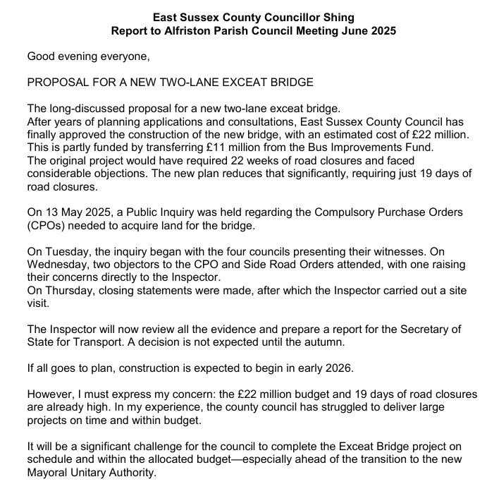
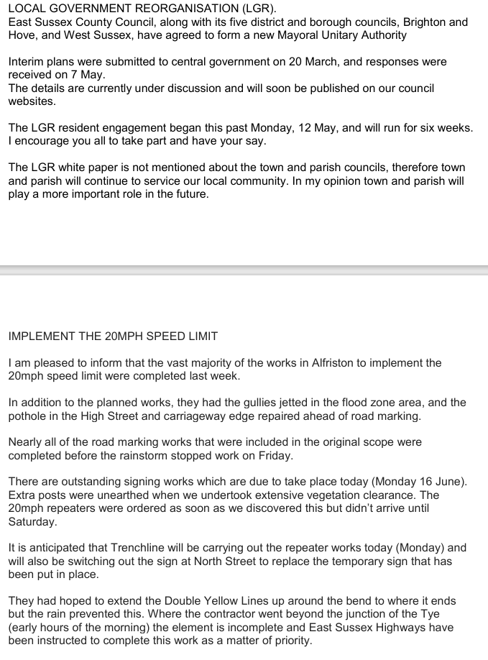

Appendix C - Update from Cllr David Greaves, WDC

