ALFRISTON PARISH COUNCIL
www.alfristonparishcouncil.org.uk
CLERK TO THE COUNCIL Alfriston War Memorial Hall
Mrs Suzanna Dry CiLCA Old School House
Tel: 07936 904743 The Tye, Alfriston, BN26 5TL
E-mail: clerk@alfristonparishcouncil.org.uk 24th November 2025

Minutes of a meeting of Alfriston Parish Council (APC), held in the Alfriston War Memorial Hall on Monday 17th November 2025 at 7.15pm
__________________________________________________________________________________
Present:
Cllr J Watkins Cllr N Parkinson
Cllr R Embry Cllr S Rabagliati
Cllr A Harris Cllr J Spring

In attendance:
Mrs Suzanna Dry – Parish Clerk & RFO
There were approximately 4 members of the public present.

183 . Chair’s Welcome

In Cllr Monteath-Wilson’s absence, Cllr Watkins Chaired the meeting and welcomed everyone.

184. Public Questions
There were no public questions.

185. Apologies for absence
Apologies were received from Cllr Monteath-Wilson.

186. Update from MP
James MacCleary’s report was read out at the meeting and a copy attached to the minutes. (Appendix A).

187. Update from Cllr Stephen Shing – East Sussex Council
No report from Cllr Shing. This will be circulated once received.

188. Update from Cllr David Greaves - Wealden District Council
Cllr Greaves presented his report to the meeting. A copy is attached to the minutes. (Appendix B).
John Hurwood of the Flood Forum, asked Cllr Greaves about available grants. The Clerk will send John Hurwood details of the Councillor Ward Budget Scheme grants that are currently available, as detailed in Cllr Greaves October report Action Point 1. Cllr Spring will liaise with Wealden for any other grant opportunities. Action Point 2.

189 . Declaration of interest
Cllr Watkins declared an interest as she is a member of AEG & Heartstart. Cllr Parkinson declared he has an interest in allotments.

190. Minutes
Cllr Harris proposed and Cllr Embry seconded a motion that the unadopted minutes of the APC Monthly meeting held on 20th October 2025, were a true and accurate record. It was unanimously RESOLVED that the Chair duly sign the minutes as an accurate record.

191. Finance
To approve the Statement of Finances for November 2025 as attached to the Agenda. Cllr Spring proposed & Cllr Parkinson seconded a motion these be approved. This was unanimously RESOLVED.

192. Coffeehouse Conversation - Saturday 22nd November.
The next Coffeehouse Conversation will be held on Saturday 22nd November, 11.00am in the Old Chapel Centre. Cllr Harris and Cllr Parkinson are leading on this. Cllr Parkinson has produced a poster and the Clerk was asked to send this out via Mailchimp and put on the website, noticeboard and A board in Market Square. Action Point 3. Cllr Parkinson will put together a slide presentation and circulate to Cllrs for comment. Action Point 4.

193. Monthly Report from PCSO
No report from PCSO Isaac Wood. This will be circulated once received.

194. Internal Interim Audit
The full report was circulated to Cllrs and attached to the Agenda, a copy is also available on the website. It was unanimously AGREED that the Internal Interim Audit Report had been reviewed and approved. The report showed no areas of concern. There were three recommendations made and the Clerk confirmed these are all in-hand. Cllr Harris thanked the Clerk for her work in ensuring all documents were available for inspection during the audit. Cllr Spring raised a concern that Cllrs cannot change the password on their council e-mail address. The Clerk will pick this up with Latitude who manage APC e-mail addresses. Action Point 5.

195. Urban Grass Cutting Service 2026/27
It was unanimously AGREED to continue with two cuts per year being carried out by ESCC, at no cost to APC

196. New Lease Agreement for Allotments
Cllrs reviewed the new lease agreement which includes a one-off deposit being held. Cllr Harris proposed and Cllr Rabagliati seconded a motion to use the amended agreement going forwards. This was unanimously RESOLVED . A copy is attached to the minutes. (Appendix C). The Clerk was asked to send the new agreement out with renewals for January 2026. Action Point 6.

197. To Ratify decision on APC Christmas Tree
Cllrs ratified the decision made by APC to agree to Alfriston Businesses sponsoring the Christmas Tree this year. And for APC to apply for and pay for the temporary licence required from ESCC Highways. The Clerk explained to the meeting that this decision had been made as it could not wait until the November meeting due to time constraints on applying for a licence.

198. Report on Highways & Twittens – Cllr Embry
Road markings - As per the discussion at last month’s meeting, I have raised a query with the Road Safety team at ESCC regarding the necessity to reinstate the central line road markings on the southern approach to the village. I have chased them, but am yet to have an update. Ref 24001397.
Mileage Signpost - The mileage signpost on the way out of the village towards Seaford has still not been replaced. However, I have chased this and been advised that it is on the Highways book of work, and will be replaced soon (ref SIG02303). There is also a temporary Give Way sign at Frog Firle that is due to be replaced.
East Sussex Highways Stakeholder Event - Our Clerk and I attended the East Sussex Highways Parish Council Engagement Event on Thursday 23rd October. The focus was on ESH and Balfour Beatty (the contractor who carries out roadworks) explaining their processes. This was a really useful event, and it is very clear that strong communications and relationship building is now a big priority. I am optimistic that this collaborative approach will lead to real improvements. Following the meeting, I raised several points with Sam Crowhurst our Customer Service Manager at Highways.
The first one was in relation to the issues we experienced with CityFibre’s poor communication. I asked her to share Network Management’s process for granting licences to third parties. An online session has been arranged to cover this topic on Thursday 20th November, which will hopefully shed more light on this topic. In this area, enforcement seems to be problematic, but I was able to get confirmation from Karl Taylor the Assistant Director, Transport & Operations at ESCC, that it is the County Council who are responsible for ensuring companies adhere to the process, therefore any concerns should rightly be raised to them.
The second item was in relation to the Beachy Head Marathon. I passed on some concerns that had been raised to me regarding the road closures, in terms of execution and safety. Following on from my point above, it is the CC’s responsibility to investigate these issues. I am awaiting feedback on this.

The third item was in regard to traffic issues, specifically HGVs continuing to incorrectly use the village as a cut through. She directed me to raise this with the Road Safety team, which I have done. I’ve asked if additional signage can be erected at the relevant points on the A27 and in Seaford, and that all satnav systems are up to date.

Cllr Rabagliati commented that he is unsure that google maps has been updated to 20 mph for the village. Myself and the Clerk believe this was actioned by Claire Scriven (Balfour Beatty) a number of months ago, but I will check this, and follow up accordingly if this has not been done. Action Point 7.

CityFibre Roadworks - Following multiple discussions between ESH and Cityfibre, the decision was made to cancel the scheduled works that involve road closures for the remainder of 2025. CityFibre will be holding a 4 hour drop in session open to the public in mid-December, where they will be able to provide residents with a clearer understanding of the works, and where any concerns and questions can be addressed.
The rescheduled works involving road closures are due to take place in January until mid-February, with the village as a whole due to be signed off for completion by the end of March.
We have asked to be included in discussions surrounding the Traffic Management Plan, so we can advise on the best routes to be used for diversions etc. We will share details with residents and traders of the plan once it has been finalised, and will provide the date of the CityFibre session once we have it.
The final point I would like to mention is regarding Business Open as Usual signs. Following discussions with Sam Crowhurst, she has confirmed that Network Management will now erect these signs for ALL roadworks that impact our village, without the need for us prompting or using our own signs held by AEG. We will monitor this closely in the next round of road closures.

199. Report on Allotments & Recreation Ground – Cllr Rabagliati
I had a very helpful handover on site with the Clerk in October. And am now carrying out the weekly playground inspections and liaising with residents who have expressed an interest in taking on an allotment. In the new year we will look at starting yearly inspections of the cricket pavilion and will liaise with the Clerk on this. Action Point 8.
200 . Report on Public Transport & Environment – Cllr Harris
Public Transport - First an apology, in my report on the meeting with Cuckmere Buses, I stated that they ran 24 minibuses. They have pointed out that the true figure is 8. This has been corrected in the minutes. Incidentally, there will be an item about Cuckmere Buses in the next edition of the Cuckmere News.
The Environment - Despite some periods of heavy rain, coinciding with very high Spring Tides, the Cuckmere has remained within its bank throughout the period.
Two trees that had been obstructing the footpath that runs down beside the campsite have been removed. On the same footpath I had noticed, and reported, a large tree that had partially fallen across the path and was only held up by a somewhat smaller tree. I am pleased to report that about three days later I came across three cheery foresters form East Sussex CC who had just finished the job of clearing the offending tree.
John Hurwood and I attended a day long event organised by Lewes Town Council, looking back 25 years to the flooding in Lewes in 2000. There were approximately 16 speakers, all excellent, looking back at the event, the causes, the actions taken then, the lessons learnt, and looking to future actions and reactions. The flooding in 2000 was the result of 8”, 200mm, of rain falling on 280 square miles of already saturated ground over a period of three days – all of which had to escape through the centre of Lewes. The key message that came through was that whilst some actions can be taken, and works done, to reduce the risk, Lewes will flood again – it has done so every 30 years on average since 1878. Thus planning and communication for flooding is essential -i.e an Emergency Plan. So credit to Councillor Parkinson and his team for the timely revision and production of our own Emergency Plan.
201. Report on Strategic Planning – Cllr Parkinson
The Emergency Plan leaflet has now been distributed to all households in the village, and my thanks to all the volunteers who helped get this done.

The Emergency Planning Officer at ESCC has responded to the Emergency Plan giving some very positive feedback and would like to meet to discuss what WDC/ESCC would do in an emergency, and how we can align our plans. Cllr Parkinson will liaise and set a date. AEG will be invited to attend. Action Point 9.

202. Report on The Tye - Cllr Spring
I was going to get renewed quotes for the dip in the Tye Rd, but will now need to wait and see when the Cityfibre roadworks will take place in the village. Once we have a schedule of work from Cityfibre, I will source quotes.

Yellow Lines on The Tye - we have run out of paint. The Clerk was asked to re-order 2 pots of paint, which should be enough to finish the job. Action Point 10.

Gritting - Cllr Spring is happy to continue with co-ordinating volunteers and carrying out gritting of The Tye Footpaths over the winter., as per last year. The Chair and Cllrs thanked Cllr Spring.

203 . Reports from Outside Bodies
203.1 Heartstart - Cllr Watkins reported that our village first responder will be able to go out alone once their training is completed after Christmas. Very pleased to advise the Eastbourne group was awarded the Kings Award for Voluntary Service. A huge congratulations to them.
203.2 Alfriston Emergency Group - No report.

203.3 Flood Forum - John Hurwood reported he had attended a meeting of the Flood Forum today. It was mentioned that APC had not paid their subscription. The Clerk was not aware of any outstanding fees but will look into this and let John Hurwood know. Action Point 11. He was able to ask the E.A. representative if there will be a spare pump that can be used in Alfriston this year, they will let him know. A multi-agency hydrological study is going to be carried out of the Cuckmere basin, looking at how to improve flooding. The Flood Forum have asked to be kept updated. There is currently no issue with shingle at the mouth of the river. The National Trust have put in a planning application to SDNPA for work at Chyngton Brooks (south of the A259 at Cuckmere Haven) with a decision due in February. This can be seen on the SDNPA website. Seaford Town Council have agreed to it. The E.A. are of the opinion this will help flooding issues upstream.

203.4 Neighbourhood Watch - No report. Although monthly reports continue to go out through the Neighbourhood Watch e-mail listing.

203.5 Twinning Committee - Report attached. (Appendix D).

203.6 St Andrew’s Church - No report.

203.7 Clergy House - No report.

203.8 Alfriston War Memorial Hall - No report.

203.9 Speedwatch - Cllr Rabagliati reported that 18 sessions have now been carried out since re-starting, with 70 speeding offences caught on camera and reported to the Police, who will follow up with letters to the offenders. Currently liaising with the Police Administrator about other sites we can use. It has been a successful month and my thanks go to our enthusiastic team of approximately 18 volunteers. The Chair thanked Cllr Rabagliati for overseeing Speedwatch.

203.10 Events - No report.

204. Correspondence to The Clerk – Asking for permission from the council.
Christmas Crafts & Fayre, Sat 13th December - (Appendix D on the Agenda). Request for an A Board Poster from 29th Nov to 13th Dec. Cllrs unanimously AGREED. Action Point 12.
Rude Mechanical Theatre - (Appendix D on the Agenda). Request for permission to perform on The Tye on Sunday 26th July 2026. Cllrs unanimously AGREED. Cllrs unanimously AGREED, subject to the usual Risk Assessment and Public Liability Insurance being in place. Action Point 13.
UK Ultra South Downs Run – Sat 6th December -- Out of courtesy organisers have advised APC the run will go through the village. They confirm noise will be kept to a minimum and Marshalls will be made aware that runners do not have priority over pedestrians.

205. Public Questions
The Chair closed the meeting at 8.26pm and opened the floor to public questions. The meeting was then re-opened at 8.30pm.

206. Date of next meeting – The next monthly meeting will be held on Monday 19th January 2025 in the AWMH at 7:15pm
The Chair closed the meeting at 8.32pm
Please see Appendices attached below and\or on the website

Appendix A - Report from James MacCleary MP
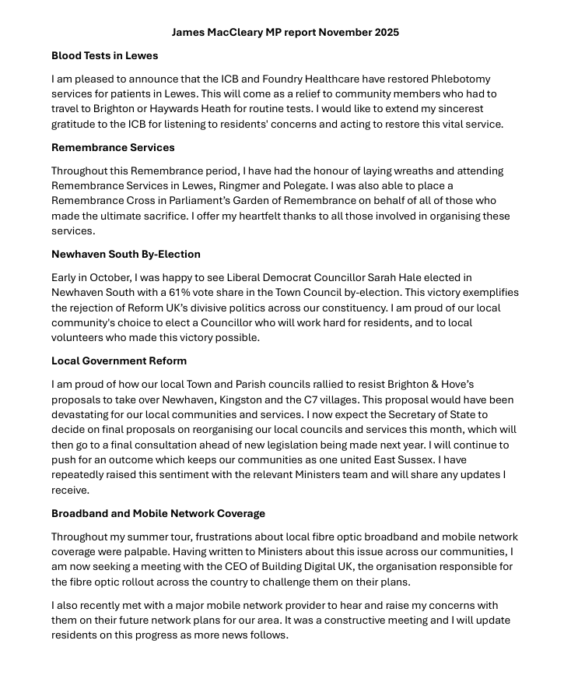
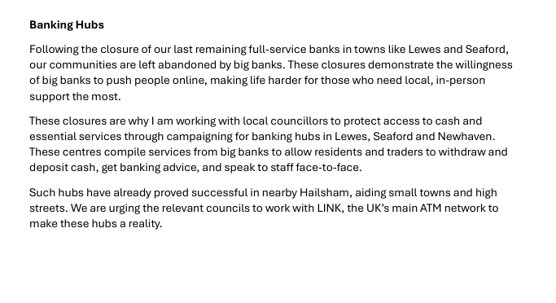

Appendix B - Monthly Report from Cllr David Greaves WDC

Appendix C - Allotment Agreement

Appendix D - Twinning Report

