ALFRISTON PARISH COUNCIL
www.alfristonparishcouncil.org.uk
CLERK TO THE COUNCIL Alfriston War Memorial Hall
Mrs Suzanna Dry CiLCA Old School House
Tel: 07936 904743 The Tye, Alfriston, BN26 5TL
E-mail: clerk@alfristonparishcouncil.org.uk 23rd October 2025
Minutes of a meeting of Alfriston Parish Council (APC), held in the Alfriston War Memorial Hall on Monday 20th October 2025 at 7.15pm
__________________________________________________________________________________
Present:
Cllr D Monteath-Wilson (Chair) Cllr A Harris
Cllr J Watkins (Vice Chair) Cllr N Parkinson
Cllr R Embry Cllr J Spring

In attendance:
Mrs Suzanna Dry – Parish Clerk & RFO
There were approximately 5 members of the public present.

144 . Chair’s Welcome

Cllr Monteath-Wilson welcomed everyone to the meeting.

145. Public Questions
There were no public questions.

146. Apologies for absence
No apologies received.

147. Update from MP
James MacCleary’s report was read out at the meeting and a copy was attached to the Agenda.

148. Update from Cllr Stephen Shing – East Sussex Council
Cllr Shing presented his report to the meeting. A copy is attached, (Appendix A).

149. Update from Cllr David Greaves - Wealden District Council
Cllr Greaves presented his report to the meeting. A copy is attached to the minutes. (Appendix B).

150 . Declaration of interest
Cllr Watkins declared an interest as she is a member of AEG & Heartstart. Cllr Parkinson declared he has an interest in allotments.

151. Minutes
Cllr Harris proposed and Cllr Embry seconded a motion that the unadopted minutes of the APC Monthly meeting held on 15th September 2025, were a true and accurate record. It was unanimously RESOLVED that the Chair duly sign the minutes as an accurate record.
152. Finance
To approve the Statement of Finances for October 2025 as attached to the Agenda. Cllr Spring proposed & Cllr Embry seconded a motion these be approved. This was unanimously RESOLVED.

153. Coffeehouse Conversations
Cllrs AGREED to hold the next Coffeehouse Conversation on Saturday 22nd November at 11.00am in the OCC. It was also AGREED that the topic would be ‘Who Does What ? A guide to the different bodies that maintain the village and how to get things done’. The Clerk was asked to book the OCC. Action Point 1. Cllrs Parkinson and Harris will lead on this with Cllr Spring giving assistance.

154. Monthly Report from PCSO
PCSO Isaac Wood’s report was read out at the meeting and a copy is attached. (Appendix C).

155. Internal Interim Audit
The Clerk reported back to Cllrs that the Internal Interim Audit had taken place last week. This is carried out by independent auditors Mulberry’s and involved a 3 hour on site meeting with The Clerk to run through APC procedures, policies and documents. The Auditor’s full written report will be circulated to Cllrs and will be an agenda item at the next APC meeting for review. There were no issues of concern.

156. Meeting Dates for 2026
Cllrs reviewed the meeting dates for 2026 and these were unanimously AGREED. The Clerk will circulate these and put on the website and noticeboard. Action Point 2.

157. Report on Highways & Twittens – Cllr Embry
Road Markings on White Way - Cllr Embry reported that these had now been completed. It is ESCC Highways policy that central markings are not put in on this section of the road, as it is believed that when there are no central road markings it makes drivers proceed with more caution. In view of the recent serious accident, Cllr Embry asked Cllrs if they wanted to take this up with Highways. It was AGREED that Cllr Embry bring this up at the next SLR meeting with Highways. The Clerk will ask for this to be added to the agenda for the meeting. Action Point 3.

Mileage Signpost - A car has knocked over the signpost on the road travelling south out of the village. Cllr Embry has reported this to Highways for them to rectify.

This Thursday the Clerk and Cllr Embry will be attending the ESCC Highways Stakeholder’s meeting, predominantly aimed at explaining their processes. It will be an opportunity to strengthen our existing relationship, meet our new Highways Service Manager and hear the challenges other parishes face.

Speedwatch - this has now re-started and Stephen Rabagliati will update the meeting under ‘Outside Bodies’. Cllr Embry thanked Stephen Rabagliati for heading this up and to all the volunteers giving their time. In conjunction with Speedwatch, it is important that residents report incidents of speeding and anti-social parking to Operation Crackdown (www.operationcrackdown.org. or tel: 101), to ensure that Sussex Police have a record of these incidents. As mentioned in the September minutes, Sussex Police have launched their ‘Safer in Sussex’ survey, which includes a section on road safety and speeding. The Clerk has put this on the APC website and sent it out on Mailchimp. We urge residents to respond. On 22nd October Sussex Police are holding a feedback session for Clerks, to discuss community safety. Our Clerk will be attending and raising the issues of speeding and parking enforcement.

Pedestrian Safety in the Village - Cllr Embry has not had any further issues raised and has had no further communication from AWLG (Alfriston Welfare Lobby Group). Following James MacCleary MP’s ‘Meet & Greet’ session in August, and his subsequent communication with the Sussex Police Traffic Team, there has been a noticeable increase in the presence of Police cars in the village.

Cityfibre Roadworks - it was very disappointing that APC didn’t receive the necessary notification on this. ESCC Highways send out notices to APC with information on road works and diversion routes, however it appears that these are no longer sent for road works carried out by third parties. It is left to the third party, in this case, Cityfibre to circulate information. Cllr Embry is picking this up with Highways and asking what the penalties are if this is not carried out. APC have asked Highways why a Works Licence was granted to Cityfibre for work on The Tye Road, as this is an unadopted road and is the responsibility of APC not Highways. We are awaiting their formal response. Cllr Embry has been given the latest information from Cityfibre regarding future road works and this has now been circulated via Mailchimp and the website. Cityfibre have advised that the majority of remaining permits are minors and should have minimal impact on the community. Once the programme is updated this will be shared with APC. Cllr Embry will ensure this is received. The Chair thanked Cllr Embry for her time and effort on this issue.

158. Report on Allotments & Recreation Ground – Cllr Vacancy
As there is a Cllr vacancy the Clerk gave an update on the following:

Allotments - A number of weed notices have been issued, giving plot holders 3 months to improve the state of their plot. These are being monitored. The water was turned off this week for the winter. We remain in credit with the water company and I have requested a refund now that the water has been turned off until March.

Playground - All issues raised in the ROSPA inspection have now been rectified and weekly inspections continue to be carried out.

159 . New Lease Agreement for Allotments
The Clerk has distributed to Cllrs an updated lease agreement for review, with an appendix to cover deposits which come into force in January. Cllr Harris had a number of suggestions which he will forward to the Clerk. Action Point 4. The Clerk was asked to bring this back to the November meeting.

160 . Report on Public Transport & Environment – Cllr Harris
Public Transport - I went to the Cuckmere Buses Stakeholders’ Meeting last Tuesday evening and was very impressed by what I heard and learnt. Cuckmere Buses is a Registered Charity with an income of over £300,000 pa. They operate a fleet of 8 vehicles, with 48 volunteer drivers, and no salaried employees. This year, anticipated passenger numbers will be 89,000, and total mileage run will be 162,000. They are the oldest community transport organisation in the country, and next year will be their 50th anniversary. They are always on the lookout for more volunteer drivers, and I discovered that there is no upper age limit!
Environment - A quiet month – lack of rain means that there have been no flooding issues. Strong winds earlier in the month brought down two trees currently obstructing the footpath beside the campsite, and I have reported these on the East Sussex Rights of Way website. I have not seen, or been told of, any other footpath issues.
I wrote to Revai Kinsella of the Water Management Alliance, complimenting her on the bank grading work, now completed, on the east side of the Cuckmere, south of the White Bridge.
As I reported to the last meeting, I will be attending a day’s forum on 31st October, organised by Lewes Town council, and titled ‘Lewes Floods. 25th Anniversary. Learning from the Past. Preparing for the Future’
I have continued my fairly fruitless campaign against Southern Water concerning storm outflows, and their latest reply to me, dated 8th October, included the following statement:- “The main driving force behind storm overflow releases is rain, and over the past year the weather has been more challenging than ever before. There has been 35% more rainfall this year than in the same period last year. With all this extra rain, and ever-increasing impermeable areas like car parks, driveways, roofs and roads, the complexity of resolving storm overflows is increasing by the day.” I have replied as follows:- The figure of a 35% increase in rainfall is clearly nonsense. Quite apart from the fact that we are now in a designated drought area, I keep a daily record of rainfall in Alfriston, which show that rainfall is actually 50% down on last year, both for the year as a whole, and for the month of September.
On climate, about 20mm of rain has fallen since the last APC meeting, and most of that on 4th October. Ardingly Reservoir is currently only at 25% of its capacity, and The Environment Agency has declared the area supplied by South Eastern Water to be officially in drought.

161. Report on Strategic Planning – Cllr Parkinson
Emergency Plan Update – The Emergency Plan phone number is now live and gets put through to the Chair, Cllr Parkinson and Cllr Spring. The Clerk has sent copies of the full plan to all stakeholders and the A4 leaflet is currently being hand delivered to all properties in the village. Any feedback is welcome. The Chair reported that she has received several verbal comments which have all been highly complimentary. Cllrs thanked Cllr Parkinson for putting this document together.

162. Report on Tye – Cllr Spring
Repair to Tye Rd sunken area - Cllr Spring reported that after the road works carried out on The Tye by Cityfibre there is now a duct under the ground at this point. Therefore new quotes will have to be requested that take into account the change in the specification. Cllr Spring will send a copy of the new specification to the Clerk and ask the same companies to re-quote. Action Point 5.

Cllr Spring and the Clerk were on hand to take delivery of the new memorial bench and have moved it to the place requested by the owners of the bench.

163. Reports from Outside Bodies
163.1 Heartstart - Cllr Watkins reported that one person has completed their training and will spend some time with another responder before becoming a first responder.
163.2 Alfriston Emergency Group - No report.

163.3 Flood Forum - John Hurwood advised there is nothing to report this month.

163.4 Neighbourhood Watch - No report. Although weekly reports continue to go out through the Neighbourhood Watch e-mail listing.

163.5 Twinning Committee - A report went out with the Agenda and a summary was read out by the Clerk.

163.6 St Andrew’s Church - The Chair reported that the Rememberance Day Service will be held on Sunday 9th November. APC will present a wreath as usual. The Judges Service is being held this year at St Andrew’s on Friday 31st October. The High Sheriff has chosen St Andrew’s this year and there will be a number of Judges and dignitaries attending.

163.7 Clergy House - No report.

163.8 Alfriston War Memorial Hall - Adrian Butcher advised there is nothing to report.

163.9 Speedwatch - Stephen Rabagliati reported there are now 20 volunteers who have registered and completed an online training event. Thanks to Bill Rendall. The first few sessions have been carried out with a number booked in over the next few days.

163.10 Events -
The Chair reported that St Andrew’s will be doing Christingle.
The Clerk reported that Will Emmett has been in contact with regard to the village Christmas Tree and sponsorship is being offered by the traders. In view of the urgent timescale, once full details are received these will be sent to Cllrs for a decision, which will be ratified at the next meeting. Action Point 6.

164. Correspondence to The Clerk – Asking for permission from the council.

A Board Poster for Quiz Evening on 14th November - (Appendix F on the Agenda). Request received from Alfriston Twinning Group for a poster to be displayed from 2-14th November. Cllrs unanimously AGREED. Action Point 7.

Postbox - The Clerk reported that James MacCleary’s office had sent through an update on their request to Royal Mail. A copy together with the Clerk’s reply is attached. (Appendix D). Cllr Embry asked if APC would consider covering the Village Stores loss in profits to enable the work to go ahead. Cllr Parkinson suggested if MP’s office have no joy APC could consider appointing an independent surveyor and Cllr Spring suggested putting a new postbox in front of the old one. It was AGREED to wait for the final outcome from the MP’s correspondence with Royal Mail.

165. Councillor Vacancy
165.1 As the only applicant, Stephen Rabagliati presented his introduction to the meeting. His application form was attached to the Agenda (Appendix G).
165.2 The Chair proposed and Cllr Watkins seconded a motion to accept Stephen Rabagliati for the position of Councillor to the portfolio of Allotments & Recreation Ground . This was RESOLVED unanimously. The Chair welcomed Cllr Rabagliati to APC. The Clerk was asked to send the necessary forms to Cllr Rabagliati to sign, together with the New Cllr pack. Action Point 8.

166. Public Questions
The Chair closed the meeting at 8.45pm and opened the floor to public questions. The meeting was then re-opened at 8.54pm.

167. Date of next meeting – The next monthly meeting will be held on Monday 17th November 2025 in the AWMH at 7:15pm

The Chair closed the meeting at 8.55pm

Please see Appendices attached below and\or on the website

Appendix A - Report from Cllr Stephen Shing ESCC
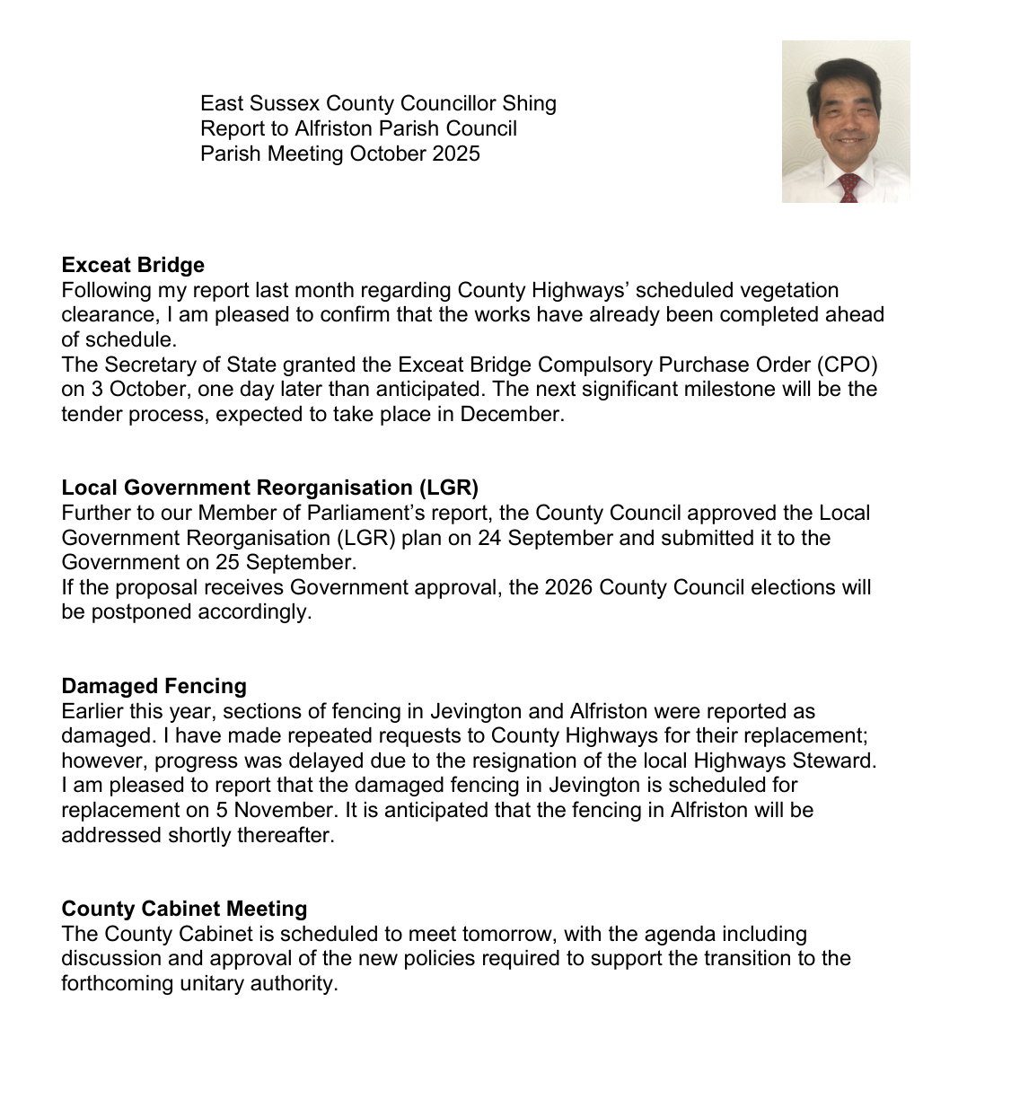
Appendix B - Report from Cllr David Greaves WDC

Report – Alfriston PC - Monday 20th October 2025

1. Councillor Ward Budgets Scheme - Update
Since the implementation of the Councillor Ward Budgets Scheme from 1st August, there has been a steady influx of grant requests from organisations around the District.
To date, we have received 55 grant requests and have paid out £55,802.60. Only 7 wards have not had any grant requests submitted as yet.
It can be difficult to identify smaller organisations and projects that might benefit from this funding. Members might like to visit the East Sussex Community Information Service website. Alternatively, contact councillorwardbudgetscheme@wealden.gov.uk for further advice or sign-posting.

- Air Quality
Officers attended the annual air quality conference run by Sussex Air this week. At the conference attendees heard that air quality in general across Sussex was improving, this is mainly due to improvements in vehicle technology. There was an interesting discussion on the proliferation of wood burning stoves and the negative effects these can cause for internal air quality, the team are going to carry out some further research on this

- 3VA Micro Grants Programme (funded by WDC through the Community Grants Programme & Cost of Living reserves)
3VA, with the support of Wealden District Council, are offering a number of micro grants to projects offering support to local people affected by the cost of living crisis. This includes groups offering Warm Welcome projects but may also include projects aiming to reduce isolation or working with people who face additional costs in their lives – for example people with disabilities.
3VA welcome applications from registered charities, not for profit groups such as CICs, unincorporated voluntary organisations, projects run by churches and parish councils.
Applications must be for a specific and defined purpose and for costs between £50 and £250. Organisations are not required to give any match funding.
The grants are intended to support projects by allowing the purchase of some “extra” which would not otherwise have been possible. For example, a piece of equipment eg an efficient urn, a toastie maker, a set of games, a projector. Or the grant might fund an additional or pilot activity. For example, bringing in an artist, offering a cookery class, running a series of budgeting workshops. Or some element of organisational development – e.g. volunteer training. We are looking for project ideas which are self-contained and which will not require ongoing funding to make them sustainable or viable.
Deadline to submit application is 30 November.
To check out the guidance notes, please go to 3VA's webpage: Wealden District
Any questions and to obtain an application form, please contact Melanie Nock, Communities development worker for Wealden at melanie.nock@3va.org.uk – who is very happy to discuss potential applications. If you have any further queries, please contact communitygrants@wealden.gov.uk.

- South East Water - Autumn update
Please click on link below:
https://mailchi.mp/southeastwater/your-latest-news-from-south-east-water-13939439?e=6ceda631e9

CLIF (Community-led Infrastructure Funding)
£2 million of funding has been allocated by Wealden District Council to empower local communities to deliver impactful, long-lasting infrastructure projects that meet local needs.

The Community-Led Infrastructure Fund (CLIF) is a three-year programme which prioritises projects that support community resilience and wellbeing, environmental sustainability, and a thriving local economy. The funding has been made available through Community Infrastructure Levy (CIL) and the Climate Emergency Reserve.

Not-for-profit organisations, including registered charities, constituted community groups, parish or town councils, schools (with community benefit), sports clubs, and cultural organisations will be able to apply for project grants ranging between £5,000 to £200,000.

All applicants must secure at least 20% match funding prior to application, been active in Wealden within the past 24 months and projects must be located within the district.

The Fund is now open for applications, and all the relevant information is located here Wealden Community Led Infrastructure Fund (CLIF) - Wealden District Council

For more information or to discuss project eligibility, organisations can contact the CLIF grant funding coordinator by email at:
CLIF@wealden.gov.uk or by phone on 01323 443322.
For further information please contact:
Nicola Watters or Sian Killean
Email: Nichola.watters@wealden.gov.uk Email: Sian.killean@wealden.gov.uk

- Grants at a Glance
Please see further attachment for this document

David Greaves 20th October 2025
Appendix C - Monthly Report from PCSO Isaac Wood
Monthly Report for Alfriston
I have viewed the crime statistics for Alfriston for the month after my last report up until today (12/10/2025). There is no incidents report to police that I deem necessary to feed back as they have no impacts on the wider community.
On various walks through the village, I have been able to speak with many key stakeholders and gain perspectives on what issues people feel need my attention.
Obviously, the main issue I have found is with persistent poor parking on double yellows in the centre on the village. As many are aware, Sussex Police do not have any powers to deal with this parking. This lies with Wealden District Council to employ parking wardens.
I can however attempt to speak with these drivers about the positioning and location of their parking, which I have done on many occasions, I am also able to deal with dangerous parking which will need to be dealt with on a case by case basis and I cannot offer blanket advice to cover all situations. These need to be phoned in on 101 as I am not accessible at all times and my email is not monitored regularly.
Through further foot patrol I have been able to encounter the newly set up speed watch which was great. I have given my email to the organisers, so hopefully this will be able to allow me to come along to sessions when I am working.
Should anyone have any queries please ask the parish council. If there is questions that they cant answer then they will be able to forward that query on to me.
Thanks, Isaac
 | Isaac Wood 42905
 | Police Community Support Officer
Wealden Neighbourhood Policing Team, Hailsham
Local PCSO for Alfriston, Alciston and Berwick
Hailsham Police Station, George Street, Hailsham, BN27 1AB
www.sussex.police.uk
Appendix D - Correspondence re Post Box from MP’s Office
Hello Conrad,
Thank you for your e-mail regarding the village post box.
Does this mean Royal Mail will not re-consider their decision to de-commission the only post box in the village High Street ?
We had hoped they would at least consider another location in the main village, as the only other post box is situated at the top of a very steep hill on the outskirts of the village, which is inaccessible to many residents. We would be very grateful if your office could push for this as the Parish Council have not been able to get a satisfactory response from Royal Mail.
With many thanks for all your help. Kind regards, Suzanna
From: MORRIS, Conrad
Sent: 10 October 2025 15:37 To: clerk@alfristonparishcouncil.org.uk Cc: MACCLEARY, James (MP)
Subject: Alfriston Postbox
Dear Suzanna,
Following the village meeting over the summer, I wanted to update you on the postbox next to the village store. I recently spoke with one of the Royal Mail directors who shared some background.
He said that during inspection, the wooden postbox was found to be rotten. When their team went to repair it, they discovered asbestos, meaning a more substantial repair would be required and the shop would need to close temporarily. His understanding was that the shop owner was not prepared to agree to that closure.
This was his understanding, so you may want to make your own enquiries to verify Royal Mail's side of the story.
Hope that helps!
With best wishes,
Conrad, Conrad Morris, Senior Parliamentary Advisor to James MacCleary MP

