ALFRISTON PARISH COUNCIL

CLERK TO THE COUNCIL Alfriston War Memorial Hall,

Mrs Suzanna Dry Old School House, The Tye,

Alfriston,East Sussex, BN26 5TL

Telephone – 07936 904 743

Email – clerk@alfristonparishcouncil.org.uk Tuesday 10th June 2025

All members of the Parish Council are summoned to a meeting of Alfriston Parish Council to be held in the Alfriston War Memorial Hall on Monday 16th June 2025 at 7.15pm.

Please note that a digital sound recording is made of all meetings of Alfriston Parish Council including Public Questions sessions. The recording is not for publication and used only to aid accurate minute taking.

S.C. Dry

Mrs Suzanna Dry CiLCA – Clerk & RFO_______________________________________________

AGENDA

45. Chair’s Welcome
46. Public Questions

47. Apologies for absence

48. Update from MP

49. Update from Cllr Stephen Shing – East Sussex County Council

50. Update from Cllr David Greaves - Wealden District Council

51. Declaration of interest

52. Minutes
To agree as a true record the minutes of the Annual Council meeting held on 19th May 2025.
To agree as a true record the minutes of the APC monthly meeting held on 19th May 2025.

53. Finance
To approve the Statement of Finances for June 2025. (Appendix A)

54. Report on Highways & Twittens – Cllr Embry
Update on Roadworks

55. Report on Allotments & Recreation Ground – Cllr Vacancy
Update on removal of rubble from allotment plot – Clerk
Allotment signs - Clerk
Update on repair to wood on playground fort – Clerk
Vacant Plots – Grass cut

56. Report on Public Transport & Environment – Cllr Harris

57. Report on Strategic Planning – Cllr Parkinson . (Appendix B)
To Ratify the decision to accept the new Emergency Telephone Number.
To discuss and resolve the Emergency Plan.

58. Report on Tye – Cllr Spring. (Appendix C)
To discuss and decide on repair to Tye Rd.
Update on broken bollard - Clerk

59. Report from Planning Committee – Cllr Watkins

Ref. No: SDNP/25/01862/LDE Pleasant Rise Farm, Cuckmere Rd BN26 5TN.

Upper Barn to continue as a dwelling without restriction No decision

(name of building did not match up with plans).

Ref. No: SDNP/25/01755/TCA 24 Saffron Gardens BN26 5XQ. Application Removed.

T1 Holm Oak. Reduce the Crown.

Ref. No: SDNP/25/01187/CND The Bakehouse, Whiteway, BN26 5TS. No decision

Variation of Condition 2 (No decision as there was no detail on what Condition 2 refers to).

59.2 Applications notified or awaiting decision from SDNPA - None

59.3 Enforcement updates from SDNPA - None

60. Reports from Outside Bodies
60.1 Heartstart
60.2 Alfriston Emergency Group
60.3 Flood Forum
60.4 Neighbourhood Watch
60.5 Twinning Committee (Appendix D )
60.6 St Andrew’s Church
60.7 Clergy House
60.8 Alfriston War Memorial Hall
60.9 Speedwatch
60.10 Events

61. Correspondence to The Clerk – Asking for permission from the Council.
To Ratify the decision to allow gazebos on The Glebe for a public event held on Saturday 31st May.
To Ratify the decision to allow A board poster on Market Square for Village Clubs, Societies & Classes
Showcase Day on 31st May.

62. Public Questions

63. Date of next meeting – to be held on Monday 21st July 2025 in the AWMH 7.00pm Planning
Meeting, 7.15pm Monthly Meeting.

Please see Appendices attached below and\or on the website.

Appendix A - Statement of Finances for June 2025

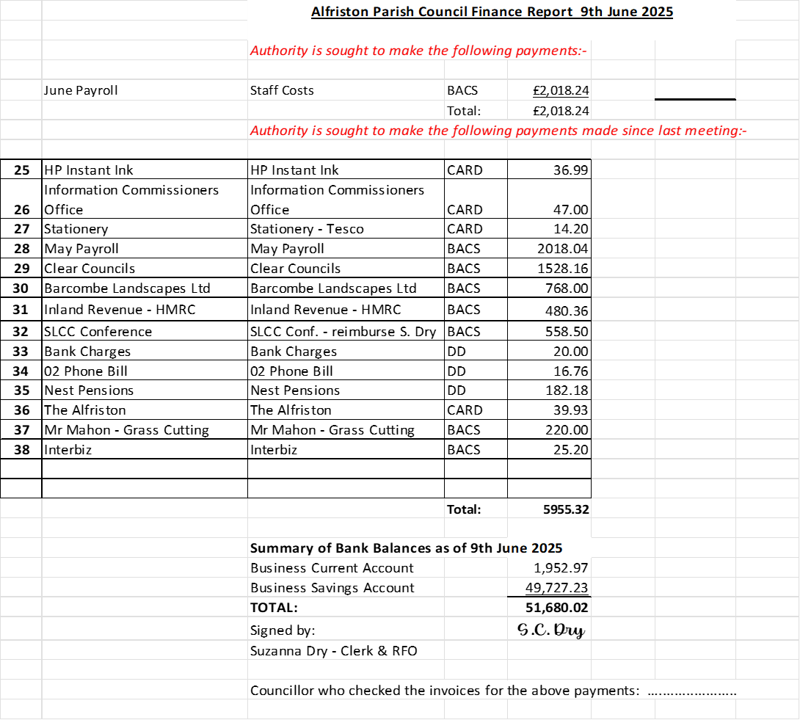

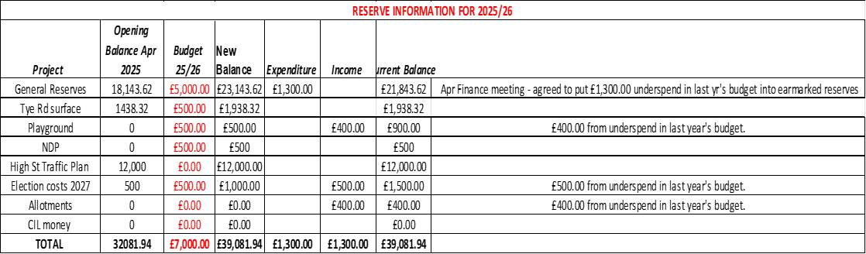

Appendix B - Strategic Planning Report, Cllr Parkinson

Appendix C - Report for The Tye, by Cllr Jonathan Spring.

1. Sunken Road Repair

Have received a quote from Hailsham Roadways to repair the sunken area
on the Tye Road. The total cost is £4508 plus vat.

It is likely this is the full cost but once the ground is opened up,
there may be other works required if it’s being caused by other than
poor repair last time, when it was back filled after a drain
installation many years ago. Therefore we require a contingency sum of
£2000 plus vat.

As we have little money in the Tye budget can I ask that we find it
from another budget to facilitate a speedy repair.

The most obvious one to me is the Highways allocation as the council
has not had to pay for as much as expected on the road scheme.

As the council has limited reserves, if we cannot find a grant, I see
the only other would be to wait until April which I really feel would
be inappropriate as it needs repair now.

2. Leak on Tye

Finally this was repaired by much chasing and pressure on Southern
Water. I spent quite a lot of time hanging on the phone and waiting
for call backs. Thanks to all those who helped chase them too, especially Martin and
Gayle. The collective pressure does work.

3. Sustainable Outdoor Pursuit Event.

As I am writing this in time for the agenda to go out, unfortunately I
have not received some update information in time to go out in
advance.

Should have this for the meeting so will update on the night.

Appendix D - Twinning Committee Report

Alfriston and Cuckmere Valley Twinning Association

Our twinning weekend to Veules-les-Roses started with an evening buffet to welcome us, including so many mouth-watering desserts that it is rumoured some were eaten for breakfast as well! A delicious restaurant lunch on Saturday was followed by a visit to a glass museum and demonstration of glass blowing at Blangy-sur-Bresle. Watching the skilled glass blower create a terrapin, a life-sized little bird and a beautiful multicoloured vase in a few minutes was fascinating, so the shop was the next stop. Our evenings were spent with our hosts, who sometimes made up a small evening group with other hosts, which was convivial. On Sunday morning everyone was taken to le Manoir d’Ango for a lively guided tour (see photo). This lovely 16th century manor house was built as a summer palace by the wealthy spice trader and shipping magnate Jehan Ango. Our next stop was back to the village hall in Veules-les-Roses for Sunday lunch, followed by some large wooden “board” games and a stroll around the pretty village. After another evening with our hosts, most members returned to Newhaven on the Monday. It was a wonderful weekend, with such friendly hosts, lots to do and plenty of fun with friends, old and new. Next year we will be welcoming our French friends to Sussex, so if you would like to be part of that, please get in touch with a view to joining us.

We have members in the Cuckmere Valley, Alfriston and Seaford. New members are always welcome, and there is no need to speak French, or to have a huge house- just come along and say hello!
Robert Morrison is our membership secretary: rmorri1847@aol.com

