ALFRISTON PARISH COUNCIL

CLERK TO THE COUNCIL Alfriston War Memorial Hall,

Mrs Suzanna Dry Old School House, The Tye,

Alfriston,East Sussex, BN26 5TL

Telephone – 07936 904 743

Email – clerk@alfristonparishcouncil.org.uk Friday 10th October 2025

All members of the Parish Council are summoned to a meeting of Alfriston Parish Council to be held in the Alfriston War Memorial Hall on Monday 20th October 2025 at 7.15pm.

Please note that a digital sound recording is made of all meetings of Alfriston Parish Council including Public Questions sessions. The recording is not for publication and used only to aid accurate minute taking.

S.C. Dry

Mrs Suzanna Dry CiLCA – Clerk & RFO_______________________________________________

AGENDA

144. Chair’s Welcome
145. Public Questions

146. Apologies for absence

147. Update from MP . (Appendix A)

148. Update from Cllr Stephen Shing – East Sussex County Council

149. Update from Cllr David Greaves - Wealden District Council

150. Declaration of interest

151. Minutes
To agree as a true record the minutes of the APC September meeting held on 15th September 2025.

152. Finance
To approve the Statement of Finances for October 2025. (Appendix B)

153. Coffeehouse Conversations
To agree date and subject of next Coffeehouse Conversation.

154. Monthly Report from PCSO

155. Internal Interim Audit
Clerk to report back on Interim Audit carried out in October.

156. Meeting Dates for 2026
To discuss and agree dates for APC meetings in 2026. (Appendix C)

157. Report on Highways & Twittens – Cllr Embry

158. Report on Allotments & Recreation Ground – Cllr Vacancy

159. New Lease Agreement for Allotments
To review and agree new lease agreement for Allotment holders to include deposit, effective January
2026.

160. Report on Public Transport & Environment – Cllr Harris

161. Report on Strategic Planning – Cllr Parkinson .

162. Report on Tye – Cllr Spring.

163. Reports from Outside Bodies
163.1 Heartstart
163.2 Alfriston Emergency Group
163.3 Flood Forum
163.4 Neighbourhood Watch
163.5 Twinning Committee (Appendix D).
163.6 St Andrew’s Church (Appendix E).
163.7 Clergy House
163.8 Alfriston War Memorial Hall
163.9 Speedwatch
163.10 Events

164. Correspondence to The Clerk – Asking for permission from the Council.
A Board Poster for Quiz Evening on 14th November for Alfriston Twinning. Poster to be up from 2-14th
November. (Appendix F ).

165. COUNCILLOR VACANCY

165.1 To receive introduction from applicant for co-option from Stephen Rabagliati. Application Form
Attached. (Appendix G ).

165.2. To Discuss and Decide on Co-Option of new Councillor.

166. Public Questions

167. Date of next meeting – to be held on Monday 17th November 2025 in AWMH 7.15pm.

Please see Appendices attached below and\or on the website.

APPENDIX A - MP’S REPORT
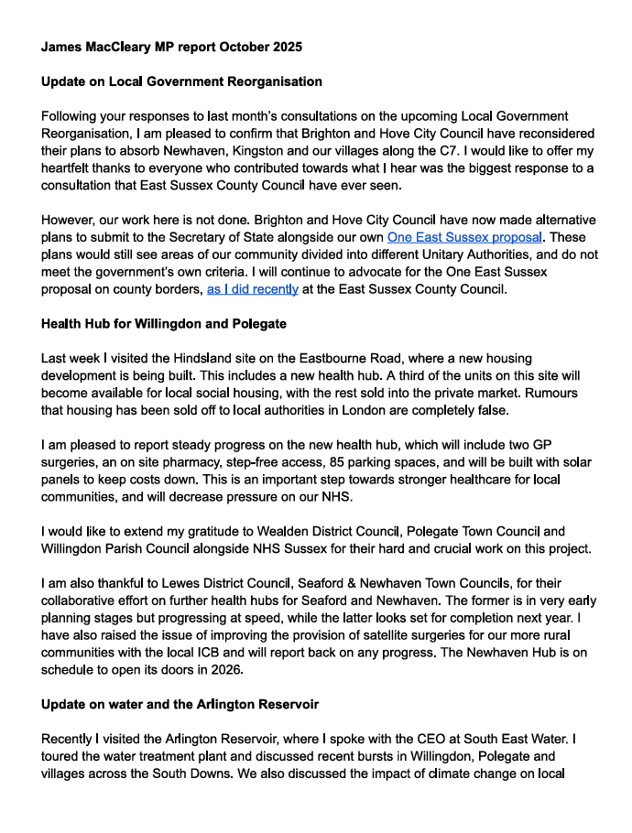
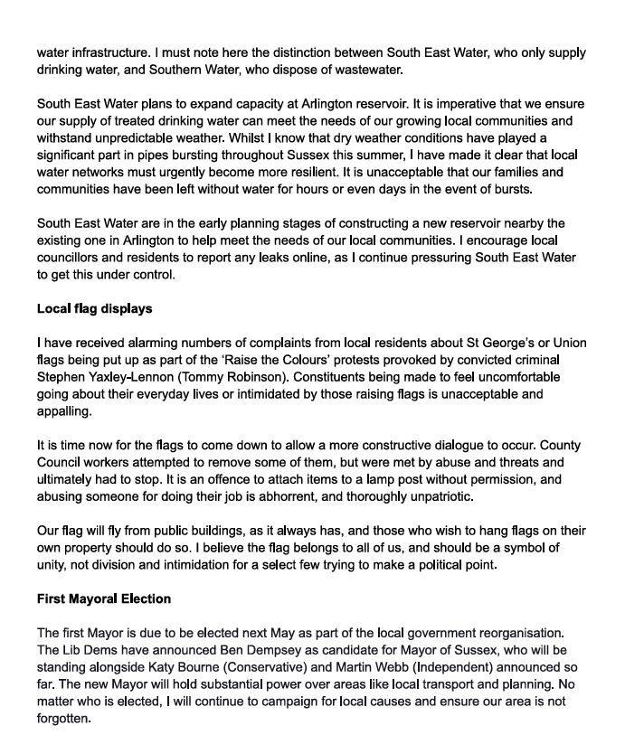

APPENDIX B - STATEMENT OF FINANCES FOR OCTOBER 2025

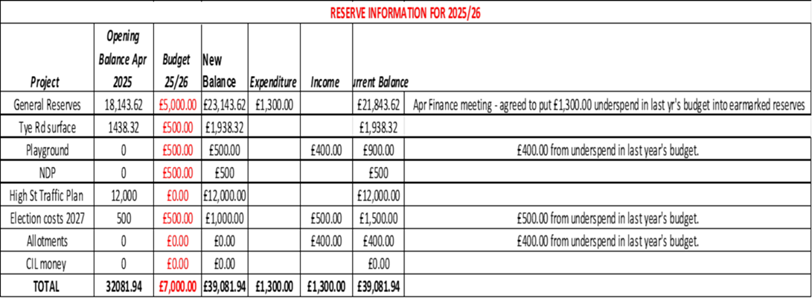

APPENDIX C - MEETING DATES FOR 2026
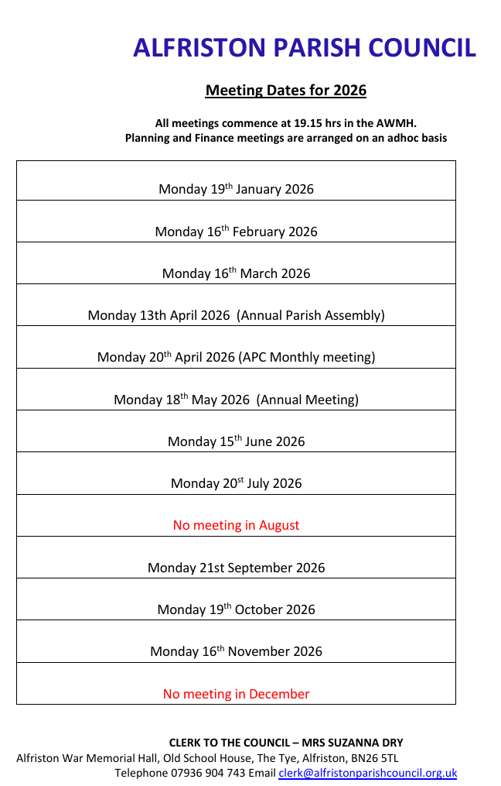

APPENDIX D - TWINNING COMMITTEE REPORT

Alfriston and Cuckmere Valley Twinning Association

We have two great events coming up this autumn, and hope you will join us. Tickets can be purchased for both events by both members and non members:-
Quiz and pudding night
Friday 14th November 2025, 7pm for 7:15 quiz start
Old Chapel Centre, Alfriston
Quiz £5 per person including dessert. Cash only. Beers, wine & soft drinks available to purchase.
Teams of up to 6, or join others on the night
Bookings angela@bobmorri16.plus.com

And coming up in December:-
Mélodie Blue
An evening of song and music, details below
Friday 12th December 2025, 7pm
Old Chapel Centre, Alfriston
Cash Only. Raffle and Bar

Mélodie Blue is a musical duo featuring Helen and Liz plus guest musician, Red Leo. Playing an eclectic selection of both French and English songs with keyboards, saxophone, cajun drum and guitar, they bring a European flair with a timelessly, easy, jazzy style that is welcoming, heart-felt and relaxing. Lots of old favourites and some current as well - what’s to miss?

We have members in the Cuckmere Valley, Alfriston and Seaford. New members are always welcome, and there is no need to speak French, or to have a huge house- just come along and say hello!
Robert Morrison is our membership secretary: rmorri1847@aol.com

APPENDIX E - ST ANDREW’S CHURCH CONCERT

From: Noa Lachman
Sent: 04 October 2025 21:57
To: clerk@alfristonparishcouncil.org.uk
Subject: Information about concert 7th December
Dear Clerk
Please find information about our concert at St Andrew's church
If you could include this on your parish magazine or website or send the information we would appreciate it
Thanks, Noa
Christmas Brass
07-12-25 3pm
St Andrew's Alfriston BN26 5TL
Long Man Brass return with a programme which mixes traditional baroque brass quintets with recent compositions by Paul Carr and Rob Wiffin. And with Christmas fast approaching, there will be plenty of festive brass music to enjoy as well.
Tickets at £15 from musicboxwealden.co.uk

APPENDIX F - REQUEST FOR A BOARD POSTER

From: Sylvia Daw on behalf of Twinning Committee
Hello hope you are all well I'm asking if Alfriston Twinning could put up a poster to advertise their quiz evening in November I'm sending a copy of the poster.
Many thanks
Sylvia on behalf of Alfriston Twinning

APPENDIX G - COUNCILLOR VACANCY APPLICATION FORM

