ALFRISTON PARISH COUNCIL

CLERK TO THE COUNCIL Alfriston War Memorial Hall,

Mrs Suzanna Dry Old School House, The Tye,

Alfriston,East Sussex, BN26 5TL

Telephone – 07936 904 743

Email – clerk@alfristonparishcouncil.org.uk Tuesday 9th September 2025

All members of the Parish Council are summoned to a meeting of Alfriston Parish Council to be held in the Alfriston War Memorial Hall on Monday 15th September 2025 at 7.15pm.

Please note that a digital sound recording is made of all meetings of Alfriston Parish Council including Public Questions sessions. The recording is not for publication and used only to aid accurate minute taking.

S.C. Dry

Mrs Suzanna Dry CiLCA – Clerk & RFO_______________________________________________

AGENDA

108. Chair’s Welcome
109. Public Questions

110. Apologies for absence

111. Update from MP . (Appendix A)

112. Update from Cllr Stephen Shing – East Sussex County Council

113. Update from Cllr David Greaves - Wealden District Council

114. District Cllr Ward Budgets Scheme
WDC Cllr. David Greaves to present scheme and grants available to the community.

115. Declaration of interest

116. Minutes
To agree as a true record the minutes of the APC July meeting held on 21st July 2025.
To agree as a true record the minutes of the APC Finance meeting held on 21st July 2025.

117. Finance
To approve the Statement of Finances for September 2025. (Appendix B)
To confirm sight and approval of External Auditor’s Report & Notice of Conclusion of Audit (Appendix C)

118. Report Back on MP’s Meet & Greet in August.

119. SDNPA Local Plan & Partnership Plan – Presentation by Vanessa Rowlands, Chair SDNPA.

120. Wealden Town & Parish Council Conference 21st October – APC representative to attend.

121. Replacement Laptop for APC
To agree on a replacement laptop for APC. Clerk’s Report attached (Appendix D).

122. Coffeehouse Conversations
To agree date and subject of next Coffeehouse Conversation.

123. Cllr Vacancy
Deadline for applications 30th September. These will be considered at the October meeting.

124. Update on Post Box - Clerk

125. Alfriston Welfare Lobby Group – Letter to APC & APC’s response attached. (Appendix E).

126. Report on Highways & Twittens – Cllr Embry
Residents Letter received on traffic calming measures & APC’s reply. (Appendix F).
To discuss and review new traffic calming measures.
Feedback from MP on Sussex Police mobile speed enforcement sessions.

127. Report on Allotments & Recreation Ground – Cllr Vacancy
Update on removal of rubble from allotment plot – Cllr Spring to report back.
Update on vacant allotments & weed notices issued - Clerk
Update on Playground - Clerk

128. Report on Public Transport & Environment – Cllr Harris

129. Report on Strategic Planning – Cllr Parkinson .
Emergency Plan Update

130. Report on Tye – Cllr Spring.
Repair to Tye Rd – to receive further quotes and agree contractor.
Dog Show 24th Aug 2025 - Feedback from event.
Cuckmere Valley Showcase & Outdoor Pursuits 24th May 2026 – Update & Agree date of event.

131. Reports from Outside Bodies
131.1 Heartstart
131.2 Alfriston Emergency Group
131.3 Flood Forum
131.4 Neighbourhood Watch (Appendix G).
131.5 Twinning Committee
131.6 St Andrew’s Church
131.7 Clergy House
131.8 Alfriston War Memorial Hall
131.9 Speedwatch
131.10 Events

132. Correspondence to The Clerk – Asking for permission from the Council.
Request for Pizza Van at AWMH for wedding on 20.06.26. (Appendix H).
Request for A Board from Alfriston Women’s Group – Sat 1st Nov. for Jumble Sale . (Appendix I).
To Ratify APC’s response to request to use The Tye for refreshment station at Ultra Marathon 13th Sept.
(Appendix J).
Request for A Board for Poetry Bee Event – 25th Oct for 3 weeks from 3rd- 25th Oct. (Appendix K).

133. Public Questions

134. Date of next meeting – to be held on Monday 20th October 2025 in the AWMH 6.45pm Planning
Meeting, 7.15pm Monthly Meeting.

Please see Appendices attached below and\or on the website.

Appendix A - MP’s Update
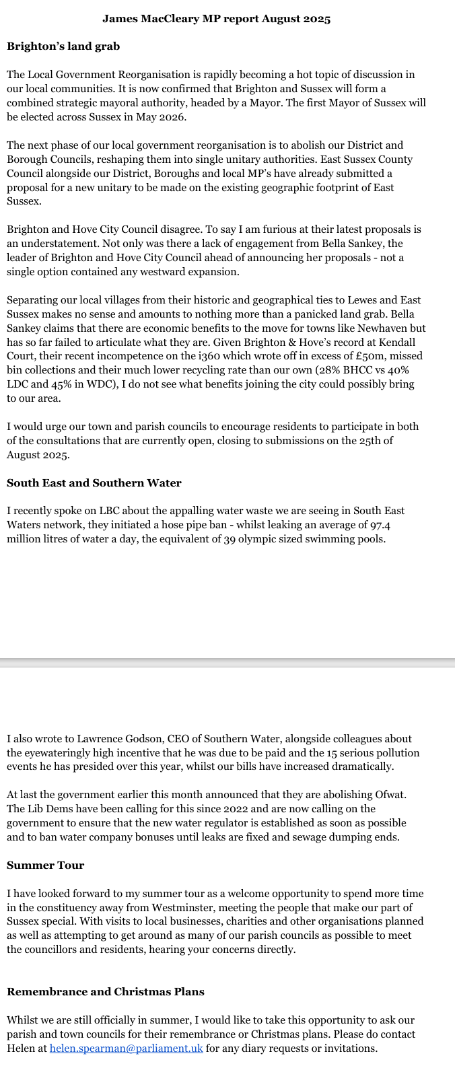

Appendix B - Statement of Finances for September 2025

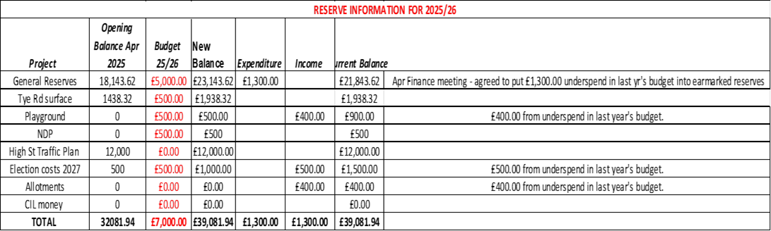

Appendix C - External Auditor’s Report & Conclusion of Audit

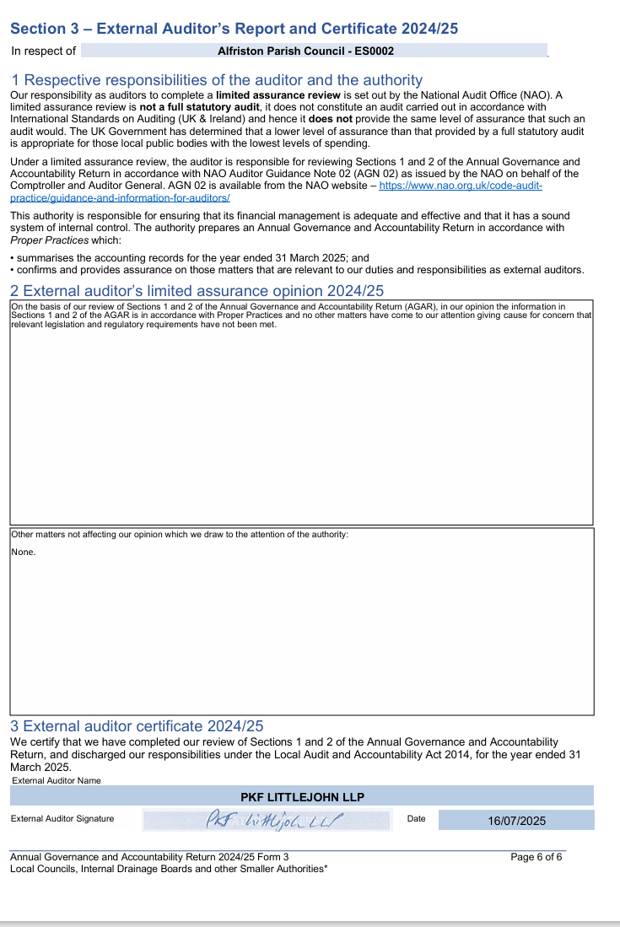

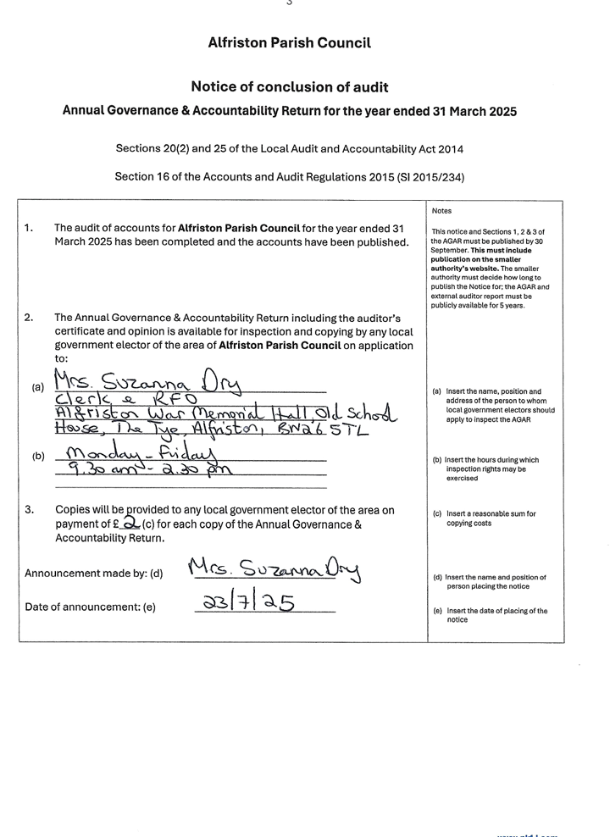

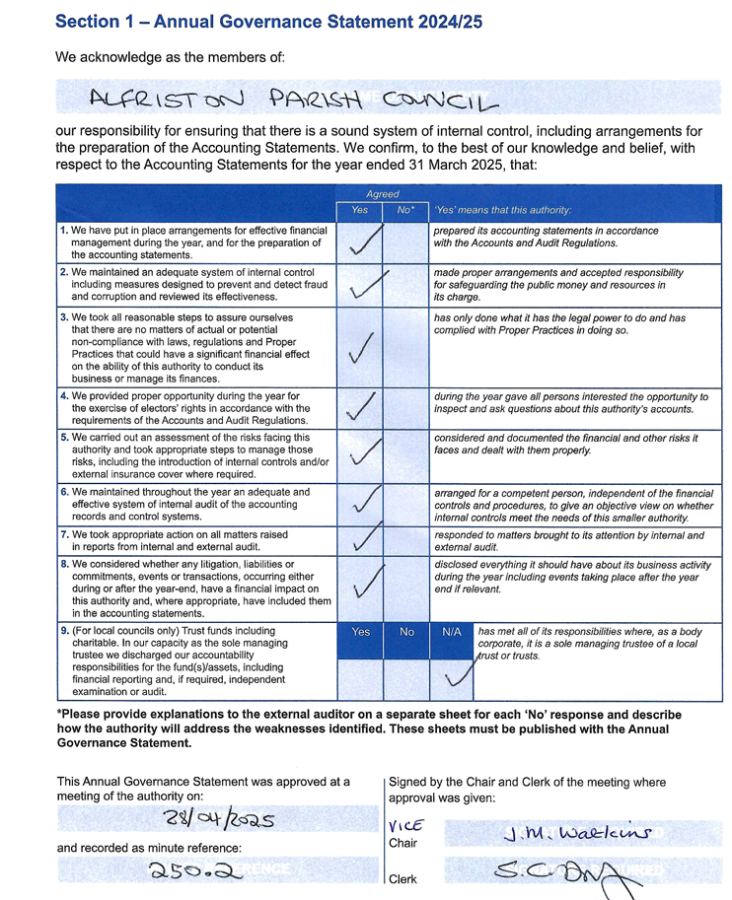

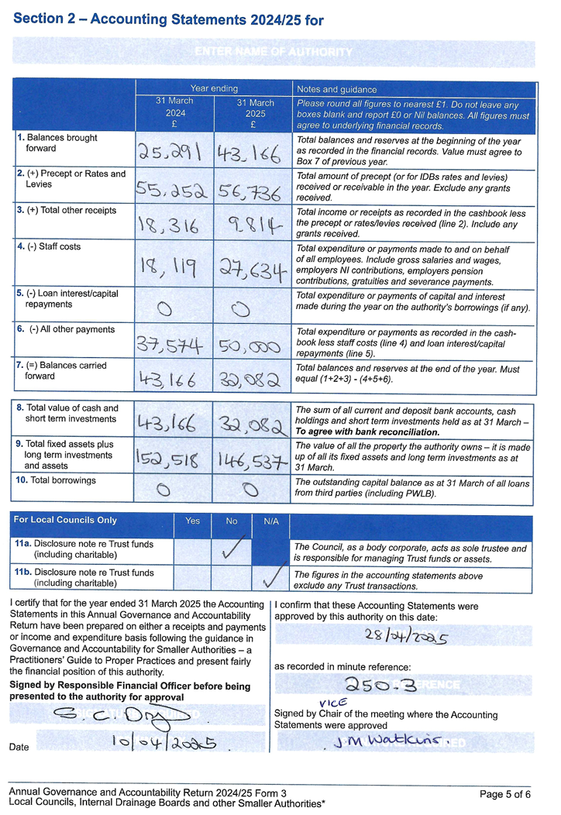

Appendix D - Clerk’s Report on APC Replacement Laptop.

ALFRISTON PARISH COUNCIL

Date: 21st August 2025
Report Subject: New Laptop for APC
By: Suzanna Dry, Clerk & RFO

The purpose of this report is to give Councillors information on purchasing a new laptop for APC.

Background

APC previously agreed that the laptop would need to be replaced in this financial year. A budget of £700.00 was therefore incorporated into this year’s budget costings.

Analysis

In order to purchase the next upgrade to the current laptop (a 2020 HP Pavilion 14, with a Ram of 4GB), with additional memory the costs are as follows:

Currys: £599.00 (includes VAT)
PC World: £649.99 (includes VAT)
Amazon: £750.00 (includes VAT)
(for an HP OmniBook 5 16” Laptop – Intel Core i5, 512 GB SSD, with 16GB Ram).

This would leave enough in the budget to get the laptop set up professionally by Ingenio Technologies. Who would then be able to carry out any maintenance\support going forwards.

Recommendation

That APC agree the motion to purchase a new laptop from Currys at a cost of £599.00 including VAT. To replace the existing laptop and have this professionally set up by Ingenio.

Appendix E - Alfriston Welfare Lobby Group Letter & APC Response

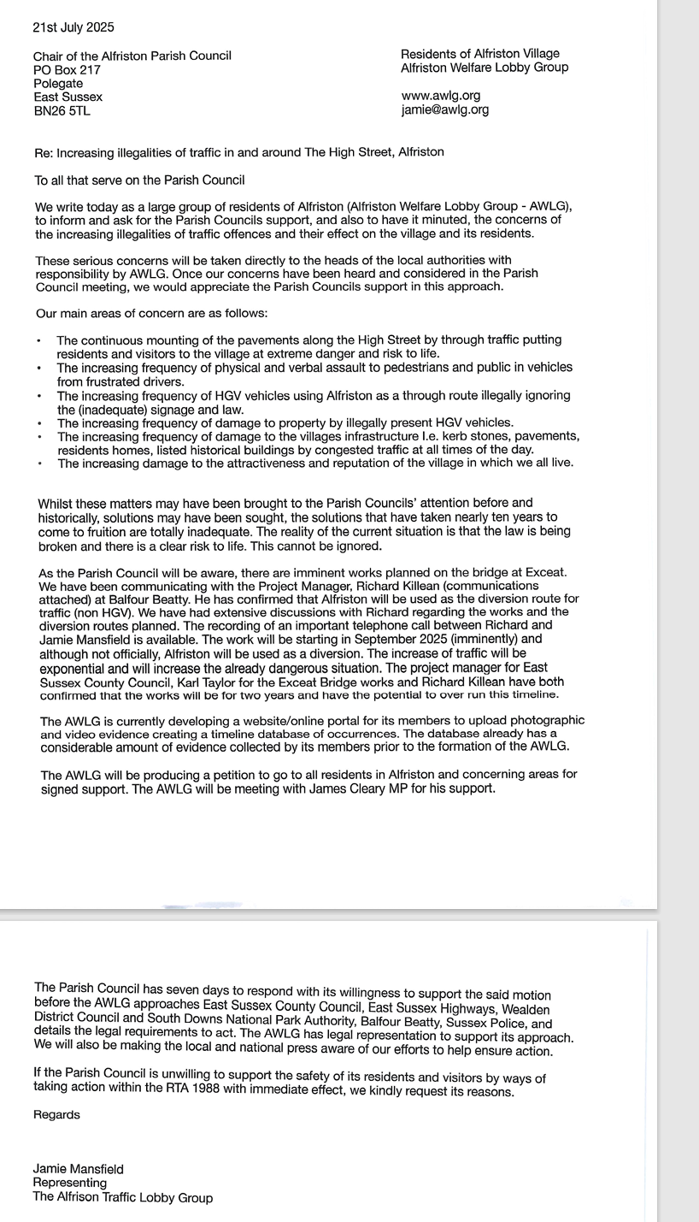

E-mail and hard copy sent to AWLG on 28th July 2025:

Dear Alfriston Welfare Lobby Group,

Increasing Traffic Offences in and around The High Street, Alfriston.

Thank you for your letter (copy attached) which was presented to the Parish Council at the July meeting.

Alfriston Parish Council can certainly appreciate your frustrations as APC have spent over a decade campaigning on this issue. This has included collection of evidence, public meetings, petitions, community surveys and calls for ideas to improve the situation. These ideas were collated and presented to ESCC Highways who have trialled some solutions and carried out safety audits of proposals. The traffic calming measures that have recently been installed were agreed by ESCC Highways having met their statutory obligations, guidelines and safety criteria.

With regard to the lack of enforcement we agree this is a major concern and have raised this with Sussex Police. APC invited the Sussex Police Neighbourhood Policing Team to attend the Annual Parish Assembly in April to discuss this, they stated how important it is that any traffic offences are reported by the public to Operation Crackdown on www.operationcrackdown.org or call 101. This is to ensure that Sussex Police have a record of all offences taking place. At the April meeting Sussex Police advised that there had been no incidents reported, therefore they were unaware of any issues. We urge you to pass your database of incidents to Operation Crackdown, so that these can logged with the Police and to advise your members of the importance of reporting incidents directly to Operation Crackdown, or to call 101. Our local PCSO Issac Wood is holding a ‘Meet & Greet’ session for residents on Sunday 10th August between 1-2pm on The Tye, where residents can discuss their concerns. The Parish Council will be advertising this throughout the village. PCSO Issac Wood can also be contacted via the Wealden Neighbourhood Policing Team at Hailsham on https://www.sussex.police.uk/area/your-area/sussex/wealden/alfriston-alciston-berwick-ripe-and-chalvington/about-us or tel. 101.

County Councillor Stephen Shing did advise at the Parish Council meeting that the Exceat Bridge will only be closed for 19 days during the whole of the works and at all other times traffic will be able to pass through. This will limit the amount of traffic being diverted through Alfriston to a very short window.

We hope you find the above information useful and wish the Alfriston Welfare Lobby Group every success in your endeavours.

With kind regards

Suzanna

For and on behalf of Alfriston Parish Council

Mrs Suzanna Dry CiLCA
Clerk and RFO

Appendix F - Residents Letter & APC’s reply re Traffic Calming Measures

APC’s Response:
Dear Susanne,

Thank you for your below e-mail regarding the traffic issues in Alfriston. I have forwarded this to the Chair and all Councillors for their information. In response to the proposals you put forward, APC can advise as follows:-

Vehicle-Activated Speed-Warning Signs in the High Street - This is indeed an option that was raised at the recent Meet & Greet session with our MP James MacCleary. APC will be looking into this possibility further. We are however aware that in order to progress any measures we need to be able to evidence the amount of speeding being carried out. This is where Speedwatch will be so valuable, once we are able to re-start the Speedwatch sessions now that the new traffic calming measures are in place, and send the results to Sussex Police. The Speedwatch Administrator is liaising with our newly appointed PCSO so that records will be sent directly to Sussex Police.

Mobile or Regular Speed Enforcement Sessions by Sussex Police - Again, as a result of the Meet & Greet session, our MP James MacCleary has written to the Sussex Police Traffic Team to request that mobile speed enforcement sessions are carried out in the High Street. We have asked James’ office for an update on this for our next APC meeting. Again, the results from Speedwatch sessions will be very valuable in evidencing our on going need for this. We also urge residents to report any speeding or anti-social driving and parking to Operation Crackdown, so that these incidents are logged directly onto the Sussex Police data. www.operationcrackdown.org or ring 101.

Community Speed Watch Programme - As mentioned previously Alfriston Speedwatch will shortly be re-starting, after an enforced break while the new traffic calming measures take effect. Our Speedwatch Administrator has used this time to engage a number of new volunteers and liaising with our PCSO.

Physical Road-Narrowing Features\Gateways - Road narrowing features - these options have previously been put forward to East Sussex County Council Highways but were dismissed due to safety concerns, following their Safety Audit. Gateways – new gateways have been installed as part of the recent traffic calming measures.

Permanent Traffic Calming Installations - The traffic calming measures recently installed were a result of over 10 years of negotiations with ESCCH. All proposals put forward in this time were either considered and/or trialled by ESCCH with Safety Audits carried out. The measures in place today are the limit of what ESCCH will allow, having met their statutory obligations, guidelines and safety criteria.

Improved Parking Enforcement - This is something that APC have raised with Wealden District Council on a number of occasions, asking for decriminalisation. Unfortunately as parking is not decriminalised in Wealden it remains with the Police to enforce, and parking wardens cannot be used. Wealden District Council will not consider changing this policy. Our only hope is that when the new Unitary Authority takes over from WDC they change to decriminalisation. This looks promising as all other districts in Sussex are already decriminalised.

As you mention, Alfriston is a medieval village with narrow roads and pavements, this therefore limits the number of interventions we can have on the road. We hope the above goes some way to answering your questions.

With kind regards
Suzanna
For and on behalf of Alfriston Parish Council.

Susanne Taylor, Alfriston, East Sussex BN26 5UG
27, August, 2025 To the Chair and Members of Alfriston Parish Council,
Dear Members of the Parish Council,
Subject: Traffic Speeds and Pedestrian Safety in Alfriston
I am writing as a visiting resident of Alfriston, having lived here for the past six months, to express growing concern about the speed and volume of through-traffic in our medieval village. I have observed frequent instances of vehicles mounting kerbs, navigating the narrow High Street with undue haste, and endangering pedestrians in an area with no pavements.
I appreciate the considerable efforts that have already been made to address this long-standing issue. In particular:
- In 2018, East Sussex County Council conducted a four-week trial of temporary traffic signals at both ends of the High Street (Star Lane and Weavers Lane), paired with an extended trial of a 20 mph speed limit—though the signal trial proved unviable, with traffic and queuing issues displaced elsewhere in the village
- Going further back, temporary water-filled barriers were installed in the narrowest section of the High Street to encourage drivers to give way rather than mounting pavements
- Most recently, as of July 2025, a village-wide 20 mph speed limit has been introduced, accompanied by gateway signs, high-friction surfacing at the transition from 30 mph, new double yellow lines, refreshed road markings, and warning signage at the village entrances
While these measures are welcome and encouraging, concerns remain about their effectiveness and enforcement. In particular, temporary barriers and signal trials did not resolve the underlying issue; and without active enforcement—even a 20 mph limit risks being ignored by motorists. My parents, Betty and Geoff Carey were long term residents in the village and during the 1980s they ran the Singing Kettle and were familiar with the parking and traffic issues in the village. During this period, there was a fulltime traffic warden assigned to the village to prevent parking on the yellow lines and assist with traffic safety. While there are obvious budget constraints on Wealden Council to reintroduce this level of traffic management, I would like to register my concerns and offer options that may be considered moving forward.
To strengthen current efforts, I respectfully request the Parish Council consider supporting or advocating for the following additional traffic calming and enforcement initiatives:
- Vehicle-Activated Speed-Warning Signs at both ends of the village, to accompany 20 mph signage and reinforce awareness. In particular high speeds we have noticed along North St past our cottage, from Waterloo Square down the hill toward the Sloe Lane Car Park.
- Mobile or Regular Speed Enforcement Sessions with Sussex Police—ideally during peak times or when speeding is most evident.
- Community Speed Watch Programme, utilising local volunteers to monitor speeds and encourage compliance.
- Physical Road-Narrowing Features or Gateways, such as textured surfaces or subtle visual width reductions—especially at entry points, reinforcing the 20 mph zone.
- Permanent Traffic Calming Installations (for example, raised crossings or rumble strips) in key locations, where safe and feasible.
- Improved Parking Enforcement, particularly in the High Street. Without decriminalised parking enforcement, double yellow lines may go disregarded
Thank you for your continued dedication to preserving Alfriston’s character, safety, and heritage. I look forward to any updates you can share on this matter.
Yours sincerely,
Susanne Taylor

Appendix G - Neighbourhood Watch Sept. Newsletter

Appendix H - Request for Permission for Pizza Van at AWMH Wedding
From: Mkaya Carrigan Sent: 15 July 2025 16:22
To: clerk@alfristonparishcouncil.org.uk
Subject: Pizza van wedding 20/06
Hello, I’m Mkaya – I am getting married in the hall on 20th June, 2026. Nice to e-meet you and I hope you are enjoying the lovely weather. We have booked a pizza van for the wedding. The measure of the van is approx 5 x 2 metres (max) and is approx. 2.3m high. Wendy and Gerry think it would be best to check with you in case it doesn’t fit directly into the assigned outdoor space of the hall. Hoping it will be ok – we have really struggled to find catering that we can afford, so would be so grateful if it could be accommodated. Thank you in advance, Mkaya
Appendix I - Request for A Board: Alfriston Women’s Group
From: Gill Chopra Sent: 8th Sept. 2025
To: Clerk@alfristonparishcouncil.org.uk
Subject: Jumble Sale Saturday 1st November
Dear Suzanna, Could you please request permission from APC for us to use the 'A' Board at the Market Square on Saturday 1st November to advertise our Jumble Sale in the War Memorial Hall that day. Many thanks.
Gill Chopra, Secretary, Alfriston Women's Group
Appendix J - Request and APC’s response to Ultra Marathon on 13th Sept. 2025.
Sent: 03rd Sept. 2025
To: Sam Calvert
Subject: Help with Ultra Marathon – Saat 13th Sept.

Dear Sam,
Thank you for your e-mail.
Unfortunately Alfriston Parish Council do not allow any running events to have an aid\refreshment station on The Tye Recreation Ground. However, in the past the area known as 'The Spots' (between the pumping station on River Lane and the White Bridge) has been used by running events. This land is owned by the Environment Agency and you would need to contact the EA regarding this. Alternatively it may be worth getting in touch with The Old Chapel Centre, who may be able to accommodate you. https://oldchapelcentre.com/.
We hope the above information is of help.
Kind Regards
Suzanna
Mrs Suzanna Dry CiLCA
Clerk and RFO
Please note that I work flexible part time hours.

> From: Sam Calvert
> Sent: 01 September 2025 10:06
> To: Alfriston Parish Clerk <clerk@alfristonparishcouncil.org.uk>
> Subject: Help with an Ultra Marathon - Saturday 13th September
>
> Good morning,
I am hoping that you are able to help?
We are hosting an Ultra Marathon event, starting in Brighton, that takes in much of the South Downs Way and includes running through your village.
Crucially, the two distances that enter Alfriston from the West on the South Downs Way, split here with the 50-mile race carrying on the SDW, and the 50k runners heading down High Street towards Newhaven. We are looking for help to position an Aid Station in/around the village, which would provide refuelling for the runners, and I am hoping that you may be able to help with this? I've put images below of the two routes, along with a link to the interactive Strava Map so you can see where the runners will be coming from/heading. You will see that we have provisionally indicated a location in The Tye, however, we are completely open to suggestions that work for yourselves and the village. With this being our first event in the area, we are looking at a combined 200 runners in these two distances, with everyone very spread out by this stage of the event and runners expected to start entering the village around 08:45 until around 13:00. Any help would be greatly appreciated! If you would like to jump on a call, I'd be very happy to run through any feedback, advice and suggestions. I look forward to hearing from you soon. Many thanks,
Sam Calvert, Event Operations Manager

Appendix K - Request for A Board – Poetry Bee Event, OCC, 25th Oct. 2025From: Gayle Hudson
Sent: 08 September 2025 13:50
To: APC Clerk <clerk@alfristonparishcouncil.org.uk>
Subject: Poetry Poster in square
Hi Suzanna, Hope all is well!I am writing to ask permission to display this poster in Market Square from start of October (4th) if possible, for 3 weeks? There is a deadline of 10th October to enter a competition and the event is on 25th October.
Look forward to hearing thank you!
Gayle

