ALFRISTON PARISH COUNCIL

CLERK TO THE COUNCIL Alfriston War Memorial Hall,

Julia Shelley Old School House, The Tye,

Alfriston,East Sussex, BN26 5TL

Telephone – 07936 904 743

Email – clerk@alfristonparishcouncil.org.uk 12th October 2026

All members of the Parish Council are summoned to a meeting of Alfriston Parish Council to be held in the Alfriston War Memorial Hall on Monday 19th October 2026 at 7.15pm.

Please note that a digital sound recording is made of all meetings of Alfriston Parish Council including Public Questions sessions. The recording is not for publication and used only to aid accurate minute taking.

Julia Shelley

Julia Shelley - Locum Clerk_____________________________________________

AGENDA

118. Chairman’s Welcome
119. Public Questions

120. Apologies for absence; Cllr Watkins

121. Vanessa Rowlands, Chair of the South Downs National Park Authority to attend re: 134.2 (this item may be moved up the agenda)

122. Update from MP. (Appendix A)

123. Update from Cllr Stephen Shing - East Sussex County Council

124. Update from Cllr David Greaves - Wealden District Council (this item may move to later in the agenda to accommodate Cllr Greaves earlier meeting)

125. Declaration of interest

126. Minutes
To agree as a true record the minutes of the APC monthly meeting held on 21st September 2026.

127. Finance
To approve the Statement of Finances for October 2026. (Appendix B).
To approve request from Cuckmere Flood Forum for a grant of £110.00 (Appendix C).

128. PCSO’s Monthly Report

129. Coffeehouse Conversation
Update on last Coffeehouse Conversation - Sat 26th September on The White Bridge- Cllr Harris
Decide on date for next Coffeehouse Conversation.

130. To discuss Recruitment of Replacement Clerk & RFO

131. To discuss request from Mr Gifford to fly his drone in the area around the Cricket Pavilion (Appendix D)

132. Report on Highways & Twittens – Cllr Embry Report on: CityFibre; Beachy Head Marathon; East Sussex Highways; The Dene Car Park; Verge Damage on the Furlongs; Exceat Bridge
132.1 Additional Bollard at Number 3 Waterloo Square. (Appendix E)
132.2 Highway work along C120 (Appendix F)

133. Report on Allotments & Recreation Ground – Cllr Rabagliati
To consider quotation for chain link fencing between gate into allotments and park.
Price for 29 metres £3594.88 (including VAT). (Appendix G)

134. Report on Public Transport & Environment – Cllr Harris
134.1 Update on the White Bridge
134.2 Update on the South Downs Works. (Appendix H)

135. Report on Strategic Planning – Cllr Parkinson; Revisions to the Emergency Plan.

136. Report on Tye – Cllr Spring.
136.1 Damaged bench and injury of member of public (email circulated pre-meeting).
136.2 Parking issues (email circulated pre-meeting).
136.3 Tree pruning request from Village Hall. Quotation received (Appendix I).

137. Reports from Outside Bodies
137.1 Heartstart
137.2 Alfriston Emergency Group
137.3 Flood Forum
137.4 Twinning Committee. (Appendix J)
137.5 St Andrew’s Church
137.6 Clergy House
137.7 Alfriston War Memorial Hall
137.8 Speedwatch
137.9 Events

138. Correspondence to The Clerk – Asking for permission from the Council

139. Public Questions

140. Date of next meeting – to be held on Monday 16th November 2026 in the AWMH.

Please see Appendices attached below and\or on the website.

Appendix A - MP Report October 2026

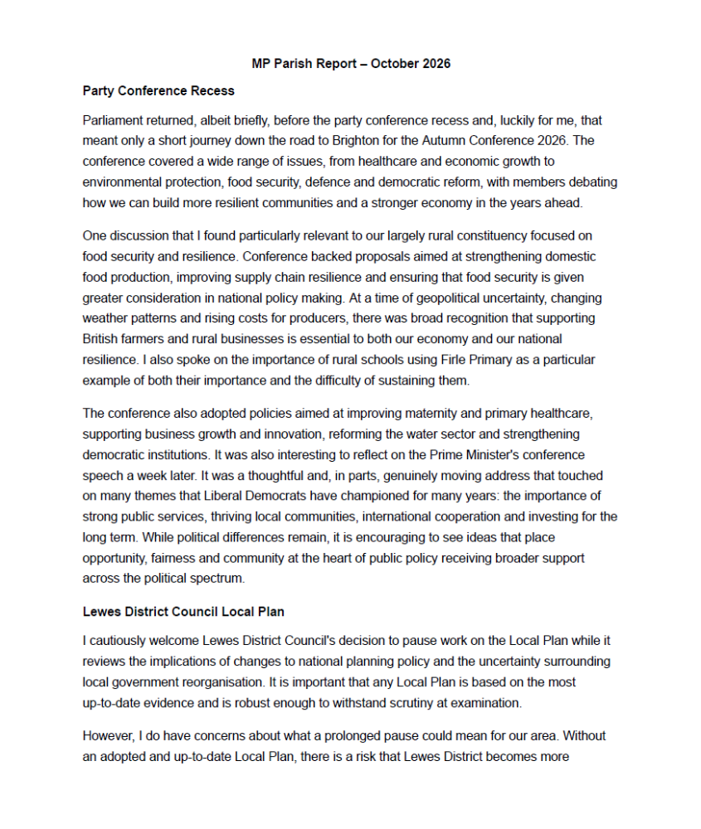
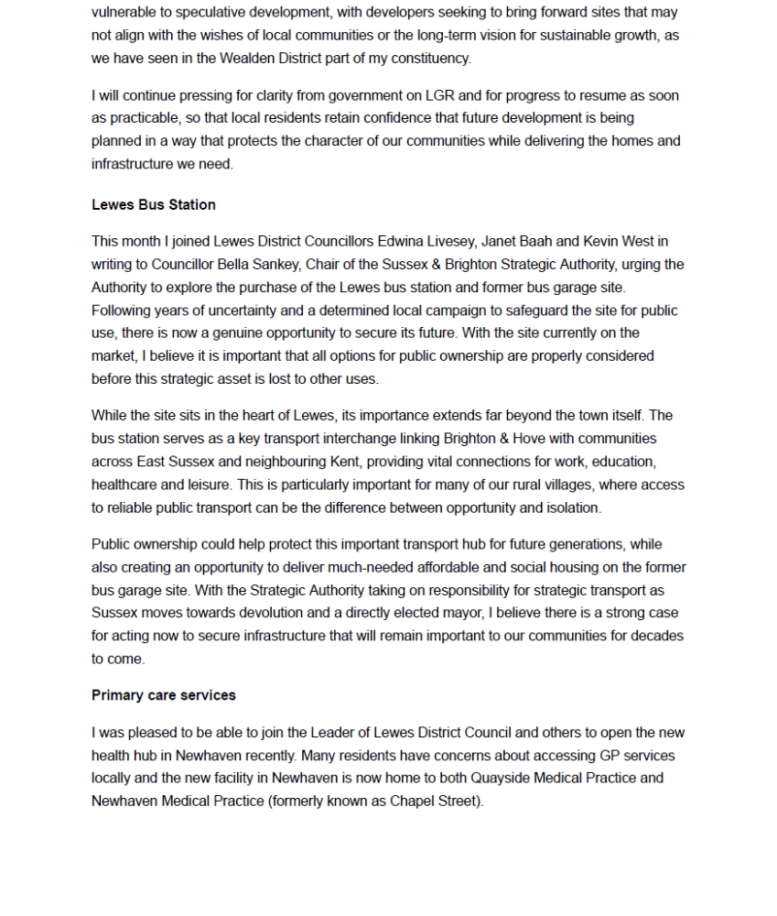
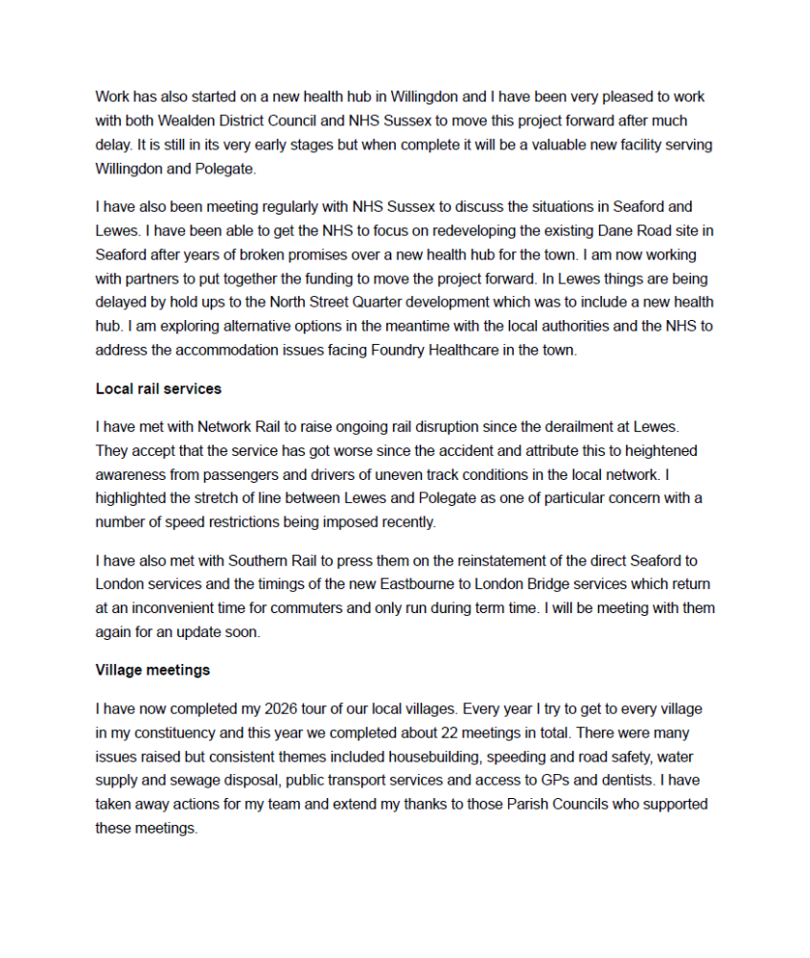


Appendix B - October Finance Report

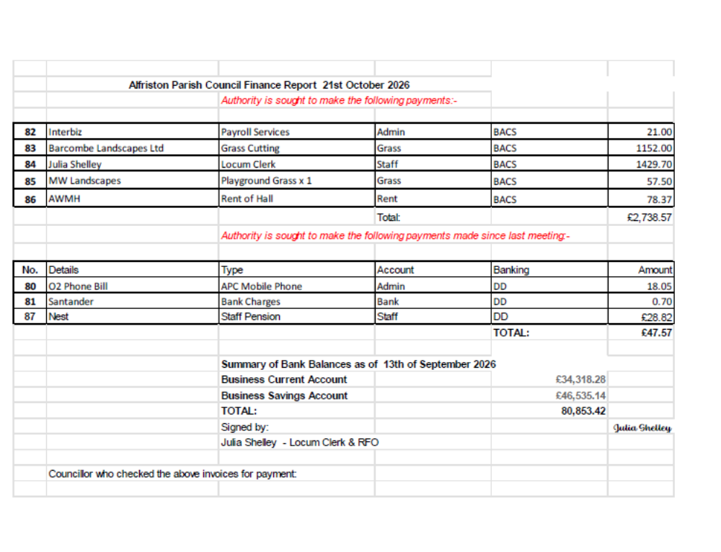

Appendix C –Grant Request

Subject: Cuckmere Flood Forum Grants

Dear Sirs,
We hope you will continue to support the Cuckmere Flood Forum with a grant this year. We are asking for a grant of £110 and expect our expenditure to be in the region of £750. We are asking all the parishes along the river to contribute as previously.

If you have an application Form, could you please forward me a copy.

We had considered whether it was the time to wind the Forum up, but the general feeling is that we should wait for the new unitary authority to see if we still needed a voice. This is on the back burner now, but we are continuing for the time being. A meeting has been called for Mowday 9th November at 3 pm in the Hellingly Hub.

There is also the large planning application for 2500 houses in Arlington, which is likely to come forward. This is directly on the river, so it will be useful to have a meeting place for discussion.

Kind regards,
Gill Hesselgrave
Clerk
Cuckmere Flood forum

Appendix D – Drone Request Cricket Pavilion

Morning,

Thanks for your reply.

I will be once a month just for me to practice my flying.

I will only be operating a height of 20m and distance of 50m.

I won’t be recording anything.

Appendix E – Bollard Request 3 Waterloo Square
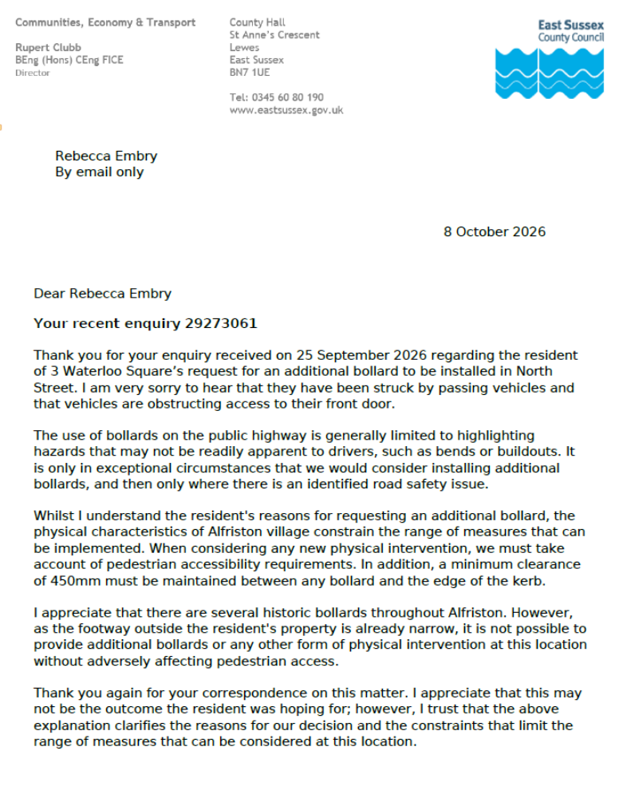

Appendix F – Highway Work Along C120

From: Julie O'Donnell <clerk@cuckmerevalleypc.org.uk>
Sent: 09 October 2026 09:52
To: Alfriston Clerk <clerk@alfristonparishcouncil.org.uk>; Claire Reynolds <longmanclerk@gmail.com>
Subject: Highways work along C120

Hi both
I hope you are well.
Cuckmere Valley Parish Council has asked me to contact the Exceat Bridge project team and ESCC Highways regarding essential road maintenance along the C120 while the bridge project continues.
To give our request greater weight, CVPC felt it would be very beneficial to team up with our neighbouring councils who are also affected by traffic along this corridor.
Could you please confirm whether your Parish Council would be happy to support the draft message below, and allow us to include your council's backing in our submission?
I am writing on behalf of Cuckmere Valley Parish Council, with the support of Alfriston and Long Man Parish Councils, regarding highway maintenance along the C120 while the Exceat Bridge project continues.
Regarding hedge cutting, we have asked Seven Sisters Country Park and Forestry England to trim the hedges on the east side of the C120. Our contractor will carry out the cutting as done last year, though we aim to bill SSCP and Forestry England for their side. The west side will be cut by the contractor at the farmers' expense, as per usual.
Regarding road maintenance, we extend our thanks to ES Highways for the recent pothole repairs. However, we ask that the remaining potholes be addressed and that all gullies along the C120 be thoroughly cleared. As this road is particularly prone to surface flooding, ensuring that surface runoff can drain freely into the gullies is essential.
Is there any way the project team can arrange and oversee these works as part of the wider highways management for the bridge project? With the main road closed, maintaining the C120 in optimum condition is essential for managing the diverted traffic safely.
I look forward to hearing from you.
Thanks
Julie

Appendix G - Allotment Quotation

Morning

So after talking to Stephen yesterday, the chainlink fence to just do the section by the park to cover the gap will be £1,420.21 (vat incl)

For the allotments that we discussed
21A, 21B, 7B, 24 & 28-30

Price will be £420 (incl vat)

Thanks

Matt Woodward
MW Landscapes Sussex Ltd

Appendix H – Update on South Downs Way Works

Subject: RE: URGENT! Tarmac laid on the South Downs Way
Date: 2026-10-02 16:08

From: Ben Bessant <Ben.Bessant@southdowns.gov.uk>
To: "highways@alfristonparishcouncil.org.uk"
<highways@alfristonparishcouncil.org.uk>
Copy: Rights Of Way <Rights.Way@eastsussex.gov.uk>, "'clerk@alfristonparishcouncil.org.uk'"
<clerk@alfristonparishcouncil.org.uk>, Comms Team <CommsTeam@southdowns.gov.uk>, Andy Gattiker <Andy.Gattiker@southdowns.gov.uk>

Dear Rebecca,

I have been forwarded your email from East Sussex County Council's Rights of Way department regarding surfacing work at Kings Ride in Alfriston.

Thank you for your email showing concern for the surfacing of the South Downs Way. The surface and drainage work that is currently been undertaken at Kings Ride Alfriston has been carefully considered and is not a simple tarmac surface. It has gone through several phases of design, informed by infiltration rate testing, LIDAR overland flow analysis, topographical surveys, public and private access requirements as well as providing a sustainable drainage solution.

The specification has been agreed in partnership between the South Downs National Park Authority and East Sussex County Council, as the Local Highway Authority, with input from residents that have private access rights along the South Downs Way at this location. Please find attached an email to Alfriston Parish Clerk on 23/03/2026 notifying them of our intentions to carry out surface and drainage improvements.

The surface type of porous tarmac has been chosen as it will withstand the wear and tear of large agricultural machinery, regular vehicle movements, as well as allowing water to infiltrate without being scoured out by the force of surface water. The subbase is made from porous aggregate with regular geotextile baffles to encourage infiltration into the chalk bedrock. To the side of the surface there is a filter drain for the entire length of the slope which will also slow the flow of water and encourage percolation into the chalk bedrock. The filter drain leads to a soakaway to provide additional capacity for water storage and infiltration.

As you may be aware that this sloped section of the South Downs Way has been surfaced several times in the past, with the previous attempt not lasting a year before it was mostly washed away. The surface that was used for this (not undertaken by the South Downs National Park
Authority) was road planings which did not withstand the surface water run-off. There is evidence of past repairs within the path, where various materials have been used, including bricks and concrete.

Where possible we opt for using chalk and flint in our surface restoration projects (as we did on the other side of Alfriston between Peachy's Corner and Chapel Hill), however due to the steep nature and usage by vehicles/machinery such a surface would not last.

I appreciate that tarmac will look stark to begin with, yet it will soften over time. We have looked at using a variety of different surfaces for this section (from chalk, to limestone, to concrete) and porous tarmac was the material that could satisfy the range of requirements for the path users and also manage the large volumes of water that run downhill. The path specification has been designed by civil engineers to reduce the current burden of surface water entering the highway drainage system which in previous years has been regularly blocked by washout from the Trail. The new specification should alleviate this and reduce the amount of debris being washed onto the highway.

The choice of surface was not taken lightly. The reason we have undertaken the work is because the previous track surface was scouring and forming gulleys which were deteriorating rapidly. The poor condition of the track and the volume of water (and debris) washing onto the highway was causing issues for residents of Kings Ride and The Broadway.
This had been communicated to us regularly, yet the path has no registered landowner and no maintenance agreement (between those with private access rights) in place, so as managers of the National Trail we undertook these much-needed enhancements.

I hope that explains our approach.

Kind regards,

Ben Bessant
National Trails & Countryside Access Officer

Appendix I – Tree Quote adjacent to Village Hall

6th October 2026

Afriston Parish Council
C/O Julia Shelley Parish Clerk

Dear Julia

Please find a quote below to

Prune back Cherry tree overhanging Villiage Hall

£120

Quote includes all labour and removal of all waste

Hope to you hear from you soon.
Yours sincerely
Daniel
Daniel Larkin
Two Willows, Green Lane, South Chailey, East Sussex, BN8 4BT
Danlarkin77@hotmail.co.uk
01323 871044 / 07710 778700
Fully qualified and insured

Appendix J – Twinning Association Update

Alfriston and Cuckmere Valley Twinning Association

September’s stroll took us inland from Seven Sisters Country Park to gently explore West Dean, a pleasant reminder to take time to enjoy the lovely villages around us. It almost goes without saying that this little leg-stretch was followed by a reviving café visit.
Events involving food at Robert & Angela’s house are always a success – they are wonderful cooks and bakers- and October’s “Coffee, Croissants and Chat” was no exception, as members gathered to…. well, the answer is in the name of the event!

Dates for your diary over the winter:-
We start 2027 with delicious traditional Epiphany gateaux made by our skilled bakers :-
Fête des Rois
Sunday 10th January 2027, 4 – 5:45pm
Old Chapel Centre, Alfriston
Teas, cash donations always welcome.
Followed by:-
Barn Dance
Saturday 6th March 2027,
Alfriston Village Hall
All welcome, non-members included
No experience needed, just join us for an evening of fun and laughter with good musicians and an excellent caller. Ticket details to follow.

Annual General Meeting
Followed by teas and chat
Sunday 21st March 2027 4 – 5:45pm
Old Chapel Centre, Alfriston

We have members in the Cuckmere Valley, Alfriston and Seaford. New members are always welcome, and there is no need to speak French, or to have a huge house- just come along and say hello!
For all enquiries, including contacting our membership secretary Robert Morrison, please use our email address acvtainfo@gmail.com

